ECONOMICS
Table of Contents
Product and brand strategy 1
Capabilities, networks, and platforms 1
Product platforms 1
Product planning 1
Product strategy 1
Competitive strategy 2
Product portfolios 2
The competitive environment 2
Differentiation and positioning 3
Differentiation 3
Product positioning 3
Competing with other products 4
Managing brands 6
Brand strategy 6
Brand extensions 6
Market entry 6
Launch and continuing improvement 7
Withdrawing products 7
Managing mature products 8
New product development 10
Innovation management and NPD 10
Considerations when developing a NPD strategy 10
• On-going corporate planning 10
• On-going market planning 10
• On-going technology management 10
NPD as a strategy for growth 10
Market penetration 11
Market development 11
Product development 11
Diversification 11
What is a new product? 12
Defining a new product 13
Classification of new products 13
New product development as an industry innovation cycle 13
Overview of NPD theories 13
Models of new product development 15
Packaging and product development 17
The basic principles of packaging 17
Characteristics of packaging 18
Product rejuvenation 18
Product and pack size variation 19
Packaging systems 19
Retailer acceptance 19
Revitalizing mature packaged goods 19
Market research and its influence on NPD 21
The purpose of new product testing 21
Techniques used in consumer testing of new products 22
When market research has too much influence 23
Discontinuous new products 23
Market research and discontinuous new products 23
Circumstances when market research may hinder the development of discontinuous new products 24
Technology-intensive products 25
Breaking with convention and winning new markets 26
When it may be correct to ignore your customers 26
Managing the new product development team 28
New products as projects 28
The key activities that need to be managed 29
Assembling knowledge 29
The generation of business opportunities 30
Existing products 30
Technology 30
Unexploited patents 30
Customers and vendors 30
Salesforce 30
Senior and top management 31
Brainstorming and synectics 31
Individuals 31
Developing product concepts 31
The screening of business opportunities 31
Distinguishing between dreams and reality 31
Development of product prototypes 32
Technical testing 33
Market introduction 33
Launch 33
NPD across different industries 33
Organization structures and cross-functional teams 33
Teams and project management 34
Functional structures 34
Matrix structures 34
Corporate venturing 35
Project management 35
Reducing product development times through computer-aided design 35
The marketing/R&D interface 35
Scarcity, Choice, and Economic Systems 36
Society’s Production Choices 36
Increasing Opportunity Cost 36
Productive Inefficiency 37
Economic Growth 37
Consumption vs. Growth 39
Economic Systems 40
Comparative Advantage 40
International Comparative Advantage 40
Resource Allocation 41
Distributing Products 42
Factors that determine the optimal channel of distribution: 42
Market Coverage 43
Transportation used to Distribute Products 43
44
Accelerate the Distribution Process 44
Characteristics of Retailers 44
Services Offered by Wholesalers 45
How Wholesalers Serve Retailers 45
Vertical Channel Integration 46
Promoting Products 47
Optimal Promotion Mix 49
Accounting and Financial Analysis 51
Responsible Financial Reporting 51
Financial Statements 52
Creating and Pricing Products 55
Product line 55
Product mix 55
Product life cycle 55
Identifying a target market 55
Factors that affect the size of a target market 56
Creating new products 56
Steps necessary to create a new product 56
Product differentiation 56
Pricing strategies 57
• Cost of production 57
• Supply of inventory 57
• Competitors’ prices 57
Setting a product’s price 57
Distributing products 59
Direct channel 59
One-level channel 59
Two-level channel 59
Selecting the degree of market coverage 59
Selecting the transportation used to distribute products 60
Characteristics of retailers 60
Services offered by wholesales 60
How wholesalers serve retailers 60
Vertical channel integration 61
Financing 62
Borrowing from financial institutions 62
Issuing bonds 62
Commercial paper 62
Common creditors that provide debt financing 62
Issuing stock 63
How firms issue securities 63
Other methods of obtaining funds 63
Deciding the capital structure 64
Remedies for debt problems 64

Product and brand strategy

Capabilities, networks, and platforms

Product platforms

Benefits gained through using product platforms are:
- Reduced cost of production
- Shared components between models
- Reduced R&D lead times
- Reduced systemic complexity
- Better learning across projects
- Improved ability to update products

Product planning

The product planning process takes place before substantial resources are applied to a project. Product planning considers the range of projects that a firm might pursue and over what time frame. It is closely linked to the broader business strategy of the firm.

Product planning activity clearly requires substantial input from R&D. Organizations seek to have a set of balanced capabilities that will enable them to match market opportunities by developing attractive market offerings, which customers perceive as conveying valuable benefits.

The product plan identifies the portfolio of products to be developed by the organization. The planning process considers product development opportunities from many sources, including marketing, R&D, customers, current product teams, and competitor analysis.

The product plan is regularly updated to reflect the changing competitive environment. Product planning decisions generally involve senior management.

Product development opportunities are usually classified as:
- New product platforms
- Derivatives of existing platforms
- Incremental improvements to existing products
- Fundamentally new products (discontinuous products)

Product strategy

New product strategy is linked to, and its objectives are derived from, marketing strategy, technology strategy, and the overall corporate strategy

Competitive strategy

New products are required because they serve a customer need and an organization need. The organization need will be articulated in the organization’s strategy.

Competitive strategy may drive new product planning on a short-term or long-term basis. In the shorter term a defensive posture may suggest that product variants are needed to shore up a declining market share.

In the longer run competitive strategy may seek a more profound contribution from new products.

Product portfolios

Another set of strategic considerations concerns the overall portfolio of products. Analyzing the organization’s total collection of products by viewing it as a portfolio may give fresh insights. This approach was initiated by the share-growth matrix, or Boston box, which used market share and market growth as dimensions against which to plot the positions of products. A typology was derived with high and low values for each of the 2 dimensions so that the 4 quadrants could be contrasted.

Alternative models have been suggested using multi-factor dimensions that are composites of variables, such as business strength and market attractiveness.

All of these models share a similar aim: to give a strategist an overview that could reveal current or potential problems or opportunities in the product strategy.

Nothing conclusive can be expected from these analyses: they are probing and investigative.

The competitive environment

The external environment constrains what can be done, sometimes even dictating what must be done. It can present possibilities and opportunities.

Close analysis of the present situation in the market is fundamental, along with speculations about how it might progress and because of the potential importance of external events and conditions some type of environment monitoring has become a key exercise in strategy search. Assessments of the present situation can be extended to conjectures about future environments. These speculations might deal with some of the following issues:
- Estimates would be needed about the way the technology will change
- Estimates might also be made about how the industry competitive structure may alter
- How any regulatory framework may evolve
- Customer needs

Differentiation and positioning

Product strategy will express how the organization seeks to differentiate and/or distance itself from its competitors and it will be the bedrock of its market positioning. For ned products to be successful in the market they need to be perceived to be beneficial by prospective buyers. The benefit needs to stand out, be distinctive, and attractive. This distinction needs to be relevant to buyers, and it needs to be seen to be relevant to them.

Differentiation

Differentiation could be based upon cost (value-for-money proposition) or upon superior quality. According to Levitt there are 4 levels on which products can be considered:
- The core product comprises the essential basics needed to compete in a product market.
- The expected product adds in what customers have become accustomed to as normal in the product market
- The augmented product offers features, services, or benefits that go beyond normal expectations.
- The potential product would include all the features and services that could be envisages as beneficial to customers.

The position of the previous categorization can be dynamic because customer expectations change.

Product positioning

Product positioning refers to the perceptions customers have about the product. It is a relative term that describes customer perceptions of the product’s position in the market relative to rival products.

Positioning studies begin with determining a relevant set of products. The criterion for inclusion is that they must be perceived by customers to be choice alternatives. Then a list of determinant attributes is generated. With this framework customers’ perceptions and preferences are then collected.

Such a study would show the proximity of, or the distance between, the perceived positions of the products considered.

If there were several clusters of preferences, each in a different part of the map, this might indicate different market segments.

Positioning strategy depends upon the choice of an appropriate base. This base must be relevant and important to customers and related to how they make choices in that product field. It should also attempt to distance the brand from the positions of rivals. Wind offers 6 bases:
- Product feature
- Benefits
- Use occasion
- User category
- Manufacture
- Endorsement

Selecting an appropriate positioning can make the difference between success and failure.

Competing with other products

One factor differentiates great companies from the others and that is the products they sell.

Most models of buyer behavior recognize two kinds of factors: objective and subjective.
- Objective factors may or may not be tangible but they must be quantifiable and measurable
- Subjective factors are intangible and are influenced by attitudes, beliefs, experience, and associations held towards the product

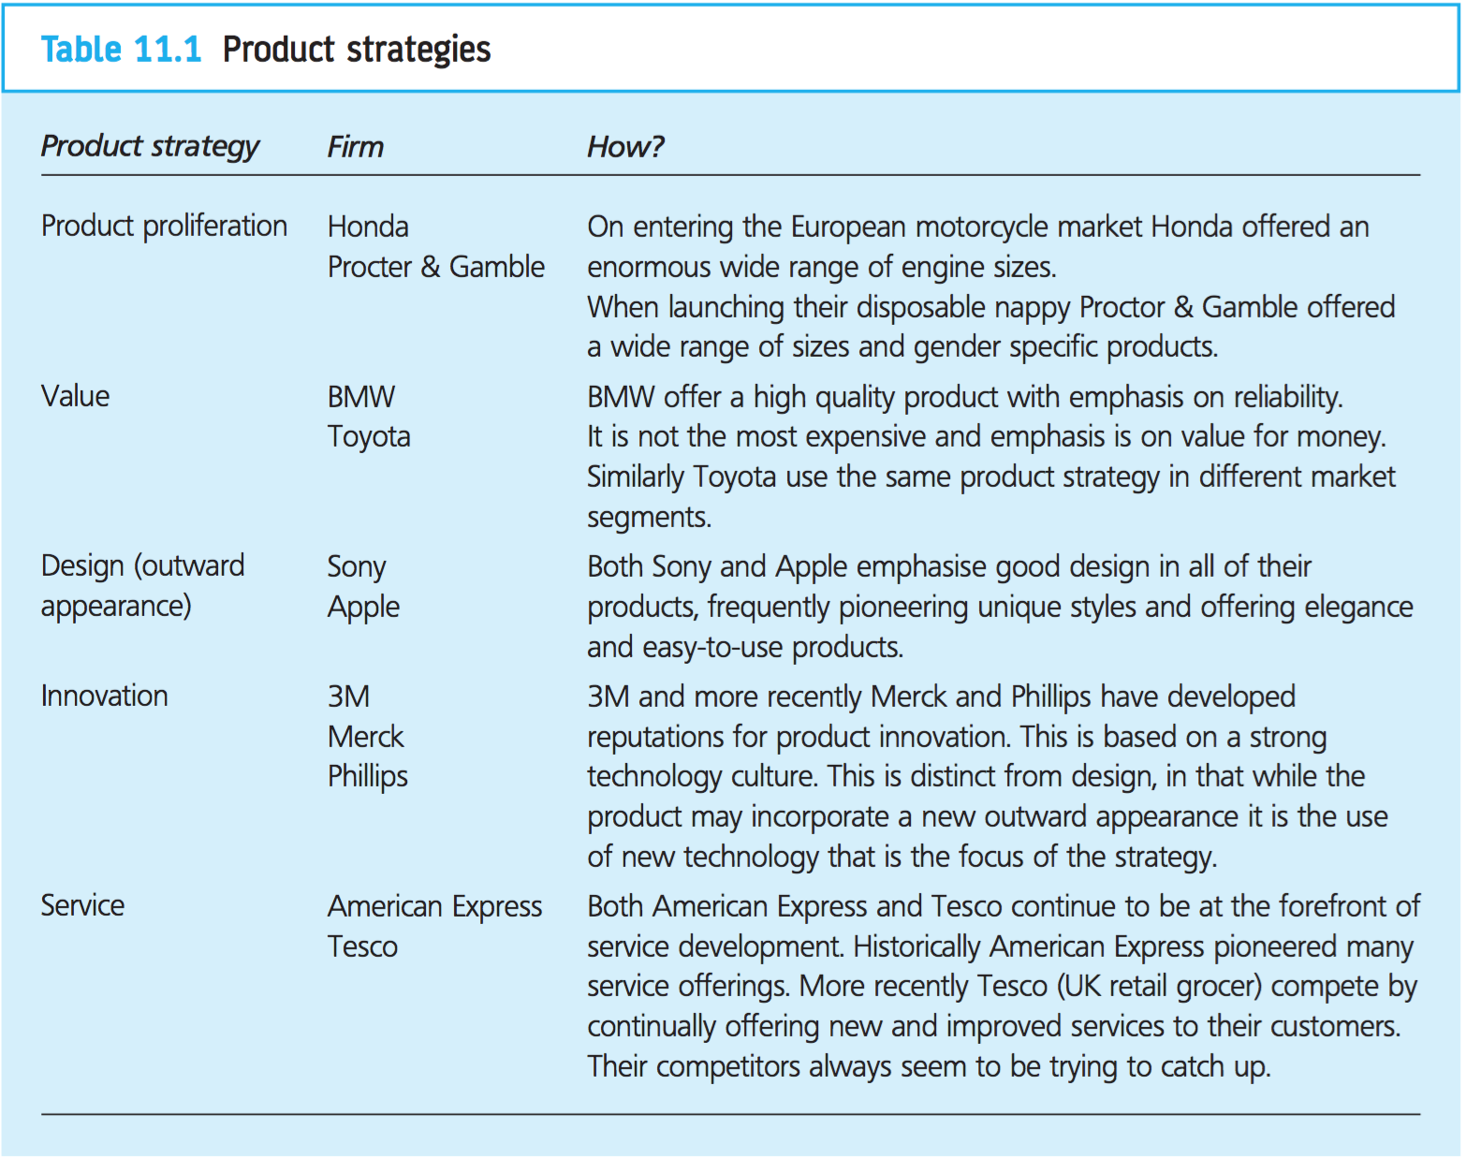

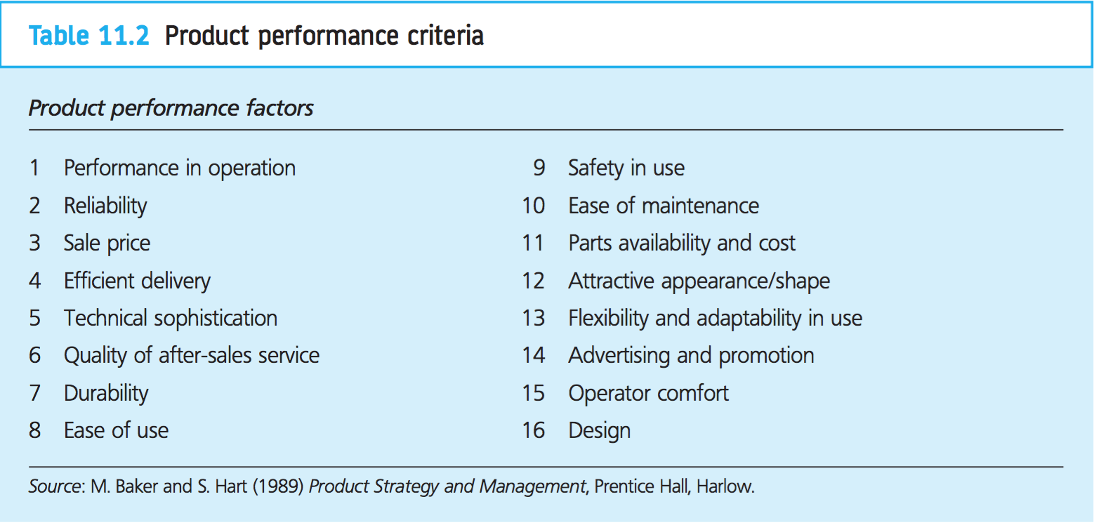

Managing brands

Branding is based on random utility theory, where customers form preferences based on their perception of attributes. Decisions are then made upon these preferences with customers selecting the product with highest expected value or utility.

The brand manager and the firm have to decide the extent to which they wish to invest in their brand and thereby develop it. Such considerations will involve all aspects of the marketing mix and in turn will obviously affect buyer perception.

Brand strategy

Brand strategy is the spearhead of the organization’s competitive intentions. It carries the company or product name into the market and shows how it is positioning itself to compete. It involves choices between having no brand name at all, so that the product is sold as a commodity, and the attempt to develop a distinctive brand name with a distinctive set of associations and expectations.

Brand extensions

A brand extension is the use of an established brand name on a new product in the same product field or in a related field. The brand name might also be stretched to an unrelated product field.

The rationale behind a brand extension strategy is to take advantage of potential carry-over effects from the original brand. 3 kinds of carry-over effects may be relevant:
- Expertise
- Prestige
- Access

Brand extensions can also be problematic. The connection with the original brand can be strained and the carry-over effects diminished or eliminated.

In some markets brand extensions are added which contribute little and at times they can be harmful to the original. They can clutter the market and confuse the consumers.

Market entry

Decisions about how and when to enter the market can make a substantial difference to the new product’s prospects. Timing the entry to the market can make or break an innovation.

Early entry is desirable and there is evidence that pioneers accrue first mover advantages. They are able to influence customer expectations and shape how customers make evaluations of products in the new field.

Being too early can be as much of a disadvantage as being too late. A weak, tentative first mover, without the motivation or resources to grow the market, can spend years making losses only to be superseded by a stronger fast follower.

Positioning decisions can be influential.

Scale of entry affects how the product performs and how the market evolves. High levels of effort and resource commitment can stimulate market evolution and a critical factor in this is market exposure.

Getting prospective customers talking and thinking about the product is vital. This may mean the establishment of a strong market presence through press articles, advertising, participation at exhibitions, and a highly visible presence in distribution channels.

Launch and continuing improvement

From a business perspective the innovation is not a success until it has established and fixed its place in the market. That depends upon how it is launched, its reception by customers, and the continuing attention given to its improvement.

The act of putting the product onto the market is not an end: it is the beginning of a new phase. Close and constant monitoring of the reactions of customers, distributors, and competitors is required to inform the proceeding strategy.

Having the product on the market allows the validation or the rejection of important estimates or assumptions about customer attitudes and behavior that would have been made during development. It could also reveal unanticipated problems or opportunities.

Thought about how the product and the market will evolve from the launch might give attention to 3 areas:
- Product platform evolution and brand extensions
- Market evolution
- Competitive evolution

Inauguration is not enough. To be effective the innovation must be well founded in the market and receive customer acceptance, and plans need to be made to secure, deepen, and widen its market position from the initial launch.

Withdrawing products

Pruning the product range can be an important part of managing the portfolio. Chronic poor sales performance would be a first indicator that consideration should be given to withdrawing products.

Exit costs would feature strongly. The arbitrary removal of one may throw into jeopardy the economics of the remainder, and so it could be that the product was continued so long as it made some contribution to overheads. Contractual obligation may tie it in. These contracts may be with suppliers, customers, distributors, or other partners in the network. An inflexible plant could also tie it. Reputation could be another issue.

Alternatively, the firm may decide to make an active commitment to stay in the declining industry in anticipation of increasing market share.

Managing mature products

As growth slows and the level of competition intensifies profit margins will come under pressure.

Mature products usually make up the majority of a firm’s source of cash generative lines. Profit margins may decline due to:
- increasing number of competitive products
- cost economies used up
- decline in product distinctiveness, etc.

With the loss-of-profit margins industries tend to stabilize, with a set of entrenched competitors. The low margins act as a barrier to entry and those firms remaining in an industry can generate sustained profits over a long period in the maturity and decline stages of a product’s life cycle.

Within the maturity and decline stages of a product’s life cycle Schofield and Arnold distinguish 4 phases to the mature phase of the traditional product life cycle:
- late growth
- early maturity
- mid-maturity
- late maturity

Firms need to be able to recognize the early signs of late growth usually characterized by aggressive price cutting. This continues into the early stages of maturity when the market becomes saturated with little or no opportunity for growth. At this stage firms are forced into taking tactical decisions regarding additional services and promotions. It is also important for firms to be vigilant for changes that take place in the market concerning segments: some segments may decline rapidly while others may still be growing. As the market moves towards mid- and late maturity customers are seen as more discerning and less loyal. Several strategies are available to firms managing mature businesses and there are several positive factors:
- price is not important to everyone and probably not to the majority
- industries that evolve gradually offer time and space for careful strategy selection
- the market is stable
- niches once secured require fewer resources to defend them
- sustainable real or perceived advantage in cost or performance will attract new business

New product development

Innovation management and NPD

Companies need to reach out to the future and develop new products that will enable them to compete over the coming decades.

New product development concerns the management of the disciplines involved in the development of new products.

Production management examines the development of new products from a manufacturing perspective. Marketing would be concerned with trying to understand the needs of the customer and how the business could best meet these needs.

Competition between companies is assessed using financial measures such as return on capital employed (ROCE), profits, and market share. Non-financial measures such as design, innovativeness, and technological supremacy may also be used.

Long-term success is dependent on the ability to compete with others, this is almost always achieved by ensuring that your company’s products are superior to the competition.

Success in one year does not ensure success in the next.

Considerations when developing a NPD strategy

- On-going corporate planning
  - In large organizations this can be a very formal activity involving strategic planners and senior managers with responsibility for setting the future direction of the business. In smaller organizations this activity may be undertaken by the owner of the business in an informal, even ad hoc way.
- On-going market planning
- On-going technology management
  - The continual analysis of internal R&D projects and external technology trawling will lead to numerous technical opportunities that need to be considered by the business.

NPD as a strategy for growth

The development of new products provides an opportunity for growing the business. NPD is only one of many options available to a business keep on growth.

Growth can be achieved organically (internal development) or through external acquisition. Consolidation and retrenchment need to be considered, especially in times of economic downturn.

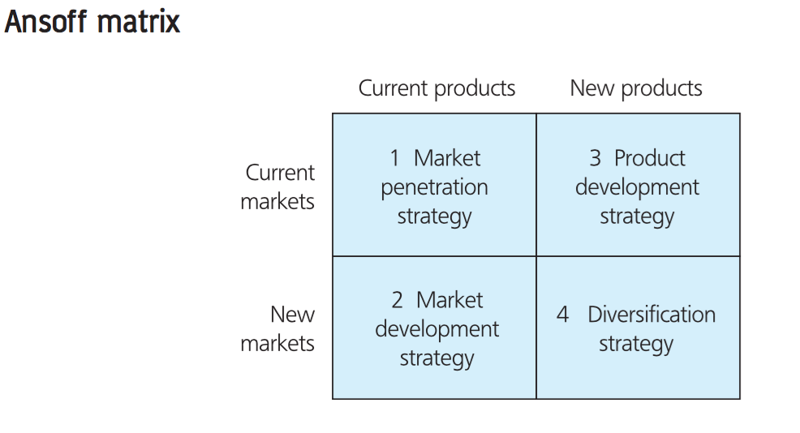

Market penetration
Opportunities are said to exist within a business’s existing markets through increasing the volume of sales. Increasing the market share of a business’s existing products by exploiting the full range of marketing-mix activities is the common approach adopted by many companies.

Market development
Growth opportunities are said to exist for a business’s products through making them available to new markets. In this instance the company maintains the security of its existing products but opts to develop and enter new markets.

Product development
Growth opportunities exist through offering new or improved products to existing markets.

Diversification
Growth exist beyond a business’s existing products and markets. The business would move into product areas and markets in which it currently does not operate. Many companies try to utilize either their existing technical or commercial knowledge base. Additional opportunities for diversified growth exist through forward, backward, and horizontal diversification.

What is a new product?

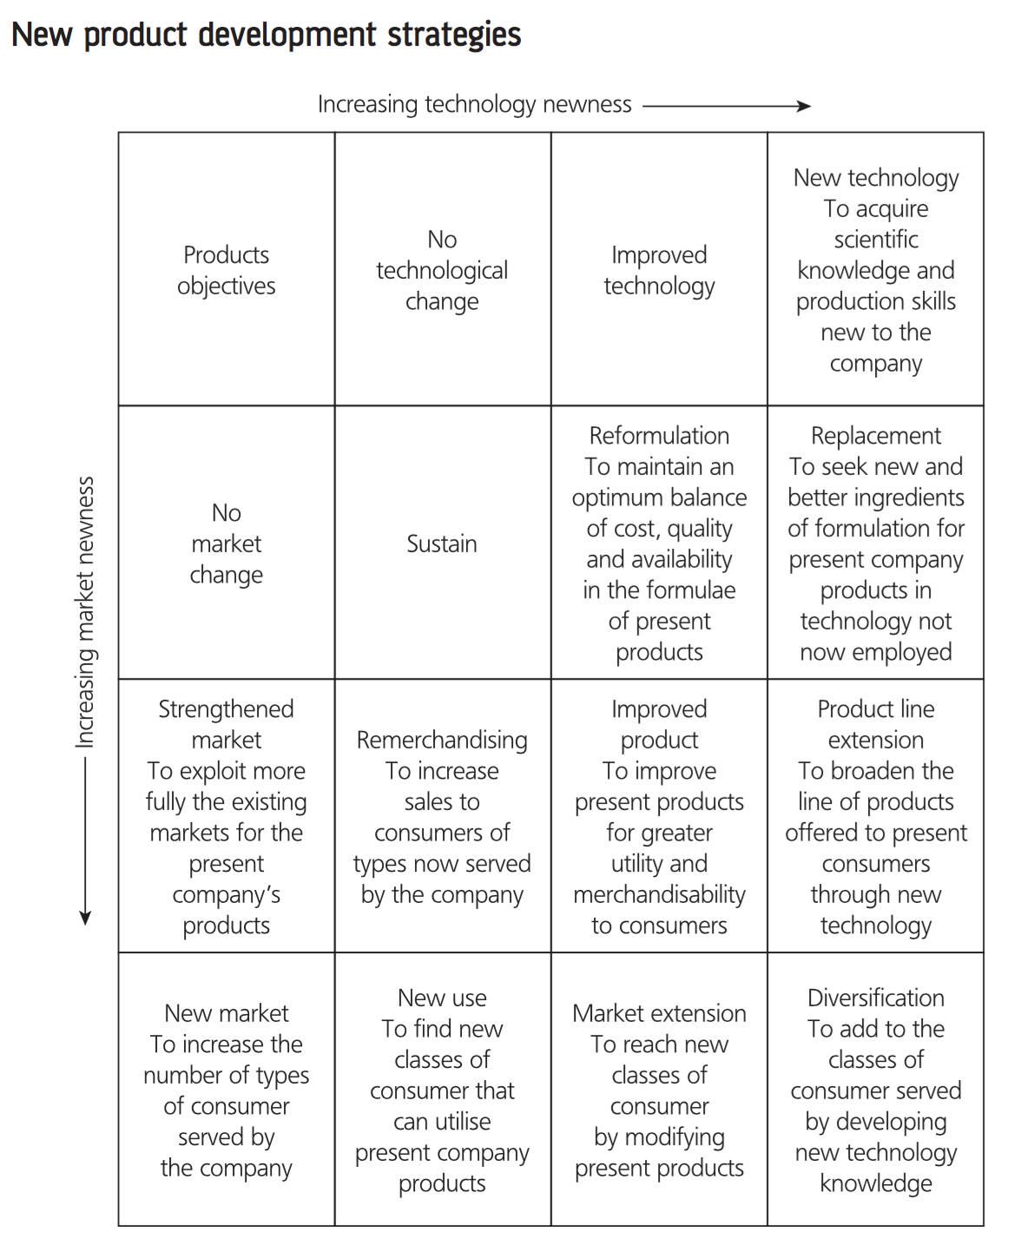

A product is a multi-dimensional concept.

Defining a new product
So long as a product is perceived as new, it is new.

Only 10% of new products introduced are new to both the market and company.
New to the company (in this instance) means that the firm has not sold this type of product before.
New to the market means that the product has not appeared before in the market.

Meeting the needs of the customer and offering products that are wanted is more important than whether a product represents a scientific breakthrough.

Classification of new products
- New to the world products
  - First of their kind and create a new market
- New product lines (new to the firm)
  - Not new to the market but new to a particular firm
- Additions to existing lines
- Improvements and revisions to existing products
- Cost reductions
- Repositioning
  - Discovery of new applications for existing products

New product development as an industry innovation cycle
Product innovations are soon followed by process innovations in what they described as an industry innovation cycle

Overview of NPD theories

The early stages of the new product development process are most usually defined as:
- Idea generation
- Idea screening
- Concept development
- Concept testing

It is easier to change a concept than a physical product. The subsequent stages involve adding to the concept as those involved with the development begin to make decisions regarding how best to manufacture the product, what materials to use, possible designs, and the potential market’s evaluations.

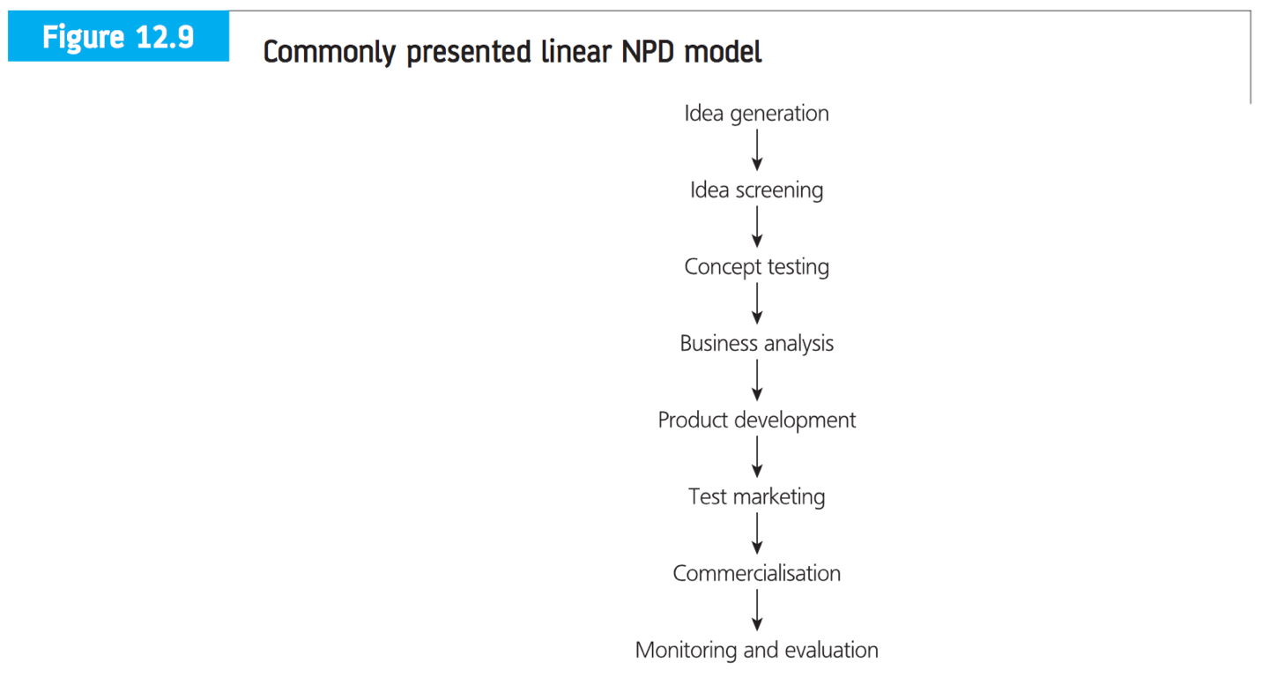

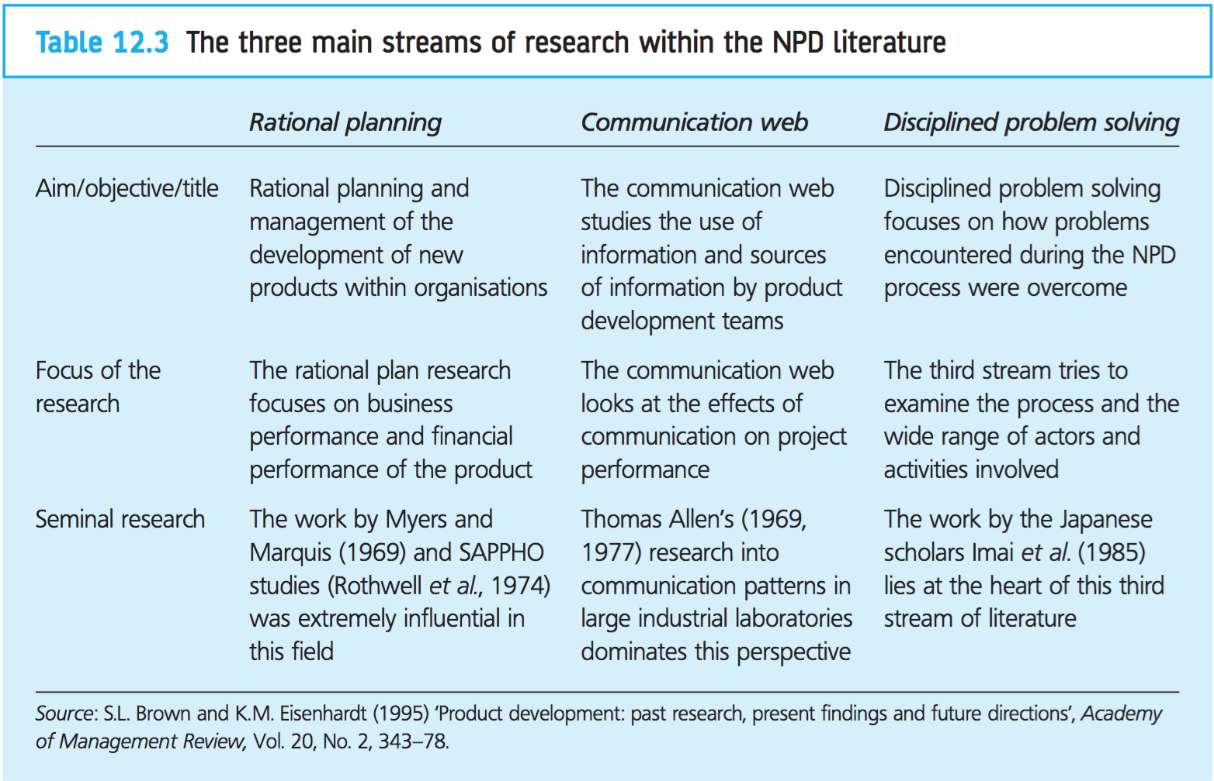

Models of new product development

It is possible to classify the numerous models into seven distinct categories:
- Departmental-stage models
  - Represent the early form of NPD models. Can be shown to be based around the linear model of innovation, where each department is responsible for certain tasks. Usually represented in the following way:
    - R&D provides the interesting technical ideas; the engineering department will then take the ideas and develop possible prototypes; the manufacturing department will explore possible ways to produce a viable product capable of mass manufacture; the marketing department will then be brought in to plan and conduct the launch. Such models are referred to as over-the-wall models.
      - It is widely accepted that this insular departmental view of the process hinders the development of new products. The process is usually characterized by a great deal of reworking and consultation between functions. Control of the project changes on a departmental basis depending on which department is currently engaged in it.
- Activity-stage models and concurrent engineering
  - Similar to departmental-stage models but because they emphasize activities conducted they provide a better representation of reality. They also facilitate iteration of the activities through the use of feedback loops. Activity-stage models have highlighted the simultaneous nature of the activities within the NPD process, hence emphasizing the need for a cross-functional approach.
- Cross-functional models (teams)
  - Common problems that occur within the product development process center around communications between different departments. This approach removes many limitations of previous models by having a dedicated project team representing people from a variety of functions. Requires a fundamental modification to an organization’s structure. It places emphasis on the use of project management and inter-disciplinary teams.
- Decision-stage models
  - Represent the new product development process as a series of decisions that need to be taken in order to progress the project. Many of these models also facilitate iteration through the use of feedback loops. A criticism of these models is that such feedback is implicit rather than explicit.
- Conversion-process models
  - View NPD as numerous inputs into a black box where they are converted into an output.
- Response models
  - Based on the work of Becker and Whistler, who used a behaviorist approach to analyze change. These models focus on the individual’s or organization’s response to a new project proposal or new idea.
- Network models
  - The process of accumulation of knowledge from a variety of different inputs, such as marketing, R&D, and manufacturing. This knowledge is built up gradually over time as the project progressed from initial idea through development.
    - Network models emphasize the external linkages coupled with the internal activities that have been shown to contribute to successful product development.

Packaging and product development

The basic principles of packaging

3 basic principles of packaging:
- Protection (and tamper proofing)
  - Primary role of packaging is preserving product integrity by protecting it against potential damage from the climate, bacteria, and transit hazards, plus any other hazard to which the product is likely to be exposed on its journey from manufacturer to consumer.
    - Many products perish in the very last stages of their journey following purchase by the consumer
  - Tamper-proof packaging indicated any tampering to consumers and resellers
- Containment
  - During the use of the product by the consumer the issue of containment becomes visible. There is a requirement for such packaging to have dispensing and resealing features.
- Identification
  - Labelling, this role of packaging includes:
    - Information on how the product is used
    - Establishment of brand identity
    - Promotion of sale
  - Identity is not simply a function of graphics; it can also be a function of shape. Shape can provide the unique brand identity for a product, or it can place the product in a specific market sector.
  - The underlying principle that ties these 3 cornerstones of packaging together is that of optimal overall cost. Whatever product is to go inside the package, it has to be filled or placed inside in an efficient operation or significant cost will be incurred. If the packet design leads to difficulties or poor performance in storage this will add to overall cost
  - Labelling: As well as the functional requirements that the label has to perform such as providing information on the following
    - Source of the product
    - Contents
    - How to use the product
    - Universal product code or bar code
    - Warnings
    - Certifications
    - How to care for the product
    - Nutritional information
    - Type and style of the product
    - Size and number of servings

These basic principles need to be met with all packaging at optimal overall cost.

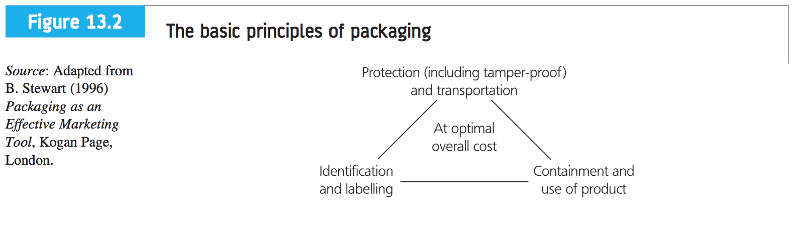

Characteristics of packaging
- Dispensing
- Storage
  - Easy product storage can offer considerable development opportunities. Refers to storage of the pack by the consumer after purchase.
- Stability
  - Does not refer to physical stability in terms of whether it remains upright; this is covered under storage. Refers to shelf-life.
- Handling
  - Adds value and consumer convenience.
- Opening/resealing
- After use and secondary use
  - The use of some packaging for storage containers has a long heritage and is recognized by many brand managers.
- Disposal
  - Easy disposal adds to consumer convenience thereby adding value.

Product rejuvenation

A number or reasons why profit margins decline:
- Increasing number of competitive products leading to over-capacity and intensive competition
- Market leaders under pressure from smaller companies
- Strong increase in R&D to find better versions of the product
- Cost economies used up
- Decline in product distinctiveness
- Dealer apathy and disenchantment with a product with declining sales
- Changing market composition where the loyalty of those first to adopt begins to waver

Packaging development provides a relatively inexpensive way of rejuvenating a product.
Continual analysis of the market in which current product operate should provide many opportunities for developing the product/brand. This is one of the fundamental responsibilities of the brand manager.

Product and pack size variation

By aligning pack sized with particular consumer life styles it is possible to increase growth through market development.

A strong association in the eyes of the consumer between larger pack size and economy. Restrictions in terms of how large a pack should be:
- Weight and ease of carrying home
- Storage space within the home
- Product usage versus shelf-life
- Capital outlay
- Ease of dispensing product from large container

Packaging systems

All packaging can be improved. However, there is an optimal overall cost to consider. The type of materials used and the package system selected are inextricable linked together. Any large-scale capital expenditure will require careful analysis and justification.

Retailer acceptance

When considering a product’s packaging it is desirable if not essential to get input from members of the distribution channel from an early stage.

For a new product to become successful it must be accepted by the final user, but success is also dependent on acceptance of the new product by the channel members through whom it passes in reaching the final customers. Whereas final users are most concerned about how the product will perform when used, channel members are much more interested in how the product will sell, whether it will be easy to stock and display, and whether it will be profitable.

Retailers want to:
- Stock only product lines that sell
- Reduce quantity purchased
- Stock goods that produce high levels of profit

Revitalizing mature packaged goods

Many brands do lose sales and become labelled mature or old. In such circumstances brand managers need to use a variety of tools and skills if they are to successfully revitalize these matured goods:
- Reminding consumers about the brand
- Improving where the product is sold
- Improving the packaging

Market research and its influence on NPD

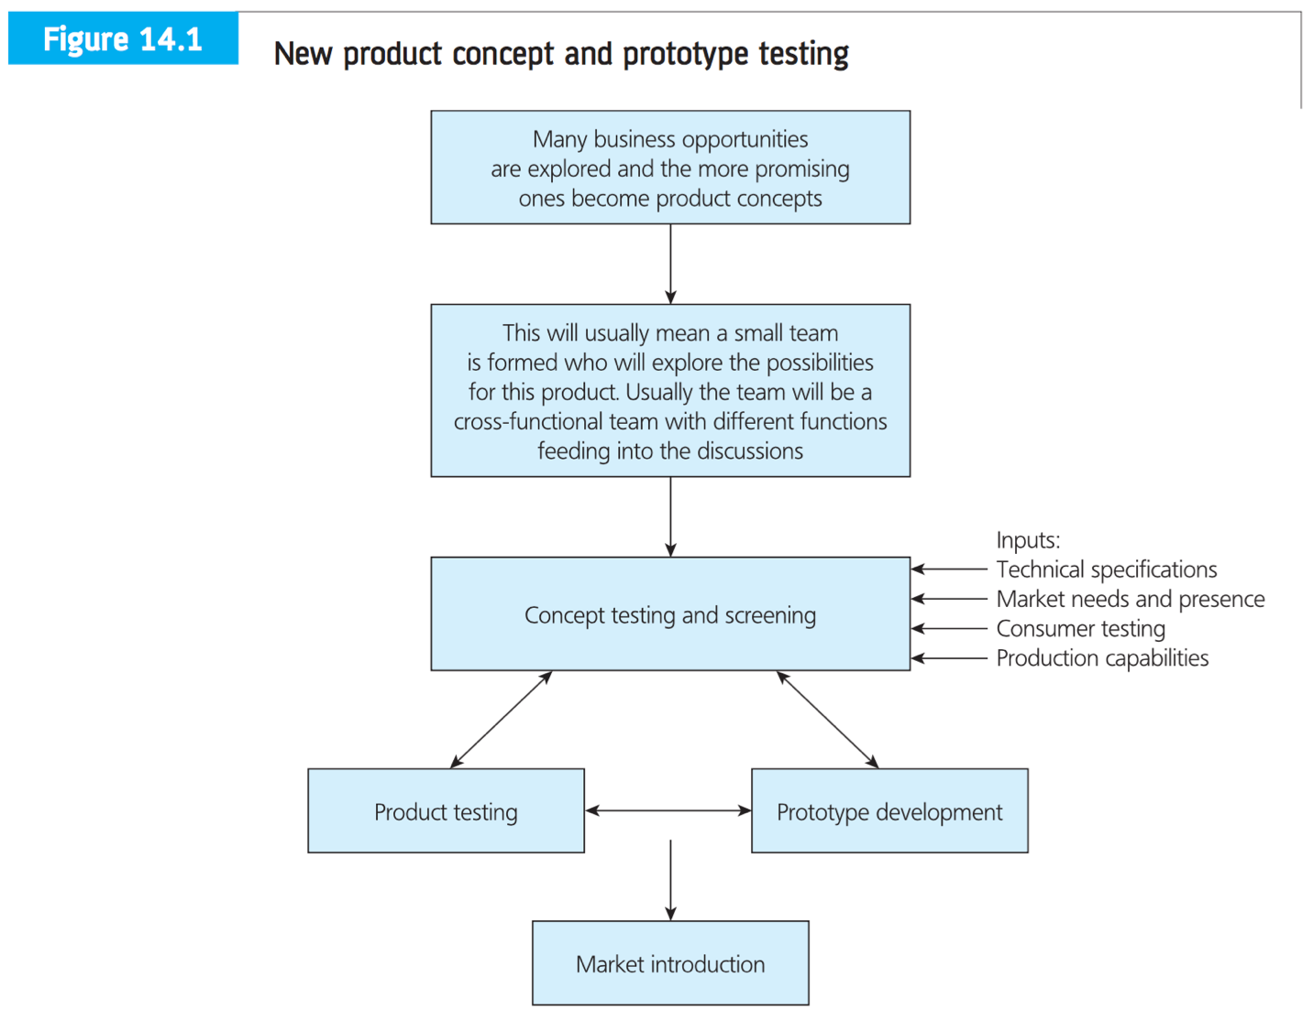

The purpose of new product testing

The main objective is to estimate the market’s reaction to the new product under consideration, prior to potentially expensive production and promotional costs. Necessary to consider a number of factors:
- The market
  - Current buying patterns
  - Existing segments
  - Customer’s view of the products available
- Purchase intention
  - Trial and repeat purchase
  - Barriers to changing brands
  - Switching costs
- Improvements to the new product
  - Overall product concept
  - Features of the product concept

All these factors are linked and usually covered in consumer new product testing and referred to as customer needs and preferences.

King argues needs can be classified into 3 types:
- Basic needs are those that a customer would expect
- Articulated needs are those that a customer can readily express
- Exciting needs are those that will surprise customers and are not being met by any provider at present

To command a higher price a manufacturer will have to develop different forms of packaging.

Techniques used in consumer testing of new products

- Concept tests
  - Qualitative techniques, especially group discussions, are used to obtain target customer reactions. Question areas would cover:
    - Understanding and believability in the product
    - Ideas about what it would look like
    - Ideas about how it would be used
    - Ideas about when and by whom it might be used
  - This helps reveal the most promising features of the new product and group to whom it might appeal. The assessment of purchase intent is the primary purpose of concept testing.
- Test centers
  - Used when the product is too large, expensive, or too complicated to be taken to consumers for testing
- Hall tests/mobile shops
  - Used for product testing or testing other aspects of the marketing mix such as advertising, price, packaging, etc. Representative sample of consumers is recruited and brought to a conveniently located hall, then exposed to the test material and asked questions about it
- Product-use tests
  - Used in business-to-business markets. Small group of potential customers selected to use the product for a limited period of time. Technical people watch how these customers use the product, from this test the manufacturer learns about customer training and servicing requirements.
- Trade shows
  - Draw large numbers of buyers who view new products in a few days. Allows manufacturer to see buyer’s reactions to various products on display.
- Monadic tests
  - Given only only product to try and asked for their opinion. Not very sensitive in comparing the test product with other products.
- Paired comparisons
  - Asked to try 2 or more products in pairs and asked which they prefer.
- In-home placement tests
  - Used when an impression of how the product performs in normal use is required.
- Test panels
  - Representative panels are recruited and used for product testing. Test materials and questionnaires can be sent through post.

When market research has too much influence

Most new products fail in the market because consumer needs and wants are not satisfied.

The role of market research in NPD is most clearly questionable with major product innovations, where no market exists.
- If potential consumers are unable adequately to understand the product, then market research can only provide negative answers
- Consumers frequently have difficulty articulating their needs

Our plan is to lead the public with new products rather than ask them what kind of products they want. The public does not know what is possible, but we do.

Discontinuous new products

Major innovations are referred to as discontinuous new product when they differ from existing products in that field, sometimes creating entirely new markets and when they require buyers to change their behavior patterns. Such products usually require a period of learning on the part of the user.

2 major difficulties are:
- The problem of selection of respondents
- The problem of the understanding of the major innovation

The type of research technique selected is crucial in obtaining accurate and reliable data.

Market research and discontinuous new products

In the case of discontinuous product innovations, the use and validity of market research methods is questionable. Such approaches discourage the development of major innovations.

Customers can be extremely unimaginative… trying to get people to change they way they do things is the biggest obstacle facing many companies.

New approaches are being recognized in the area of discontinuous product innovations. One technique adopts a process of probing and learning, where valuable experience is gained with every step taken and modifications are made to the product and the approach to the market based on that learning. This is not trial and error but careful experimental design and exploration of the market often using the heritage of the organization.

Circumstances when market research may hinder the development of discontinuous new products

Much of the problem is due to the way we view a product. We often view it in isolation from:
- Its context
- The way it is used
- The role of the customer-supplier relationship

This contributes to misleading views on new products.
Product develops and product testers need to recognize that a product will be viewed differently by channel members than by end-users. End-users will be concerned about how the product will perform, whereas channel members are more interested in how the product will sell, whether it will be easy to stock and display, and whether it will be profitable.

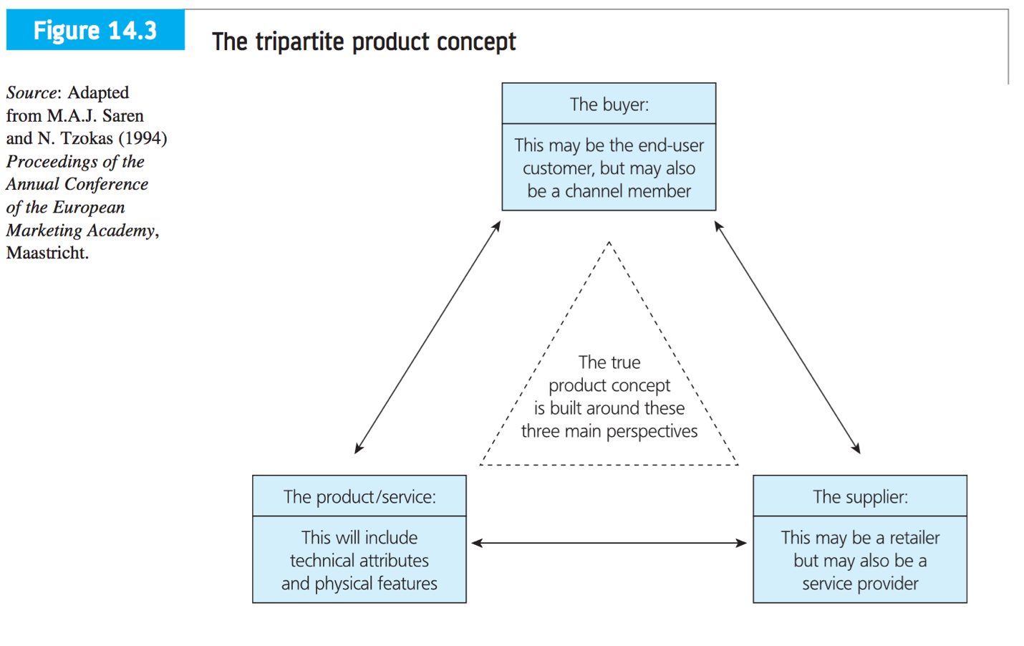

Technology-intensive products

Adopting a technology-push approach to product innovations can allow a company to:
- target and control premium market segments
- establish its technology as the industry standard
- build a favorable market reputation
- determine the industry’s future evolution
- achieve high profits

It is, however, costly and risky.

Industrial markets are characterized by:
- relatively few (information-rich) buyers
- products often being customized and involving protracted negotiations regarding specifications
- the buyers usually being expert in the technology of the new product

In situations of low information symmetry consumers have difficulty in understanding the core product and are unable to articulate their needs and any additional benefits sought.

In situation of high information symmetry consumers are readily able to understand the core product and are able to articulate their needs and a wide range of additional benefits sought.

Discontinuous product innovations or radical product innovations frequently have to overcome the currently installed technology base, usually through displacement. Known as the installed base effect, this is the massive inertial effect of an existing technology or product that tends to preclude or severely slow the adoption of a superseding technology or products creating an artificial adoption barrier that can become insurmountable for some socially efficient and advantageous innovations.

The idea of being shackled with an obsolete technology leads to the notion of switching costs. Switching is the one-time cost to the buyer who converts to the new product. Buyer switching costs may arise as a result of prior commitments to a technology and to a particular vendor.

The effect of both types of switching costs for a buyer is a disincentive to explore new vendors. There is a clear dilemma facing firms: market research may reveal genuine limitations with the new product but it may also produce negative feedback on a truly innovative product that may create a completely new market. The uncertainty centers on 2 key variables:
- information symmetry about the core technology between producer and buyer
- the installed base effect and switching costs

Breaking with convention and winning new markets

Established businesses that have been successful for many years develop comfortable routines and become complacent. A particular problem exists because firms rely too heavily on market research and that some of the techniques reinforce the present and do not peer into the future.

If sufficient care is not exercised by manager’s market research can be used to support conservative product development decision making.

Successful companies of the future will be those that are part of its creation, by developing products that will be used in the future.

When it may be correct to ignore your customers

Traditional marketing activities of branding, advertising and positioning, market research, and consumer research act as an expensive obstacle course to product development rather than facilitation the development of new product ideas.

Market research can provide a valuable contribution to the development of innovative products. The difficulties lie in the selection and implementation of research methods.

Development and adoption process for discontinuous or complex products is particularly difficult. The benefits to potential users may be difficult to identify and value, and usually because there are likely to be few substitute products available it is difficult for buyers to compare and contrast.

Sometimes product developers have to lead buyers/consumers and show them the benefits, even educate them.

A number of false dichotomies here:
- That you must either lead or follow customers
- That you cannot stay close to both current and potential customers
- That technology-push cannot be balanced with market-pull

Customers respond most positively to what is familiar and comfortable and that customers view the high costs of new technology, including switching costs, in a largely negative way. Firms need to try to understand how customers will view innovations in the marketplace. May include adoption influences such as consumption pattern, product capability, and technological capability. Valid good management should be capable of selecting the appropriate market research techniques to avoid superficial consumer reactions.

Firms become myopic towards their current customers and fail to see the largely slowly changing market.

Managing the new product development team

New products as projects

NPD is not the preserve of one single department. Because a variety of different functions and departments are involved it is said to be complicated to manage. While two separate new products may be similar generically, there will frequently be different product characteristics to be accommodated and different market and technology factors to be addressed. To be successful NPD needs to occur with the participation of a variety of personnel drawn from across the organization.

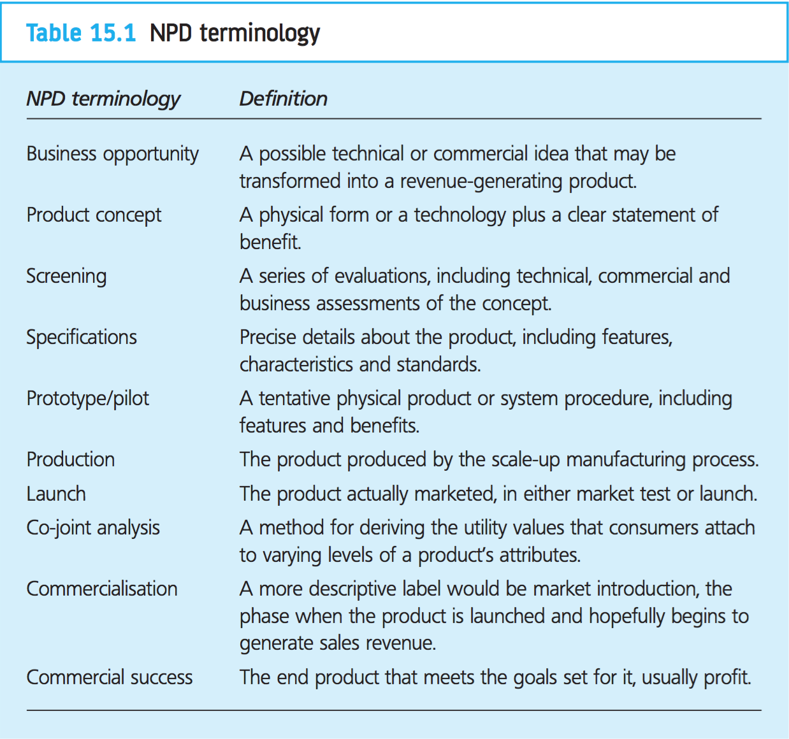

The key activities that need to be managed

Business managers and the managers of project teams need to know what particular activities should be undertaken. It is more useful to view the NPD process as a series of linked activities.

12 activities identified by Cooper’s study of new product success and failure:
- Initial screening
- Preliminary market assessment
- Preliminary technical assessment
- Detailed market study
- Financial analysis
- Product development
- Product testing (in-house)
- Product testing (with customer)
- Test marketing
- Trial production
- Full-scale production
- Product launch

Early activities are defined as the assembly of knowledge and the generation of business opportunities. These usually occur before a physical representation of the product has been developed. Up to this point costs have been relatively low, especially when compared to subsequent activities. These activities, defined as product concept development and development of product prototypes, transform a concept into physical form. The final activities are market and technical testing and market introduction.

Assembling knowledge

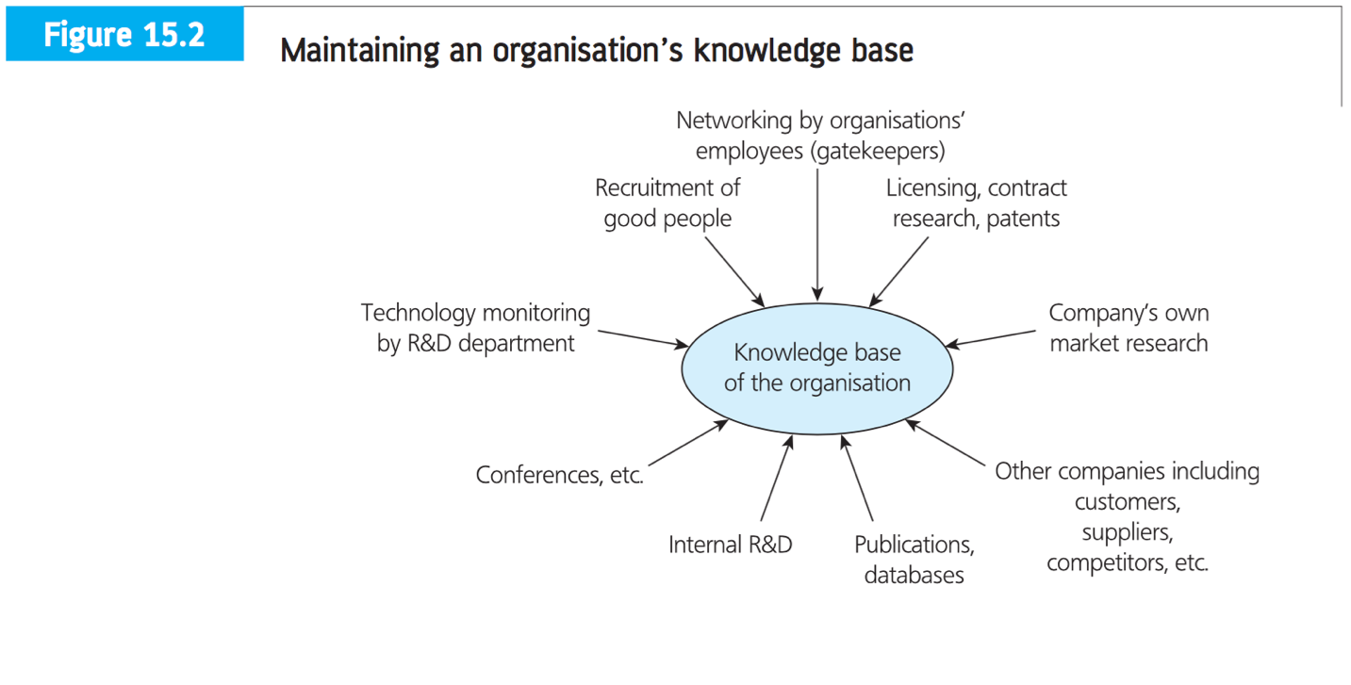

The generation of business opportunities
This stage in the NPD process is also referred to as opportunity identification. It is the process of collecting possible business opportunities that could realistically be developed by the business into successful products.

Existing products
Many new ideas will come from a company’s existing range of products.

Technology
Obvious source of ideas is R&D department with is funded to research technology and develop new product ideas. Also responsible for keeping abreast of external technological development of interest to the company. Frequently referred to as technology assessment.

Unexploited patents
The development of patents is part of the day to day operation for companies that have invested heavily in R&D. Many of these patents could be used in new products, though most aren’t.

Customers and vendors
Highest percentage of new product ideas originate with customers, especially in fast-moving consumer goods.

Salesforce
Vendors, or sales representatives, are a good source of new product ideas.

Senior and top management
Many company leaders have taken personal responsibility for technological innovation in their companies.

Brainstorming and synectics
Brainstorming is a creativity exercise used with groups of about 6 to 8 people.

Individuals
Product ideas can originate from areas not usually associated with product development.

Developing product concepts

This activity involves transforming a list of ideas into potential product concepts. The identification of an opportunity might be sufficient to reveal the product required, other times the concept may be clear but details must be added.

For a product idea to become a new product concept:
- Form: this is physical thing to be created.
- Technology: in most cases there is one clear technology that is at the base of the innovation
- Need: the benefits gained by the customer, which give the product value

Once the details are known the product idea is said to be a product concept.

An idea is an idea. A concept is the conjunction of all the essential characteristics of the product idea, which usually incorporates form, technology, and need while, usually, lacking detail.

The screening of business opportunities

Screening product ideas = evaluation process.

The main purpose of the screening ideas is to select those that will be successful and drop those that will not.

Distinguishing between dreams and reality
Very important part of the screening process. There must be a distinction between those opportunities that the business could develop into a product and those which it could not, and which could generate revenue and those which couldn’t.
Market research provides valuable market analysis input at this stage.
- Initial screen, entry screen, or preliminary screen
  - First formal evaluation of the idea
  - Involves a technical feasibility check and marketing feasibility check
  - Comparison with the strategic opportunity
  - Evaluate whether the product would fit with the businesses’ existing activities
  - Advantage = it can be done quickly and easily and prevents expenditure on inappropriate product ideas
- Customer screen, concept testing
  - Can vary between informal discussions with potential customers and feedback on developed prototypes
  - Is extremely difficult and mistakes are very easily made
  - People have difficulty reacting to an entirely ned product concept without a learning period
- Technical screen, technical testing
  - Can vary from tech support to extensive analysis by an in-house R&D department or analysis by a third party
- Final screen
  - Normally involves the use of scoring models and computer assessment programs
  - One of the most serious criticisms of scoring models is their use of weights, because these are judgmental
- Business analysis
  - May involve the construction of preliminary marketing plans, technical plans, financial reviews, and projected budgets.
  - May raise potential problems that were previously unforeseen.

Development of product prototypes

The phase during which the item acquires finite form and becomes a tangible good.

- Rapid prototyping
  - Reducing the time to develop products is a top priority for firms especially in consumer markets
  - Time to market is measured in months
  - Rapid prototyping is the process of developing a range of prototypes quickly for consideration by the firm
  - Stereolithography (SLA) is the most widely used rapid prototyping tech
    - It builds plastic parts or objects a layer at a time by tracing a laser beam on the surface of a vat of liquid photopolymer.
    - This class of materials, originally developed for the printing and packaging industries, quickly solidifies wherever the laser beam strikes the surface of the liquid.
    - Basic SLA process goes:
      - Create a 3D model in a CAD program
      - A piece of software chops the CAD model into thin layers (5-10 mm)
      - The 3D printer’s laser paints one of the layers, exposing the liquid plastic in the tank and hardening it
      - The platform drops down into the tank a fraction of a mm and the lasers paints the next layer
      - Process repeats until completion

Technical testing

Closely linked to the development of product prototypes in the technical testing of a new product.

Market introduction

- Commercialization is not necessarily the stage at which large sums of money are spent on advertising or productions plants, since a company can withdraw from a project following the results of test marketing.
- Important to remember that for some products, the decision to finance a project with 10 years of research is taken fairly early on in the development of the products, where most of the expense is incurred
- With fast moving consumer goods, advertising is a large part of the cost, so the decision is taken towards the launch phase

Launch
Must not lose sight of reality, most new products are improvements or minor line extensions and may attract almost no attention. Other products are so important that they will receive extensive coverage.

NPD across different industries

Innovation and NPD are context dependent. A simple way of looking at this is to divide the wide range of activities involved in the development of a new product into technical and marketing activities.
- Industrial problems have different considerations from those of the food and beverage industry
- Cross-functional teams help shorten the development of times of truly innovative products
- More bureaucratic structures may provide better outcomes for less innovative products.

Organization structures and cross-functional teams

The nature of the industry and the product being developed will significantly influence the choice of structure. The organizational structure will considerably affect the way its activities are managed. It is not possible to alter one without causing an effect on the other.

Teams and project management
- New product project teams in small to medium-sized organizations are usually comprised of staff from several different functions who operate on a part-time basis.
- Membership of the project team may be just one of the many roles they perform
- In larger organizations there may be resources to enable personnel to be wholly concerned with a project
- Ideally a project team will have a group of people with the necessary skills, able to work together, share ideas, and reach compromises
- May include external consultants or key component suppliers

Functional structures
- NPD is a cross-disciplinary process and suffers if it segregated by function
  - Traditional functional company structure allows for a strong managerial layer with information flowing up and down the organization
- Another common approach used by large manufacturing companies is to organize the company by product type
  - Each product has its own functional activities
  - Some functions are centralized across the whole organization to improve efficiency or provide common features
  - This type of structure supports the notion of product platforms where a generic group of technologies are used in a variety of products
- Even though many organizations have clearly defined company structures, closer inspection of the actual activities will invariably reveal an informal structure that sits on top of the formal

Matrix structures

The use of a matrix structure requires a project-style approach to NPD. Each team will comprise a group of 4 – 8 people from different functions.
- A matrix structure is any organization that employs a multiple-command system including not only a multiple-command management structure but also related support mechanisms and associated organizational culture and behavior patterns.
- Matrix structures are associated with dual lines of communication and authority
- They are seen as cross-functional because the involve bringing people together from 2 or more separate organizational functional areas
- Traditional hierarchy is functional, while the horizontal overlay consists of business areas known as business teams

Corporate venturing

The idea behind corporate venturing is that fledgling businesses should be given the freedom to grow outside the constraints of an existing large, established organization. Conventional management thinking argues that new ventures should be sheltered from the normal planning and control systems, otherwise they will be strangled. Ideally, they should be given high-level sponsorship from senior management, but must be able to manage their own relationships with other companies.
- An internal corporate venture is a separate organization or system designed to facilitate the needs of a new business.
- Companies usually adopt an internal corporate venture when the product involved is outside their existing activities

Project management

The project has to be well planned, managed, and controlled. It is the set of achievable targets and realistic objectives that helps to ensure a successful project. Ensuring that resources are available at the appropriate time contributes to good project management.

Reducing product development times through computer-aided design

When concurrent engineering is used in conjunction with other management tools the results can be very impressive.

The marketing/R&D interface

The main barriers to an effective R&D/marketing interface have been found to be related to:
- Perceptual
- Cultural
- Organizational
- Language factors

Marketing managers tend to focus on shorter timespans than R&D managers.

Products rarely fail in the marketplace: weak products are usually eliminated prior to entry to the market.

Scarcity, Choice, and Economic Systems

Society’s Production Choices
The opportunity cost of having more of one good is measured in the units of the other good that must be sacrificed.
Table 1
Choice | Tank Production  (number per year) | Wheat Production  (bushels per year)
A | 0 | 1,000,000
B | 1,000 | 950,000
C | 2,000 | 850,000
D | 3,000 | 700,000
E | 4,000 | 400,000
F | 5,000 | 0

Production possibilities frontier (PPF): A curve showing all combinations of two goods that can be produced with the resources and technology currently available.

Figure 1

Increasing Opportunity Cost
According to the law of increasing opportunity cost, the more of something we produce, the greater the opportunity cost of producing even more of it.
The law of increasing opportunity cost causes the PPF to have a concave shape, becoming steeper as we move rightward and downward. This is because the slope of the PPF, $\frac{change in quantity of wheat}{change in quantity of tanks}$, can be interpreted as the change in wheat per additional tank.
The law of increasing opportunity cost applies both ways, that is: the opportunity cost of producing more wheat increases as we produce more of it.
The reason for increasing opportunity cost = Because most resources, by their very nature, are better suited to some purposes than to others.
The principle of increasing opportunity cost applies to most of society’s production choices. The more of something we produce, the greater the opportunity cost of producing still more.

Productive Inefficiency
Productively inefficient: A situation in which more of at least one good can be produced without sacrificing the production of any other good. Operating inside the PPF.
A firm, an industry, or an entire economy is productively inefficient if it could produce more of at least one good without producing less of any other good.
Productive efficiency: The absence of any productive inefficiency.
Recessions: Another reason an economy might operate inside the PPF and thus be productively inefficient.

Economic Growth
Figure 2

Figure 3

Figure 4

A technological change or an increase in resources, even when the direct impact is to increase production of just one type of good, allows us to choose greater production of all types of goods.

Consumption vs. Growth
Figure 5

Figure 6

The more capital we produce this year, the more capital we’ll have in the future to produce other things. The trade-off: Any resources used to produce capital this year are not being used to produce consumer goods and other things that we can enjoy right now.
In order to produce more goods and services in the future, we must shift resources towards R&D and capital production, and away from producing things we’d enjoy right now.

Economic Systems
Specialization: A method of production in which each person concentrates on a limited number of activities.
Exchange: The act of trading with others to obtain what others desire.
Specialization and exchange enable us to enjoy greater production and higher living standards than would otherwise be possible. As a result, all economies exhibit high degrees of specialization and exchange.
The gains from specialization and exchange come from:
- Development of Expertise
- Minimizing Downtime
- Comparative Advantage

Comparative Advantage
Table 2
 | Labor Required For:
 | 1 Fish | 1 Cup of Berries
Maryanne | 1 hour | 1 hour
Gilligan | 3 hours | 1 ½ hours
Absolute Advantage | Maryanne | Maryanne
Comparative Advantage | Maryanne | Gilligan

Table 3
 | Change In Fish Production | Change In Berry Production
Maryanne | +1 | -1
Gilligan | -1 | +2
Total Island | +0 | +1

Absolute advantage: The ability to produce a good or service, using fewer resources than other producers use.
Comparative advantage: The ability to produce a good or service at a lower opportunity cost than other producers.
Total production of every good or service will be greatest when individuals specialize according to their comparative advantage.

International Comparative Advantage
A nation has a comparative advantage in producing a good if it can produce it at a lower opportunity cost than some other nation.

Table 4
 | Labor Required For:
 | 1 Bushel of Soybeans | 1 T-Shirt
United States | ½ hour | ¼ hour
China | 5 hours | 1 hour
Absolute Advantage | US | US
Comparative Advantage | US | China

Table 5
 | Soybeans (Bushels) | T-Shirts
United States | +10 | -20
China | -8 | +40
Total World Production | +2 | +20

Total production of every good or service is greatest when nations shift production toward their comparative advantage goods and trade with each other.

Resource Allocation
Deciding how society’s scarce resources will be divided among competing claims and desires:
- Which goods and services should be produced with society’s resources?
- How would they be produced?
- Who should get them?
Traditional Economy: An economy in which resources are allocated according to long-lived practices from the past.
Command or Centrally Planned Economy: An economic system in which resources are allocated according to explicit instructions from a central authority.
Market Economy: An economic system in which resources are allocated through individual decision making.
Market: A group of buyers and sellers with the potential to trade with each other.
Price: The amount of money that must be paid to a seller to obtain a good or service.
When resources are allocated by the market, and people must pay for their purchases, they are forced to consider the opportunity cost to society of the goods that they consume. In this way, markets help to create a sensible allocation of resources.
Market economies = market capitalism.
Capitalism: An economic and political system in which a country’s trade and industry are controlled by private owners for profit, rather than by the state.
Socialism: A political and economic theory of social organization that advocates that the means of production, distribution, and exchange should be owned or regulated by the community as a whole.
Mixed Economy: A market economy in which the government also plays an important role in allocating resources.

Distributing Products

Marketing intermediaries: Firms that participate in moving the product from the producer toward the customer.
Direct channel: The situation when a producer of a product deals directly with customers.
- Advantages:
  - Full difference between manufacturer’s cost and the price paid by the consumer goes to the producer.
  - Producer can easily obtain firsthand feedback on the product.
- Disadvantages:
  - Need more employees.
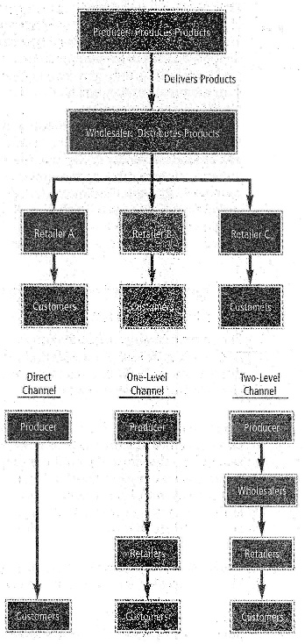
  - Manufacturer may have to sell its product on credit.
Figure 19 Two-level Channel of Distribution (top)
One-level channel: One marketing intermediary is between the producer and the customer.
Merchants: Marketing intermediaries that become owners of products and then resell them.
Agents: Marketing intermediaries that match buyers and sellers of products without becoming owners.
Two-level channel: Two marketing intermediaries are between the producer and the customer.
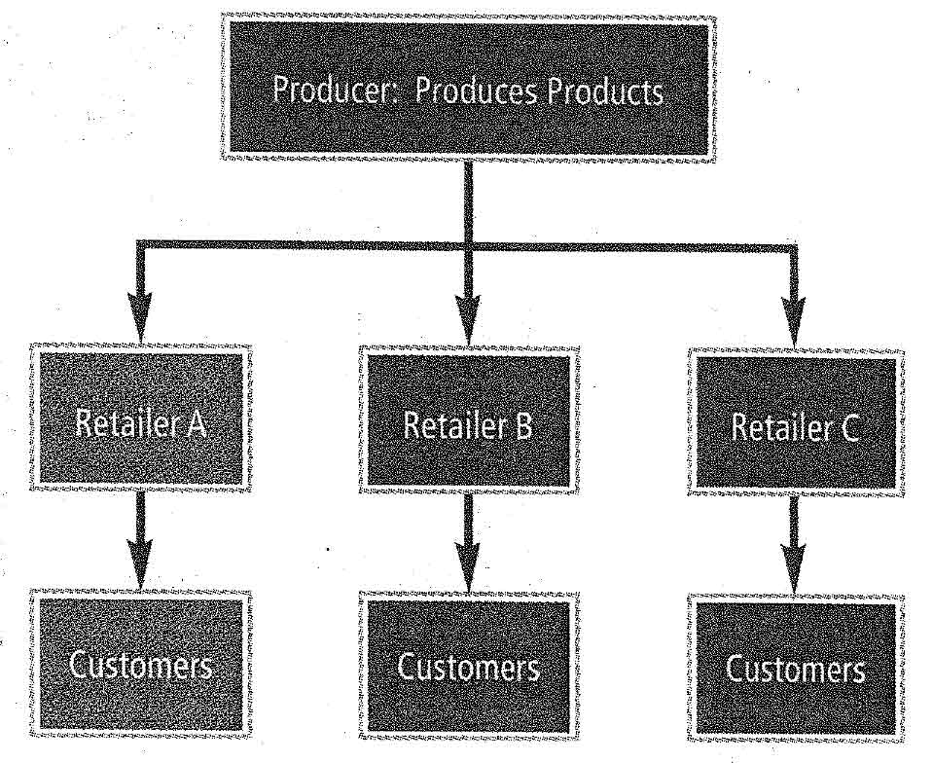
Figure 8 One-level Channel of Distribution

Factors that determine the optimal channel of distribution:
- Ease of Transporting: If a product can be easily transported, the distribution channel is more likely to involve intermediaries. If the product cannot be transported, the producer may attempt to sell directly to consumers.
- Degree of Standardization: Products that are standardized are more likely to involve intermediaries. When specifications are unique for each consumer, the producer must deal directly with consumers.
- Internet Orders: Firms that fill orders over the internet tend to use a direct channel, since their website serves as a retail store.
Market Coverage: The degree of product distribution among outlets.
Intensive distribution: The distribution of a product across most or all possible outlets.
Selective distribution: The distribution of a product through selected outlets.
Exclusive distribution: The distribution of a product through only one or a few outlets.
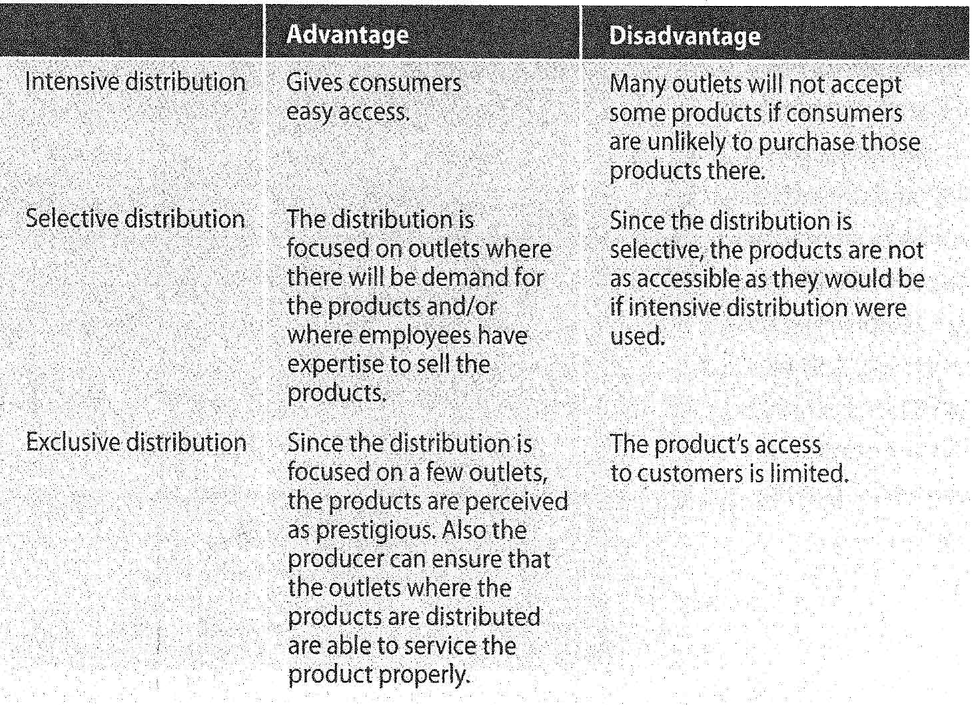

Transportation used to Distribute Products
- Truck: Commonly used because they can reach any destination on land quickly and make several stops.
- Rail: Useful for heavy products, especially when the producer and marketing intermediary are located close to a railroad. Railroads are not useful for short distances.
- Air: Quick and relatively inexpensive for light items.
- Water: Often used for transporting bulk products.
- Pipeline: Effective for oil and gas, though limited use to only few types of products.
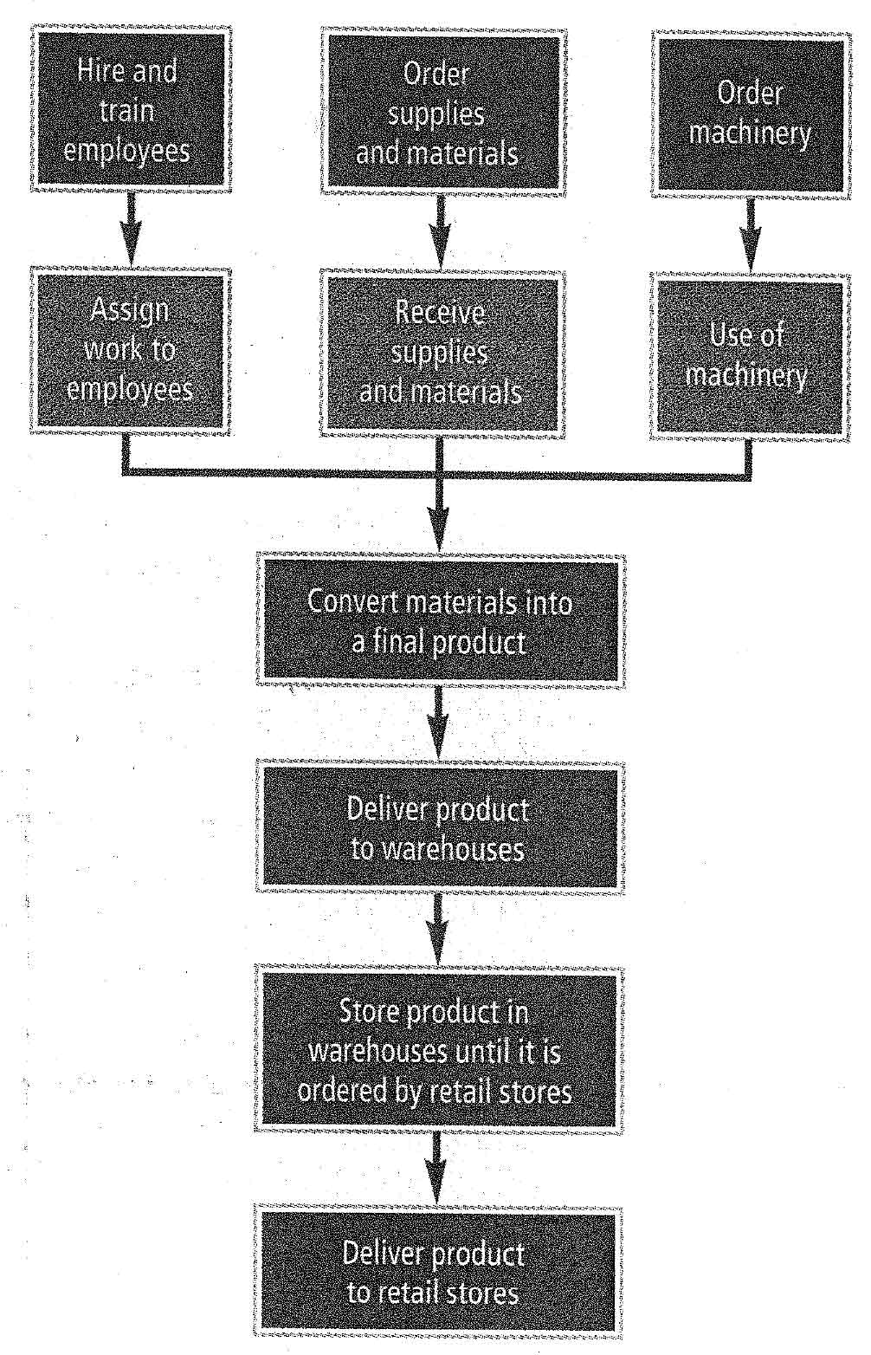
Figure 21 Steps involved in the production and distribution of products

Accelerate the Distribution Process
- Streamline the channel of distribution: The final product reached customers more quickly. Commonly results in the elimination of warehouses, except in the case of heavy products.
- Use of the internet for distribution: Information on websites means customers can compare prices and quality of products. The result is more competition and less brand loyalty. The internet also eliminates the distance between producers and consumers, thereby eliminating the need for wholesalers, distributors, and retailers, greatly improving a firm’s efficiency. Products may be sold at a lower price, and firm’s relationship with suppliers and freight haulers changes.
- Integrate the production and distribution processes
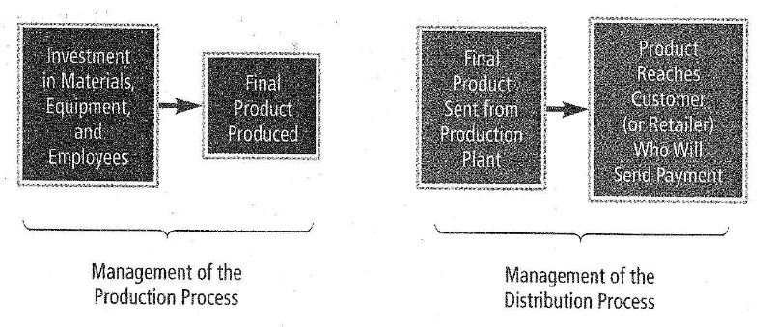
Figure 10 Relationship between production and distribution
E-marketing: Facilitates the integration between a firm’s production and distribution processes.

Characteristics of Retailers
- Number of outlets
  - Independent retail store: A retailer that has only one outlet.
  - Chain: A retailer that has more than one outlet.
- Quality of service
  - Full-service retail store: A retailer that generally offers much sales assistance to customers and provides servicing if needed.
  - Self-service retail store: A retailer that does not provide sales assistance or service and sells products that do not require much expertise.
- Variety of products offered
  - Specialty retail store: A retailer that specializes in a particular type of product. Advantage: May carry certain degree of prestige. Disadvantage: Not as convenient for consumers who need to purchase a variety of goods.
  - Variety retail store: A retailer that offers numerous types of goods.
- Store versus nonstore
  - Nonstore retailer: Retailer that does not use a store to offer its products or services.
  - Mail-order retailers: Receives orders through the mail or phone, and sends them through mail.
  - Websites: Advantage over mail-order is no need to send out catalogs, and changes can be made easily and frequently.
  - Vending machines: Accessible at all hours.

Services Offered by Wholesalers
Wholesalers: Intermediaries that purchase products from manufacturers and sell them to retailers.
- Warehousing: Purchase products from the manufacturer in bulk and maintain these products at their own warehouses.
- Sales expertise: Use their sales expertise when selling products to retailers, often persuading them.
- Delivery to retailers: Responsible for delivering products to various retailers.
- Assumption of credit risk: Purchase the products from manufacturers and sell them to retailers on credit.
- Information: Receive feedback from retailers and can provide valuable information to manufacturers.

How Wholesalers Serve Retailers
- Warehousing: Maintain sufficient inventory so that retailers can order small amounts frequently, thus retailers need not maintain large inventories.
- Promotion: Promote their products, thereby increasing sales of those sold by retail stores.
- Displays: Setup displays, designed to attract customers’ attention whilst taking little space, of the products for retailers
- Credit: Offer products to retailers on credit.
- Information: Can inform retailers about policies implemented by other retailers regarding pricing, sales, opening times.

Vertical Channel Integration
Vertical channel integration: Two or more levels of distribution are managed by a single firm.
Benefit: It can serve as a producer and intermediary. The intermediaries (outlets) allow the product to be widely distributed. All earnings generated by the producer or the outlets are beneficial.
Manufacturer:
- Can it absorb the cost of leasing store space and employing workers?
- Can the firm offer enough product lines to make a full store?
- Will the additional revenue to be earned cover all additional costs incurred?
- Will the firm lose the business that it had developed with other retail firms once it begins to compete with those firms at the retail level?
Retailers:
- Can it absorb the expenses resulting from production, including the cost of a production plant and new employees?
- Does it have the expertise to adjust the production process as consumer tastes change over time?

Promoting Products

Promotion: The act of informing or reminding consumers about a specific product or brand.
Used to supplement the other marketing strategies (product, pricing, and distribution strategies)
- To make consumers aware of a new product.
- To introduce the product.
- Remind consumers the product exists.
- Remind consumers about the product’s qualities and advantages over competitors.
- Can include special incentives to induce consumers to purchase a specific product.
- Can be used on a long-term basis to protect product’s image and retain market share.
Promotion mix: The combination of promotion methods that a firm uses to increase acceptance of its products.
- Advertising: A nonpersonal sales presentation communicated through media or nonmedia forms to influence a large number of consumers. The most common reason to advertise is to enhance the image of a specific brand.
  - Brand advertising: A nonpersonal sales presentation about a specific brand. (to inform about changes in the product)
  - Comparative advertising: Intended to persuade customers to purchase a specific product by demonstrating a brand’s superiority by comparison with other competing brands.
  - Reminder advertising: Intended to remind consumers of a product’s existence.
  - Institutional advertising: A nonpersonal sales presentation about a specific institution’s product.
  - Industry advertising: A nonpersonal sales presentation about a specific industry’s product.
  - Forms of advertising:
    - Newspapers: Convenient way to reach a certain geographic market, usually local. Can be inserted quickly.
    - Magazines: Used for products distributed nationwide.
    - Radio: Talks to audience, lacks visual effects. Tends to focus locally, able to target specific demographic.
    - Television: Talks to audience and includes visual effects. Can be used locally or nationwide. Able to target specific markets.
      - Infomercials: Commercials that are televised separately rather than within a show.
    - Internet: A form of nonpersonal communication that can create awareness and persuade the customer.
    - Email: Some are general and apply to all customers, others are personalized to fit a specific interest.
    - Direct mail: Used by local service firms.
    - Telemarketing: The use of the telephone for promoting and selling products.
    - Outdoor ads: Shown on billboards or signs, usually quite large.
    - Transportation ads: Displayed on forms of transportation, such as buses or taxis. Attempt to provide strong visual effect.
    - Specialty ads: Other forms of nonmedia advertising, like t-shirts, hats, etc.
- Personal selling: A personal sales presentation used to influence one or more consumers.
  - Identify the target market: Focus on types of customers most likely to purchase the product; contact these potential customers by phone or mail.
  - Contact potential customers: Schedule appointments with potential customers who are located in the same area on the same days.
  - Make the sales presentation: Demonstrate the use and benefits of the product.
  - Answer questions: Prepare for typical questions and allow potential customers to ask questions.
  - Close the sale: Close the sale after the presentation, perhaps by offering a discount if a purchase is made immediately.
  - Follow up: Call customers who recently purchased the product to ensure their satisfaction. Call other potential customers who decided not to purchase the product to determine whether they would like to reconsider.
  - Sales manager: An individual who manages a group of sales representatives.
- Sales promotion: The set of activities that is intended to influence consumers.
  - Rebates: A potential refund by the manufacturer to the consumer. Firms send refund directly to consumers after product is purchased.
  - Coupons: A promotional device used in newspapers, magazines, and ads to encourage the purchase of a product. Product is sold at a discounted price to consumers with coupons.
  - Sampling: Offering free samples to encourage consumers to try a new brand or product. Free samples of products are distributed to consumers.
    - Brand loyalty: The loyalty of consumers to a specific brand over time.
  - Displays: Special displays to promote particular products. Used to attract customers who are in the store for other reasons. Products are placed in a prominent area in stores.
  - Premiums: A gift or prize provided free to consumers who purchase a specific product. Gifts or prizes are provided free to consumers who purchase a specific product.
- Public relations: Actions taken with the goal of creating or maintaining a favorable public image.
  - Special events
  - News releases: A brief written announcement about a firm provided by that firm to the media.
  - Press conferences: An oral announcement about a firm provided by that firm to the media.

Optimal Promotion Mix
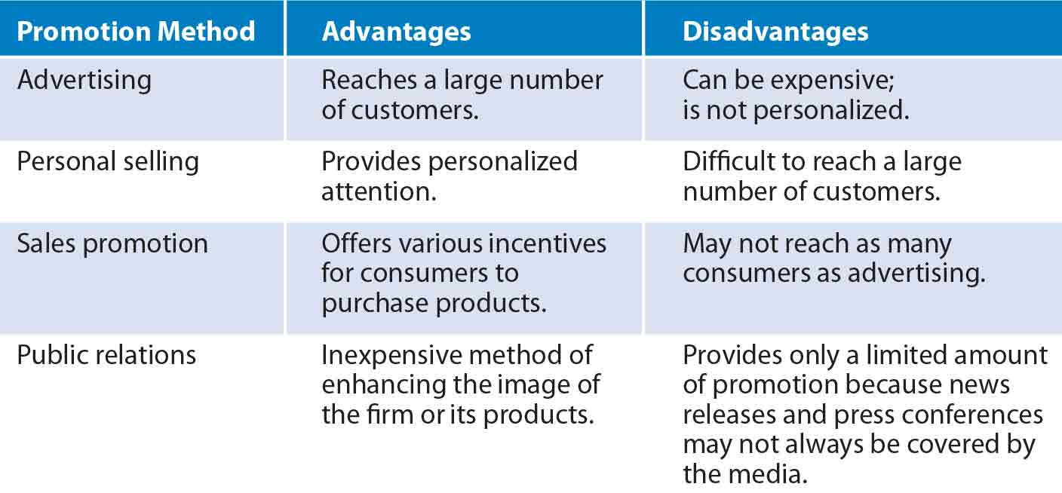
Pull strategy: Firms direct their promotion directly at the target market, and consumers in turn request the product from wholesales or producers.
Push strategy: Producers direct their promotion of a product at wholesalers or retailers, who in turn promote it to consumers.
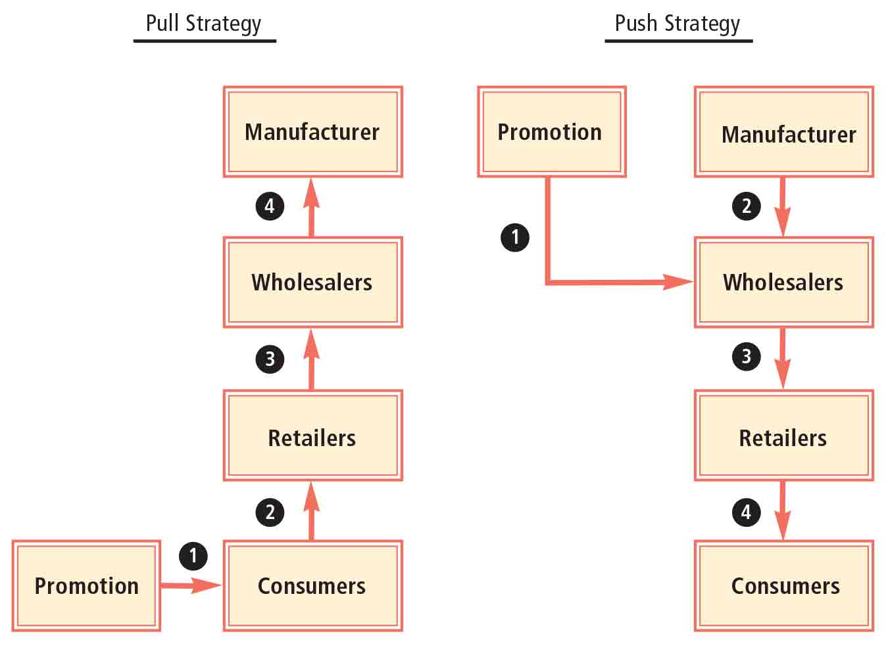
Promotion budget: The amount of funds that have been set aside to pay for all promotion methods over a specified period.
- Phase of the product lifecycle: Products that are just being introduced to the market will require more promotions.
- Competition: Defensive strategy based on amount competitors advertise.
- Economic conditions

Accounting and Financial Analysis

Accounting: Summary and analysis of a firm’s financial condition.
Public accountants: Accountants who provide accounting services for a variety of firms for a fee.
Certified public accountants (CPA): Accountants who meet specific educational requirements and pass a national examination.
Bookkeeping: The recording of a firm’s financial transactions.
Financial accounting: Accounting performed for reporting purposes. Must be conducted in accordance with generally accepted accounting principles (GAAP). Guidelines established by Financial Accounting Standards Board (FASB), Securities and Exchange Commission (SEC), and IRS.
- Reporting to investors: Publicly owned firms are required to periodically report their financial conditions to investors who own, or will own, shares in the future. Most shareholders are not employees.
- Online reporting: Use of the internet to make financial information available.
- Reporting to creditors: Reporting to existing or prospective creditors, who can assess the firm’s financial statements to determine the probability of defaulting on loans.
Managerial accounting: Accounting performed to provide information to help managers of the firm make decisions.
- Financial managers use historical cost and revenue for budgeting decisions.
- Marketing managers use sales information to evaluate the impact of a particular promotion strategy.
- Production managers use seasonal sales information to determine the necessary production level in the future.
Auditing: An assessment of the records that were used to prepare a firm’s financial statements.
Internal auditors: Specialize in evaluating various divisions of a business to ensure that they are operating efficiently.
A firm should use whatever method of accounting provides the most accurate indication of its financial condition. By doing so it may benefit in two ways:
- Gain some credibility with existing and prospective stockholders by providing clear and consistent reports that are easily understood.
- Using an understandable and logical accounting method makes it easier for the firm’s managers to detect and correct deficiencies.

Responsible Financial Reporting
Independent auditor: Annual financial reports audited by an independent accounting firm of public accountants, required for publicly traded firms. Auditor’s role is to certify that the financial statements are accurate and within the generally accepted reporting guidelines.
The Board of Directors represents the shareholders. They can try to prevent the firm from providing misleading financial reports, however some boards don’t effectively represent the stockholders. Problems may arise when board members are compensated with stock. A good solution is to ensure board members can’t sell any of their stock while serving on the board.
Sarbanes-Oxley Act
- An auditing firm is allowed to provide nonaudit services when auditing a client only if the client’s audit committee preapproves these services before the audit begins.
- Auditing firms may not audit companies whose CEO, CFO, or other managers in similar roles were employed by the auditing firm in the one-year period prior to the audit.
- Those board members of the firm who are assigned to oversee the audit to ensure that it is done properly should not receive consulting or advising fees or other compensation from the auditing firm.
- The CFO and other managers of the firm must file an internal control report along with each annual report.
- The CEO and CFO must certify that the audited statements fairly represent the operations and financial condition of the firm.
- Major fines or prison terms are imposed on employees who mislead investors or hide evidence.

Financial Statements
Income statement: Indicated the revenue, costs, and earnings of a firm over a period of time.
- Net sales: Total sales adjusted for any discounts.
- Cost of goods sold: The cost of materials used to produce the goods that were sold.
- Gross profit: Net sales minus the cost of goods sold.
- Operating expenses: Composed of selling expenses and general and administrative expenses.
- Earnings before interest and taxes (EBIT): Gross profit minus operating expenses.
- Earnings before taxes: Earnings before interest and taxes minus interest expenses.
- Net income (earnings after taxes): Earnings before taxes minus taxes.
- Percentage of sales measurement: Firms commonly measure each income statement item as a percentage of total sales.
Balance sheet: Reports the book value of all assets, liabilities, and owner’s equity of a firm at a given point in time.
- Asset: Anything owned by a firm.
- Liability: Anything owed by a firm.
- Basic accounting equation: $Assets = Liabilities + Owner’s Equity$
- Current assets: Assets that will convert into cash within one year.
- Fixed assets: Assets that will be used by a firm for more than one year.
- Deprecation: A reduction in the value of fixed assets to reflect deterioration in the assets over time.
- Accounts payable: Money owed by a firm for the purchase of materials.
- Notes payable: Short-term loans to a firm made by creditors such as banks.
- Owner’s equity: Includes the par (or stated) value of all common stock issued, additional paid-in capital, and retained earnings.
- Percentage of total assets measurement: A firm can use its balance sheet to determine the percentage of its investment in each type of asset.
Ratio analysis: An evaluation of the relationships between financial statement variables.
- Measures of Liquidity: A firm’s ability to meet short-term obligations
$$Current Ratio =\frac{ Current Assets}{Current Liabilities}$$

$$Quick Ratio = \frac{Cash + Marketable Securities + Accounts Receivable}{Current Liabilities}$$

- Measures of Efficiency
$$Inventory Turnover=\frac{Cost of Goods Sold}{Inventory}$$
Assesses the relation between a firm’s inventory level and sales.

$$Asset Turnover=\frac{Net Sales}{Total Assets}$$
Measures efficiency with which firms use their assets.

- Measures of Financial Leverage: The degree to which a firm uses borrowed funds to finance its assets.
$$Debt to Equity ratio=\frac{Long Term Debt}{Owner^{'}s Equity}$$
A measure of the amount of long-term financing provided by debt relative to equity.
$$Times Interest Earned=\frac{Earnings Before Interest and Taxes (EBIT)}{Annual Interest Expense}$$
Measures the ability of a firm to cover its interest payments.

- Measures of Profitability
$$Net Profit Margin=\frac{Net Income}{Net Sales}$$
A measure of net income as a percentage of sales.

$$Return on Assets \left(ROA\right)=\frac{Net Income}{Total Assets}$$
Measures a firm’s net income as a percentage of the total amount of assets utilized by the firm.

$$Return on Equity \left(ROE\right)=\frac{Net Income}{Owner^{'}s Equity}$$
Measures the return to the common stockholders (net income) as a percentage of their investment in the firm; earnings as a proportion of the firm’s equity.
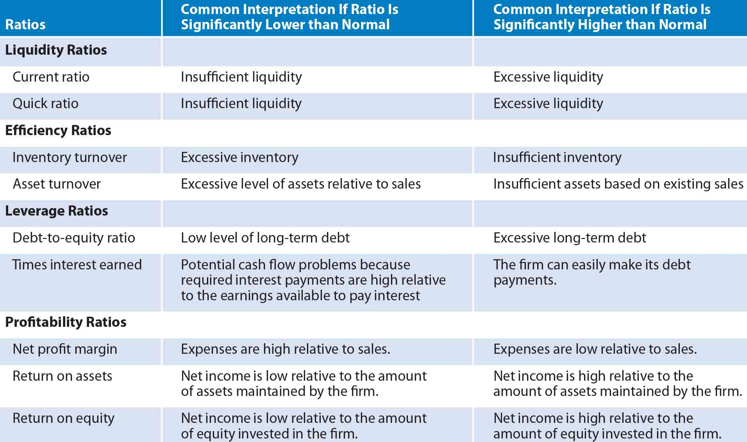
Limitations of Ratio Analysis:
- Firms operate in multiple industries
- Firms use different accounting practices
- Seasonal variation

Creating and Pricing Products

Product: a physical good or service that can satisfy consumer needs.
- Firms must continually improve existing products and develop new products to satisfy customers over time, which allows firms to generate high sales growth, thus increasing their value over time

Convenience products: Products that are widely available to consumers, are purchased frequently, and are easily accessible

Shopping products: products that are not purchased frequently
- Consumers usually shop around and compare quality and price of competing products

Specialty products: Products that specific consumers consider to be special and therefore make a special effort to purchase

Product line: a set of related products or services offered by a single firm

Product mix: the assortment of products offered by a firm
- When a product is subject to wide swings in demand, firms tend to diversify their product mix so as to not be completely dependent on one market.
- A common diversification strategy is for a firm to diversify products within its existing production capabilities.
- A product mix that contains several related products can allow for more efficient use of salespeople

Product life cycle: The typical set of phases that a product experiences over its lifetime. The typical product life cycle has four specific phases:
- Introduction phase: the initial period in which consumers are informed about a product
  - Price skimming: the strategy of initially setting a high price for a product if no other competing products are in the market yet
- Growth phase: the period in which sales of a product increase rapidly
- Maturity phase: the period in which additional competing products have entered the market, and sales of a product level off because of competition
- Decline phase: the period in which sales of a product decline, either because of reduced consumer demand for that type of product or because competitors are gaining market share

Identifying a target market

Target market: a group of individuals or organizations with similar traits who may purchase a particular product.
- Consumer markets: markets for various consumer products and services
- Industrial markets: markets for industrial products that are purchased by firms
- Common traits used to describe a target market include the consumer’s gender, age, and income bracket.

Factors that affect the size of a target market
- Demographics: characteristics of the human population or specific segments of the population
  - One of the most relevant demographic characteristics is age
- Geography
- Economic factors
  - As economic conditions change, so do consumer preferences
  - Interest rates can also have a major impact on consumer demand
- Social values

E-marketing: the electronic interaction with consumers in order to develop, improve, or promote products.

Creating new products

Obsolete: less useful than in the past

Fashion obsolescence: no longer being in fashion

Technological obsolescence: being inferior to new products

Marketing research: The accumulation and analysis of data in order to make a particular marketing decision

Patents: allow exclusive rights to the production and sale of a specific product

Steps necessary to create a new product
- Develop a product idea
- Assess the feasibility of a product idea
- Design and test the product
- Distribute and promote the product
- Post-audit the product

Product differentiation: A firm’s effort to distinguish its product from competitors’ products in a manner that makes the product more desirable
- Unique product design
- Unique packaging
- Unique branding
  - Branding: a method of identifying products and differentiating them from competing products
  - Trademark: a brand’s form of identification that is legally protected from use by others
  - Family branding: branding of all or most products produced by a company
  - Individual branding: the assignment of a unique brand name to different products or groups of products
  - Producer brands: brands that reflect the manufacturer of the products
  - Store brands: brands that reflect the retail store where the products are sold
  - Generic brands: products that are not branded by the producer or the store
  - Benefits of branding:
    - Branding continually exposes the company’s name to the public
    - Companies with a brand name can more easily enter new markets
    - Useful for differentiating a product
    - Crucial to obtaining space in a store
  - Co-branding: firms agree to offer a combination of two noncompeting products at a discounted price

Pricing strategies

Firms set the prices of their products by considering:
- Cost of production
  - Cost-based pricing: estimating the per-unit cost of producing a product and then adding a markup
    - Economies of scale means that the average production cost per unit decreases as production volume increases
- Supply of inventory
- Competitors’ prices
  - Penetration pricing: the strategy of setting a lower price than those of competing products to penetrate a market
  - Price-elastic: the demand for a product is highly responsive to price changes
  - Price-inelastic: the demand for a product is not very responsive to price changes
  - Defensive pricing: the strategy of reducing a product’s price to retain market share
  - Predatory pricing: the strategy of lowering a product’s price to drive out new competitors
  - Prestige pricing: the strategy of using a higher price for a product that is intended to have a top of the line image

Setting a product’s price

- Fixed costs: operating expenses that do not change in response to the number of products produced
- Variable costs: operating expenses that vary directly with the number of products produced
- Break-even point: the quantity of units at which total revenue equals total cost
- Contribution margin: the difference between price and variable cost per unit

Additional pricing decisions:
- Discounting
- Sales prices
- Credit terms

Distributing products

Marketing intermediaries: firms that participate in moving the product from the producer toward the customer

Direct channel: the situation when a producer of a product deals directly with customers
- Advantages
  - Full difference between the manufacturer’s cost and the price paid by the consumer goes to the producer
  - The producer can easily obtain firsthand feedback on the product
  - Becoming more popular thanks to the internet
- Disadvantages
  - Manufacturers that use a direct channel need more employees
  - The manufacturer may have to sell its products on credit

One-level channel: one marketing intermediary is between the producer and the customer
- Merchants: marketing intermediaries that become owners of products and then resell them
- Agents: marketing intermediaries that match buyers and sellers of products without becoming owners

Two-level channel: two marketing intermediaries are between the producer and the customer

Factors that determine the optimal channel of distribution
- Ease of transporting
- Degree of standardization
- Internet orders

Selecting the degree of market coverage

Market coverage: the degree of product distribution among outlets

- Intensive distribution: the distribution of a product across most or all possible outlets
- Selective distribution: the distribution of a product through selected outlets
- Exclusive distribution: the distribution of a product through only one or a few outlets

Selecting the optimal type of market coverage can be decided based on marketing research.

Selecting the transportation used to distribute products

- Truck
- Rail
- Air
- Water
- Pipeline

By streamlining the channel of distribution the product is able to reach customers more quickly.

The distribution process can also be accelerated by improving its interaction with the production process.

Characteristics of retailers

- Number of outlets
  - Independent retail store: a retailer that has only one outlet
  - Chain: a retailer that has more than one outlet
- Quality of service
  - Full-service retail store: a retailer that generally offers much sales assistance to customers and provides servicing if needed
  - Self-service retail store: a retailer that does not provide sales assistance or service and sells products that do no require much expertise
- Variety of products offered
  - Specialty retail store: a retailer that specializes in a particular type of product
  - Variety retail store: a retailer that offers numerous types of goods
- Store versus nonstore
  - Nonstore retailer: retailer that does not use a store to offer its products or services
  - Mail-order retailer
  - Websites
  - Vending machines

Services offered by wholesales
- Warehousing
- Sales expertise
- Delivery to retailers
- Assumption of credit risk
- Information

How wholesalers serve retailers
- Warehousing
- Promotion
- Displays
- Credit
- Information

Vertical channel integration: two or more level of distribution are managed by a single firm

Financing

Debt financing: the act of borrowing funds

Capital: long-term funds

Borrowing from financial institutions
- Creditworthiness
- Pledging collateral
  - Collateral: assets of the borrower that are transferred to the lender if the borrower defaults on the loan
- Loan rate
  - Prime rate: the rate of interest typically charged on loans to the most creditworthy firms that borrow

Types of business loans:
- Term loan: used to finance the purchase of fixed assets, typically matures between 3 – 10 years
- Line of credit: allows the firm to borrow up to a specified amount of money within a specified period of time
- Loans backed by the government

Issuing bonds
- Bonds: long-term debt securities purchased by investors
- Par value: the amount that bondholders receive at maturity
- Indenture: a legal document that explains the firm’s obligations to bondholders
- Secured bonds: bonds backed by collateral
- Unsecured bonds: bonds that are not backed by collateral
- Call feature: provides the issuing firm with the right to repurchase its bonds before maturity
- Protective covenants: restrictions imposed on specific financial policies of a firm that has issued bonds

Commercial paper: a short-term debt security normally issued by firms in good financial condition

Common creditors that provide debt financing
- Commercial banks: financial institutions that obtain deposits from individuals and use the funds primarily to provide business loans
- Savings institutions: financial institutions that obtain deposits from individuals and use the deposited funds primarily to provide mortgage loans
- Finance companies: financial institutions that typically obtain funds by issuing debt securities and lend most of their funds to firms
- Pension funds: receive employee and firm contributions toward pensions and invest the proceeds for the employees until the funds are needed
- Insurance companies: receive insurance premiums from selling insurance to customers and invest the proceeds until the funds are needed to pay insurance claims
- Mutual funds: investment companies that receive funds from individual investors and then pool and invest those funds in securities
- Bond mutual funds: investment companies that invest the funds received from investors in bonds
- Dividend policy: the decision regarding how much of the firm’s quarterly earnings should be retained versus distributed as dividends to owners

Issuing stock
- Common stock: a security that represents partial ownership of a particular firm
- Preferred stock: a security that represents partial ownership of a particular firm and offers specific priorities over common stock
- Venture capital firm: a firm composed of individuals who invest in small businesses
- IPO: the first issue of stock to the public
- Stock mutual funds: investment companies that invest funds received from individual investors in stocks
- Secondary market: a market where existing securities can be traded among investors

How firms issue securities

Public offering: the selling of securities to the public

- Underwritten: the investment bank guarantees a price to the issuing firm, no matter what price the securities are sold for
- Best-effort basis: the investment bank does not guarantee a price to the firm issuing securities
- Underwriting syndicate: a group of investment banks that share the obligations of underwriting securities
- Prospectus: a document that discloses relevant financial information about securities and about the firm issuing them
- Flotation costs: costs of issuing securities; include fees paid to investment banks for their advice and efforts to sell the securities, printing expenses, and registration fees
- Private placement: the selling of securities to one or a few investors

Other methods of obtaining funds

- Financing from suppliers
- Leasing: renting assets for a specified period of time

Deciding the capital structure

Capital structure: the amount of debt versus equity financing

ROE = Net income / Shareholder’s equity

Remedies for debt problems

- Extension: provides additional time for a firm to generate the necessary cash to cover its payments to its creditors
- Composition: specifies that a firm will provide its creditors with a portion of what they are owed
- Private liquidation: creditors may informally request that a failing firm liquidate its assets and distribute the funds received from liquidation to them
- Formal remedies
  - Reorganization: can include the termination of some of its businesses, and increased focus on other businesses, revisions to the organization structure, and downsizing
  - Liquidation value: the amount of funds that would be received as a result of the liquidation of a firm

