Entrepreneurship

Table of Contents
The foundation of entrepreneurship 1
What is an entrepreneur? 1
The benefits of entrepreneurship 2
The potential drawbacks of entrepreneurship 2
What’s feeding the entrepreneurial fire 2
The cultural diversity of entrepreneurship 3
The power of small business 3
Putting failure into perspective 4
Avoid the pitfalls 4
Inside the entrepreneurial mind: from ideas to reality 5
Creativity, innovation, and entrepreneurship 5
Creativity – a necessity for survival 5
Creative thinking 5
Barriers to creativity 6
How to enhance creativity 6
Enhancing organizational creativity 6
Enhancing individual creativity 7
The creative process 7
Techniques for improving the creative process 8
Intellectual property 9
Patents 9
Trademarks 9
Copyrights 9
Designing a competitive business model and building a solid strategic plan 11
Building a competitive advantage 11
The Strategic Management Process 12
Step 1. Develop a clear vision and translate it into a meaningful mission statement. 12
Mission 13
Step 2. Assess the company's strengths and weaknesses 13
Step 3. Scan the environment for significant opportunities and threats facing the business. 14
Step 4. Identify the key factors for success in the business 15
Step 5. Analyze the competition 15
Step 6. Create company goals and objectives 16
Step 7. Formulate strategic options and select the appropriate strategies 16
Step 8. Translate strategic plans into action plans 17
Step 9. Establish accurate controls 17
Conducting a feasibility analysis and crafting a winning business plan 19
Conducting a feasibility analysis 19
1. Industry and market feasibility analysis 19
2. Product or service feasibility analysis 20
3. Financial feasibility analysis 21
Why develop a business plan? 21
Elements of a business plan 22
What lenders and investors look for in a business plan 22
Forms of business ownership 23
• Sole proprietorship 23
• Partnership 23
• Corporation 26
• S corporation 28
• Limited liability company 28
Professional corporation 29
The joint venture 30
Franchising and the entrepreneur 31
Types of franchising 31
Benefits of buying a franchise 31
Drawbacks of buying a franchise 32
Franchising and the law 32
The right way to buy a franchise 35
Trends shaping franchising 35
Buying an existing business 37
Advantages of buying an existing business 37
Disadvantages of buying an existing business 37
The steps in acquiring a business 37
• Analyze your skills, abilities, and interests 37
• Prepare a list of potential candidates 37
• Investigate those candidates evaluate the best ones 37
• Explore financing options 37
• Ensure a smooth transition 37
Evaluating an existing business 38
Methods for determining the value of a business 39
Balance sheet techniques: Net worth = total assets – total liabilities 39
Balance sheet technique 39
Variation: Adjusted balance sheet technique 40
Earnings approach 40
Variation 1: Excess earnings method 40
Variation 2: Capitalized earnings approach 41
Variation 3: Discounted future earnings approach 41
Market approach 41
Understanding the seller’s side 41
Structuring the deal 42
Exit strategies 42
Negotiating the deal 42
Negotiation process 43
Building a powerful marketing plan 44
Building a guerilla marketing plan 44
Pinpointing the target market 44
Determining customer needs and wants through market research 44
The value of market research 44
How to conduct market research 45
Guerilla marketing principles 45
The marketing mix 48
• Product 48
• Place 49
• Price 49
• Promotion 49
Creating a successful financial plan 50
Basic financial statements 50
Balance sheet 50
Income statement (profit and loss (P&L) statement) 50
The projected income statement 51
The projected balance sheet 51
Ratio analysis 52
Liquidity ratios 52
Leverage ratios 52
Operating ratios 52
Profitability ratios 53
Interpreting business ratios 53
Break-even analysis 53
Adding a profit 54
Break-even point in units 54

The foundation of entrepreneurship

What is an entrepreneur?

An entrepreneur is one who creates a new business in the face of risk and uncertainty for the purpose of achieving profit and growth by identifying significant opportunities and assembling the necessary resources to capitalize on them.

The process of creative destruction, in which entrepreneurs create new ideas and new businesses that make existing ones obsolete, is a sign of a vibrant economy. In reality it is an indication of a healthy, growing, economic system that is creating new and better ways of serving people’s needs and improving their quality of life and standard of living.

Summary of the entrepreneurial profile:
- Desire for responsibility
- Preference for moderate risk
- Confidence in their ability to succeed
- Desire for immediate feedback
- High level of energy
- Future orientation
  - Traditional managers are concerned with managing available resources, entrepreneurs are more interested in spotting and capitalizing on opportunities.
  - Opportunity entrepreneurs: Those who start businesses because they spot an opportunity in the marketplace
  - Necessity entrepreneurs: Those who start businesses because they cannot find work
  - Serial entrepreneurs: Those who repeatedly start businesses and grow them to a sustainable size before striking again. Leapfroggers: people who start a company, manage its growth until they get bored, and then sell it to start another. Jugglers (parallel entrepreneurs) are people who start and manage several companies at once.
- Skill organizing
- Value of achievement over money

Other characteristics frequently exhibit by entrepreneurs:
- High degree of commitment
- Tolerance for ambiguity
- Flexibility
- Tenacity

The benefits of entrepreneurship

Owners of small businesses believe they work harder, earn more money, and are more satisfied than if they work for someone else.
- Opportunity to create your own destiny
  - Owning a business provides entrepreneurs the independence and the opportunity to achieve what is important to them.
- Opportunity to make a difference
  - Entrepreneurs are starting businesses because they see an opportunity to make a difference in a cause that is important to them. Known as social entrepreneurs, these business builders seek innovative solutions to some of society’s most vexing problems.
- Opportunity to reach your full potential
- Opportunity to reap impressive profits
- Opportunity to contribute to society and be recognized for your efforts
- Opportunity to do what you enjoy and have fun at it

The potential drawbacks of entrepreneurship

Individuals who prefer the security of a steady paycheck, a comprehensive benefit package, two-week paid vacation, and the support of a corporate staff probably shouldn’t go into business themselves.
- Uncertainty of income
- Risk of losing your entire investment
- Long hours and hard work
- Lower quality of life until the business gets established
- High level of stress
- Complete responsibility
- Discouragement

What’s feeding the entrepreneurial fire

- Entrepreneurs as heroes
- Entrepreneurial education
- Demographic and economic factors
- Shift to a service economy
- Technology advancements
- Independent lifestyle
- E-commerce and the WWW
- International opportunities
  - Most small companies do not take advantage of export opportunities. Small companies that have expanded successfully into foreign markets tend to rely on the following strategies:
    - Researching foreign markets thoroughly
    - Focusing on a singly country initially
    - Utilizing government resources designed to help small companies establish an international presence
    - Forging alliances with local partners

The cultural diversity of entrepreneurship

- Young entrepreneurs
- Women entrepreneurs
- Minority enterprises
- Immigrant entrepreneurs
- Part-time entrepreneurs
- Home-based businesses
  - Operating a business from home keeps start-up and operating costs to a minimum
  - Home-based companies allow owners to maintain a flexible life and work style
  - Technology allows entrepreneurs to run a wide variety of businesses from their homes
  - Many entrepreneurs use the internet to operate e-commerce businesses
- Family businesses
  - A family-owned business is one that includes two or more member of a family with financial control of the company
- Copreneurs: Entrepreneurial couples who work together as co-owners of their business
- Corporate castoffs
- Corporate dropouts
- Social entrepreneurs: Entrepreneurs who use their skills not only to create profitable business but also to achieve social and environmental goals for the common good
- Retiring baby boomers

The power of small business

Small business: One that employs fewer than 100 people. Majority are concentrated in the service and retail industry.

Gazelles: Small companies that are growing at 20% or more per year with at least $100,000 in annual sales; they create 70% of net new jobs in the economy.

Mice: small companies that never grow much and don’t create many jobs.

Putting failure into perspective

Because of their limited resources, inexperienced management, and lack of financial stability, small businesses suffer relatively high mortality rates. Failure is a natural part of the creative process.

One hallmark of successful entrepreneurs is the ability to fail intelligently, learn why they failed so that they can avoid making the same mistakes again.

Avoid the pitfalls

- Know your business in depth
- Develop a solid business plan
- Manage financial resources
  - Have adequate start-up capital
    - Estimate how much capital you need to get the business going and then double that figure
  - Cash is the most valuable financial resource
- Understand financial statements
- Learn to manage people effectively
- Set your business apart for the competition
- Maintain a positive attitude

Inside the entrepreneurial mind: from ideas to reality

Entrepreneurs achieve success by creating value in the marketplace when they combine resources in new and different ways to gain a competitive edge over rivals.

Creativity, innovation, and entrepreneurship

Creativity: The ability to develop new ideas and to discover new ways of looking at problems and opportunities.

Innovation: The ability to apply creative solutions to problems and opportunities to enhance or to enrich people’s lives.

Entrepreneurship is the result of a disciplined, systematic process of applying creativity and innovation to needs and opportunities in the marketplace. It involves applying focused strategies to new ideas and new insights to create a product or a service that satisfies customers’ needs or solves their problems. It requires owners to be bold enough to try new ideas, flexible enough to throw aside those that don’t work, and wise enough to learn about what will work based on observations of past failures.

Creativity – a necessity for survival

Merely generating one successful creative solution to address a problem or a need usually isn’t good enough to keep an entrepreneurial enterprise successful in the long run. Success in this fiercely competitive, global environment requires entrepreneurs to tap their creativity constantly.

Creative thinking

The human brain develops asymmetrically, and each hemisphere tends to specialize in certain functions.
- The left-brain is guided by linear, vertical thinking
  - Handles language, logic, and symbols
  - Processes information in a step-by-step fashion
  - Narrowly focused and systematic, proceeding in a highly logical fashion from one point to the next
- The right-brain relies on kaleidoscopic, lateral thinking
  - Takes care of the body’s emotional, intuitive, and spatial functions
  - Processes information intuitively, all at once, relying heavily on images
  - Unconventional, unsystematic, and unstructured. It is this right-brain driven, lateral thinking that lies at the heart of the creative process

Barriers to creativity

Ten mental lock that limit individual creativity:
- Searching for the one right answers
- Focusing on being logical
- Blindly following the rules
- Constantly being practical
- Viewing play as frivolous
- Becoming overly specialized
- Avoiding ambiguity
- Fearing looking foolish
- Fearing mistakes and failure
- Believing that “I’m not creative”

How to enhance creativity

Enhancing organizational creativity

Creativity doesn’t just happen in organizations; entrepreneurs must establish an environment in which creativity can flourish. Ensuring that workers have the freedom and the incentive to be creative is one of the best ways to achieve innovation by following these suggestions:
- Include creativity as a core company value
- Embracing diversity
- Expecting creativity
- Expecting and tolerating failure
- Creating an organizational structure that nourishes creativity
- Encouraging curiosity
- Create a change of scenery periodically
- Viewing problems as opportunities
- Providing creativity training
- Providing support
  - Intrapreneurs: Entrepreneurs who operate within the framework of an existing business
- Developing a procedure for capturing ideas
- Talking with customers, or interacting with them
- Looking for uses for your company’s products or services in other markets
- Rewarding creativity
- Modeling creative behavior
  - Creativity is caught as much as it is taught

Enhancing individual creativity

- Allow yourself to be creative
- Give your mind fresh input every day
- Observe the products and services of other companies, especially those in completely different markets
- Recognize the creative power of mistakes
- Notice what is missing
- Keep a journal handy to record your thoughts and ideas
- Listen to other people
- Listen to customers
- Talk to a child
- Do something ordinary in an unusual way
- Keep a toy box in your office
- Do not throw away seemingly bad ideas
- Read books on stimulating creativity or take a class on creativity
- Take some time off
- Be persistent

The creative process

- Preparation: involves getting the mind ready for creative thinking.
  - Adopt the attitude of the lifelong student
  - Read
  - Clip articles of interest to your and create a file for them
  - Take time to discuss your ideas with other people
  - Join professional or trade associations and attend their meetings
  - Invest time in studying other countries and their cultures
  - Develop listening skills
  - Eliminate creative distractions
- Investigation: requires one to develop a solid understanding of the problem, situation, or decision at hand.
- Transformation: involves viewing the similarities and the differences among the information collected. Requires 2 types of thinking:
  - Convergent thinking: the ability to see similarities and the connections among various data and events
  - Divergent thinking: the ability to see among various data and events
    - Evaluate the parts of the situation several times
    - Rearrange the elements of the situation
    - Try taking two seemingly nonsensical ideas and combining them
    - Several approaches might be successful
- Incubation: reflect on the information collected
  - Walk away from the situation
  - Take the time to daydream
  - Relax and play regularly
  - Dream about the problem or opportunity
  - Work on the problem or opportunity in a different environment
- Illumination: occurs at some point during the incubation stage when a spontaneous breakthrough occurs
- Verification: validate the idea as realistic and useful
- Implementation: transform the idea into reality

Techniques for improving the creative process

- Brainstorming: a process in which a small group of people interact with very little structure with the goal of producing a large quantity of novel and imaginary ideas
  - Keep the group small
  - Make the group diverse
  - Encourage participants to engage in some type of aerobic exercise
  - Emphasize that company rank and department affiliation are irrelevant
  - Have a well defined problem for the group to address
  - Provide everyone involved with relevant background material
  - Limit the session to 40-60 minutes
  - Take a field trip
  - Appoint someone the job of recorded
  - Throw logic out the window
  - Use a seating pattern that encourages communication and interaction
  - Encourage all ideas
  - Establish a goal of quantity over quality
  - Forbid evaluation and criticism
  - Build ideas on those already suggested
  - Dare to imagine the unreasonable
- Mind-mapping: a graphical technique that encourages thinking on both sides of the brain, visually displays the various relationships among ideas, and improves the ability to view a problem from many sides
  - Start by writing down or sketching a picture symbolizing the problem or area of focus in the center of a large blank page
  - Write down every idea that comes to mind
  - When the flow of ideas slows, stop
  - Allow your mind to rest for a few minutes then begin to integrate the ideas on the page into a mind map.
- Force field analysis: a useful technique for evaluation the forces that support and oppose a proposed change. Allows to weigh advantages vs disadvantages of a decisions.
- Triz: a systematic approach designed to help solve any technical problem. Step-by-step process that is based on the study of hundreds of the most innovative patents across the globe.
  - Changing the dynamics of the object or the environment
  - Discarding or recovering parts of an objects
  - Causing an object to vibrate or oscillate
  - Changing the properties of the object
- Rapid prototypic: plays an important part in the creative process because it serves as a way to screen ideas that are not practical or just wont work so that entrepreneurs can focus their creative energy on other ideas.
  - Transforming an idea into an actual model will point out flaws in the original idea and will lead to improvements in its design. 3 principles of rapid prototyping are:
    - Rough
    - Rapid
    - Right

Intellectual property

Patents: a grant from the federal government’s Patent and Trademark Office to the inventor of a product, giving the exclusive right to make, use, or sell the invention in this country for 20 years from the date of filing the patent application. To receive a patent, an inventor must follow these steps:
- Establish the invention’s novelty
- Document the device
- Search existing patents
- Study search results
- Complete a patent application
- File the patent application

Trademarks: Any distinctive word, phrase, symbol, design, name, logo, slogan, or trade dress that a company uses to identify the origin of a product or to distinguish it from other goods on the market.

Service mark: Offers the same protection as a trademark but identifies and distinguishes the source of a service rather than a product.

Trade dress: The unique combination of elements that a company uses to create a product’s image and to promote it.

Copyrights: An exclusive right that protects the creators of original works of authorship such as literary, dramatic, musical, and artistic works. A valid copyright on a work lasts for the life the creator + 70 years (50 in Europe) after his death. When it expires the work becomes public property and can be used by anyone free of charge.
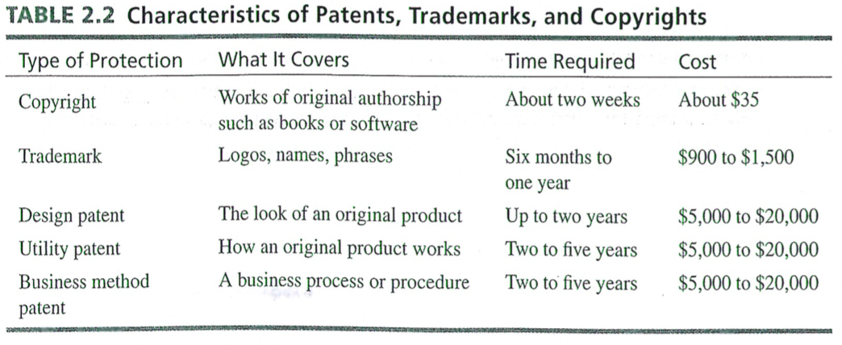

Designing a competitive business model and building a solid strategic plan

Companies lacking clear strategies may achieve some success in the short run, but as soon as competitive conditions stiffer or an unanticipated threat arises, they usually hit the wall and fold. The biggest change that entrepreneurs face is the shift in world’s economy from a base of financial to intellectual capital.

Intellectual capital: A key source of a company’s competitive advantage that is comprised of:
- Human capital: talents, creativity, skills, and ability of the workforce.
- Structural capital: the accumulated knowledge and experience that a company possesses.
- Customer capital: the established customer base, positive reputation, ongoing relationships, and goodwill.

Building a competitive advantage

Competitive advantage: The aggregation of factors that sets a small business apart from its competitors and gives it a unique position in the market superior to its competition.

4 aspect of the business defines its competitive advantage:
- Products they sell
- Service they provide
- Pricing they offer
- Way they sell

They key to success over time is building a sustainable competitive advantage.

Core competencies: A unique set of capabilities that a company develops in key operational areas that allow it to vault past competitors.

To be effective strategically, these core competencies should be difficult for competitors to duplicate, and they must provide customers with an important perceived benefit.

Successful small companies are able to build strategies that exploit all of the competitive advantages that their size gives them by:
- Responding quickly to customers’ needs
- Providing personalized customer service
- Remaining flexible and willing to change
- Constantly searching for new, emerging market segments
- Building and defending market niches
- Remaining entrepreneurial and willing to take risks and act with lightning speed
- Constantly innovating
- Erecting “switching costs,” the costs a customer incurs by switching to a competitor’s product or service, through personal service and loyalty

One of the biggest pitfalls many entrepreneurs stumble into is failing to differentiate their companies from the crowd of competitors.
Developing core competencies does not necessarily require a company to spend a great deal of money, what it does require is creativity, imagination, and vision to identify things that it does best and are most important to customers.
The strategic management procedure for a small business should include the following:
- use a relatively short planning horizon
- be informal and not overly structured
- encourage the participation of employees and outside parties to improve reliability and creativity
- do not begin with settings objectives, as this may interfere with the creative process early on
- maintain flexibility
- focus on strategic thinking, not just planning
- ensure development process is ongoing because the competitive environment constantly changes

The Strategic Management Process

A continuous process that consists of nine steps:
- Develop a clear vision and translate it into a meaningful mission statement
- Assess the company's strengths and weaknesses
- Scan the environment for significant opportunities and threats facing the business.
- Identify the key factors for success in the business.
- Analyze the competition
- Create company goals and objectives.
- Formulate strategic options and select the appropriate strategies.
- Translate strategic plans into action
- Establish accurate controls

Step 1. Develop a clear vision and translate it into a meaningful mission statement.

Vision: Future-oriented and touches everyone associated with the company. Its goal is to focus everyone's attention on the same target and to inspire them to reach it.

- Vision provides direction
- Vision determines decisions
- Vision motivates people
- Vision allows for perseverance in the face of adversity

Vision is based on an entrepreneur's values. The best way to put values into action is to create a written mission statement that communicates those values to everyone that company touches.

Mission The mission statement = An enduring declaration of a company's purpose that addresses the first question of any business venture: What business am I in?
A great mission statement sets the tone for the entire company and focuses its attention in the right direction.

3 keys issues to be addressed in a mission statement:
- The purpose of the company
- The business we are in
- The values of the company

The power of the mission statement:
- The owner communicates the advantage to workers who communicate it to the customers
- Customers recommend the company to their friends because the understand the benefits.

Writing a powerful mission statement:
- keep it short
- keep it simple
- know what makes your company different
- take a broad view, but not too broad
- get everyone involved
- keep it current
- reflects the values and beliefs you hold dear
- includes values that are worthy of your employees' best efforts
- reflects a concern for the future
- keep the tone positive and upbeat
- lay an ethical foundation for your company
- appropriate for your company's culture
- revise it when necessary
- use it

Step 2. Assess the company's strengths and weaknesses

Building a successful competitive strategy requires a business to magnify its strengths and overcome or compensate for its weaknesses.
Strengths: Positive internal factors that a company can use to accomplish its mission, goals, and objectives. Might include special skills or knowledge, positive public image, experienced sales force, establish base of loyal customers, etc.

Weaknesses: Negative internal factors that inhibit the accomplishment of a company's mission, goals, and objectives. Might include lack of capital, shortage of skilled workers, inability to master technology, inferior location, etc.

Identifying strengths and weaknesses helps owners understand their businesses as they exist. The key to building a successful strategy is using the company's underlying strengths as its foundation and matching them against competitors' weaknesses.

Prepare a balance sheet of the company's strengths and weaknesses. This balance sheet should analyze all key performance areas of the business:
- human resources
- finance
- production
- marketing
- product development
- organization
- etc.

Positive side
- important skills
- knowledge
- resources
Negative side
- limitations that detract from the company's ability to compete

Step 3. Scan the environment for significant opportunities and threats facing the business.

Opportunities: Positive external options that a firm can exploit to accomplish its mission, goals, and objectives.

Entrepreneurs should analyze only those opportunities that are most significant to the business.

Threats: Negative external forces that inhibit a company's ability to achieve its mission, goals, and objectives.

Threats can be new competitors, rising interest rates, mounting energy prices, technological advances making a product obsolete, etc.

External forces have direct impact on the behavior of the markets in which a business operates, the behavior of competitors, and customers. Entrepreneurs should focus on the 3 or 4 most significant threats confronting their companies.

Step 4. Identify the key factors for success in the business

To gain a competitive advantage a small business must identify and manipulate the controllable variables that determine the relative success of market participants.

Key success factors (KSF): The factors that determine a company's ability to compete successfully in an industry.

Many of these sources of competitive advantages are based on cost factors such as manufacturing cost per unit, distribution cost per unit, and development cost per unit. Other less tangible factors include: superior product quality, solid relationships with dependable suppliers, superior customer service, highly trained and knowledgeable sales force, prime store locations, readily available customer credit, etc.

Step 5. Analyze the competition

Keeping tabs on competitors’ movements through competitive intelligence programs is a vital strategic activity.

The primary goals of a competitive intelligence program include:
    - Avoiding surprises from existing competitors' new strategies and tactics
    - identifying potential new competitors
    - improving reaction time to competitor's actions
    - anticipating rivals' next strategic moves

Competitor analysis: sizing up the competition gives a business owner a more realistic view of the market and their company’s position in it.

Direct competitors offer the same products and services.
Significant competitors offer some of the same products and services.
Indirect competitors offer the same or similar products or services only in a small number of areas, and target customers seldom overlap.

Competitive profile matrix: A tools that allows business owners to evaluate their companies against major competitors using the key success factors for the market.

Step 6. Create company goals and objectives

Goals: The broad, long-range attributes a business seeks to accomplish; they tend to be general and sometimes even abstract.

Objectives: More specific targets of performance, commonly addressing areas such as profitability, productivity, growth, and other key aspects of a business.

Well written objectives have the following characteristics:
- They are specific
- They are measurable
- They are assignable
- They are realistic, yet challenging
- They are timely
- They are written down

Step 7. Formulate strategic options and select the appropriate strategies

Strategy: A road map of the actions an entrepreneur draws up to fulfill a company’s mission, goals, and objectives.

Three strategic options:
- Cost leadership
  - Cost leadership strategy: A strategy in which a company strives to be the low-cost producer relative to its competitors in the industry.
    - Dangers include:
      - Focusing exclusively on e.g. lower manufacturing costs, without considering the impact of purchasing, distribution, or overhead costs.
      - Incorrectly identifying the company’s true cost drivers.
      - Focusing on pushing costs down, thereby eliminating product or service features that customers consider essential.
- Differentiation
  - Differentiation strategy: A strategy in which a company seeks to build customer loyalty by positioning its goods or services in a unique or different fashion.
    - The key is to be unique at something that is important to the customer.
    - Dangers include:
      - Trying to differentiate a product or service on the basis of something that doesn’t boost performance or lower its cost to customers.
      - Trying to differentiate on the basis of something that customers don’t find important.
      - Imitations and knockoffs from competitors also pose a threat to a successful differentiation strategy.
      - Over-differentiating and charging so much that the company prices its products out of the market.
      - Focusing only on the physical characteristics of a product or service and ignoring important psychological factors such as status, prestige, and image.
- Focus
  - Focus strategy: A strategy in which a company selects one or more market segments, identifies customers’ special needs, wants, and interests, and approaches them with a good or service designed to excel in meeting those needs, wants, and interests.
    - Dangers include:
      - Companies sometimes must struggle to capture a large enough share of a small market to be profitable.
      - Large competitors entering a niche market and eroding it.
      - Constant struggle to keep costs down.
      - Companies with successful niche strategy get distracted and try to branch out.

Step 8. Translate strategic plans into action plans

Implement a strategy: Implementing a strategy successfully requires both a process that fits a company’s culture and the right people committed to making that process work. To make strategic plans workable, they should be divided into projects, defining each of the following:
- Purpose
- Scope
- Contribution
- Resource requirements
- Timing
Involving employees and delegating adequate authority is essential because these projects affect them directly.

Step 9. Establish accurate controls

Controlling the strategy: Controlling plans and projects and keeping them on schedule means that an entrepreneur must identify and track key performance indicators.

Balanced scorecard: A set of multidimensional measurements that are unique to a company and that incorporate both financial and operational measures to give managers a quick yet comprehensive picture of a company’s overall performance.

Ideally, a balanced scorecard looks at a business from five important perspectives:
- Customer perspective
- Internal business perspective
- Innovation and learning perspective
- Financial perspective
- Corporate citizenship

Conducting a feasibility analysis and crafting a winning business plan

Feasibility analysis: The process of determining whether or not an entrepreneur’s idea is a viable foundation for creating a successful business.

Conducting a feasibility analysis

A feasibility analysis consists of three interrelated components:

1. Industry and market feasibility analysis

- Determine how attractive an industry is overall as a home for a new business
  - Assess it from the macro level
Five forces model: A model that recognizes the power of 5 forces on an industry:
- Rivalry among competing firms: strongest of 5 forces
  - An industry is more attractive when:
    - The number of competitors is large, or small (<5)
    - Competitors are not similar in size or capability
    - The industry is growing at a fast pace
    - The opportunity to sell a differentiated product or service exists
- Bargaining power of suppliers: The greater the leverage that suppliers of key raw materials or components have, the less attractive the industry.
  - An industry is more attractive when:
    - Many suppliers sell a commodity product to the companies in it
    - Substitute products are available for the items that suppliers provide
    - Companies in the industry find it easy to switch from one supplier to another or to substitute products
    - When the items supplier to the industry account for a relatively small portion of the cost of the industry’s finished products
- Bargaining power of buyers: When the number of customers is small and the cost of switching to competitor’s products is low, buyers’ influence on companies is high
  - An industry is more attractive when:
    - Industry customers switching costs to competitors’ products or to substitutes are relatively high
    - Number of buyers in the industry is large
    - Customers demand products that are differentiated rather than purchase commodity products that they can obtain from any supplier
    - Customers find it difficult to gather information on suppliers’ costs, prices, and product features
    - When the items companies sell to the industry account for a relatively small portion of the cost of their customers’ finished products
- Threat of new entrants: The larger the pool of potential new entrants to an industry, the great the threat to existing companies.
  - An industry is more attractive to new entrants when:
    - The advantages of economies of scale are absent
    - Capital requirements to enter the industry are low
    - Cost advantages are not related to company size
    - Buyers are not extremely brand-loyal
    - Governments do not restrict new companies from entering the industry
- Threat of substitute products or services
  - An industry is more attractive when:
    - Quality substitute products are not readily available
    - The prices of substitute products are not significantly lower than those of the industry’s products
    - Buyers’ cost of switching to substitute products is high

- Identify possible niches a small business can occupy profitably
  - Questions entrepreneurs should address are:
    - Which niche(s) in the market will we occupy?
    - How large is this market segment, and how fast is it growing?
    - What is the basis for differentiating our product or service from competitors?
    - Do we have a superior business model that will be difficult for competitors to reproduce?

Business prototyping: A process in which entrepreneurs test their business models on a small scale before committing serious resources to launch a business that might not work

2. Product or service feasibility analysis

Product or feasibility analysis: An analysis that determines the degree to which a product or service idea appeals to potential customers and identifies the resources necessary to produce the product or provide the service.

Primary research: Information that an entrepreneur collects firsthand and analyzes. Techniques include:
- Customer surveys and questionnaires
- Focus groups: A market research technique that involves enlisting a small number of potential customers, usually 8 – 12, to give an entrepreneur feedback on specific issues about a product or service, or the idea itself

Secondary research: Information that has already been compiled and is available for use, often at a very reasonable cost or sometimes even free. Techniques include:
- Trade associations and business directories
- Direct mail lists
- Demographic data
- Census data
- Market research
- Articles
- Local data
- WWW

Prototypes: An original, functional model of a new product that entrepreneurs can put into the hands of potential customers so they can see, test, and use it. They usually point out problems in a product’s design.

In-home trials: A research technique that involves sending researchers into customers’ homes to observe them as they use the company’s product or service.

3. Financial feasibility analysis

The major elements to be included in a financial feasibility analysis include:
- Capital requirements
- Estimated earnings
- Return on investment

Why develop a business plan?

Business plan: A written summary of an entrepreneur’s proposed business venture, it’s operational and financial details, its marketing opportunities and strategy, and its managers’ skills and abilities.

A business plan server 2 essential functions:
- It guides an entrepreneur by charting the company’s future course of action and devising a strategy for success.
- It attracts lenders and investors.

To get external financing, a business plan must pass 3 tests with potential lenders and investors:
- Reality test
  - Externally proves that a market for the product or service really does exist
  - Internally it focuses on the product or service itself
- Competitive test
  - Externally it determines the companies relative position to its key competitors
  - Internally it determines management’s ability to create a company that will gain an edge over existing rivals
- Value test
  - Must prove that it offers a high probability of repayments or an attractive rate of return

Elements of a business plan
- Title page and table of contents
- Executive summary
  - Concise, maximum 2 pages, summarizes all the relevant points of the business venture.
    - Business model and competitive edge
    - Target markets and benefits it will provide
    - Qualifications of the founds and key employees
    - Key financial highlights
- Vision and mission statement
- Company history
- Business and industry profile
  - Overview of the industry or market segment in which business will operate
  - Goals: Broad, long-range statements of what a company plans to achieve in the future that guide its overall direction
  - Objectives: Short-term specific performance targets that are attainable, measurable, and controllable
- Business strategy
- Description of the company’s product or service
  - Feature: A descriptive fact about a product or service
  - Benefit: What a customer gains from the product or service
- Marketing strategy
- Documenting market claims
- Description of the management team
- Plan of operation
- Pro forma financial statements
- The loan or investment proposal

What lenders and investors look for in a business plan
- Capital
- Capacity
- Collateral
- Character
- Conditions

Forms of business ownership

Choosing a form of ownership is important because it has far-reaching effects for both the entrepreneur and business. Changing from one ownership form to another can be difficult, time consuming, complicated, expensive, and it can trigger onerous tax consequences for the owners. Choose a structure that gives you the protection you need but with as few rules as possible.

Some of the most important issues to consider:
- Tax considerations
- Liability exposure
- Start-up and future capital requirements
- Control
- Managerial ability
- Business goals
- Management succession plans
- Cost of formation

Wide choice of forms of ownerships including:
- Sole proprietorship: A business owned and managed by one individual; the business and the owner are one and the same in the eyes of the law.
  - Advantages:
    - Simple to create
    - Least costly form of ownership to begin
    - Profit incentive
    - Total decision-making authority
    - No special legal restrictions
    - Easy to discontinue
  - Disadvantages:
    - Unlimited personal liability: A situation in which the sole proprietor is personally liable for all of the business’s debts
    - Limited skills and capabilities
    - Feelings of isolation
    - Limited access to capital
    - Lack of continuity of the business
- Partnership: An association of two or more people who co-own a business for the purpose of making a profit
  - Partnership agreement: A document that states in writing the terms under which the partners agree to operate the partnership and protects each partner’s interest in the business
    - The most important feature of the partnership agreement is that is resolves potential sources of conflict that could later result in partnership battles and the dissolution of an otherwise successful business
    - The standard partnership agreement will likely include:
      - Name of the partnership
      - Purpose of the business
      - Domicile of the business
      - Duration of the partnership
      - Names of the partners and their legal addresses
      - Contributions of each partner to the business
      - How the profits and losses will be distributed
      - Expansion through the addition of new partners
      - Agreement on the distribution of assets if the partners voluntarily dissolve the partnership
      - Sale of partnership interests
      - Salaries, draws, and expense accounts for the partners
      - Absence or disability of one of the partners
      - Dissolution of the partnership
      - Alternations or modifications of the partnership agreement
  - Uniform Partnership Act (UPA) – codifies the body of law dealing with partnerships in the US. The 3 key elements of any partnership are common ownership interest in a business, sharing the business’s profits and losses, and the right to participate in managing the operation of the partnership.
  - Each partner has a right to:
    - Participate in the management and operation of the business
    - Share in any profits the business might earn from operations
    - Receive interest on loans made to the business
    - Be compensated for expenses incurred in the name of the partnership
    - Have access to the business’s books and records
    - Receive a formal accounting of the partnership’s business affairs
  - Each partner is obligated to:
    - Share in any losses sustained by the business
    - Work for the partnership without salary
    - Submit differences that may arise in the conduct of the business to majority vote or arbitration
    - Give the other partners complete information about all business affairs
    - Give a formal accounting of the partnership’s business affairs
    - Live up to a fiduciary responsibility of the partnership and place the interest of the partnership above his or her personal interests
  - Advantages
    - Easy to establish
    - Complementary skills
    - Division of profits
    - Larger pool of capital
    - Ability to attract limited partners
      - General partners: Partners who share in owning, operating, and managing a business and who have unlimited personal liability for the partnership’s debts
      - Limited partners: Partners who make financial investments in a partnership, do not take an active role in managing a business, and whose liability for the partnership’s debts is limited to the amount they have invested
      - Silent partners: Limited partners who are not active in a business but generally are known to be members of the partnership
      - Dormant partners: Limited partners who are neither active in a business nor generally known to be associated with the business
    - Minimal government regulation
    - Flexibility
    - Taxation
  - Disadvantages:
    - Unlimited liability of at least one partner
    - Capital accumulation
    - Difficulty in disposing of partnership interest without dissolving the partnership
    - Lack of continuity
    - Potential for personality and authority conflicts
    - Partners are bound by the law of agency
  - Limited partnership: A partnership composed of at least one general and at least one limited partner
    - Forming a limited partnership requires its founders to file a Certificate of Limited Partnership with the Secretary of State, and typically includes:
      - The name of the limited partnership
      - The general character of its business
      - The address of the office of the firm’s agent authorized to receive summonses or other legal notices
      - The name and business address of each partner, specifying general and limited
      - The amount of cash contributions actually made, and agreed to be made in the future, by each partner
      - A description of the value of non-cash contributions made or to be made by each partner
      - The times at which additional contributions are to be made
      - Whether and under what conditions a limited partner has the right to grant limited partner status to an assignee of his or her interest in the partnership
      - The time or the circumstances when a partner may withdraw from the firm
      - The amount of, or method of determining, the funds to be received by a withdrawing partner
      - Any right of a partner to receive distributions of cash or other property from the firm, and times and circumstances for such distributions
      - The time or circumstances when the limited partnership is to be dissolved
      - The rights of the remaining general partners to continue the business after withdrawal of a general partner
      - Any other matters the partners want to include
  - Limited liability partnership: A special type of limited partnership in which all partners, who in many states must be professionals, are limited partners
    - Forming an LLP requires the same steps as the LP
  - Master limited partnership: A partnership whose shares are traded on stock exchanges, just like a corporation’s
    - Just like regular LP’s, except they behave like corporations and shares are traded publicly
- Corporation: A separate legal entity apart from its owners that receives the right to exist from the state in which it is incorporated
  - Domestic corporation: A corporation doing business in the state in which it is incorporated
  - Foreign corporation: a corporation doing business in a state other than the one in which it is incorporated
  - Alien corporation: A corporation formed in another country but doing business in the US
  - Closely held corporation: A corporation whose shares are controlled by a relatively small number of people, often family members, relatives, friends, or employees
  - Publicly held corporation: A corporation that has a large number of shareholders and whose stock usually is traded on one of the large stock exchanges
  - How to incorporate:
    - Most states allow entrepreneurs to incorporate without the assistance of an attorney. To create a corporation, every state requires a Certificate of Incorporation or charter to be files with the secretary of state. The following is generally required to be in the Certificate of Incorporation:
      - The corporation’s name
      - The corporation’s statement of purpose
      - The corporation’s time horizon
      - Name and addresses of the incorporators
      - Place of business
      - Capital stock authorization
      - Capital required at the time of incorporation
      - Provisions for preemptive rights
        - Preemptive rights: The rights of a corporation’s original investors to purchase enough shares of future stock issues to maintain their original percentage of ownership in the company
      - Restrictions on transferring shares
        - Treasury stock: The shares of its own stock that a corporation owns
        - Right of first refusal: A provision requiring shareholder who want to sell their stock to offer it first to the corporation
      - Names and addresses of the officers and directors of the corporation
      - Rules under which the corporation will operate
        - Bylaws: The rules and regulations the officers and directors establish for a corporation’s internal management and operation
  - Advantages:
    - Limited liability of stockholders
      - Courts ignore the limited liability shield the corporate form of ownership provides when an entrepreneur:
        - Uses corporate assets for personal reasons or commingles them with their personal assets
        - Fails to act in a responsible manner and creates and unwarranted level of financial risk for the stockholders
        - Makes financial misrepresentations, such as operating with more than one set of books
        - Takes actions in the name of the corporation that were not authorized by the board of directors
    - Ability to attract capital
      - Private placement: A fund-raising tool in which a company sells shares of its stock to a limited number of private investors
      - Initial public offering: A fund-raising tool in which a company sells shares of its stock to the public
    - Ability to continue indefinitely
    - Transferable ownership
  - Disadvantages:
    - Cost and time involved in the incorporation process
    - Double taxation: A disadvantage of the corporate form of ownership in which a corporation’s profits are taxed twice: at the corporate rate and at the individual rate (on the portion of profits distributed as dividends).
    - Potential for diminished managerial incentives
    - Legal requirements and regulatory red tape
    - Potential loss of control by the founders
- S corporation: A corporation that retains the legal characteristics of a regular (C) corporation but has the advantage of being taxed as a partnership it it meets certain criteria
  - To attain S status, the following criteria must be met:
    - It must be a domestic corporation
    - It cannot have a nonresident alien as a shareholder
    - It can issue only one class of common stock (all shares must carry the same rights)
    - It must limit its shareholders to individuals, estates, and certain trusts
    - It cannot have more than 100 shareholders
    - Less than 25% of the gross revenues during 3 successive tax years must be from passive sources
  - Advantages:
    - All advantages from a corporation
    - Serves as a conduit for its net income, passing all of its profits or losses through to the individual shareholders (eliminates double taxation)
      - Problems with this: If the corporation earns a profit but its managers choose to plow that income back into the business in the form of retained earnings, shareholders still must pay taxes on their share of the company’s net income. (taxes on phantom income)
    - Avoids paying taxes on assets that have appreciated in value and are sold
    - Not subject to self-employment tax that sole proprietors and general partners must pay, but are responsible for payroll taxes of their employees
  - Disadvantages:
    - Maximum individual tax rate is higher than maximum corporate rate
    - Costs of many benefits – insurance, meals, lodging, etc. – paid to shareholders with > 2% stock can’t be deducted as a business expense for tax purposes, they are considered taxable income
    - Limited range of retirement benefits
- Limited liability company: A relatively new form of ownership that, like an S corporation, is a cross between a partnership and a corporation; it is not subject to many of the restrictions imposed on S corporations
  - Advantages similar to S corporation, but:
    - LLC’s can have < 100 shareholders and multiple class of stock
    - Owners have limited liability without imposing any requirements on their characteristics or any ceiling on their numbers
    - Members can include aliens, partnerships, and corporations
    - Doesn’t restrict members’ ability to become involved in managing the company
    - Avoid double taxation by not paying income tax, its income flows through to the members, who are responsible for paying income taxes on their shares of the LLC’s net income
    - Flexibility: divide income (tax liability) as they see fit, including allocation that differ from their percentages of ownership
    - Members’ share of an LLC’s earnings is not subject to self-employment tax, managing member’s share of the LLC’s earning is subjected to self-employment tax
  - Articles of organization: The document that creates an LLC by establishing its name, its method of management, its duration, and other details
  - Operating agreement: The document that establishes for an LLC the provisions governing the way it will conduct business
    - The operating agreement must create an LLC that has more characteristics of a partnership than of a corporation to maintain favorable tax treatment. An LLC cannot have any more than 2 of the following four corporate characteristics:
      - Limited liability
      - Continuity of life
      - Free transferability of interest
      - Centralized management
  - Disadvantages:
    - Expensive to create
    - Annual fees
    - Limited life spans
    - Not suitable for companies whose owners plan to raise money through IPO’s or who want to use stock options or an ESOP (employee stock ownership plan)

Switching to an LLC from a general partnership, limited partnership, or a sole proprietorship is usually not a problem. However, owner of corporation and S corporations would incur large tax obligations if they converted to LLC’s.

Professional corporation
Ideally suited for professionals, who must always be concerned about malpractice lawsuits, because they offer limited liability. No different from creating a regular corporation. Often identified by P.C. (Professional Corporation), P.A. (Professional Association), or S.C. (Service Corporation). Following limitation beyond standard corporation:
- All shares of stock of the corporation must be owned and held by individuals licensed in the profession of the corporation
- At least one of the incorporators must be licensed in the profession
- At least one director and one officer must be licensed in the profession
- The articles of incorporation, in addition to all other requirements, must designate the personal services to be provided by the corporation
- The professional corporation must obtain from the appropriate licensing board a certification that declares the shares of stock are owned by individuals who are duly licensed in the profession

The joint venture
A joint venture is very much like a partnership, except that it is formed for a specific purpose. In any endeavor in which neither party can effectively achieve the purpose alone, a joint venture is a common choice. The partners form a new joint venture for each new project they undertake. The income derived from a joint venture is taxed as if it arose from a partnership.

Franchising and the entrepreneur

Franchising: A system of distribution in which semi-independent business owners (franchisees) pay fees and royalties to a parent company (franchisor) in return for the right to become identified with its trademark, to sell its products or services, and often to use its business format and system.

Franchisees don’t have the freedom to change the way they run their business, but they do have access to a formula for success that the franchisor has worked out.

The franchisor provides valuable services such as a proven business system, training and support, name recognition, and many other forms of assistance; the franchisee pays an initial franchise fee as well as an ongoing percentage of the outlet’s sales to the franchisor as a royalty and agrees to operate the outlet according to the franchisor’s terms.

Types of franchising
- Trade name franchising: a system of franchising in which a franchisee purchases the right to use the franchisor’s trade name without distributing particular products under the franchisor’s name
- Product distribution franchising: A system of franchising in which a franchisor licenses a franchisee to sell its products under the franchisor’s brand name and trademark through a selective, limited distribution network
- Pure franchising: (or comprehensive or business format franchising) A system of franchising in which a franchisor sells a franchisee a complete business format and system

Benefits of buying a franchise

Most new franchise outlets don’t break even for at least 6 to 18 months. However, they often cite the following advantages:
- A business system
- Management training and support
- Brand name appeal
- Standardized quality of goods and services
- National advertising programs
- Financial assistance
- Proven products and business formats
- Centralized buying power
- Site selection and territorial protection
- Greater chance for success
  - Success rate of franchisees is higher when a franchise system:
    - Requires franchisees to have prior industry experience
    - Requires franchisees to actively manage their stores
    - Has built a strong brand name
    - Offers training programs designed to improve franchisees’ knowledge and skills

Drawbacks of buying a franchise

The biggest drawback of franchising is that a franchisee must sacrifice some freedom to the franchisor. Other disadvantages include:
- Franchise fees and ongoing royalties
- Strict adherence to standardized operation
- Restrictions on purchasing
- Limited product line
- Contract terms and renewal
- Unsatisfactory training programs
- Market saturation
- Less freedom

Franchising and the law

Franchise Disclosure Document (FDD): A document that every franchisor is required by law to give prospective franchisees before any offer or sale of a franchise, it outlines 23 important pieces of information.

The 23 major topics required by the Trade Regulation rule are on the next page.

The information contained in the FDD neither fully protects a potential franchisee from deception nor does it guarantee success.

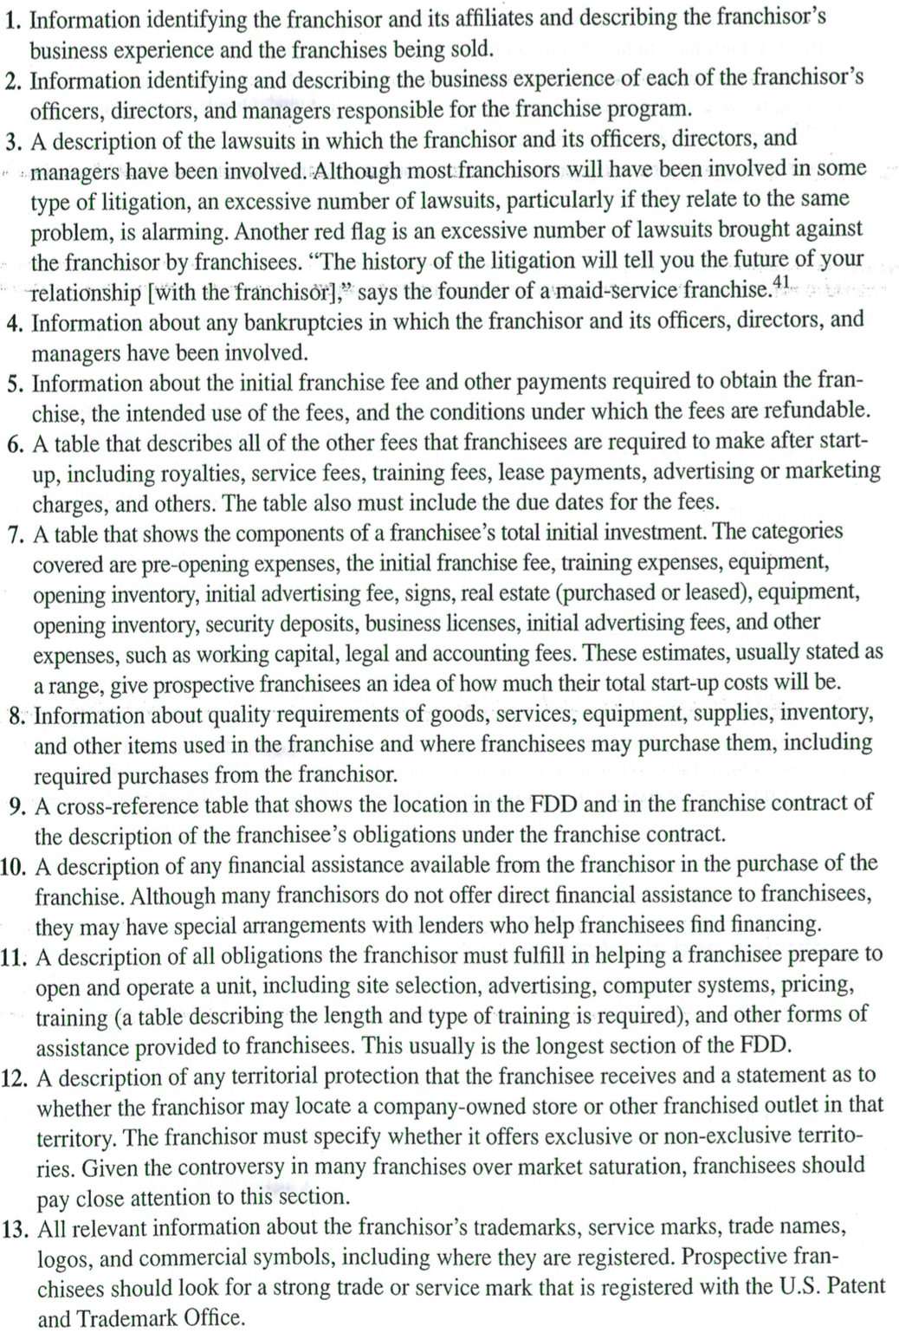
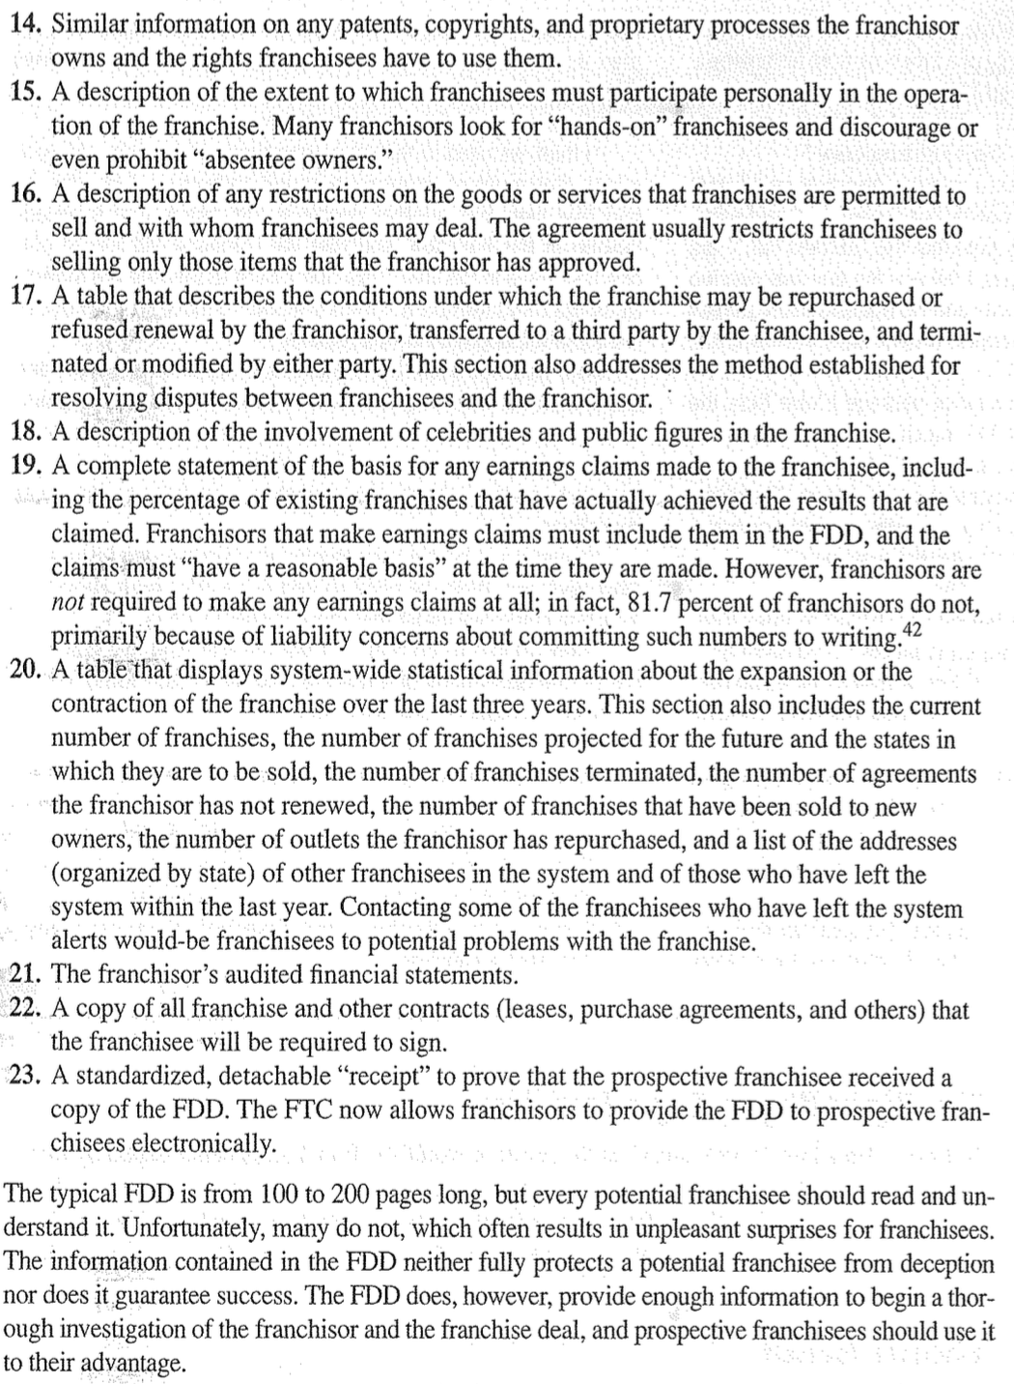

The right way to buy a franchise
- Evaluate yourself
- Research the market
- Consider your franchise options
- Get a copy of a franchisor’s FDD
  - The following make a franchise stand out:
    - A unique concept or marketing approach
    - Profitability
    - A registered trademark
    - A business system that works
    - A solid training program
    - Affordability
    - A positive relationship with franchisees
  - Watch for clauses that give the franchisor absolute control and discretion
  - Franchisee turnover rate: The rate at which franchisees leave a franchise system. If the turnover rate is > 5%, the franchise is probably sound.
- Talk to existing franchisees
- Ask the franchisor some tough questions
- Make your choice

Trends shaping franchising

Franchising has experienced 3 major growth waves.
- Early 1970’s when fast-food joints used the concept to grow rapidly
- Mid-1980’s as the US economy shifted heavily toward the service sector
- Early 1990’s and continues today characterized by new, low-cost franchises that focus on specific market niches

Other significant trends include:
- The changing face of franchisees (more diverse)
- Multiple-unit franchising: A method of franchising in which a franchisee opens more than one unit in a broad territory within a specific time period
- International opportunities
- Master franchising: A method of franchising that gives a franchisee the right to create a semi-independent organization in a particular territory to recruit, sell, and support other franchises
- Smaller, non-traditional locations
  - Intercept marketing: The principle of putting a franchise’s products or services directly in the paths of potential customers, wherever they may be
- Conversion franchising: A franchising trend in which owners of independent businesses become franchisees to gain the advantage of name recognition
- Piggybacking: A method of franchising in which two or more franchises team up to sell complementary products or services under one roof
- Serving dual-career couples of aging baby boomers

Buying an existing business

Advantages of buying an existing business
- A successful existing business may continue to be successful
- An existing business may already have the best location
- Employees and suppliers are established
- Equipment is installed and productive capacity is known
- Inventory is in place and trade credit is established
- The new business owner hits the ground running
- The new owner can use the experience of the previous owner
- Financing is easier to obtain
- It’s a bargain

Disadvantages of buying an existing business
- It’s a loser
- The previous owner may have created ill will
- Employees inherited with the business may not be suitable
- The business location may have become unsatisfactory
- Equipment and facilities may be obsolete or inefficient
- Change and innovation are difficult to implement
- Inventory may be outdated or obsolete
- Accounts receivable may be worth less than face value
- The business may be overpriced

The steps in acquiring a business

- Analyze your skills, abilities, and interests
- Prepare a list of potential candidates
  - Hidden market: Low-profile companies that might be for sale but are not advertised as such. To tap into this market there are several sources:
    - Business brokers
    - Professionals who provide business services such as bankers, accountants, attorneys, investment bankers, etc.
    - Industry contacts
    - Networking
    - Knowing on the doors of businesses
    - Trade associations
    - Newspapers and trade journals listing businesses for sale
- Investigate those candidates evaluate the best ones
- Explore financing options
- Ensure a smooth transition
  - Concentrate on communicating with employees
  - Be honest with employees
  - Listen to employees
  - Consider asking the seller to serve as a consultant until the transition is complete

Evaluating an existing business

A smart buyer will assemble a team of specialists to help investigate a potential business opportunity. The team is usually composed of a banker, an accountant familiar with the particular industry, an attorney, and perhaps a small business consultant or business broker.

Due diligence: The process of investigating the details of a company that is for sale to determine the strengths, weaknesses, opportunities, and threats facing it.
- Why is the business for sale?
- What is the physical condition of the business?
  - Book value is not the same as market value. Other important factor that the potential buyer should investigate include:
    - Accounts receivable
    - Lease arrangements
    - Business records
    - Intangible assets
    - Locations and appearance
- How current is the company’s product line?
- What is the potential for the company’s products or services?
- What are the customers’ characteristics and composition?
- What are the competitors’ characteristics and composition?
- What legal aspects should you consider?
  - Biggest potential legal traps include:
    - Lien: A creditor’s claim against an asset
    - Bulk transfer: Protects the buyer of a business’s assets from the claims unpaid creditors might have against those assets
    - Contract assignments: The rights and the obligations a buyer would assume under existing contracts with suppliers, customers, employees, lessors, etc.
      - Duo-on-sale clause: Loan contract provision that prohibits a seller from assigning a loan arrangement to the buyer. Instead, the buyer is required to finance the remaining loan balance at prevailing interest rates
    - Covenants not to compete: (Restrictive covenant or noncompete agreement) An agreement between a buyer and a seller in which the seller agrees not to compete with the buyer within a specific time and geographic area
    - Ongoing legal liabilities: These typically arise from 3 sources
- Physical premises
- Product liability claims
- Labor relations
    - Product liability lawsuits: Lawsuits that claim a company is liable for damages and injuries caused by the products it makes or sells
- Is the business financially sounds?
  - Some of the financial records that a potential buyer should examine include:
    - Income statements and balance sheets for the last 3-5 years
    - Income tax returns for the past 3-5 years
      - Skimming: Taking money from sales without reporting it as income
    - Owner’s compensation (and that of relatives)
    - Cash flow
  - Always walk away from a deal if the present owner refuses to disclose the company’s financial records, or any other operating information needed.

Methods for determining the value of a business

Goodwill: The difference in the value of an established business and one that has not yet built a solid reputation for itself.

A few hard and fast rules in establishing the value of a business:
- Compute a company’s value using several techniques and choose the one that makes more sense
- Deal must be financially feasible for both parties
- The potential buying must have access to the business records
- Valuations should be based on facts
- No surprises

Most small companies sell for 2 to 12 times their EBIT, averaging between 6 and 7. Factors that increase the multiplier include proprietary products and patents, strong dominant market share. Factors that decrease the multiplier include generic products, dependence on a single customer or a small group of customers, reliance on the skills of a single manager, declining market share, dependence on a single product.

Balance sheet techniques: Net worth = total assets – total liabilities

Balance sheet technique: A method of valuing a business based on the value of the company’s net worth

$$Net worth=Total assets-Total liabilities$$

Variation: Adjusted balance sheet technique: A method of valuing a business based on the market value of the company’s net worth

Business valuations based on balance sheet methods suffer one major drawback: they do not consider the future earnings potential of the business.

Earnings approach: A method of valuing a business that recognizes that a buyer is purchasing the future income (earnings) potential of a business

Variation 1: Excess earnings method: This method combines both the value of a business’s existing assets (minus liabilities) and an estimate of its future earnings potential to determine its selling price. This technique offers an estimate of goodwill.
- Compute adjusted tangible net worth
  - $Tangible net worth= Total tangible assets \left(adjusted for market value\right)- Total liabilities$
- Calculate the opportunity cost of investing in the business
  - Opportunity cost: The cost of the next best alternative choice; the cost of giving up one alternative to get another
  - 3 components in the rate of return used to value a business:
    - basic, risk free return
    - inflation premium
    - risk allowance for investing in the particular business
- Project net earnings: estimate the company’s net earnings for the upcoming year before subtracting the owner’s salary
  - Add back any direct payments to the owners, including salary and bonuses. Add a reasonable salary for a manager to take the owner’s place
  - Add all other expenses the company pays for the owners
  - Add the cost of any leases the company has with the owners or their family members
  - Add any extraordinary expenses
- Compute extra earning power
  - Difference between forecasted earnings (3) and total opportunity costs (2)
- Estimate the value of intangibles
  - Multiply extra earning power (4) by a years-of profit
  - Normal risk business = 3-4 years-of-profit to be used
- Determine the value of the business
  - Add together the adjusted tangible net worth (1) and the value of the intangibles (5)

Because the buyer can amortize both the cost of goodwill and a restrictive covenant over 15 years, the tax treatment of either would be the same for him. The seller would prefer to have the amount of the purchase price in excess of the value of the assets allocated to goodwill, which is a capital asset. The gain on the capital asset would be taxed at the lower capital gains rates. If that same amount were allocated to a restrictive covenant, the seller must treat it as ordinary income, which would be taxed at regular rates that are higher than the capital gains rates.

Variation 2: Capitalized earnings approach: A method of valuing a business that divides estimated earnings by the rate of return the buyer could earn on a similar risk investment.

$$Capitalized earnings=\frac{Net earnings (after deducting owner^{'}ssalary)}{Rate of return}$$

Variation 3: Discounted future earnings approach: A method of valuing a business that forecasts a company’s earnings several years into the future and then discounts them back to their present value
- Project future earnings for 5 years into the future
  - $Forecasted earnings for year i=\frac{\left(Optimistic earning for year i\right)+ Most likely forecast for year i × 4+(Pessimistic forecast for year i)}{6}$
- Discount these future earnings at the appropriate present value rate
  - Should reflect the rate they could earn on a similar risk investment
- Estimate the income stream beyond 5 years
  - Multiply the 5th year income by 1/rate of return
- Discount the income estimate beyond 5 years using the present value factor for the 6th year
- Compute the total value of the business
  - Add the present value of the company’s estimated earnings for years 1 through 5 (2) and the present value of its earnings from year 6 on (4)

Market approach: (Price/earnings) A method of valuing a business that uses the price/earnings (P/E) ratio of similar, publicly held companies to determine value

$$Value = Average P/E ratio × Estimated net earnings$$

This method has several disadvantages:
- Necessary comparisons between publicly traded and privately owned companies
- Unrepresentative earnings estimate
- Finding similar companies for comparison
- Applying the after-tax earnings of a private company to determine its value

Understanding the seller’s side

Financial buyers: Usually individuals, see buying a business as a way to generate income for themselves. They look for businesses in which they can make an initial down payment and finance the remaining %. Their primary concern is the company’s ability to generate profits and positive cash flow.

Strategic buyers: Often other businesses or competitors, view buying a company as part of a larger picture that gives them an advantage such as access to a new, fast-growing market, unique product, or new technology.

Selling a business involves developing a plan that maximizes the value of the business.

Structuring the deal

Planning the structure of the deal is one of the most important decisions a seller can make. Tax considerations are of the utmost importance.

Exit strategies
- Straight business sale
  - Owners must decide whether to sell the assets of the business or transfer ownership to the buyer through a sale of company stock
- Business sale with an agreement from the founder to stay on
  - Earn-out: An exit strategy in which an entrepreneur can increase his or her payout by staying on and making sure that the company hits specific performance targets
- Form a family-limited partnership
- Sell a controlling interest
- Restructuring the company
- Sell to an international buyer
- Use a two-step sale
- Establish an employee stock ownership plan (ESOP)
  - Employee stock ownership plan (ESOP): An employee benefit plan in which a trust created for employees purchases stock in their employers’ company

Negotiating the deal

Value is what the business is actually worth; price is what the buyer agrees to pay.

Buyers seek to:
- Get the business at the lowest possible price
- Negotiate favorable payment terms
- Get assurances that they are buying the businesses they think they are getting
- Avoid putting the seller in a position to open a competing business
- Minimize the amount of cash paid up front

Sellers are looking to:
- Get the highest price possible
- Sever all responsibility for the company’s liabilities
- Avoid unreasonable contract terms that might limit their future opportunities
- Maximize the cash they get from the deal
- Minimize the tax burden from the sale
- Make sure the buyer will be able to make all future payments

Negotiation process

The negotiation process will go much more smoothly and faster if both parties work to establish a cooperative relationship based on honesty and trust. A successful deal requires both parties to examine and articulate their respective positions while trying to understand they other party’s position. Recognize that neither will benefit without a deal, both must make concessions to keep negotiations alive.
A buyer should go into the negotiation with a list of objectives ranked in order of priority. Then they must develop what they perceive to be the seller’s list of priorities.

Building a powerful marketing plan

An effective marketing plan projects numbers and analyzes them but rather than focusing on cash flow, net income, and owner’s equity, a marketing plan concentrates on the customer.

Building a guerilla marketing plan

Marketing: The process of creating and delivering desired goods and services to customers; involves all of the activities associated with winning and retaining loyal customers.

Guerilla marketing strategies: Unconventional, low-cost, creative techniques designed to give small companies an edge over their larger, richer, more powerful rivals.

Pinpointing the target market

Target market: The specific group of customers at whom a company aims its goods or services

The most successful businesses have well-defined portraits of the customers they are seeking to attract. Market research allows them to know their income levels, lifestyles, buying patterns, likes and dislikes, and psychological profiles.

Determining customer needs and wants through market research

Demographics: The study of important population characteristics such as age, income, education, race, and others

The value of market research

Market research: The vehicle for gathering the information that services as the foundation for the marketing plan; it involves systematically collecting, analyzing, and interpreting data pertaining to a company’s market, customers, and competitors.

Market research does not have to be time consuming, complex, or expensive to be useful. Online surveys, customer opinion polls, and other research projects are easy to conduct and cheap.

To spot significant trends, entrepreneurs can use the following techniques:
- Read as many current publications as possible
- Monitor blogs and newsgroups
- Watch the top 10 TV shows
- See the top 10 movies
- Talk to at least 150 customers a year about what they are buying and why
- Talk with the 10 smartest people you know
- Listen to your children

How to conduct market research

The goal of market research is to reduce the risks associated with making business decisions:
- Define the objective
- Collect the data
  - Individualized (one-to-one) marketing: A system based on gathering data on individual customers and developing a marketing program designed to appeal specifically to their needs, tastes, and preferences
  - Primary research techniques include:
    - Customer surveys and questionnaires
    - Focus groups
    - Daily transactions
    - Other ideas
  - Data mining: A process in which computer software that uses statistical analysis, database technology, and artificial intelligence finds hidden patterns, trends, and connections in data so that business owners can make better marketing decisions and predictions about customers’ behavior.
- Analyze and interpret the data
- Draw conclusions and act

Guerilla marketing principles

12 principles can help business owners in creating powerful, effective guerilla marketing strategies:
- Find a niche and fill it
- Use the power of publicity
  - Publicity is any commercial news covered by the media that boosts sales but for which a small company doesn’t pay. Publicity has power; because it’s from an unbiased source. The following can help stimulate publicity:
    - Write an article that will interest your customers or potential customers
    - Sponsor an event designed to attract attention
    - Involve celebrities on the cheap
    - Contact local TV and radio stations and offer to be interviewed
    - Publish a newsletter
    - Contact local business and civic organization and offer to speak to them
    - Offer or sponsor a seminar
    - Write news releases and email them to the media
    - Volunteer to serve on community and industry board and committees
    - Sponsor a community project or support a nonprofit organization or charity
    - Promote a cause
- Don’t just sell; entertain
  - Entertailing: A marketing concept designed to draw customers into a store by creating a kaleidoscope of sights, sounds, smells, and activities, all designed to entertain and sell.
    - Sponsor events that will attract your target customers
    - Give customers the opportunity to interact with your products
    - Use technology creatively
    - Remember that the ultimate goal is to sell
- Strive to be unique
- Connect with customers on an emotional level
  - Unique selling proposition (USP): A key customer benefit of a product or service that sets it apart from the competition; it answers the critical question every customer asks: what’s in it for me?
- Create an identity for your business through branding
  - Branding: Communicating a company’s unique selling proposition to its target customers in a consistent and integrated manner
- Embrace social networking
- Start a blog
  - Successful blogging strategy includes:
    - Be honest, balanced, and interesting when writing a blog
    - Post blog entries consistently so that readers have a reason to return
    - Ask customers for feedback
    - Strive to cultivate the image of an expert or a trusted friend on a topic that is important
    - Use services such as google alerts that can the web for a company’s name and send e-mail alerts when it finds posts about a company
    - Promote the blog via email and promotional websites
- Create videos online
  - YouTube strategy:
    - Think educational
    - Be funny
    - Connect with current events
    - Involve customers
    - Keep it short
- Focus on the customer
  - 20% of a typical company’s customers account for about 80% of sales = makes more sense to focus on existing customers
  - Customer experience management (CEM): The process systematically creating the optimum experience for the customers every time they interact with the company
  - Total quality management (TQM): The philosophy of producing a high quality product or service and achieving quality in every aspect of the business and its relationship with the customer; the focus is on continuous improvement in the quality delivered to customers.
    - Return on quality (ROQ) recognizes that, although any improvement in quality may improve a company’s competitive ability, only those improvements that produce a reasonable rate of return are worthwhile
    - Companies that excel at providing quality products and services discover tangible benefits in the form of increased sales, repeat customers, higher customer retention, and lower costs. Guidelines:
      - Build quality into the process
      - Foster teamwork and dismantle the barriers that divide departments
      - Establish long-term ties with select suppliers
      - Provide managers and employees the training needed to participate fully in the quality improvement program
      - Empower workers at all levels of the organization
      - Get managers’ commitment to the quality philosophy
      - Be willing to make changes in processes wherever they may be necessary
      - Pay attention to the little things
      - Reward employees for quality work
      - Develop a company-wide strategy for constant improvement of product and service quality
      - Back up the company’s quality pledge with a guarantee
- Attention to convenience
- Concentration on innovation
- Dedication to service and customer satisfaction
  - Achieve stellar customer service and satisfaction:
    - Listen to customers
    - Define superior service
    - Set standards and measure performance
    - Examine your company’s service cycle
    - Hire the right employees
    - Train employees to deliver superior service
    - Empower employees to offer superior service
    - Treat employees with respect and show them how valuable they are
    - Use technology to provide improved service
    - Use mystery shoppers to measure customer service
    - Reward superior service
    - Get top managers’ support
    - View customer service as an investment, not an expense
- Emphasis on speed
  - Time compression management: A marketing strategy that relies on 3 principles:
    - Speeding products to market
    - Shortening customer response time in manufacturing and delivery
    - Reducing the administrative time required to fill an order
  - Companies relying on TCM to help them turn speed into a competitive edge should:
    - Re-engineer the entire process rather than attempt to do the same things in the same way, only faster
    - Create cross-functional teams of workers and give them the power to attack and solve problems
    - Set aggressive goals for time reduction and stick to the schedule
    - Rethink the supply chain
    - Instill speed in the culture
    - Use technology to find shortcuts wherever possible
    - Put the internet to work for you

The marketing mix

The major elements of the marketing strategy are the four P’s of marketing:
- Product
  - The product itself is an essential element in marketing
  - Product life cycle: Describes the stages of development, growth, and decline in a product’s life
  - Introductory stage: The stage in which a product or service must break into the market and overcome customer inertia
  - Growth and acceptance stage: The stage in which customers begin to purchase a product in large enough numbers for sales to rise and profits to materialize
  - Maturity and competition stage: The stage in which sales rise, but profits peak and then fall as competitors enter the market
  - Product decline stage: The stage in which sales continue to fall and profit margins decline drastically
  - 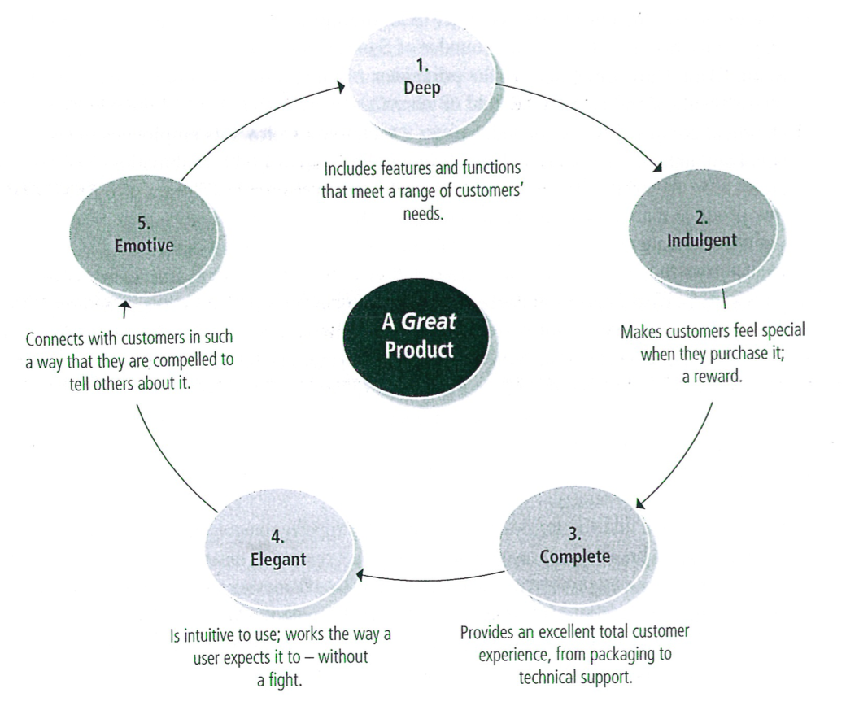
- Place
  - Place or method of distribution has grown in importance as customers expect greater service and more convenience from businesses.
  - One of the forces driving the rapid growth of the internet as a shopping tool
- Price
  - Key factor in the decision to buy
  - Affects both sales volume and profits
  - Non-price competition, such as free trials, delivery, lengthy warranties, and money back guarantees, intends to play down the product’s price and stress its durability, quality, reputation, and special features
- Promotion
  - The goal of promotion is to inform and persuade consumers.
  - Advertising communicates to potential customers through some mass medium the benefits of a good or service

Creating a successful financial plan

Financial management: A process that provides entrepreneurs with relevant financial information in as easy-to-read format on a timely basis; it allows entrepreneurs to know not only how their businesses are doing financially but also why they are performing that way.

To reach profit objectives, entrepreneurs must be aware of their companies’ overall financial position and the changes in financial states that occur over time.

Basic financial statements

Balance sheet: A financial statement that provides a snapshot of a business’s financial position, estimating its worth on a given date; it is built on the fundamental accounting equation: $Assets = Liabilities + Owner’s Equity$
- Current assets: Assets such as cash and other items to be converted into cash within one year, or within a company’s normal operating cycle
- Fixed assets: Assets acquired for long-term use in a business
- Liabilities: Creditor’s claims against a company’s assets
- Current liabilities: Those debts that must be paid within one year or within the normal operating cycle of a company
- Long-term liabilities: Liabilities that come due after one year
- Owner’s equity: The value of the owner’s investment in a business

Income statement (profit and loss (P&L) statement): A financial statement that represents a moving picture of a business, comparing its expenses against its revenue over a period of time to show its net profit or loss
- To calculate net profit or loss, sales revenue for the year must be recorded, which includes all income that flows into the business from sales of goods and services + other sources (rent, investments, interest), in the revenue section of the income statement.
- To determine net sales revenue, owners subtract the value of returned items and refunds from gross revenue.
- Cost of goods sold: The total cost, including shipping, of the merchandise sold during an accounting period.
  - Add purchases to beginning inventory and subtract ending inventory
- $Gross Profit = Net Sales Revenue – Cost of Goods Sold$
- Gross profit margin = Gross Profit / Net Sales Revenue
- Operating expenses: Those costs that contribute directly to the manufacture and distribution of goods
  - General expenses are indirect costs that contribute directly to the manufacture and distribution of goods
- $Total Revenue – Total Expenses = Net Income or Loss$

Statement of cash flows: A financial statement showing the changes in a company’s working capital from the beginning of the year by listing both the sources and the uses of those funds.
- Must assemble the balance sheets and the income statements for present year
- Begin with company net income for the period + the sources of company’s funds (borrowed, contributions, decreases in accounts receivable, increases in accounts payable, decreases in inventory, depreciation, etc.)
  - Depreciation is listed as a source of funds because it is a non-cash expense that has already been deducted as a cost of doing business, and since it has already been paid it is a source of funds.
- Now subtract plant and equipment purchases, dividends, repayment of debt, increases in accounts receivable, decreases in accounts payable, increases in inventory etc.
- This difference between the total sources and the total uses is the increase or decrease in working capital

The projected income statement

When creating pro forma financial statements for a brand new business, an entrepreneur typically relies on published statistics summarizing the operation of similar-size companies in the same industry.

One of the most important tasks is to determine the amount of funding required to begin operations as well as the amount required to keep the company going through its initial growth period.

Financial forecasts must be based in reality. Two options:
- Develop a sales forecast and work down
- Set a profit target and work up

An entrepreneur’s target income is the sum of a reasonable salary for the time spent running the business and a normal return on the amount invested in the company. This target profit must then be translated into net sales figures for the forecasted period.

$$Net profit margin=\frac{Net Profit}{Net Sales}$$

The projected balance sheet

Cash is one of the most useful assets the business owns; it is highly liquid and can quickly be converted into other tangible assets.
A company’s cash balance should cover its operating expenses (less depreciation, non-cash expense) for at least one inventory turnover period.

$$Cash requirements=\frac{cash expenses}{average inventory turnover}$$

$$Average inventory turnover=\frac{cost of goods sold}{inventory level}$$

To complete the projected balance sheet record all of the firm’s liabilities, the claims against its assets.

Ratio analysis: A method of expressing the relationships between any two accounting elements that allows business owners to analyze their companies’ financial performances. There are 12 key ratios:
Liquidity ratios: Tell whether a business will be able to meet its short-term obligations as they come due
- Current ratio: measures a firm’s solvency by indicating its ability to pay current liabilities out of current assets
  - $Current ratio=\frac{current assets}{current liabilities}$
- Quick ratio: A conservative measure of a firm’s liquidity, measuring the extent to which its most liquid assets cover its current liabilities
  - $Quick ratio=\frac{quick assets}{current liabilities}$
Leverage ratios: Measure the financing supplied by a firm’s owners against that supplied by its creditors; they are a gauge of the depth of a company’s debt.
- Debt ratio: Measures the percentage of total assets financed by a company’s creditors compared to its owners
  - $Debt ratio=\frac{total debt (or liabilities)}{total assets}$
- Debt to equity (or net worth) ratio: The relationship between the capital contributions from creditors and those from owners. It measures how highly leveraged a company is.
  - $Debt to equity ratio=\frac{total debt (or liabilities)}{tangible net worth}$
- Times interest earned: Measures a small firm’s ability to make the interest payments on its debt
  - $Times interest earned=\frac{Earnings Before Interest and Taxes (EBIT)}{total interest expense}$
Operating ratios: Help an entrepreneur evaluate a small company’s overall performance and indicate how effectively the business employs its resources
- Average inventory turnover ratio: Measures the number of times its average inventory is sold out, or turned over, during an accounting period
  - $Average inventory turnover ratio=\frac{cost of goods sold}{average inventory}$
- Average collection period ratio (days sales outstanding, DSO): Measures the number of days it takes to collect accounts receivable
  - $Receivables turnover ratio=\frac{credit sales}{accounts receivable}$

  - $Average collection period ratio=\frac{days in accounting period}{receivables turnover ratio}$
- Average payable period ratio (days payable outstanding, DPO): Measures the number of days it takes a company to pay its accounts payable
  - $Payables turnover=\frac{purchases}{accounts payable}$

  - $Average payable period=\frac{days in accounting period}{payable turnover ratio}$
- Total asset turnover ratio (net sales to total assets): Measures a company’s ability to generate sales in relation to its asset base
  - $Total asset turnover ratio=\frac{net sales}{total assets}$
Profitability ratios: Indicate how efficiently a company is being managed
- Net profit on sales ratio: Measures a company’s profit per dollar of sales
  - $Net profit on sales ratio=\frac{net profit}{net sales}$
- Return on assets (ROA, net profit to assets): A ratio that tells how much profit a company generates for each dollar of assets that it owns
  - $Net profit to assets ratio=\frac{net profit}{total assets}$
- Net profit to equity ratio: Measures the owner’s rate of return on investment
  - $Net profit to equity=\frac{net profit}{owner^{'}s equity (or net worth)}$

Interpreting business ratios

Critical numbers: Indicators that measure key financial and operational aspects of a company’s performance; when these numbers are moving in the right direction, a business is on track to reach its objectives

Break-even analysis

Break-even point: The level of operation (sales dollars or production quantity) at which a company neither earns a profit nor incurs a loss.

Fixed expenses: Expenses that do not vary with changes in the volume of sales or production

Variable expenses: Expenses that vary directly with changes in the volume of sales or production

Compute the break-even point:
- Forecast the expenses the business can expect to incur
- Categorize the expenses estimated in (1) into fixed expenses and variable expenses
- Calculate the ratio of variable expenses to net sales
- Compute the break-even point by inserting this information into the following formula
  - $Break even sales\left(\$\right)=\frac{total fixed cost}{contribution margin expressed as a percentage of sales}$

Adding a profit

$$Sales \left(\$\right)=\frac{total fixed expenses+desired net income}{contribution margin expressed as a percentage of sales}$$

Break-even point in units

$$Break even volume=\frac{total fixed costs}{sales price per unit-variable cost per unit}$$

$$Contribution margin=price per unit-variable cost per unit$$

$$break even volume \left(units\right)=\frac{total fixed costs}{per unit contribution margin}$$

$$Sales \left(units\right)=\frac{total fixed cost+desired net income}{per unit contribution margin}$$

