Finance

Contents
CHAPTER 1 – What is Economics? 1
What is economics? 1
Opportunity Cost 1
The Four Resources 1
Microeconomics and Macroeconomics 2
Methods of Economics 2
CHAPTER 2 – Scarcity, Choice, and Economic Systems 4
Society’s Production Choices 4
Increasing Opportunity Cost 5
Productive Inefficiency 5
Economic Growth 6
Consumption vs. Growth 7
Economic Systems 8
Comparative Advantage 9
International Comparative Advantage 9
Resource Allocation 10
Chapter 3 - Supply and Demand 11
Markets 11
Characterizing a Market 11
Demand 11
Supply 15
Putting Supply and Demand Together 19
The Three-Step Process 22
Chapter 4 – Working with Supply and Demand 23
Chapter 5 – Creating and Pricing Products 35
Product life cycle: The typical set of phases that a product experiences over its lifetime. 35
Target market 35
Factors that affect the size of a target market 35
Steps necessary to create a new product: 36
Product Differentiation 36
Pricing Strategies 36
Additional Pricing Decisions 37
Chapter 6 – Distributing Products 38
Factors that determine the optimal channel of distribution: 39
Market Coverage 39
Transportation used to Distribute Products 40
40
Accelerate the Distribution Process 40
Characteristics of Retailers 41
Services Offered by Wholesalers 41
How Wholesalers Serve Retailers 41
Vertical Channel Integration 42
Chapter 7 – Promoting Products 43
Optimal Promotion Mix 45
Chapter 8 – Accounting and Financial Analysis 47
Responsible Financial Reporting 48
Financial Statements 48
Chapter 9 – Financing 52
Types of business loans 53
Common creditors that provide debt financing 54
Equity Financing 54
Retaining earnings 54
Issuing stock 54
Going Public 55
Securities 56
Other methods of obtaining funds 56
Capital structure 56
Remedies for debt problems 56

CHAPTER 1 – What is Economics?

What is economics?
Economics is a social science that seeks to explain something about society.
- Economics is the study of choice under conditions of scarcity
  - Scarcity: A situation in which the amount of something available is insufficient to satisfy the desire for it.
As individuals we face a scarcity of time and spending power. Given more of either, we could each have more of the goods and services that we desire.

Opportunity Cost
The opportunity cost of any choice is what we must forego when we make that choice.
When the alternatives to a choice are mutually exclusive, only the next best choice, the one that would actually be chosen, is used to determine the opportunity cost of the choice.
Explicit cost: The money sacrificed, and actually paid out, for a choice
Implicit cost: The value of something sacrificed when no direct payment is made.
Foregone income: Sacrificing income that could have been incurred.
The opportunity cost of a choice includes both explicit and implicit costs.
The explicit cost of a choice may only be a part, and something a small part, of the opportunity cost of a choice.

The Four Resources
Resources: The labor, capital, land (including natural resources), and entrepreneurship that are used to produce goods and services.
- Labor: The time human beings spend producing goods and services.
- Capital: A long-lasting tool that is used to produce other goods.
  - Physical capital: The part of the capital stock consisting of physical goods, such as machinery, equipment, and factories.
  - Human capital: The skills and training of the labor force.
    - They are produced (through education and training), they produce other things, and they last for many years.
      - Neither satisfy the definition of capital if it isn’t long-lasting.
  - Capital stock: The total amount of capital in a nation that is productively useful at a particular point in time.
- Land: The physical space on which production takes place, as well as the natural resources that come with it.
- Entrepreneurship: The ability and willingness to combine the other resources: labor, capital, and land into a productive enterprise.
- Input: Anything, including a resource, used to produce a good or service.
  - Resources vs. Inputs: An input is anything used to make a good or service, including not only resources but also many other things made from them like: cement, rolled steel, electricity, etc. These are in turn used to make goods and services. Resources are the special inputs that fall into one of 4 categories: labor, land, capital, entrepreneurship. They are the ultimate source of everything that is produced.
Virtually all production carries an opportunity cost: To produce more of one thing, society must shift resources away from producing something else.

Microeconomics and Macroeconomics
Microeconomics: The study of the behavior of individual households, firms, and governments; the choices they make; and their interaction in specific markets.
Macroeconomics: The study of the behavior of the overall economy.
Positive economics: The study of how the economy works.
Normative economics: The practice of recommending policies to solve economic problems.
Policy differences among economists arise from
- Positive disagreements (about the outcomes of different policies)
- Differences in values (how those outcomes are evaluated).

Methods of Economics
Model: An abstract representation of reality. A model represents reality by abstracting or taking from the real world. By including some, but not all, of the details of the real world, a model helps us understand the world more clearly. A model should be as simple as possible to accomplish its purpose.
Simplifying assumption: Any assumption that makes a model simpler without affecting any of its important conclusions.
Critical assumption: Any assumption that affects the conclusions of a model in an important way.
$$Slope of a straight line=\frac{Change in vertical variable}{Change in horizontal variable} or \frac{Δy}{Δx}$$
$$Linear Equations: Y=a+bX$$

CHAPTER 2 – Scarcity, Choice, and Economic Systems

Society’s Production Choices
The opportunity cost of having more of one good is measured in the units of the other good that must be sacrificed.
Table 1
Choice | Tank Production  (number per year) | Wheat Production  (bushels per year)
A | 0 | 1,000,000
B | 1,000 | 950,000
C | 2,000 | 850,000
D | 3,000 | 700,000
E | 4,000 | 400,000
F | 5,000 | 0

Production possibilities frontier (PPF): A curve showing all combinations of two goods that can be produced with the resources and technology currently available.

Figure 1

Increasing Opportunity Cost
According to the law of increasing opportunity cost, the more of something we produce, the greater the opportunity cost of producing even more of it.
The law of increasing opportunity cost causes the PPF to have a concave shape, becoming steeper as we move rightward and downward. This is because the slope of the PPF, $\frac{change in quantity of wheat}{change in quantity of tanks}$, can be interpreted as the change in wheat per additional tank.
The law of increasing opportunity cost applies both ways, that is: the opportunity cost of producing more wheat increases as we produce more of it.
The reason for increasing opportunity cost = Because most resources, by their very nature, are better suited to some purposes than to others.
The principle of increasing opportunity cost applies to most of society’s production choices. The more of something we produce, the greater the opportunity cost of producing still more.

Productive Inefficiency
Productively inefficient: A situation in which more of at least one good can be produced without sacrificing the production of any other good. Operating inside the PPF.
A firm, an industry, or an entire economy is productively inefficient if it could produce more of at least one good without producing less of any other good.
Productive efficiency: The absence of any productive inefficiency.
Recessions: Another reason an economy might operate inside the PPF and thus be productively inefficient.

Economic Growth
Figure 2

Figure 3

Figure 4

A technological change or an increase in resources, even when the direct impact is to increase production of just one type of good, allows us to choose greater production of all types of goods.

Consumption vs. Growth
Figure 5

Figure 6

The more capital we produce this year, the more capital we’ll have in the future to produce other things. The trade-off: Any resources used to produce capital this year are not being used to produce consumer goods and other things that we can enjoy right now.
In order to produce more goods and services in the future, we must shift resources towards R&D and capital production, and away from producing things we’d enjoy right now.

Economic Systems
Specialization: A method of production in which each person concentrates on a limited number of activities.
Exchange: The act of trading with others to obtain what others desire.
Specialization and exchange enable us to enjoy greater production and higher living standards than would otherwise be possible. As a result, all economies exhibit high degrees of specialization and exchange.
The gains from specialization and exchange come from:
- Development of Expertise
- Minimizing Downtime
- Comparative Advantage

Comparative Advantage
Table 2
 | Labor Required For:
 | 1 Fish | 1 Cup of Berries
Maryanne | 1 hour | 1 hour
Gilligan | 3 hours | 1 ½ hours
Absolute Advantage | Maryanne | Maryanne
Comparative Advantage | Maryanne | Gilligan

Table 3
 | Change In Fish Production | Change In Berry Production
Maryanne | +1 | -1
Gilligan | -1 | +2
Total Island | +0 | +1

Absolute advantage: The ability to produce a good or service, using fewer resources than other producers use.
Comparative advantage: The ability to produce a good or service at a lower opportunity cost than other producers.
Total production of every good or service will be greatest when individuals specialize according to their comparative advantage.

International Comparative Advantage
A nation has a comparative advantage in producing a good if it can produce it at a lower opportunity cost than some other nation.

Table 4
 | Labor Required For:
 | 1 Bushel of Soybeans | 1 T-Shirt
United States | ½ hour | ¼ hour
China | 5 hours | 1 hour
Absolute Advantage | US | US
Comparative Advantage | US | China

Table 5
 | Soybeans (Bushels) | T-Shirts
United States | +10 | -20
China | -8 | +40
Total World Production | +2 | +20

Total production of every good or service is greatest when nations shift production toward their comparative advantage goods and trade with each other.

Resource Allocation
Deciding how society’s scarce resources will be divided among competing claims and desires:
- Which goods and services should be produced with society’s resources?
- How would they be produced?
- Who should get them?
Traditional Economy: An economy in which resources are allocated according to long-lived practices from the past.
Command or Centrally Planned Economy: An economic system in which resources are allocated according to explicit instructions from a central authority.
Market Economy: An economic system in which resources are allocated through individual decision making.
Market: A group of buyers and sellers with the potential to trade with each other.
Price: The amount of money that must be paid to a seller to obtain a good or service.
When resources are allocated by the market, and people must pay for their purchases, they are forced to consider the opportunity cost to society of the goods that they consume. In this way, markets help to create a sensible allocation of resources.
Market economies = market capitalism.
Capitalism: An economic and political system in which a country’s trade and industry are controlled by private owners for profit, rather than by the state.
Socialism: A political and economic theory of social organization that advocates that the means of production, distribution, and exchange should be owned or regulated by the community as a whole.
Mixed Economy: A market economy in which the government also plays an important role in allocating resources.

Chapter 3 - Supply and Demand

Supply and Demand is an economic model, designed to explain how prices are determined in certain types of markets.

Markets
A market is a group of buyers and sellers with the potential to trade with each other.

Characterizing a Market

Broad vs Narrow Definition
Macro vs Micro
Aggregation: The process of combining distinct things into a single whole.
In economics, markets can be defined broadly or narrowly, depending on our purpose.
Circular flow: A simple model that shows how goods, resources, and dollar payments flow between households and firms.
Product markets: Markets in which firms sell goods and services to households.
Resource markets: Markets in which households that own resources sell them to firms.
Competitive market: (Perfectly competitive market) A market in which no buyer or seller has the power to influence the price
In perfectly competitive markets (or just competitive markets), each buyer and seller takes the market price as a given.
The supply and demand model is designed to show how prices are determined in perfectly competitive markets.

Demand
Quantity demanded: The quantity of a good that all buyers in a market would choose to buy during a period of time, given their constraints.
- Quantity Demanded implies a choice
  - Not about needs and desires, but about how much households would choose to buy when they take into account the opportunity cost of their decisions.
- Quantity Demanded is hypothetical
  - Makes no assumptions about the availability of the good.
- Quantity Demanded depends on price
Law of demand: As the price of a good increases, the quantity demanded decreases.
The law of demand states that when the price of a good rises and everything else remains the same, the quantity of the good demanded will fall.
Ceteris paribus: All else remaining the same.
Demand schedule: A list showing the quantities of a good that consumers would choose to purchase at different prices, with all other variables held constant.
Demand curve: A graph of a demand schedule; a curve showing the quantity of a good or service demanded at various prices, with all other variables held constant.
The demand curve shows the relationship between the price of a good and the quantity demanded in the market, holding constant all other variables that influence demand. Each point on the curve shows the total quantity that buyers would choose to buy at a specific price.
Figure 7

A change in the price of a good causes a movement along the demand curve.
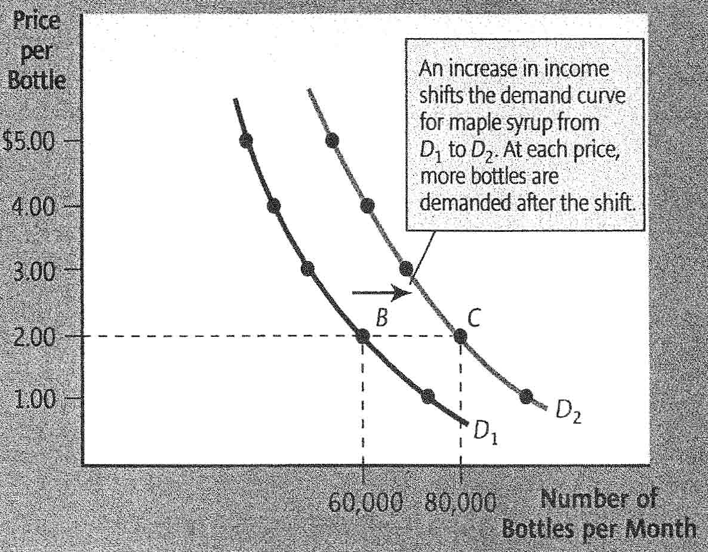
A change in any variable that affects demand, except for the good’s price, causes the demand curve to shift.
Change in quantity demanded: A movement along a demand curve in response to a change in price.
Change in demand: A shift of a demand curve in response to a change in some variable other than price.
Income: The amount that a person or firm earns over a particular period.
Normal good: A good that people demand more of as their income rises.
Inferior good: A good that people demand less of as their income rises.
Wealth: The total value of everything a person or firm owns, at a point in time, minus the total amount owed.
A rise in income will increase the demand for a normal good, and decrease the demand for an inferior good.
An increase in wealth will increase demand (shift the curve rightward) for a normal good, and decrease demand (shift the curve leftward) for an inferior good.
Substitute: A good that can be used in place of some other good and that fulfills more or less the same purpose.
Complement: A good that is used together with some other good.
A rise in the price of a substitute increases the demand for a good, shifting the demand curve to the right.
A rise in the price of a complement decreases the demand for a good, shifting the demand curve to the left.
In many markets, an expectation that price will rise in the future shifts the current demand curve rightward, while an expectation that price will fall shift the current demand curve leftward.
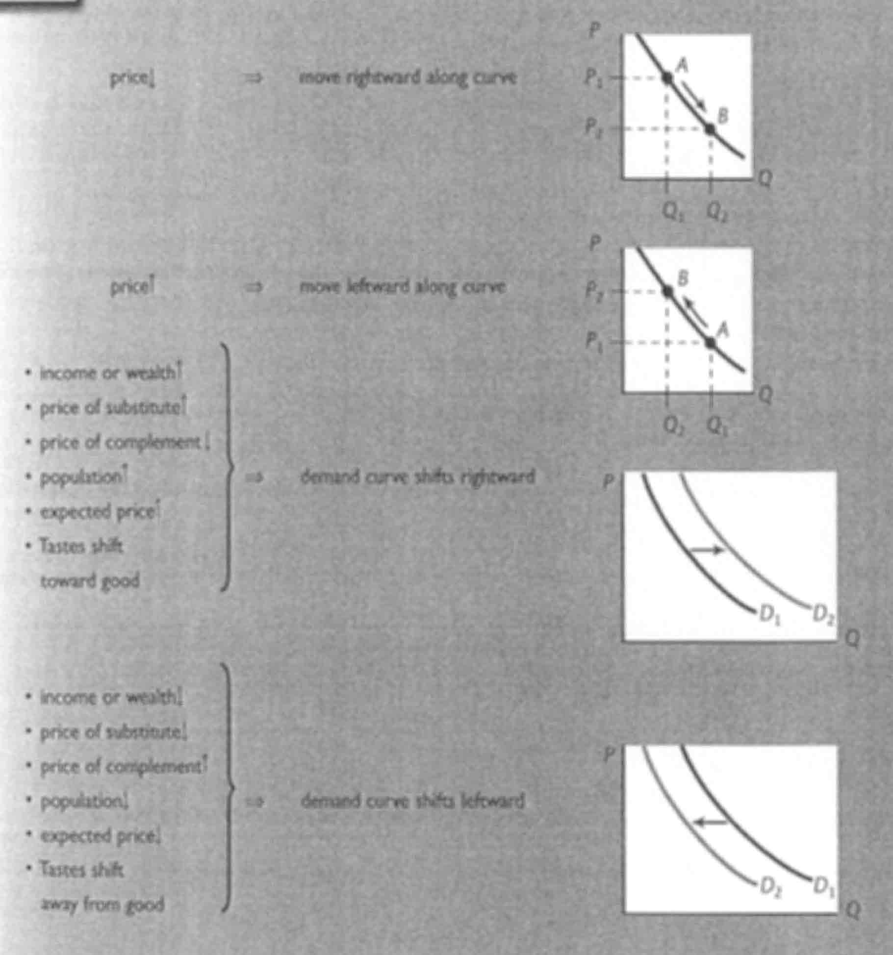

Supply
Quantity supplied: The specific amount of a good that all sellers in a market would choose to sell over some time period, given their constraints.
- Quantity supplied implies a choice
  - The quantity that firms choose to sell, the quantity that gives them the highest profit given the constraints they face.
- Quantity supplied is hypothetical
- Quantity supplied depends on price
Law of supply: As the price of a good increases, the quantity supplied increases.
The law of supply states that when the price of a good rises, and everything else remains the same, the quantity of the good supplied will rise.
Supply schedule: A list showing the quantities of a good or service that firms would choose to produce and sell at different prices, with all other variables held constant.
Supply curve: A graph of a supply schedule, showing the quantity of a good or service supplied at various prices, with all other variables held constant.
The supply curve shows the relationship between the price of a good and the quantity supplied in the market, holding constant the values of all other variables that affect supply. Each point on the curve shows the quantity that sellers would choose to sell at a specific price.
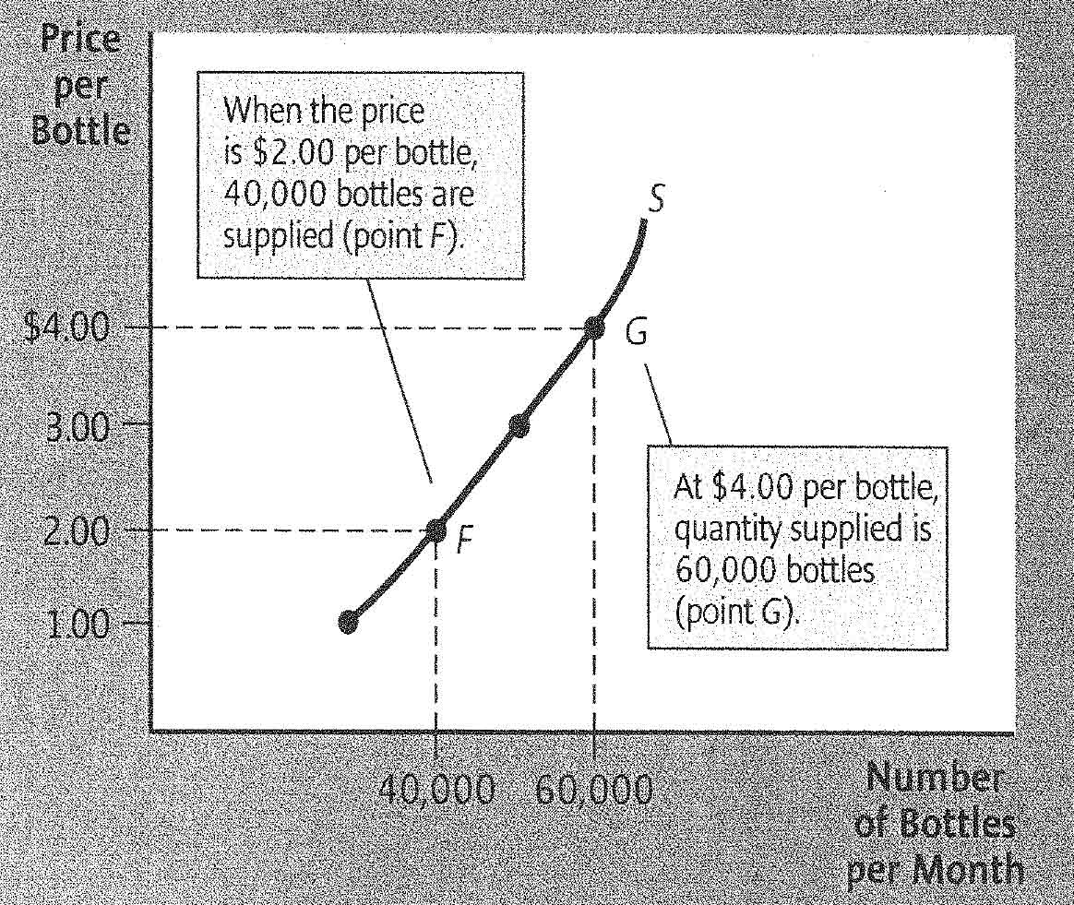
A change in the price of a good causes a movement along the supply curve.
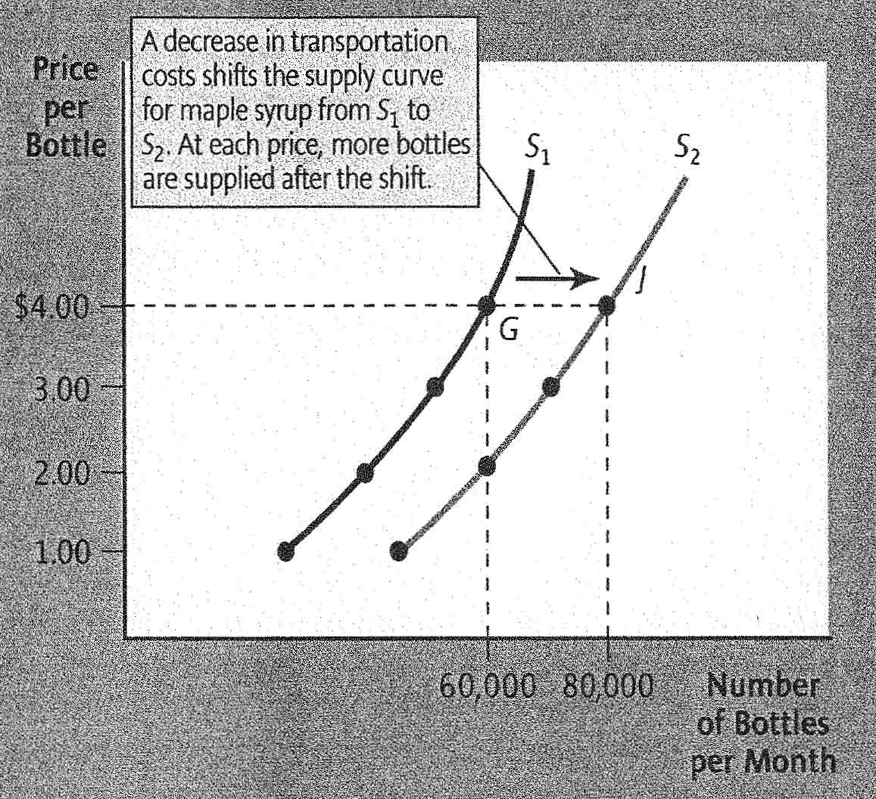
A change in any variable that affect supply, except for the good’s price, causes the supply curve to shift.
Change in quantity supplied: A movement along a supply curve in response to a change in price.
Change in supply: A shift of a supply curve in response to a change in some variable other than price.
A fall in the price of an input causes an increase in supply, shifting the supply curve to the right.
Alternative goods: Other goods that firms in a market could produce instead of the good in question.
Alternative market: A market other than the one being analyzed in which the same good could be sold.
When the price for an alternative rises, either an alternate good or the same good in an alternate market, the supply curve shifts leftward.
Cost-saving technological advances increase the supply of a good, shifting the supply curve to the right.
An increase in the number of sellers, with no other change, shift the supply curve rightward.
In many markets, an expectation of a future price rise shifts the current supply curve leftward. Similarly, an expectation of a future price drop shifts the current supply curve rightward.
Favorable weather increases crop yields, and causes a rightward shift of the supply curve for that crop. Unfavorable weather destroys crops and shrinks yields, and shifts the supply curve leftward.
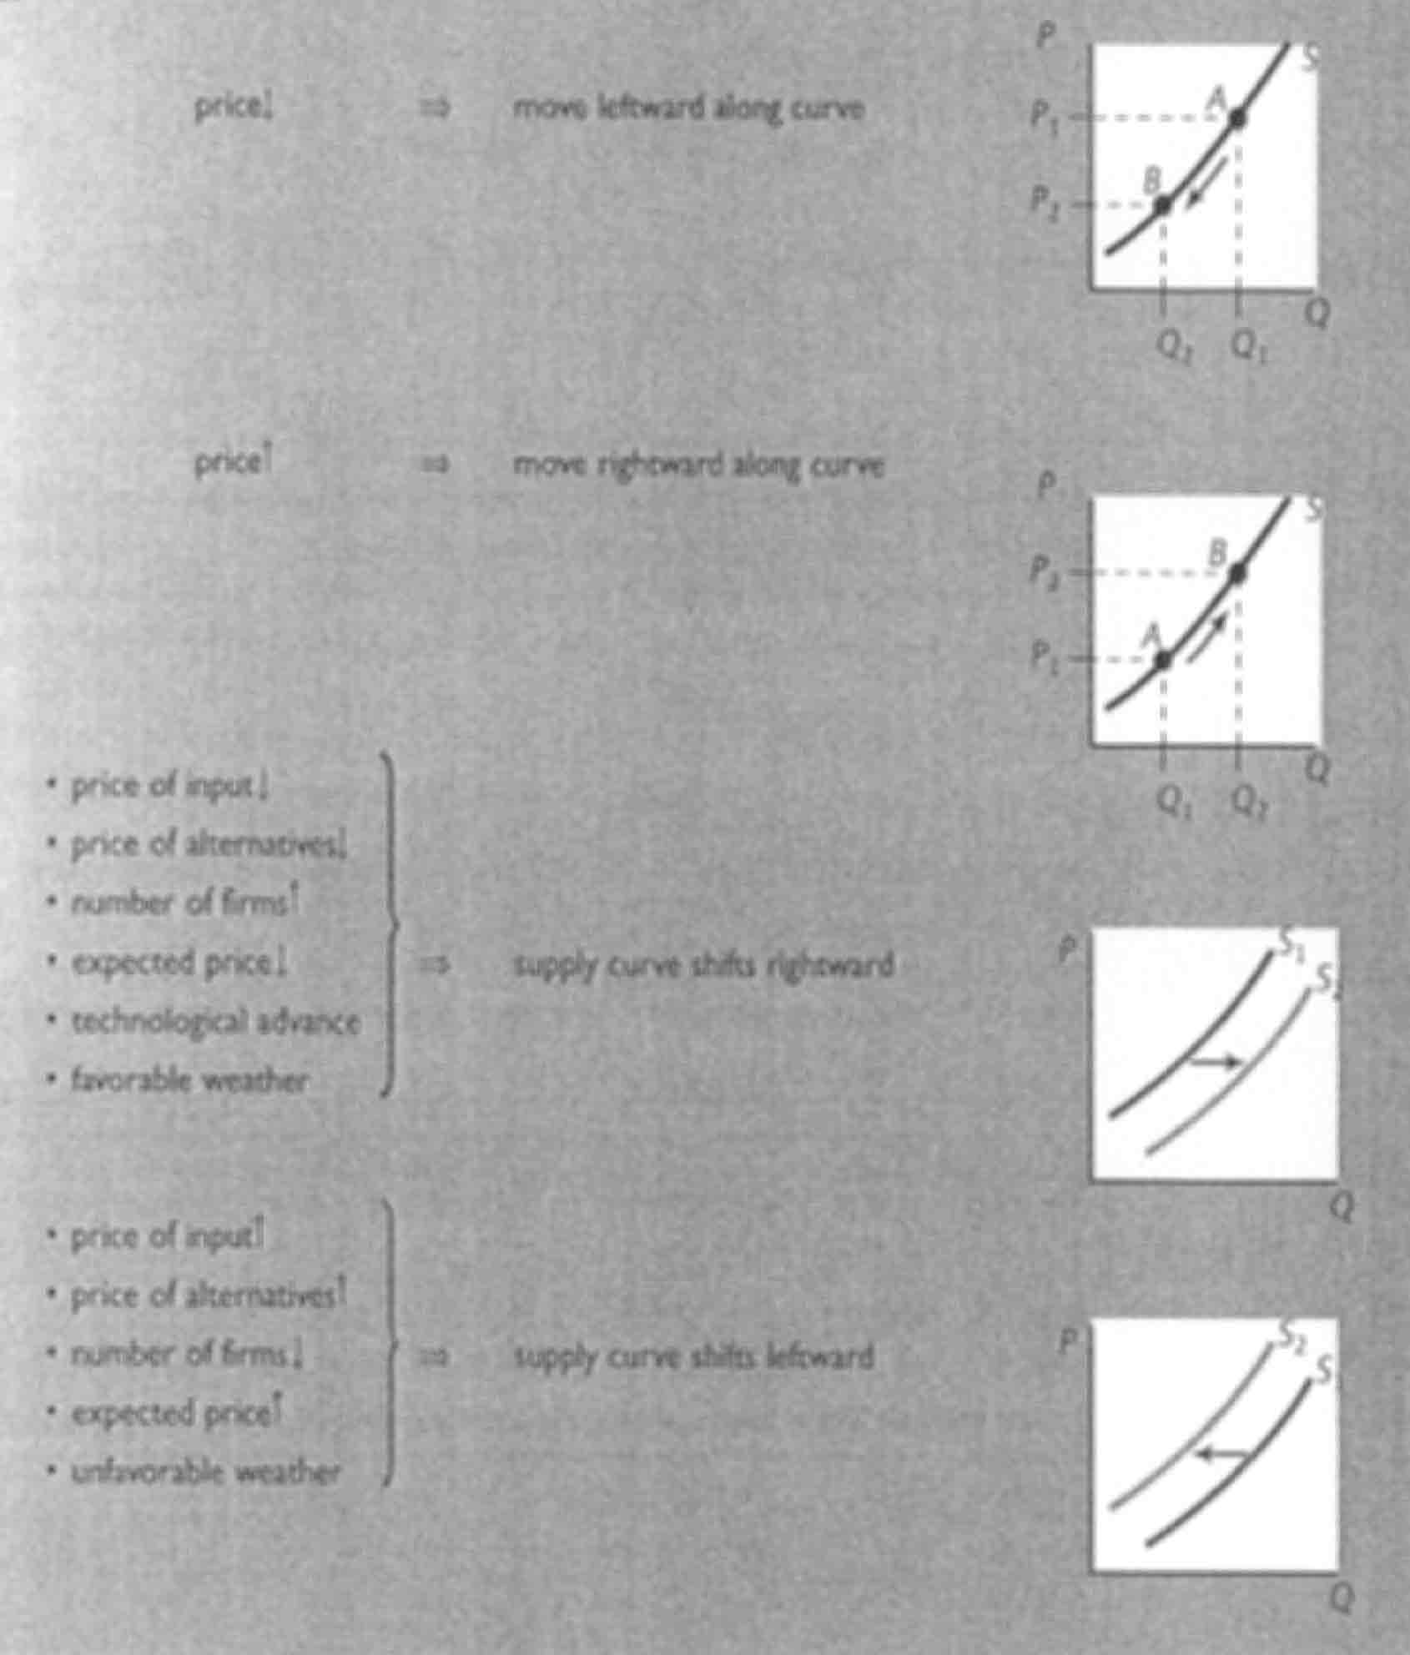

Putting Supply and Demand Together
Equilibrium price: The market price that, once achieved, remains constant until either the demand curve or supply curve shifts.
Equilibrium quantity: The market quantity bought and sold per period that, once achieved, remains constant until either the demand curve or supply curve shifts.
The equilibrium price and equilibrium quantity are values for price and quantity in the market that, once achieved, will remain constant, unless and until the supply curve or the demand curve shifts.
Excess demand: At a given price, the amount by which quantity demanded exceeds quantity supplied.
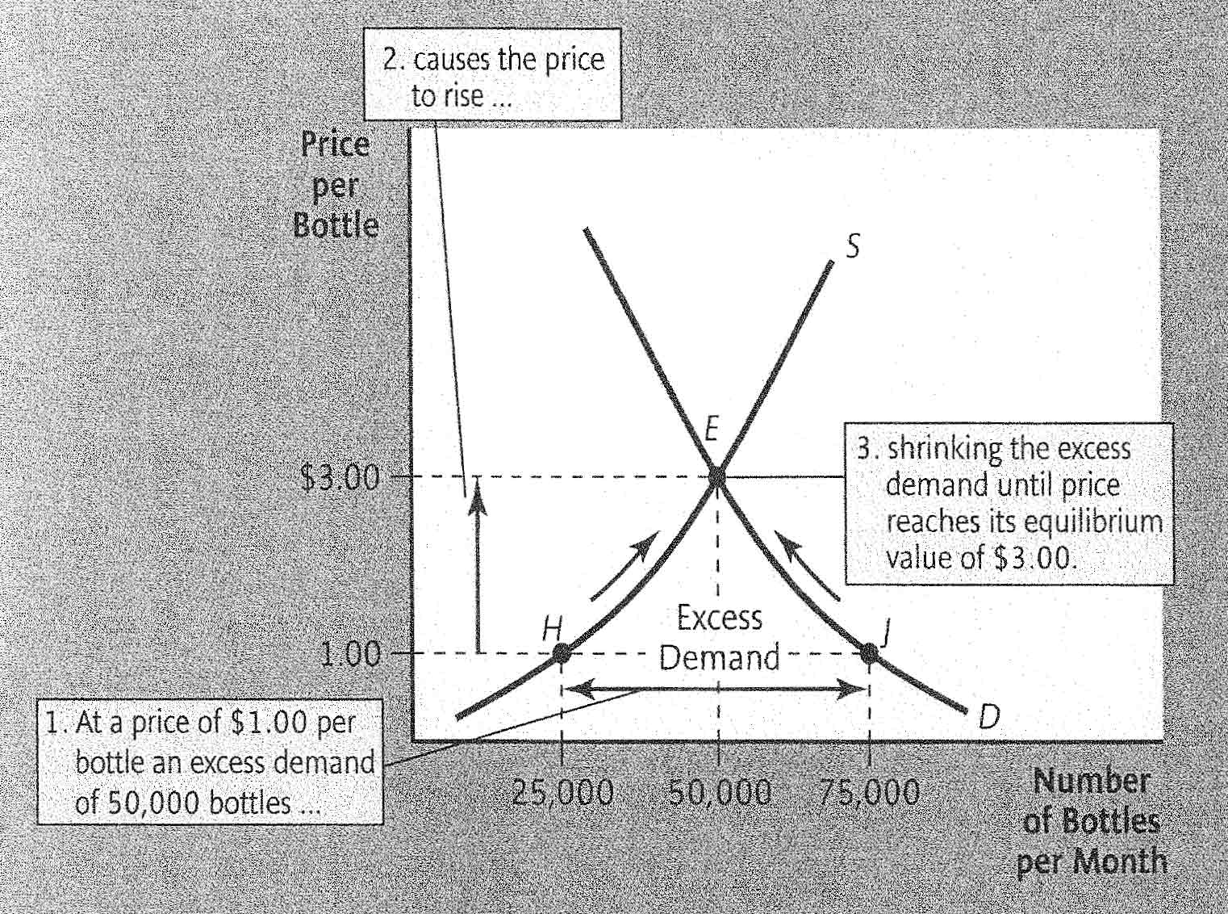

Excess supply: At a given price, the amount by which quantity supplied exceeds quantity demanded.
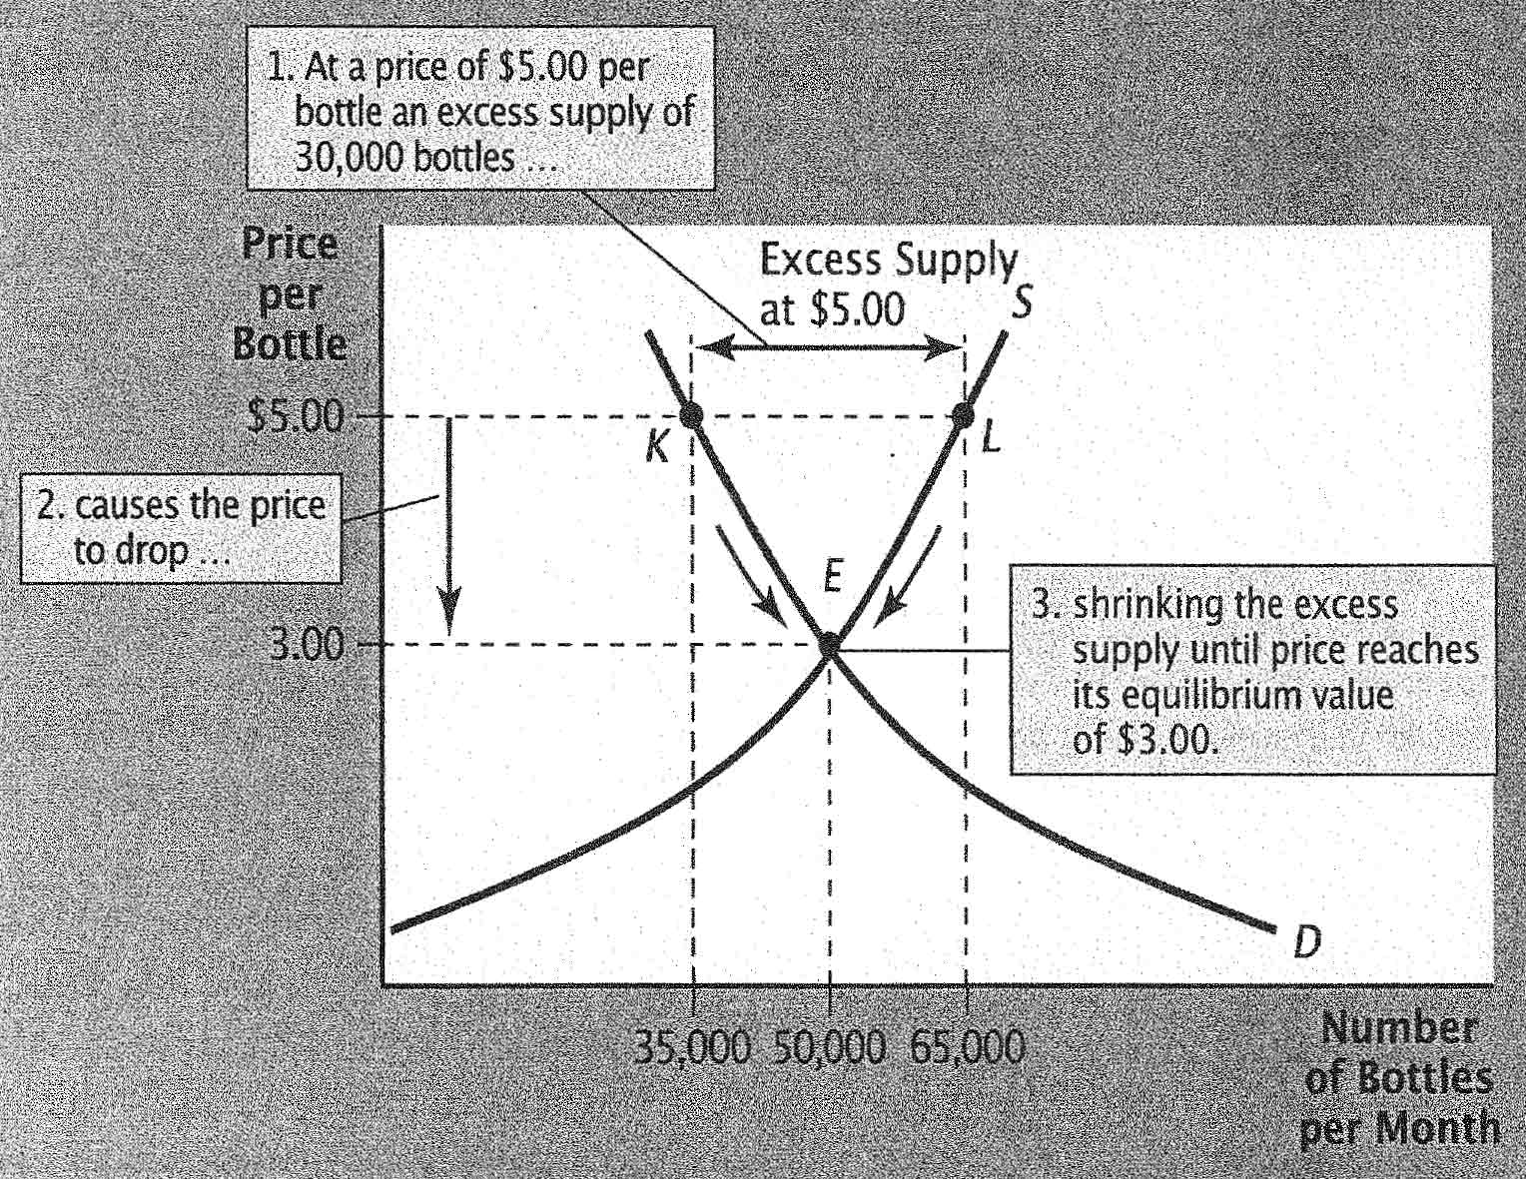
To find the equilibrium in a competitive market, draw the supply and demand curves. Market equilibrium occurs where the two curves cross. At this crossing point, the equilibrium price is found on the vertical axis, and the equilibrium quantity on the horizontal axis.
A rightward shift in the demand curve causes a rightward movement along the supply curve. Equilibrium price and equilibrium quantity both rise.
A leftward shift of the supply curve causes a leftward movement along the demand curve. Equilibrium price rises, but equilibrium quantity falls.

The Three-Step Process
Step 1 - Characterize the Market: Decide which market or markets best suit the problem being analyzed, and identify how trading occurs in that market.
Step 2 – Find the Equilibrium: Describe the conditions necessary for equilibrium in the market, and a method for determining that equilibrium.
Step 3 – What happens when things change: Explore how events or government policies change the market equilibrium.

Chapter 4 – Working with Supply and Demand

Price ceiling: A government-imposed maximum price in a market.
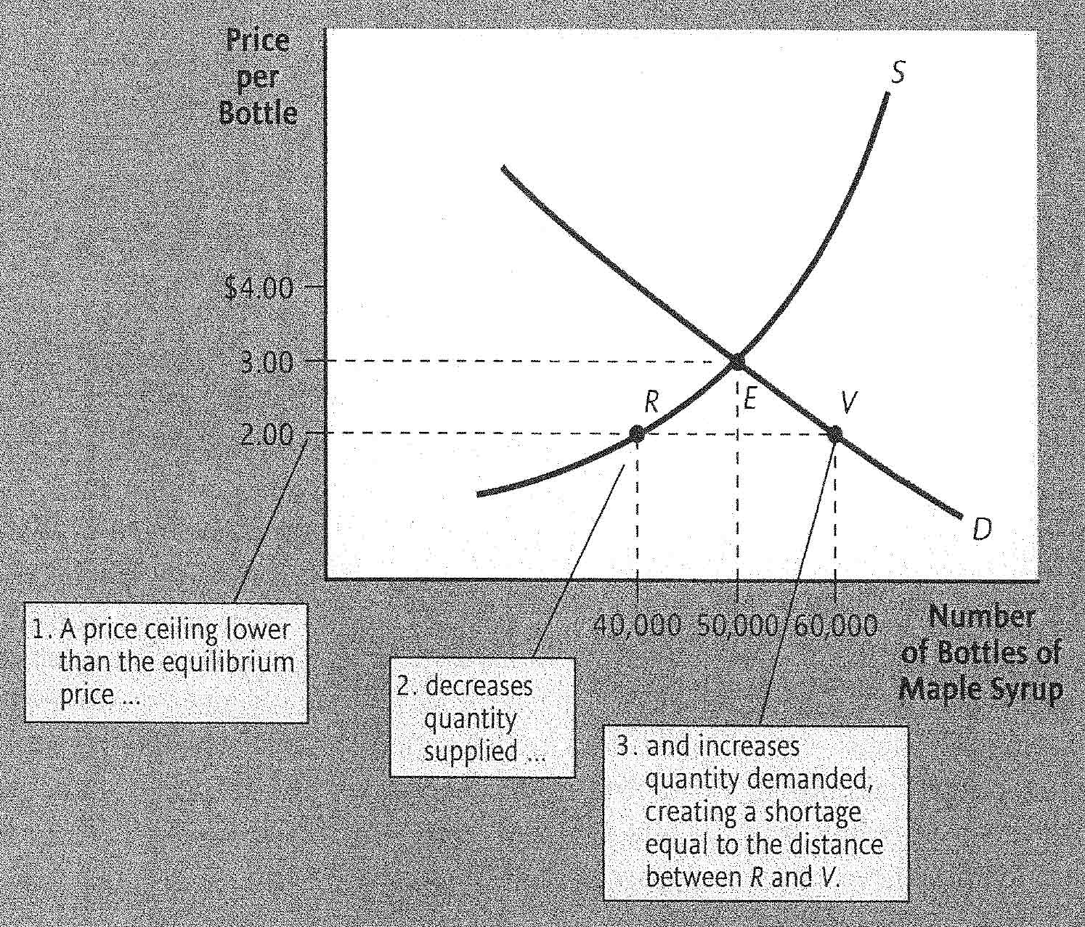
Short side of the market: The smaller of quantity supplied and quantity demanded at a particular price.
Shortage: An excess demand not eliminated by a rise in price, so that quantity demanded continues to exceed quantity supplied.
When quantity supplied and quantity demanded differ, the short side of the market, whichever of the two quantities is smaller, will prevail.
Black market: A market in which goods are sold illegally at a price above the legal ceiling.
A price ceiling creates a shortage and increases the time and trouble required to buy the good. While the price decreases, the opportunity cost may rise.
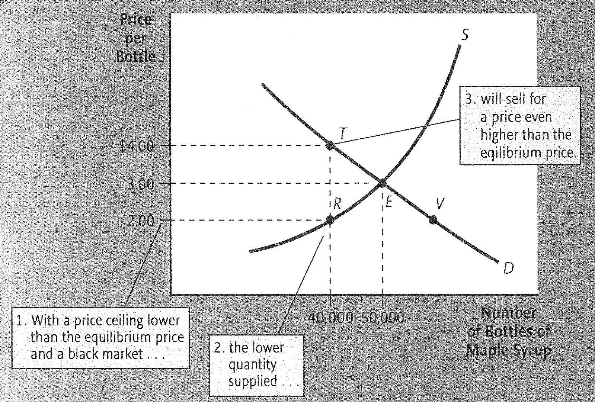
Rent controls: Government imposed maximum rents on apartments and homes.
Price floor: A government-imposed minimum price in a market.
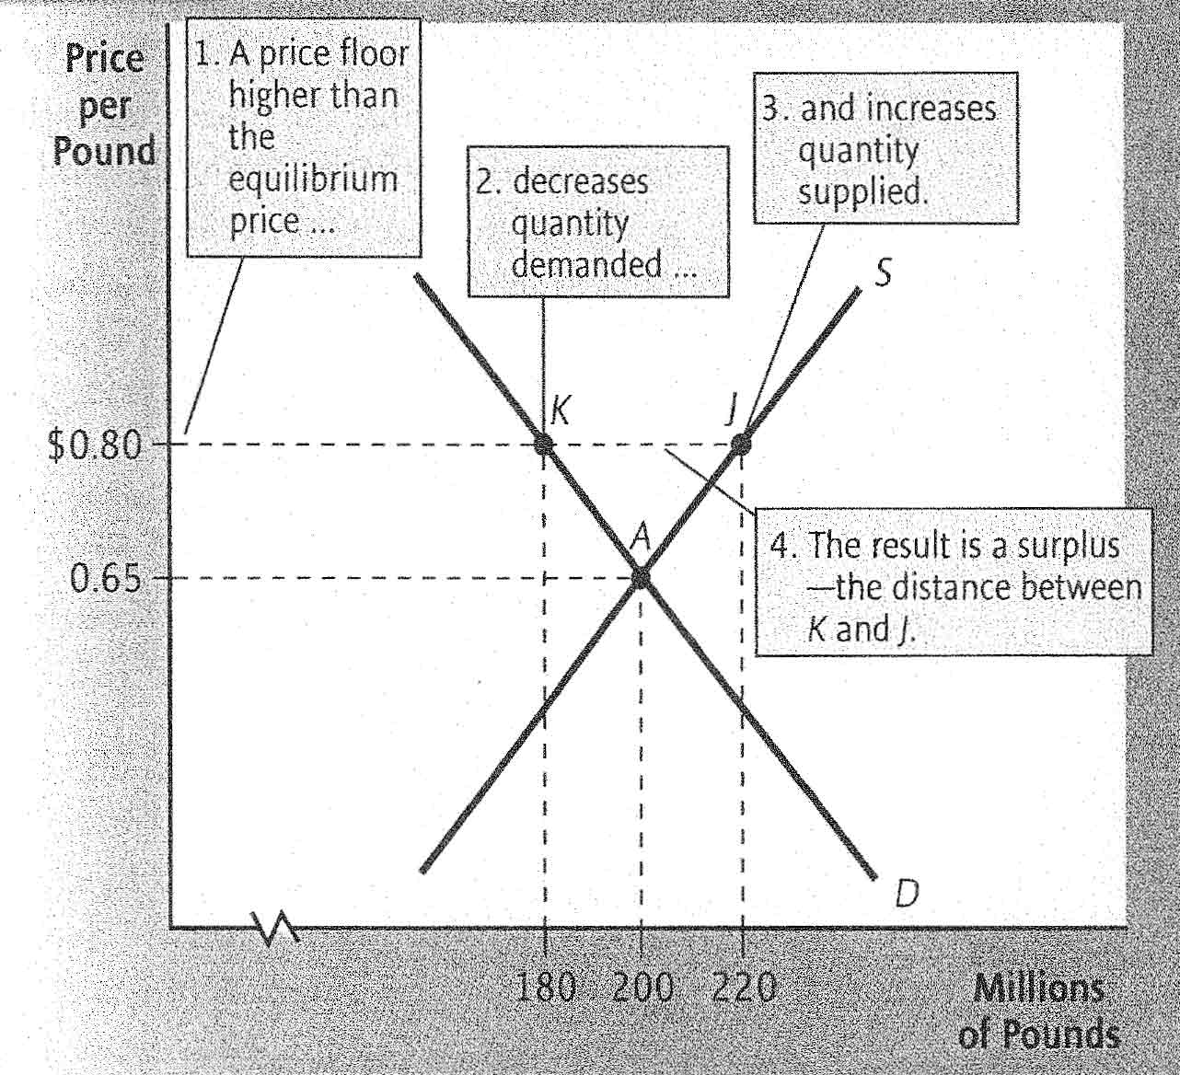

Surplus: An excess supply not eliminated by a fall in price, so that quantity supplied continues to excess quantity demanded.
A price floor creates a surplus of a good. In order to maintain the price floor, the government must prevent the surplus from driving down the market price. In practice, the government often accomplishes this goal by purchasing the surplus itself.
Excise tax: A tax on a specific good or service.
A tax collected from sellers shifts the supply curve upward by the amount of the tax.
Tax incidence: The division of a tax payment between buyers and sellers, determined by comparing the new (after tax) and old (pretax) market equilibriums.
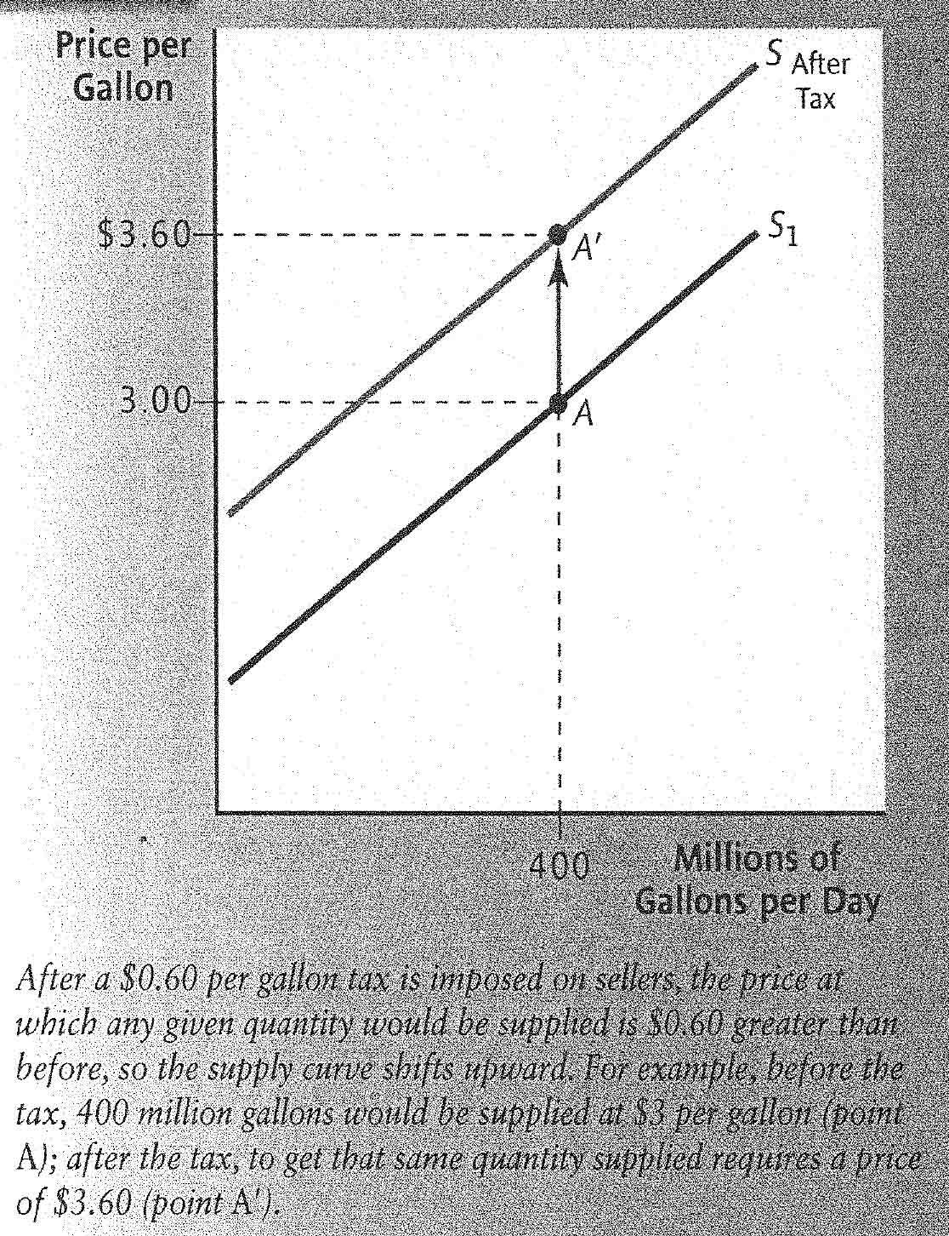
Figure 8 A tax on sellers shift the supply curve upward

–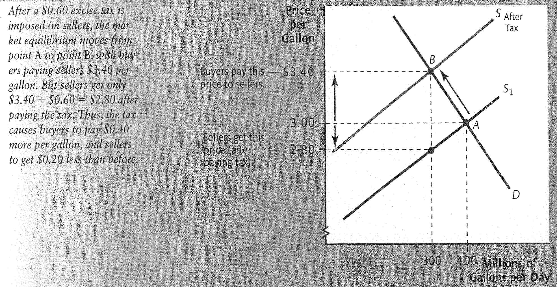
Figure 9 The effect of an excise tax imposed on sellers
The incidence of a tax that is collected from sellers generally falls on both sides of the market. Buyers pay more and sellers receive less, for each unit sold.
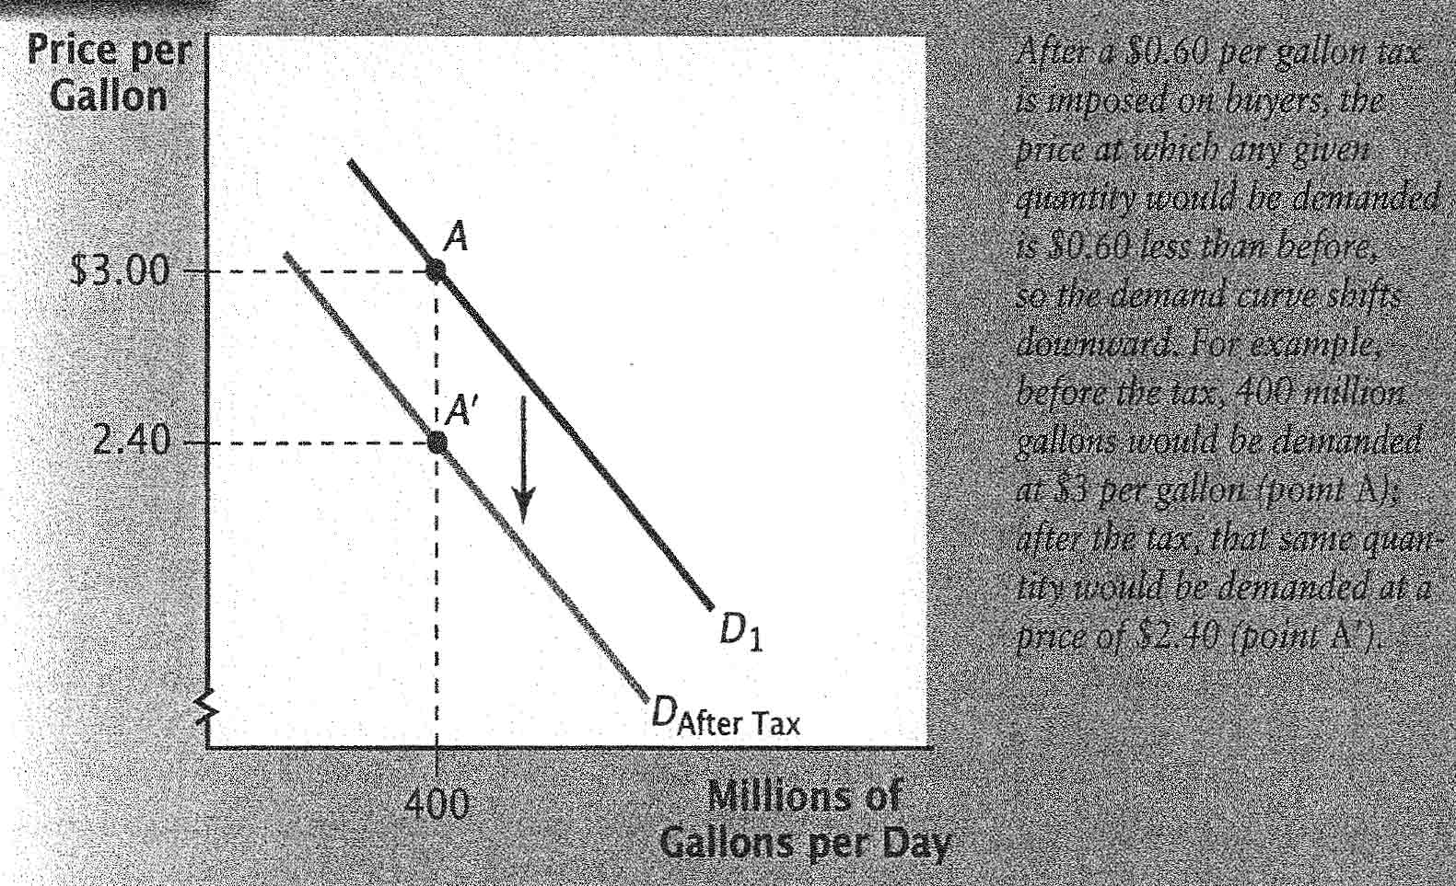
Figure 10 A tax on buyers shift the demand curve downward
A tax collected from buyers shifts the demand curve downward by the amount of the tax.
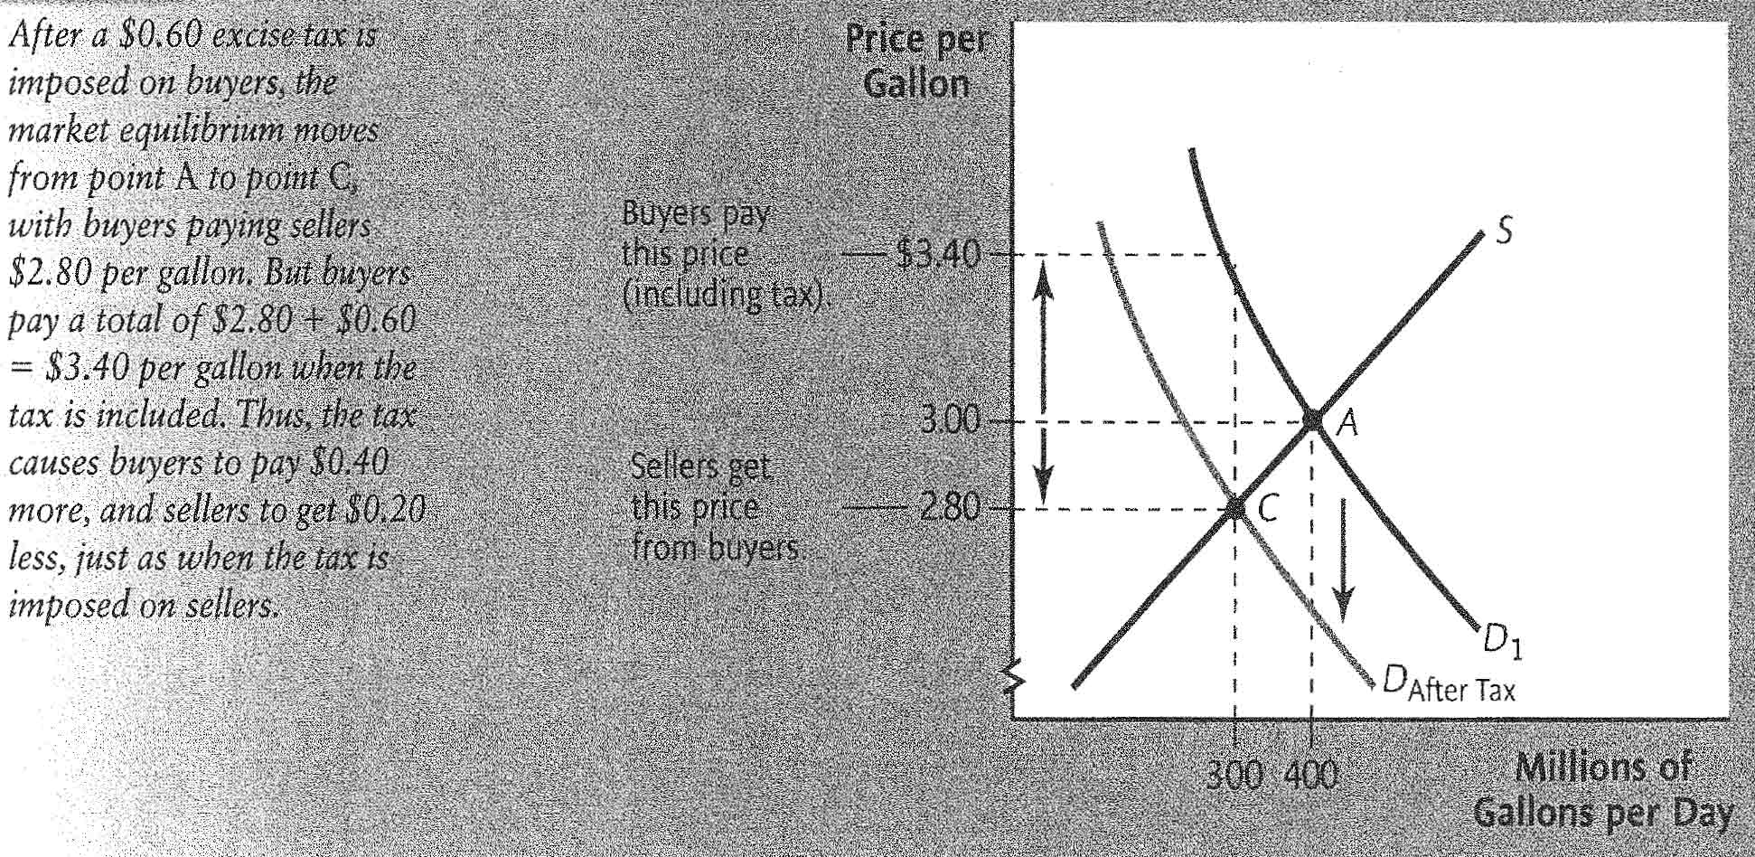
Figure 11 The effect of an excise tax imposed on buyers
The incidence of a tax that is collected from buyers falls on both sides of the market. Buyers pay more, and sellers receive less, for each unit sold.
The incidence of a tax (the distribution of the burden between buyers and sellers) is the same whether the tax is collected from buyers or sellers.
Subsidy: A government payment to buyers or sellers on each unit purchased or sold.
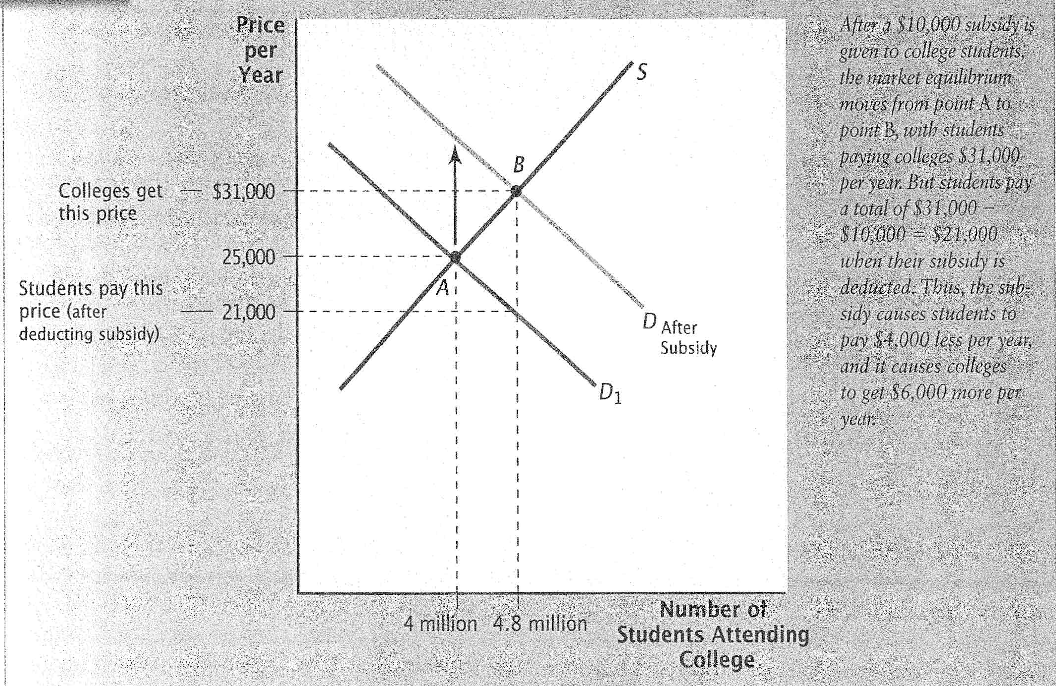
Figure 12 A subsidy for students attending college
A subsidy paid to buyers shifts the demand curve upward by the amount of the subsidy.
A subsidy paid to buyers benefits both sides of a market. Buyers pay less and sellers receive more for each unit sold.
The distribution of benefits from a subsidy is the same, regardless of whether the subsidy is paid to buyers or sellers.
Stock variable: A variable representing a quantity at a moment in time.
Flor variable: A variable representing a process that takes place over some time period.
A stock variable measures a quantity at a moment in time. A flow variable measures a process that takes place over a period of time.
Supply curve for housing: A vertical line showing the total number of homes in a market that are available for ownership. The housing stock.
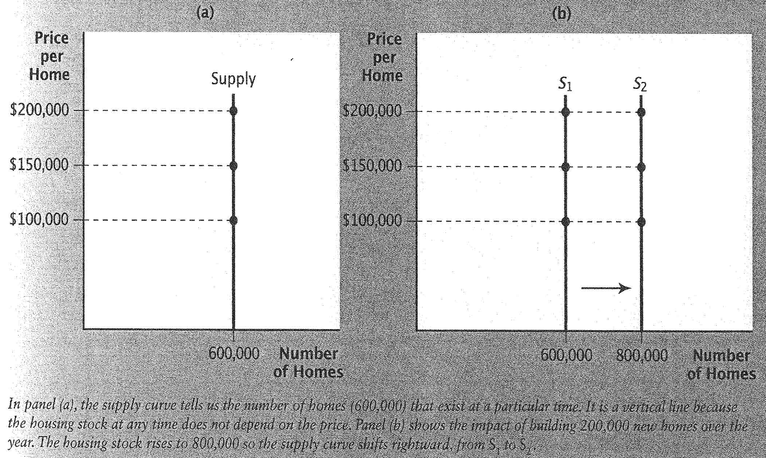
Figure 13 The supply curve in a housing market

Demand curve for housing: A curve showing, at each price, the total number of homes that everyone in the market would like to own, given the constraints that they face.
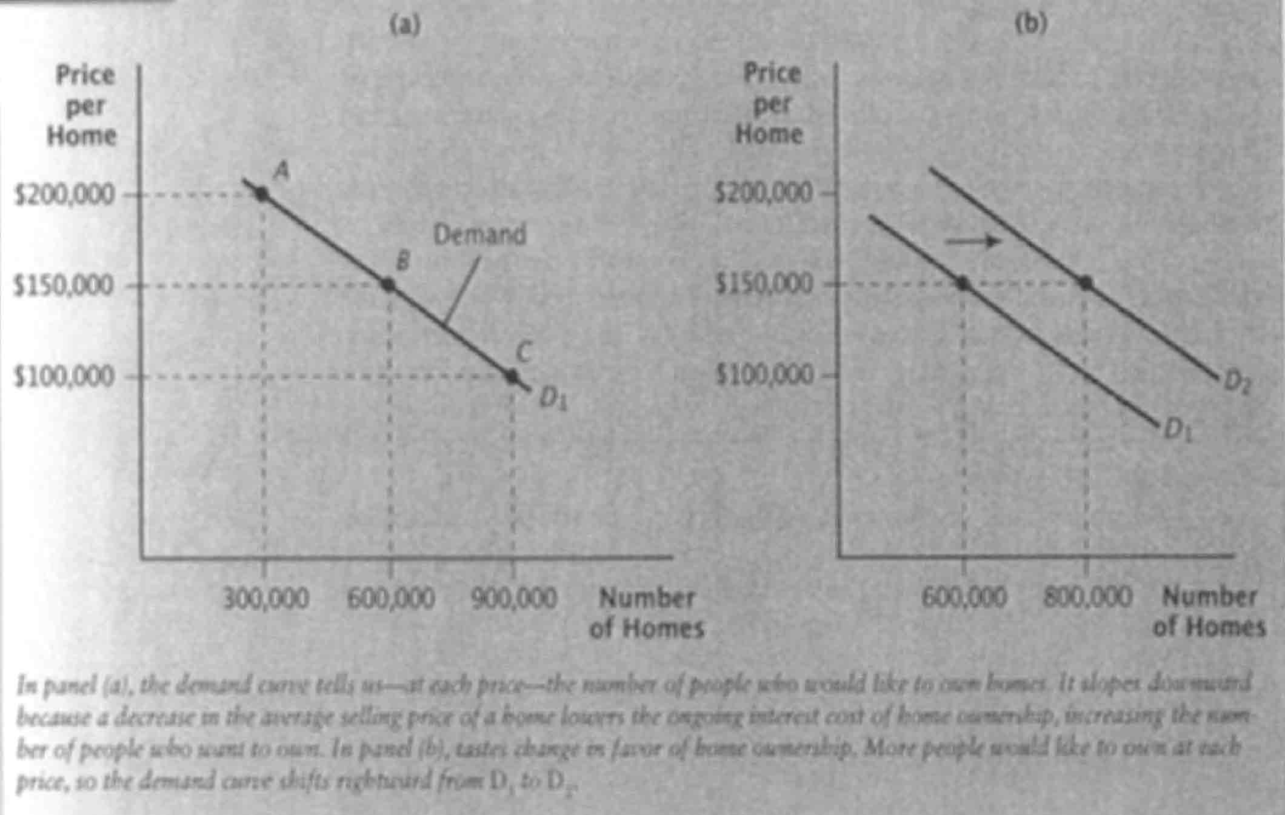
Figure 14 The demand curve in a housing market
Mortgage: A loan given to a home-buyer for part of the purchase price of the home.
Both current and prospective homeowners face an interest cost of ownership. This cost rises when current home prices rise, and falls when current home prices fall.
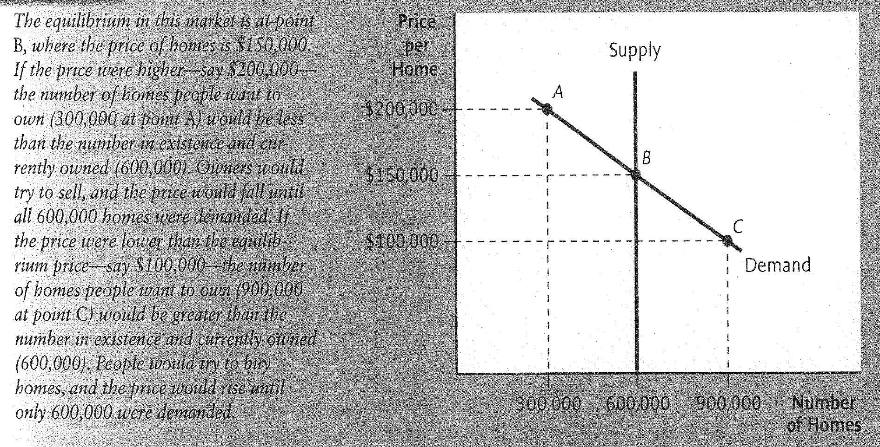
Figure 15 Equilibrium in a housing market
The equilibrium price in a housing market is the price at which the quantity of homes demanded (the number that people want to own) and quantity supplied (the housing stock) are equal.
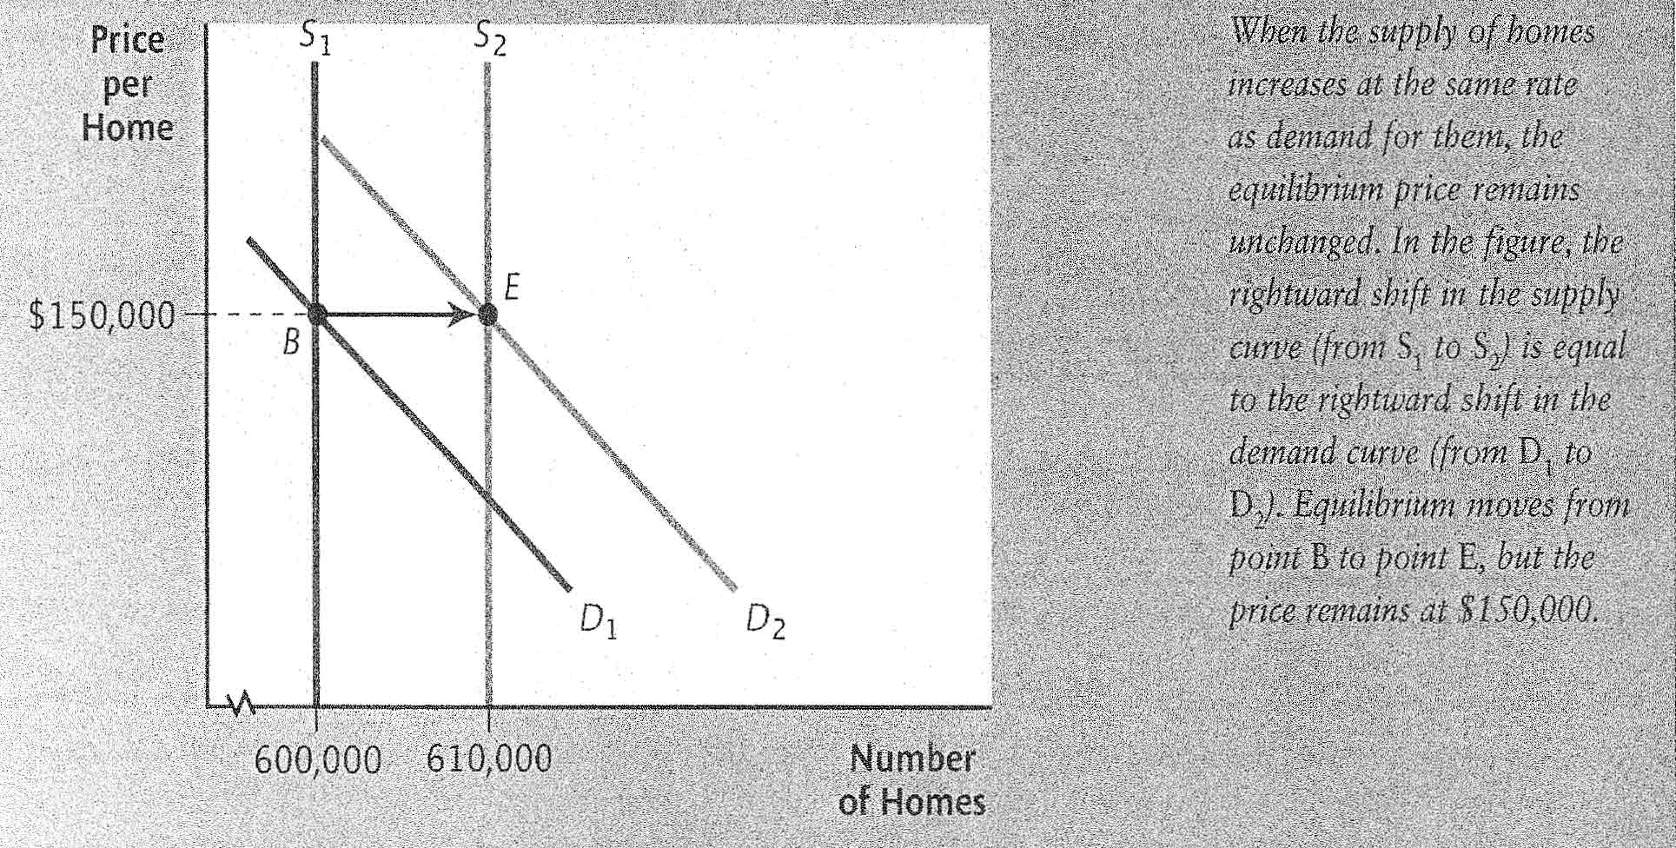
Figure 16 A stable housing market
When the housing stock grows at the same rate as housing demand, housing prices remain unchanged.
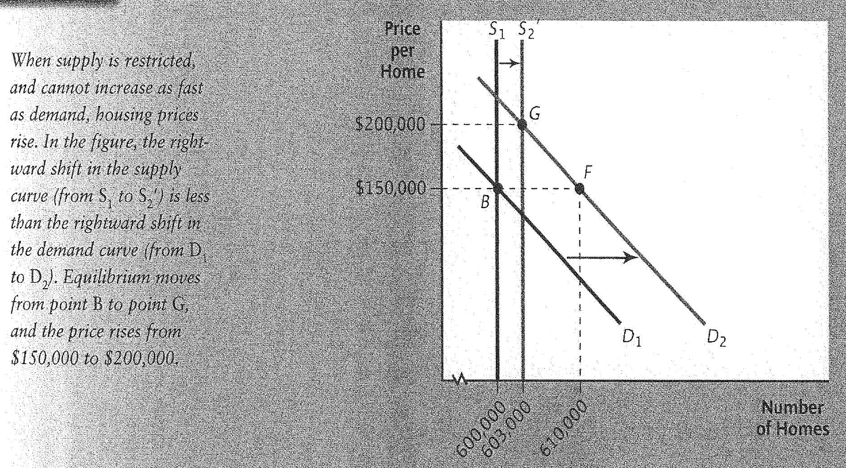
Figure 17 A housing market with restricted supply growth
When restrictions on new building prevent the housing stock from growing as fast as demand, housing prices rise.
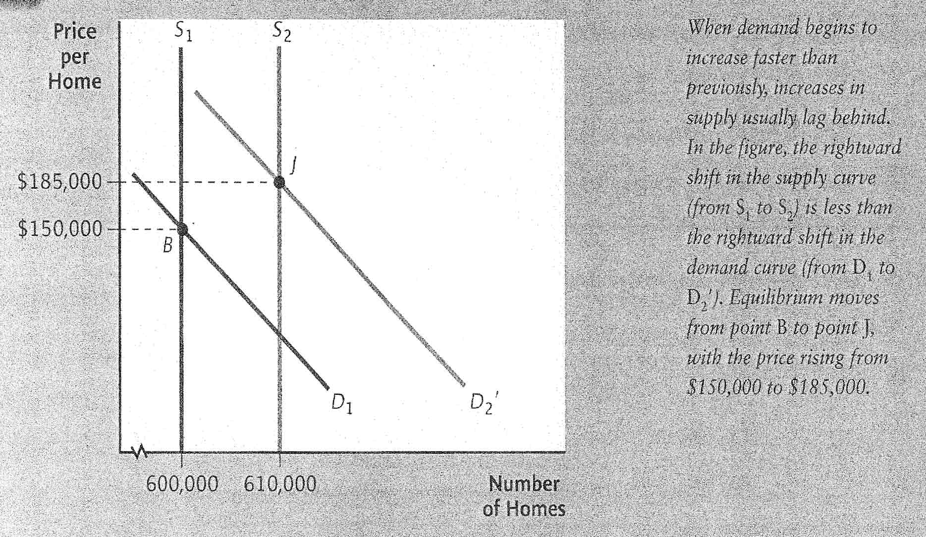
Figure 18 Accelerating demand growth

Capital gain: The gain to the owner of an asset when it is sold for a price higher than its original purchase price.
Capital loss: The loss to the owner of an asset when it is sold for a price lower than its original purchase price.
When the demand for housing begins rising faster than previously, the housing stock typically lags behind, and housing prices rise.

Chapter 5 – Creating and Pricing Products

Product: A physical good or service.
Convenience products: Products that are widely available to consumers, are purchased frequently, and are easily accessible.
Shopping products: Products that are not purchased frequently.
Specialty products: Products that specific consumers consider to be special and therefore make a special effort to purchase.
Product line: A set of related products or services offered by a single firm.
Product mix: The assortment of products offered by a firm.

Product life cycle: The typical set of phases that a product experiences over its lifetime.
- Introduction phase: The initial period in which consumers are informed about a product.
  - Price skimming: The strategy of initially setting a high price for a product if no other competing products are in the market yet.
- Growth phase: The period in which sales of a product increase rapidly.
- Maturity phase: The period in which additional competing products have entered the market, and sales of a product level off because of competition.
- Decline phase: The period in which sales of a product decline, either because of reduced consumer demand for that type of product or because competitors are gaining market share.
Target market: A group of individuals or organizations with similar traits who may purchase a particular product. These traits often include the consumer’s gender, age, and income bracket.
Consumer markets: Markets for various consumer products and services (such as cameras, clothes, and household items)
Industrial markets: Markets for industrial products that are purchased by firms (such as plastic and steel)
Factors that affect the size of a target market:
- Demographics: Characteristics of the human population or specific segments of the population.
- Geography
- Economic factors
- Social values
E-marketing: The electronic interaction with consumers in order to develop, improve, or promote products.
Obsolete: Less useful than in the past.
Fashion obsolescence: No longer being in fashion.
Technological obsolescence: Being inferior to new products.
Marketing research: The accumulation and analysis of data in order to make a particular marketing decision.
Patents: Allow exclusive rights to the production and sale of a specific product.

Steps necessary to create a new product:
- Develop of product idea: Determine what consumers want. This may involve monitoring consumer behavior.
- Assess the feasibility of a product idea: Determine whether benefits will exceed costs.
- Design and test the product: Determine whether consumers will buy the product.
- Distribute and promote the product: Make the product available and make consumer in the target market aware that the product exists.
- Post-audit the product: Determine whether the product needs to be revised.
Product Differentiation: A firm’s effort to distinguish its product from competitor’s products in a manner that makes the product more desirable.
- Unique product design: Higher level of product safety, reliability, or ease of use.
- Unique packaging: Packaging to get consumers’ attention or to improve convenience.
- Unique branding: Using the firm’s image to gain credibility, or using a unique brand name to imply prestige.
  - Branding: A method of identifying products and differentiating them from competing products.
  - Trademark: A brand’s form of identification that is legally protected from use by other firms.
  - Family branding: Branding of all or most products produced by the company.
  - Individual branding: The assignment of a unique brand name to different products or groups of products.
  - Producer brands: Brands that reflect the manufacturer of the products.
  - Store brands: Brands that reflect the retail store where the products are sold.
  - Generic brands: Products that are not branded by the producer or the store.
  - Co-branding: Firms agree to offer a combination of two noncompeting products at a discounted price.

Pricing Strategies
- Cost of production
  - Cost-based pricing: Estimating the per-unit cost of producing a product and then adding a markup.
  - Economies of scale: Average per-unit cost of production decreases as production volume increases.
- Supply of inventory
- Competitor’s prices
  - Penetration pricing: The strategy of setting a lower price than those of competing products to penetrate a market.
  - Price-elastic: The demand for a product is highly responsive to price changes.
  - Price-inelastic: The demand for a product is not very responsive to price changes.
  - Defensive pricing: The strategy of reducing a product’s price to defend (retain) market share.
  - Predatory pricing: The strategy of lowering a product’s price to drive out new competitors.
  - Prestige pricing: The strategy of using a higher price for a product that is intended to have a top-of-the-line image.
Fixed costs: Operating expenses that do not change in response to the number of products produced.
Variable costs: Operating expenses that very directly with the number of products produced.
$$Total Cost=\left(Fixed Cost\right)+[\left(Quantity\right)*\left(Variable Cost per Unit\right)]$$
$$Total Revenue=Quantity*Price per Unit$$
$$Profits=Total Revenue-Total Cost$$
Break-even point: The quantity of units at which total revenue equals total cost.
Contribution margin: The difference between price and variable cost per unit.
$$Break Even Quantity=\frac{Fixed Cost}{Price-Variable Cost per Unit}$$

Additional Pricing Decisions
- Discounting
- Sales Prices
- Credit Terms

Chapter 6 – Distributing Products

Marketing intermediaries: Firms that participate in moving the product from the producer toward the customer.
Direct channel: The situation when a producer of a product deals directly with customers.
- Advantages:
  - Full difference between manufacturer’s cost and the price paid by the consumer goes to the producer.
  - Producer can easily obtain firsthand feedback on the product.
- Disadvantages:
  - Need more employees.
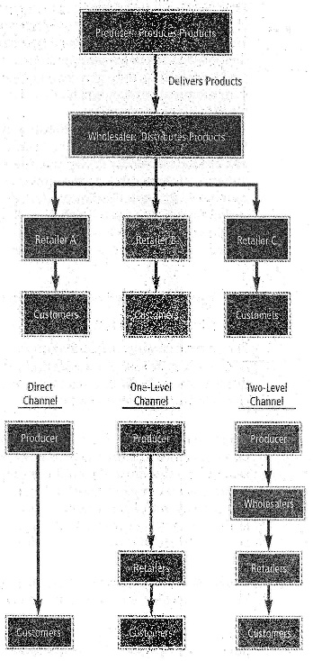
  - Manufacturer may have to sell its product on credit.
Figure 19 Two-level Channel of Distribution (top)
One-level channel: One marketing intermediary is between the producer and the customer.
Merchants: Marketing intermediaries that become owners of products and then resell them.
Agents: Marketing intermediaries that match buyers and sellers of products without becoming owners.
Two-level channel: Two marketing intermediaries are between the producer and the customer.
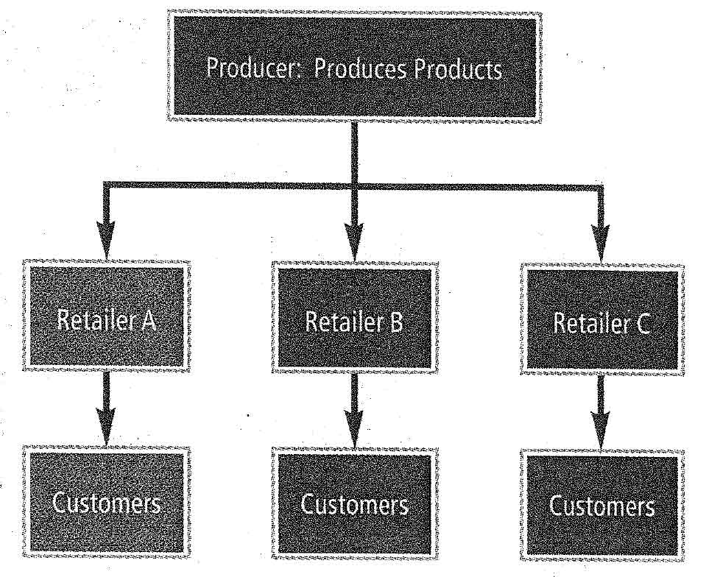
Figure 20 One-level Channel of Distribution

Factors that determine the optimal channel of distribution:
- Ease of Transporting: If a product can be easily transported, the distribution channel is more likely to involve intermediaries. If the product cannot be transported, the producer may attempt to sell directly to consumers.
- Degree of Standardization: Products that are standardized are more likely to involve intermediaries. When specifications are unique for each consumer, the producer must deal directly with consumers.
- Internet Orders: Firms that fill orders over the internet tend to use a direct channel, since their website serves as a retail store.
Market Coverage: The degree of product distribution among outlets.
Intensive distribution: The distribution of a product across most or all possible outlets.
Selective distribution: The distribution of a product through selected outlets.
Exclusive distribution: The distribution of a product through only one or a few outlets.
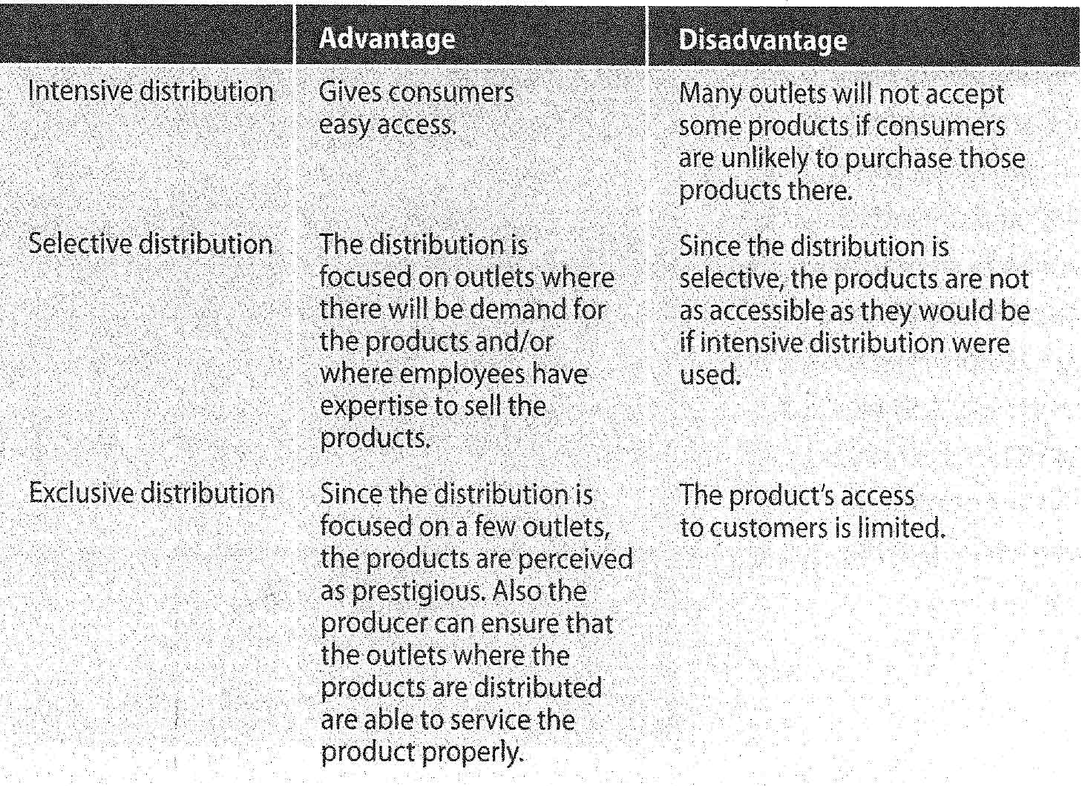

Transportation used to Distribute Products
- Truck: Commonly used because they can reach any destination on land quickly and make several stops.
- Rail: Useful for heavy products, especially when the producer and marketing intermediary are located close to a railroad. Railroads are not useful for short distances.
- Air: Quick and relatively inexpensive for light items.
- Water: Often used for transporting bulk products.
- Pipeline: Effective for oil and gas, though limited use to only few types of products.
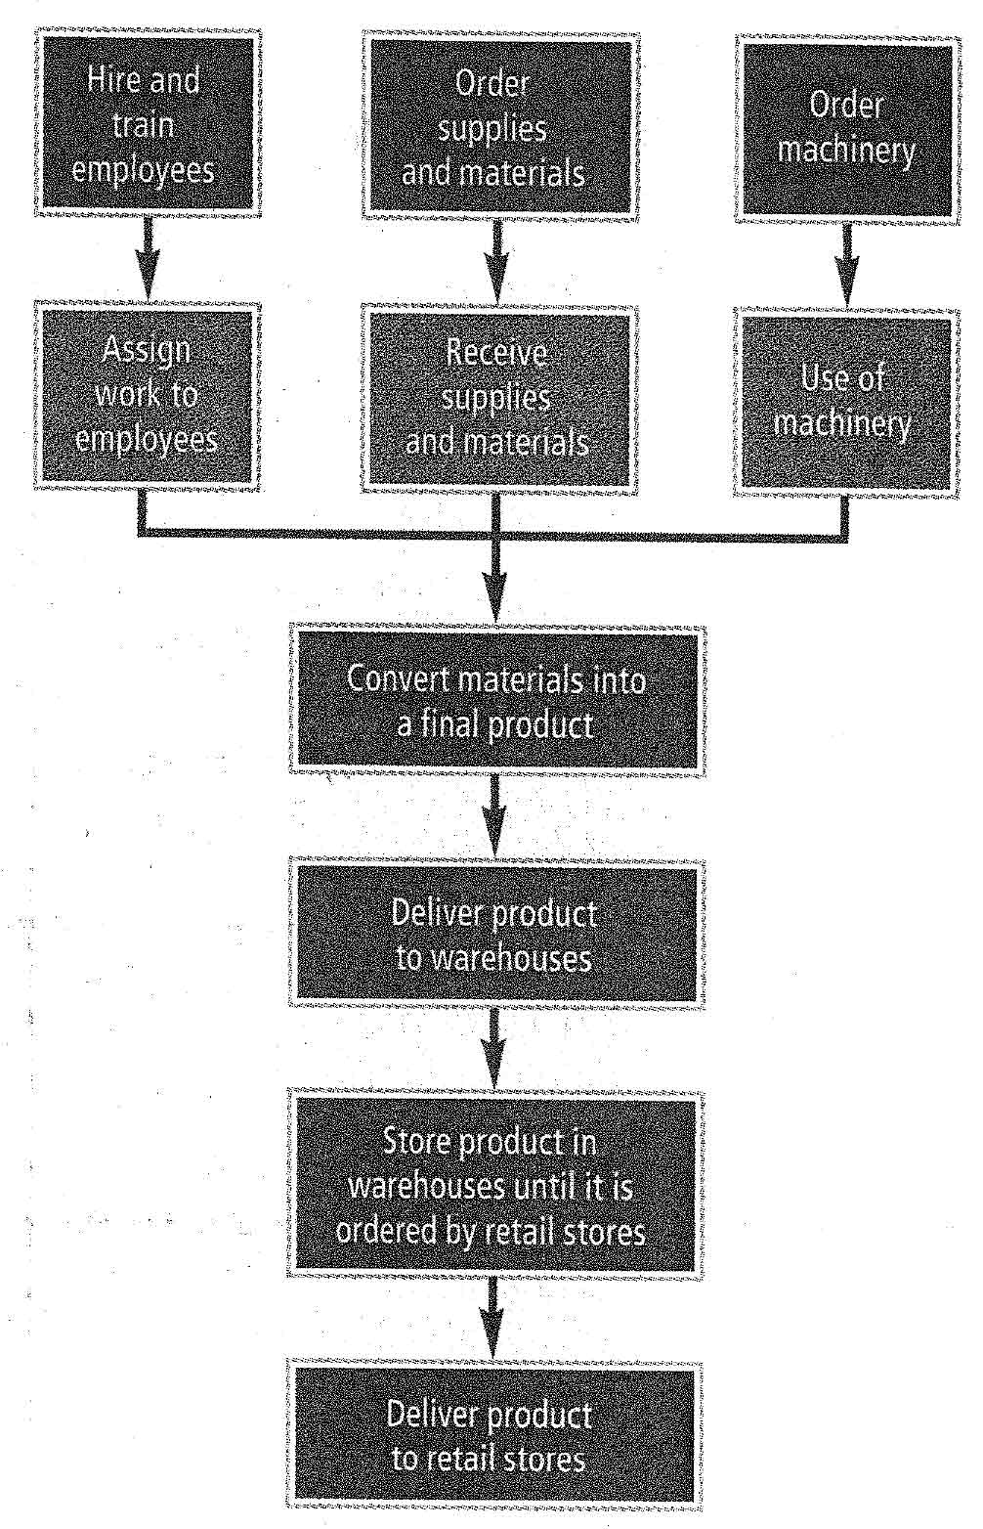
Figure 21 Steps involved in the production and distribution of products

Accelerate the Distribution Process
- Streamline the channel of distribution: The final product reached customers more quickly. Commonly results in the elimination of warehouses, except in the case of heavy products.
- Use of the internet for distribution: Information on websites means customers can compare prices and quality of products. The result is more competition and less brand loyalty. The internet also eliminates the distance between producers and consumers, thereby eliminating the need for wholesalers, distributors, and retailers, greatly improving a firm’s efficiency. Products may be sold at a lower price, and firm’s relationship with suppliers and freight haulers changes.
- Integrate the production and distribution processes
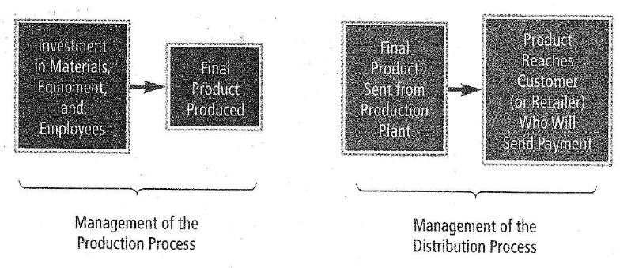
Figure 22 Relationship between production and distribution
E-marketing: Facilitates the integration between a firm’s production and distribution processes.

Characteristics of Retailers
- Number of outlets
  - Independent retail store: A retailer that has only one outlet.
  - Chain: A retailer that has more than one outlet.
- Quality of service
  - Full-service retail store: A retailer that generally offers much sales assistance to customers and provides servicing if needed.
  - Self-service retail store: A retailer that does not provide sales assistance or service and sells products that do not require much expertise.
- Variety of products offered
  - Specialty retail store: A retailer that specializes in a particular type of product. Advantage: May carry certain degree of prestige. Disadvantage: Not as convenient for consumers who need to purchase a variety of goods.
  - Variety retail store: A retailer that offers numerous types of goods.
- Store versus nonstore
  - Nonstore retailer: Retailer that does not use a store to offer its products or services.
  - Mail-order retailers: Receives orders through the mail or phone, and sends them through mail.
  - Websites: Advantage over mail-order is no need to send out catalogs, and changes can be made easily and frequently.
  - Vending machines: Accessible at all hours.

Services Offered by Wholesalers
Wholesalers: Intermediaries that purchase products from manufacturers and sell them to retailers.
- Warehousing: Purchase products from the manufacturer in bulk and maintain these products at their own warehouses.
- Sales expertise: Use their sales expertise when selling products to retailers, often persuading them.
- Delivery to retailers: Responsible for delivering products to various retailers.
- Assumption of credit risk: Purchase the products from manufacturers and sell them to retailers on credit.
- Information: Receive feedback from retailers and can provide valuable information to manufacturers.

How Wholesalers Serve Retailers
- Warehousing: Maintain sufficient inventory so that retailers can order small amounts frequently, thus retailers need not maintain large inventories.
- Promotion: Promote their products, thereby increasing sales of those sold by retail stores.
- Displays: Setup displays, designed to attract customers’ attention whilst taking little space, of the products for retailers
- Credit: Offer products to retailers on credit.
- Information: Can inform retailers about policies implemented by other retailers regarding pricing, sales, opening times.

Vertical Channel Integration
Vertical channel integration: Two or more levels of distribution are managed by a single firm.
Benefit: It can serve as a producer and intermediary. The intermediaries (outlets) allow the product to be widely distributed. All earnings generated by the producer or the outlets are beneficial.
Manufacturer:
- Can it absorb the cost of leasing store space and employing workers?
- Can the firm offer enough product lines to make a full store?
- Will the additional revenue to be earned cover all additional costs incurred?
- Will the firm lose the business that it had developed with other retail firms once it begins to compete with those firms at the retail level?
Retailers:
- Can it absorb the expenses resulting from production, including the cost of a production plant and new employees?
- Does it have the expertise to adjust the production process as consumer tastes change over time?

Chapter 7 – Promoting Products

Promotion: The act of informing or reminding consumers about a specific product or brand.
Used to supplement the other marketing strategies (product, pricing, and distribution strategies)
- To make consumers aware of a new product.
- To introduce the product.
- Remind consumers the product exists.
- Remind consumers about the product’s qualities and advantages over competitors.
- Can include special incentives to induce consumers to purchase a specific product.
- Can be used on a long-term basis to protect product’s image and retain market share.
Promotion mix: The combination of promotion methods that a firm uses to increase acceptance of its products.
- Advertising: A nonpersonal sales presentation communicated through media or nonmedia forms to influence a large number of consumers. The most common reason to advertise is to enhance the image of a specific brand.
  - Brand advertising: A nonpersonal sales presentation about a specific brand. (to inform about changes in the product)
  - Comparative advertising: Intended to persuade customers to purchase a specific product by demonstrating a brand’s superiority by comparison with other competing brands.
  - Reminder advertising: Intended to remind consumers of a product’s existence.
  - Institutional advertising: A nonpersonal sales presentation about a specific institution’s product.
  - Industry advertising: A nonpersonal sales presentation about a specific industry’s product.
  - Forms of advertising:
    - Newspapers: Convenient way to reach a certain geographic market, usually local. Can be inserted quickly.
    - Magazines: Used for products distributed nationwide.
    - Radio: Talks to audience, lacks visual effects. Tends to focus locally, able to target specific demographic.
    - Television: Talks to audience and includes visual effects. Can be used locally or nationwide. Able to target specific markets.
      - Infomercials: Commercials that are televised separately rather than within a show.
    - Internet: A form of nonpersonal communication that can create awareness and persuade the customer.
    - Email: Some are general and apply to all customers, others are personalized to fit a specific interest.
    - Direct mail: Used by local service firms.
    - Telemarketing: The use of the telephone for promoting and selling products.
    - Outdoor ads: Shown on billboards or signs, usually quite large.
    - Transportation ads: Displayed on forms of transportation, such as buses or taxis. Attempt to provide strong visual effect.
    - Specialty ads: Other forms of nonmedia advertising, like t-shirts, hats, etc.
- Personal selling: A personal sales presentation used to influence one or more consumers.
  - Identify the target market: Focus on types of customers most likely to purchase the product; contact these potential customers by phone or mail.
  - Contact potential customers: Schedule appointments with potential customers who are located in the same area on the same days.
  - Make the sales presentation: Demonstrate the use and benefits of the product.
  - Answer questions: Prepare for typical questions and allow potential customers to ask questions.
  - Close the sale: Close the sale after the presentation, perhaps by offering a discount if a purchase is made immediately.
  - Follow up: Call customers who recently purchased the product to ensure their satisfaction. Call other potential customers who decided not to purchase the product to determine whether they would like to reconsider.
  - Sales manager: An individual who manages a group of sales representatives.
- Sales promotion: The set of activities that is intended to influence consumers.
  - Rebates: A potential refund by the manufacturer to the consumer. Firms send refund directly to consumers after product is purchased.
  - Coupons: A promotional device used in newspapers, magazines, and ads to encourage the purchase of a product. Product is sold at a discounted price to consumers with coupons.
  - Sampling: Offering free samples to encourage consumers to try a new brand or product. Free samples of products are distributed to consumers.
    - Brand loyalty: The loyalty of consumers to a specific brand over time.
  - Displays: Special displays to promote particular products. Used to attract customers who are in the store for other reasons. Products are placed in a prominent area in stores.
  - Premiums: A gift or prize provided free to consumers who purchase a specific product. Gifts or prizes are provided free to consumers who purchase a specific product.
- Public relations: Actions taken with the goal of creating or maintaining a favorable public image.
  - Special events
  - News releases: A brief written announcement about a firm provided by that firm to the media.
  - Press conferences: An oral announcement about a firm provided by that firm to the media.

Optimal Promotion Mix
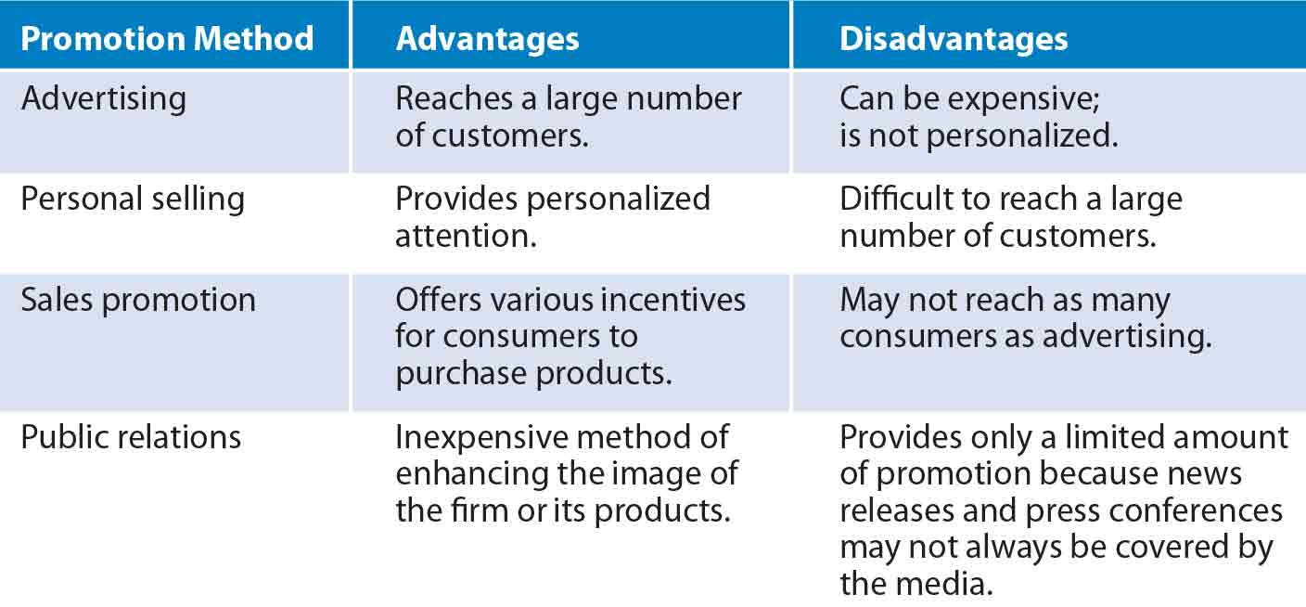
Pull strategy: Firms direct their promotion directly at the target market, and consumers in turn request the product from wholesales or producers.
Push strategy: Producers direct their promotion of a product at wholesalers or retailers, who in turn promote it to consumers.
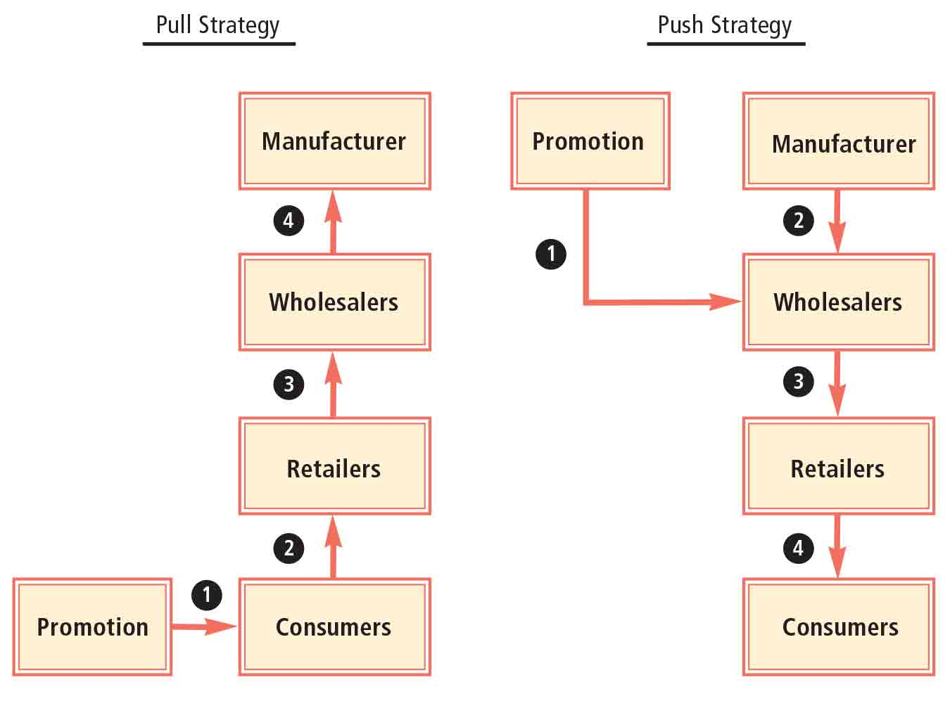
Promotion budget: The amount of funds that have been set aside to pay for all promotion methods over a specified period.
- Phase of the product lifecycle: Products that are just being introduced to the market will require more promotions.
- Competition: Defensive strategy based on amount competitors advertise.
- Economic conditions

Chapter 8 – Accounting and Financial Analysis

Accounting: Summary and analysis of a firm’s financial condition.
Public accountants: Accountants who provide accounting services for a variety of firms for a fee.
Certified public accountants (CPA): Accountants who meet specific educational requirements and pass a national examination.
Bookkeeping: The recording of a firm’s financial transactions.
Financial accounting: Accounting performed for reporting purposes. Must be conducted in accordance with generally accepted accounting principles (GAAP). Guidelines established by Financial Accounting Standards Board (FASB), Securities and Exchange Commission (SEC), and IRS.
- Reporting to investors: Publicly owned firms are required to periodically report their financial conditions to investors who own, or will own, shares in the future. Most shareholders are not employees.
- Online reporting: Use of the internet to make financial information available.
- Reporting to creditors: Reporting to existing or prospective creditors, who can assess the firm’s financial statements to determine the probability of defaulting on loans.
Managerial accounting: Accounting performed to provide information to help managers of the firm make decisions.
- Financial managers use historical cost and revenue for budgeting decisions.
- Marketing managers use sales information to evaluate the impact of a particular promotion strategy.
- Production managers use seasonal sales information to determine the necessary production level in the future.
Auditing: An assessment of the records that were used to prepare a firm’s financial statements.
Internal auditors: Specialize in evaluating various divisions of a business to ensure that they are operating efficiently.
A firm should use whatever method of accounting provides the most accurate indication of its financial condition. By doing so it may benefit in two ways:
- Gain some credibility with existing and prospective stockholders by providing clear and consistent reports that are easily understood.
- Using an understandable and logical accounting method makes it easier for the firm’s managers to detect and correct deficiencies.

Responsible Financial Reporting
Independent auditor: Annual financial reports audited by an independent accounting firm of public accountants, required for publicly traded firms. Auditor’s role is to certify that the financial statements are accurate and within the generally accepted reporting guidelines.
The Board of Directors represents the shareholders. They can try to prevent the firm from providing misleading financial reports, however some boards don’t effectively represent the stockholders. Problems may arise when board members are compensated with stock. A good solution is to ensure board members can’t sell any of their stock while serving on the board.
Sarbanes-Oxley Act
- An auditing firm is allowed to provide nonaudit services when auditing a client only if the client’s audit committee preapproves these services before the audit begins.
- Auditing firms may not audit companies whose CEO, CFO, or other managers in similar roles were employed by the auditing firm in the one-year period prior to the audit.
- Those board members of the firm who are assigned to oversee the audit to ensure that it is done properly should not receive consulting or advising fees or other compensation from the auditing firm.
- The CFO and other managers of the firm must file an internal control report along with each annual report.
- The CEO and CFO must certify that the audited statements fairly represent the operations and financial condition of the firm.
- Major fines or prison terms are imposed on employees who mislead investors or hide evidence.

Financial Statements
Income statement: Indicated the revenue, costs, and earnings of a firm over a period of time.
- Net sales: Total sales adjusted for any discounts.
- Cost of goods sold: The cost of materials used to produce the goods that were sold.
- Gross profit: Net sales minus the cost of goods sold.
- Operating expenses: Composed of selling expenses and general and administrative expenses.
- Earnings before interest and taxes (EBIT): Gross profit minus operating expenses.
- Earnings before taxes: Earnings before interest and taxes minus interest expenses.
- Net income (earnings after taxes): Earnings before taxes minus taxes.
- Percentage of sales measurement: Firms commonly measure each income statement item as a percentage of total sales.
Balance sheet: Reports the book value of all assets, liabilities, and owner’s equity of a firm at a given point in time.
- Asset: Anything owned by a firm.
- Liability: Anything owed by a firm.
- Basic accounting equation: $Assets = Liabilities + Owner’s Equity$
- Current assets: Assets that will convert into cash within one year.
- Fixed assets: Assets that will be used by a firm for more than one year.
- Deprecation: A reduction in the value of fixed assets to reflect deterioration in the assets over time.
- Accounts payable: Money owed by a firm for the purchase of materials.
- Notes payable: Short-term loans to a firm made by creditors such as banks.
- Owner’s equity: Includes the par (or stated) value of all common stock issued, additional paid-in capital, and retained earnings.
- Percentage of total assets measurement: A firm can use its balance sheet to determine the percentage of its investment in each type of asset.
Ratio analysis: An evaluation of the relationships between financial statement variables.
- Measures of Liquidity: A firm’s ability to meet short-term obligations
$$Current Ratio =\frac{ Current Assets}{Current Liabilities}$$

$$Quick Ratio = \frac{Cash + Marketable Securities + Accounts Receivable}{Current Liabilities}$$

- Measures of Efficiency
$$Inventory Turnover=\frac{Cost of Goods Sold}{Inventory}$$
Assesses the relation between a firm’s inventory level and sales.

$$Asset Turnover=\frac{Net Sales}{Total Assets}$$
Measures efficiency with which firms use their assets.

- Measures of Financial Leverage: The degree to which a firm uses borrowed funds to finance its assets.
$$Debt to Equity ratio=\frac{Long Term Debt}{Owner^{'}s Equity}$$
A measure of the amount of long-term financing provided by debt relative to equity.
$$Times Interest Earned=\frac{Earnings Before Interest and Taxes (EBIT)}{Annual Interest Expense}$$
Measures the ability of a firm to cover its interest payments.

- Measures of Profitability
$$Net Profit Margin=\frac{Net Income}{Net Sales}$$
A measure of net income as a percentage of sales.

$$Return on Assets \left(ROA\right)=\frac{Net Income}{Total Assets}$$
Measures a firm’s net income as a percentage of the total amount of assets utilized by the firm.

$$Return on Equity \left(ROE\right)=\frac{Net Income}{Owner^{'}s Equity}$$
Measures the return to the common stockholders (net income) as a percentage of their investment in the firm; earnings as a proportion of the firm’s equity.
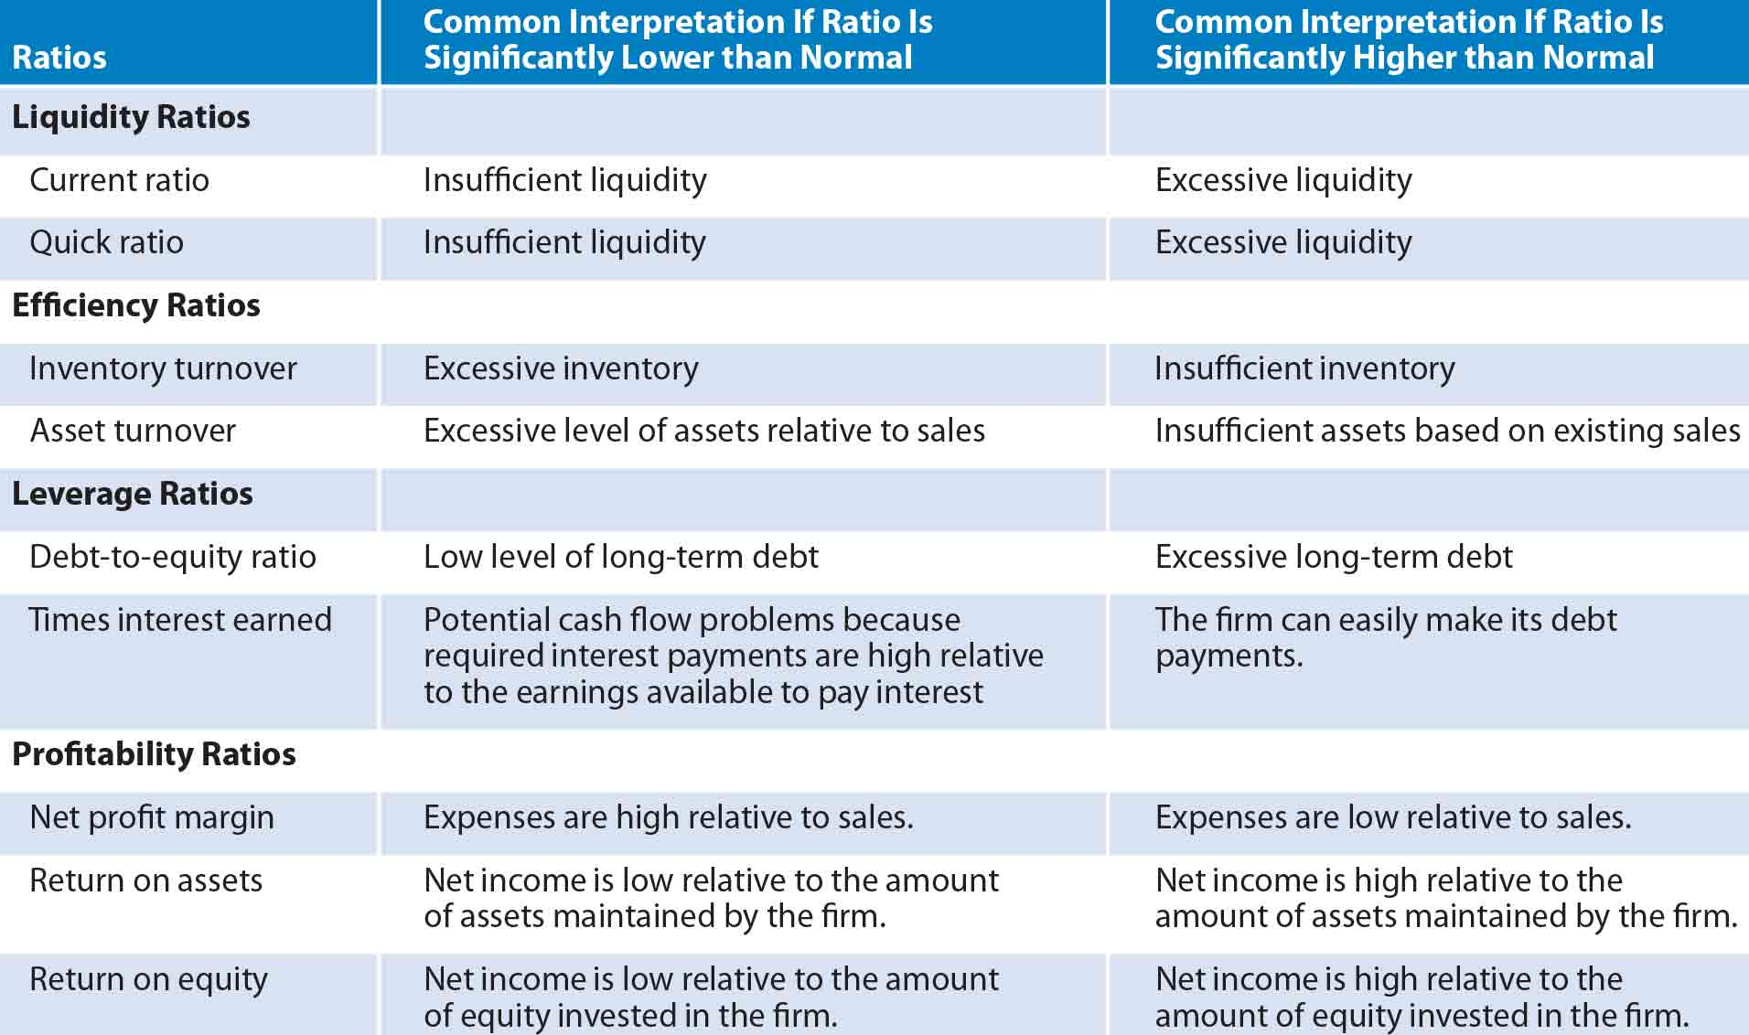
Limitations of Ratio Analysis:
- Firms operate in multiple industries
- Firms use different accounting practices
- Seasonal variation

Chapter 9 – Financing

Debt financing: The act of borrowing funds. Disadvantage = interest.
Capital: Long-term funds
Lenders assess the Creditworthiness of a firm according to several factors:
- Planned use of borrowed funds
- Financial condition of firm’s business
- Outlook for industry or environment surrounding the firm’s business
- Available collateral of business that can be used as a loan
Collateral: Assets of the borrower that are transferred to the lender if the borrower defaults on the loan.
Loan rate: Banks determine the average rate of interest that they pay on their deposits, which represents their cost of funds, and add on a premium. Like deposit rates, loan rates change over time in response to general interest rate movements.
Prime rate: The rate of interest typically charged on loans to the most creditworthy firms that borrow.
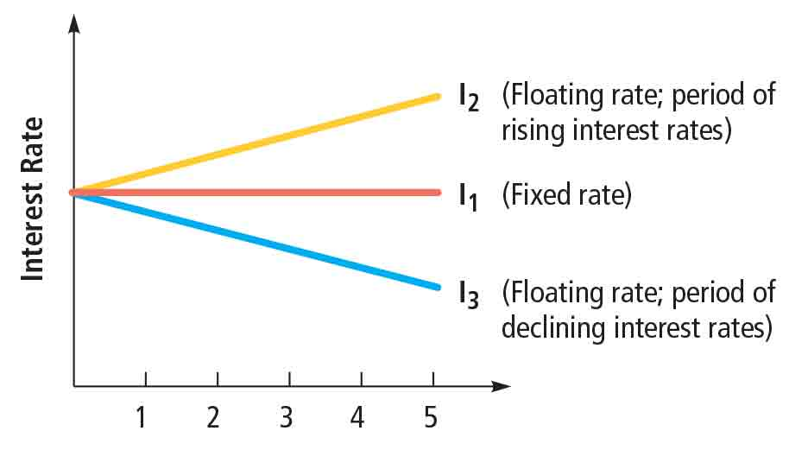

Types of business loans
- A common type is intended to support ongoing business operation. These loans provide necessary funding to cover expenses until the product is sold and cash is received.
- Term loan: Used to finance the purchase of fixed assets such as machinery. The maturity is typically between 3 and 10 years.
- Line credit: Allows the firm to borrow up to a specified amount of money within a specified period of time. More flexible, useful when a firm knows it will need credit, but not exactly when.
- Loans backed by the US government: The Small Business Administration (SBA) backs loans provided by lenders to small businesses under various programs. Backing by the SBA increases financial institution’s incentive to lend because risk is reduced by a guarantee by the SBA that up to 75% will be paid back. Most popular of these programs is the 7(a). To qualify businesses must show they are capable of repayment, and make a down payment of ~ 25%. Size of these loans is 200k to 10m.
Bonds: Long-term debt securities (IOUs) purchased by investors. Usually have lower interest rates than loans.
Par value: The amount that bondholders receive at maturity. Maturity is usually between 10 and 30 years.
Coupon payments: The coupon (interest) payments paid per year are determined by applying the coupon rate to the par value. They are usually paid semiannually and are fixed over the life of the bond.
Indenture: A legal document that explains the firm’s obligations to bondholders.
Secured bonds: Bonds backed by collateral.
Unsecured bonds: Bonds that are not backed by collateral
Call feature: Provides the issuing firm with the right to repurchase its bonds before maturity.
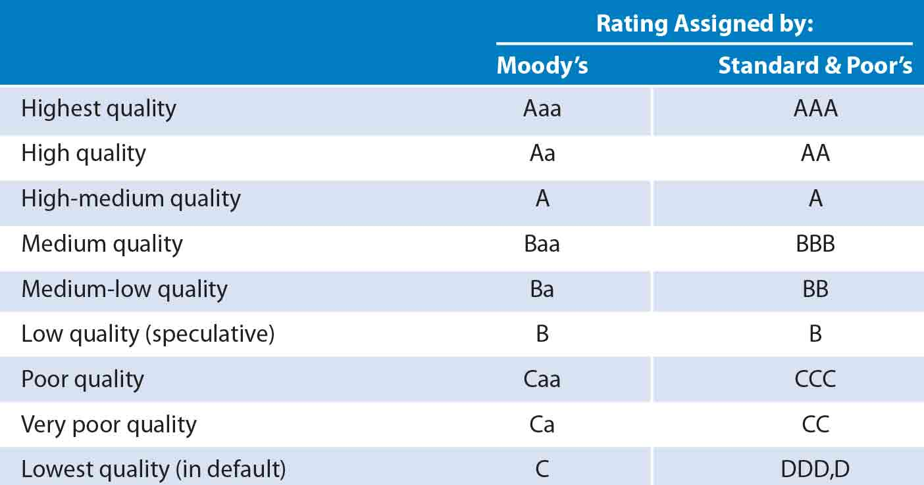
Protective covenants: Restrictions imposed on specific financial policies of a firm that has issued bonds.
Commercial paper: A short-term debt security normally issued by firms in good financial condition.

Common creditors that provide debt financing
- Commercial banks: Financial institutions that obtain deposits from the individuals and use the funds primarily to provide business loans.
- Savings institutions: Financial institutions that obtain deposits from the individuals and use the funds primarily to provide mortgage loans.
- Finance companies: Financial institutions that typically obtain funds by issuing debt securities (IOUs) and lend most of their funds to firms.
- Pension funds: Receive employee and firm contributions toward pensions and invest the proceeds for the employees until the funds are needed.
- Insurance companies: Receive insurance premiums from selling insurance to customers and invest the proceeds until the funds are needed to pay insurance claims.
- Mutual funds: Investment companies that receive funds from individual investors and then pool and invest those funds in securities.
  - Bond mutual funds: Investment companies that invest the funds received from investors in bonds.

Equity Financing: the act of receiving investment from owners (by issuing stock or retaining earnings)
Retaining earnings: Reinvested in the firm.
Dividend policy: The decision regarding how much of the firm’s quarterly earnings should be retained (reinvested in the firm) versus distributed as dividends to owners. Some firms establish their dividend payment as a % of future earnings.

Issuing stock
Common stock: A security that represents partial ownership of a particular firm.
Preferred stock: A security that represents partial ownership of a particular firm and offers specific priorities over common stock.
Venture capital firm: A firm composed of individuals who invest in small businesses. They act as investors rather than creditors.

Going Public
Initial Public Offering (IPO): The first issue of stock to the public.
- Allows a firm to obtain additional funds without boosting its existing debt level and without relying on retained earnings.
- Can obtain large amount of funds without increasing future interest payments to creditors.
- Responsible for informing shareholders of financial conditions by filing reports with the Securities and Exchange Commission, which is expensive. This information in turn is accessible to investors.
- Forces firm to sell part of ownership at a relatively low cost.
- Ownership structure is diluted.
- Investment banks charge high fees for advising and placing the stock with investors. Additionally, legal, accounting, and printing fees are incurred.
Stock mutual funds: Investment companies that invest funds received from individual investors in stocks.
Secondary market: A market where existing securities can be traded among investors. Most popular: NYSE (New York Stock Exchange) AMEX (American Stock Exchange) OTC (Over-the-counter market). OTC is traded via an electronic network: Nasdaq (National Association of Securities Dealers Automated Quotations)
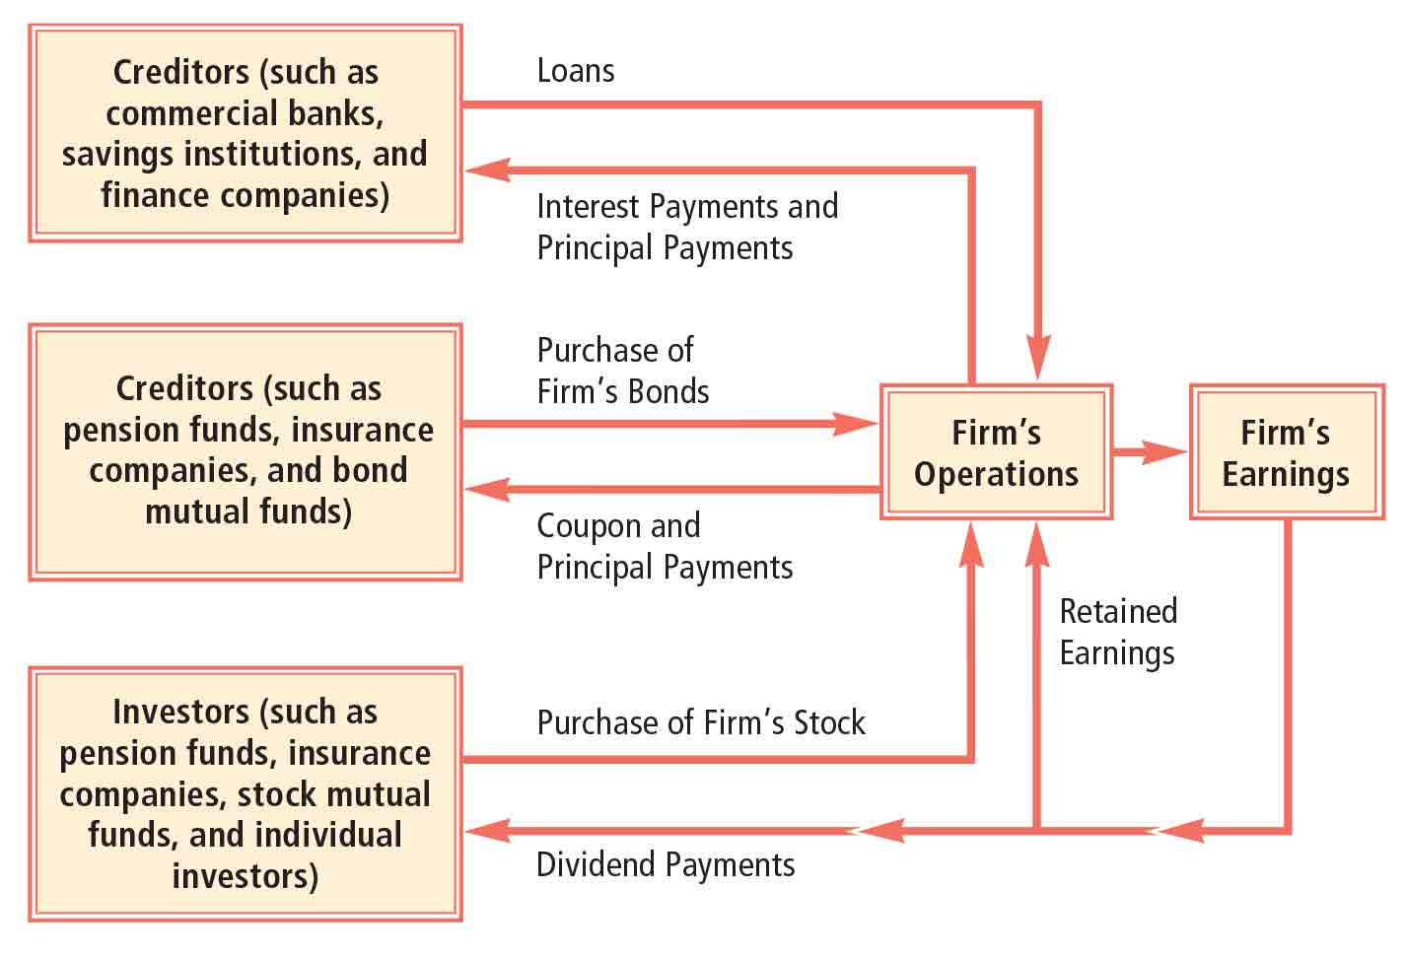
Figure 23 Comparison between equity and debt financing

Securities
Public offering: The selling of securities to the public. They include IPOs and additional securities by firms that went public earlier.
Origination: Investment banks advice firms on the amount of stocks or bonds they can issue.
Underwritten: The investment bank guarantees a price to the issuing firm, no matter what price the securities are sold for.
Best-efforts basis: The investment bank does not guarantee a price to the firm issuing securities.
Underwriting syndicate: A group of investment banks that share the obligations of underwriting securities.
Prospectus: A document that discloses relevant financial information about securities and about the firm issuing them.
Flotation costs: Costs of issuing securities; include fees paid to investment banks for their advice and efforts to sell the securities, printing expenses, and registration fees.
Private placement: The selling of securities to one or a few investors.

Other methods of obtaining funds
- Financing from suppliers
- Leasing: Renting assets for a specified period of time.

Capital structure: The amount of debt versus equity financing
- The use of debt as a source of funds is desirable because the interest payments are tax-deductible. When firms use equity as a source of funds this isn’t the case.
- Too much debt can increase the risk of defaulting on debt payments, reducing chances of receiving additional credit.
Using little equity (mostly debt) can achieve a higher return on equity, however this exposes a firm to the risk of being unable to cover its interest payments.

Remedies for debt problems
- Extensions: Provides additional time for a firm to generate the necessary cash to cover its payments to its creditors.
- Composition: Specifies that a firm will provide its creditors with a portion of what they are owed.
- Private liquidation: Creditors may informally request that a failing firm liquidate (sell) its assets and distribute the funds received from liquidation to them.
- Formal remedies
  - Reorganization: Can include termination of some businesses, an increased focus on other businesses, revisions of the organizational structure, and downsizing.
    - Liquidation value: The amount of funds that would be received as a result of the liquidation of a firm.
  - Liquidation under bankruptcy: If the firm and its creditors cannot agree on some informal agreement, and reorganization isn’t feasible, the firm will file for bankruptcy. The firm is obligated to file a list of creditors and up-to-date financial statements.

