Management & Organization
Contents
Chapter 1 – Functions of a Business 1
How a business generates profits 1
Conditions that affect business profits 1
Resources Used by Businesses 1
Key Stakeholders in a Business 2
Business Environment 3
Types of Business Decisions 3
How business decisions rely on information 4
Chapter 2 – Business Ethics and Social Responsibility 5
Responsibility to Customers 5
How firms ensure their responsibility 5
How the government ensures responsibility 5
Responsibility to Employees 6
How firms ensure responsibility toward employees 6
Responsibility to Stockholders 6
How firms ensure responsibility 6
How the government ensures responsibility 6
How stockholders ensure responsibility 7
Responsibility to Creditors 7
Responsibility to the Environment 7
Responsibility to the Community 8
Satisfying the community versus stockholders 8
Chapter 3 – Managing Effectively 9
Levels of Management 9
Functions of Managers 10
Use of technology to improve management functions 11
Software to improve management functions 11
Managerial Skills 11
Managing Time 12
Chapter 4 – Organizational Structure 13
How organizational structure varies among firms 13
Accountability in an Organizational Structure 14
Distributing Authority Among the Job Positions 15
Structures that Allow more Employee Input 16
Departmentalizing Tasks 17
Chapter 5 – Improving Productivity and Quality 18
Selecting a Site 18
Factors affecting the site decision 18
Evaluating possible sites 18
Design and Layout 18
Factors affecting design and layout 19
Production Control 19
Improving Production Efficiency 21
Chapter 6 – Motivating Employees 22
Theories on Motivation 22
Maslow’s Hierarchy of Needs 22
Herzberg’s Job Satisfaction Study 23
McGregor’s Theory X and Theory Y 23
Theory Z 23
Expectancy theory 23
Equity theory 23
Reinforcement theory 23
Improving Employee Motivation 24
Chapter 7 – Hiring, Training, and Evaluation Employees 25
Providing Equal Opportunity 25
Compensation Packages 25
Developing skills of employees 26
Evaluation of Employee Performance 26

Chapter 1 – Functions of a Business

Businesses are established to sell products or services that satisfy the needs of customers. By offering products or services that have higher quality or a lower price, businesses increase the satisfaction level of consumers.

How a business generates profits
A business generates profits when the revenue it receives exceeds its expenses. It receives revenue when it sells its products or services. It incurs expenses from paying its employees and when it purchases machinery or facilities. The profits go to the owners.

Conditions that affect business profits
- There needs to be demand for the product.
- Business must offer an advantage over its competition.
- Needs to use efficient system for producing its products or services in order to limit expenses.
Free-market economy: Countries in which people can create their own businesses to serve the preferences and needs of consumers. Governments in these economies recognize the advantages of allowing business ownership, a major one being reduced unemployment.
Socialist economy: Businesses are owned by the government and not profit oriented. Most people can’t afford to create a business in these economies, and no incentive to produce products that satisfy consumer’s needs.
Nonprofit organization: An organization that serves a specific cause and is not intended to make profits.

Resources Used by Businesses
- Natural resources: Any resources that can be used in their natural form, like land.
- Human resources: People who are able to perform work for a business.
- Capital: Machinery, equipment, tools, and physical facilities used by a business.
  - Technology: Knowledge or tools used to produce products and services.
  - Information technology: Technology that enables information to be used to produce products and services.
  - E-business or e-commerce: Use of electronic communications, such as the internet, to produce or sell products or services.
- Entrepreneurship: The creation of business ideas and the willingness to take risk; the act of creating, organizing, and managing a business.
  - Entrepreneurs: People who organize, manage, and assume the risk of starting a business.

Key Stakeholders in a Business

Stakeholders: People who have an interest in a business; the business’s owners, creditors, employees, suppliers, and customers.
- Owners: Firms rely on entrepreneurs (owners) to create business ideas and possibly to provide some financial support. They rely on other owners and creditors to provide additional financial support.
  - Stock: Certificates of ownership of a business.
  - Stockholders (shareholder): Investors who become partial owners of firms by purchasing the firm’s stock.
- Creditors: Financial institutions or individuals who provide loans.
- Employees: Firms hire employees to conduct their business operations.
  - Managers: Employees who are responsible for managing job assignments of other employees and making key business decisions. The goal of a firm’s managers is to maximize its value, and therefore its stock.
- Suppliers: Provide materials needed for production.
- Customers: Purchase the product or service.
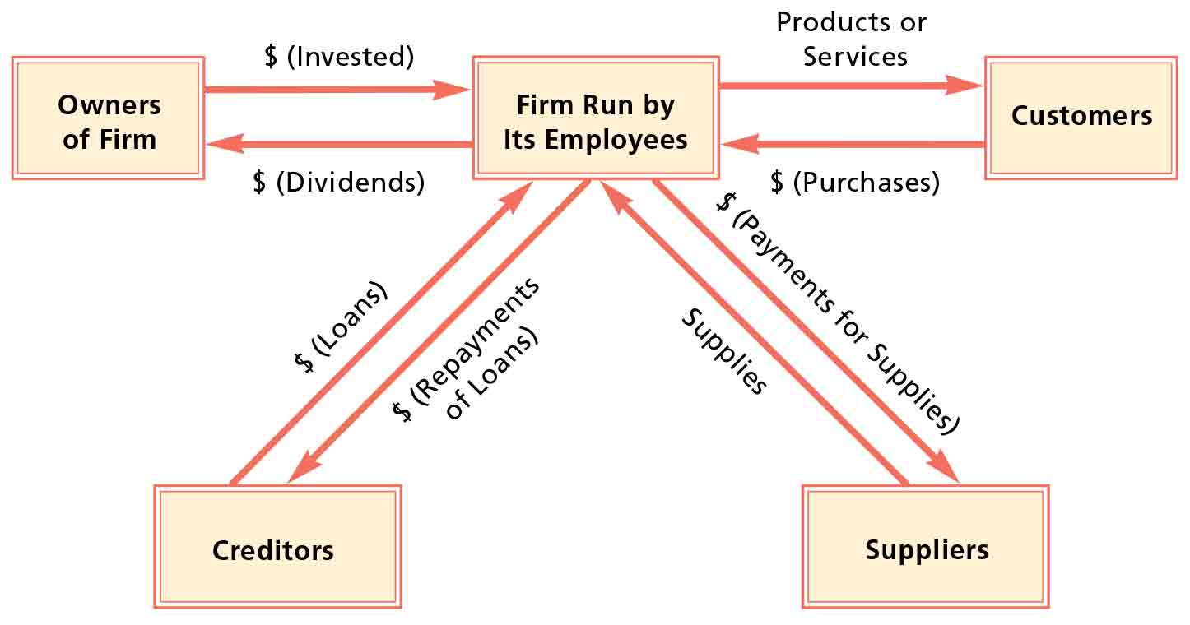
Figure 1 Interaction among owners, employees, customers, suppliers, and creditors

Business Environment
- Social environment: Includes demographics and consumer preferences, represents the social tendencies to which a business is exposed. Changes in consumer preference over time can affect the demand. Tastes are highly influenced by technology.
  - Demographics: Characteristics of the human population or specific segments of the population. Demand may increase or decrease in response to change in demographics.
- Industry environment: Represents the conditions within the firm’s industry to which the firm is exposed. Conditions vary according to the demand and the competition.
- Economic environment: Economic conditions have a strong impact on the performance of each business. Strong economy = high employment + compensation = higher purchasing power. Vice versa for a weak economy.
- Global environment: May affect all firms directly or indirectly. Some firms rely on foreign countries for some of their supplies, sell to foreign countries, or setup subsidiaries in foreign countries. Global economic conditions can affect local economic conditions.

Types of Business Decisions

Management: Means by which employees and other resources (such as machinery) are used by the firm.
Marketing: Means by which products (or services) are developed, priced, distributed, and promoted to customers.
Finance: Means by which firms obtain and use funds for their business operations.
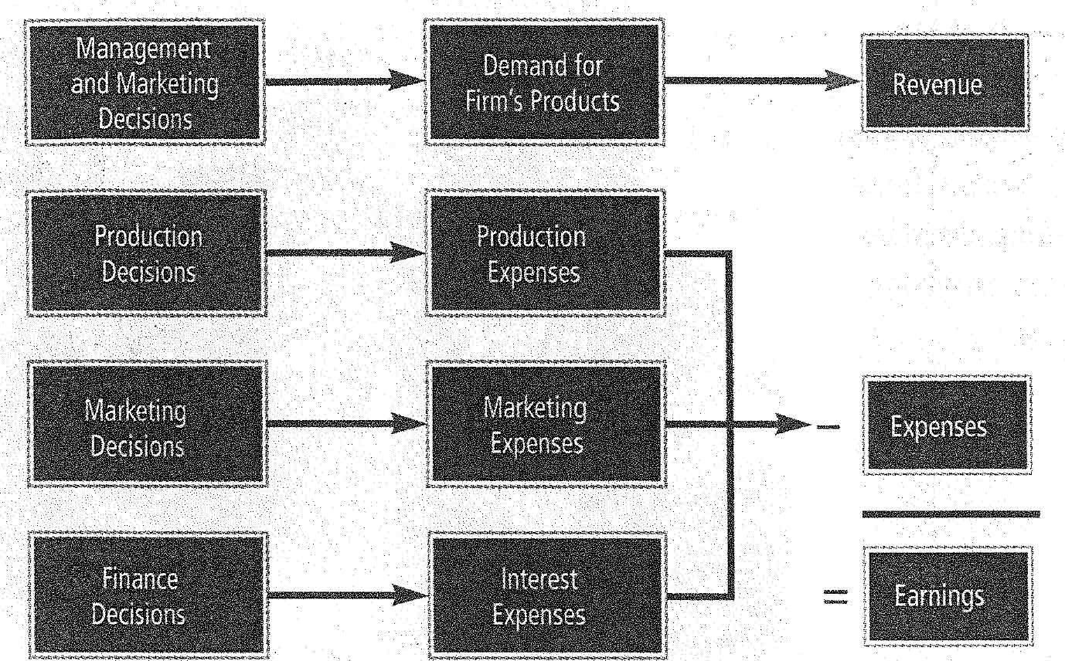
Figure 2 How business decisions affect a firm's earnings

How business decisions rely on information
Accounting: Summary and analysis of the firm’s financial condition.
Information systems: Represent information technology, people, and the procedures that work together to provide appropriate information to the firm’s employees so they can make business decisions.

Chapter 2 – Business Ethics and Social Responsibility

Responsibility to Customers

Social responsibility: A firm’s recognition of how its business decisions can affect society.
Consumerism: The collective demand by consumers that business satisfy their needs.
- Responsible production practices: Firms should produce products in a way that ensures customer safety. Products should carry proper warning labels and information on possible side effects.
- Responsible sales practices: Firms need guidelines that discourage employees from using overly aggressive sales strategies or deceptive advertising. Customer satisfaction surveys can also be used.

How firms ensure their responsibility
- Establish a code of responsibilities: The code is not intended to cover every possible action by a firm, it’s merely a guide.
  - Business responsibilities: A set of obligations and duties regarding product quality and treatment of customers, employees, and owners that a firm should fulfill when conducting business.
- Monitor complaints: Listen and resolve customer complaints.
- Obtain and utilize customer feedback: Ask customers for feedback.

How the government ensures responsibility
- Government regulation of product safety: Regulates the quality of some products.
- Government regulation of advertising: Laws established against deceptive advertising, however, unable to prevent all unethical business practices.
- Government regulation of industry competition: Promotes competition.
  - Monopoly: A firm that is the sole provider of goods or services.
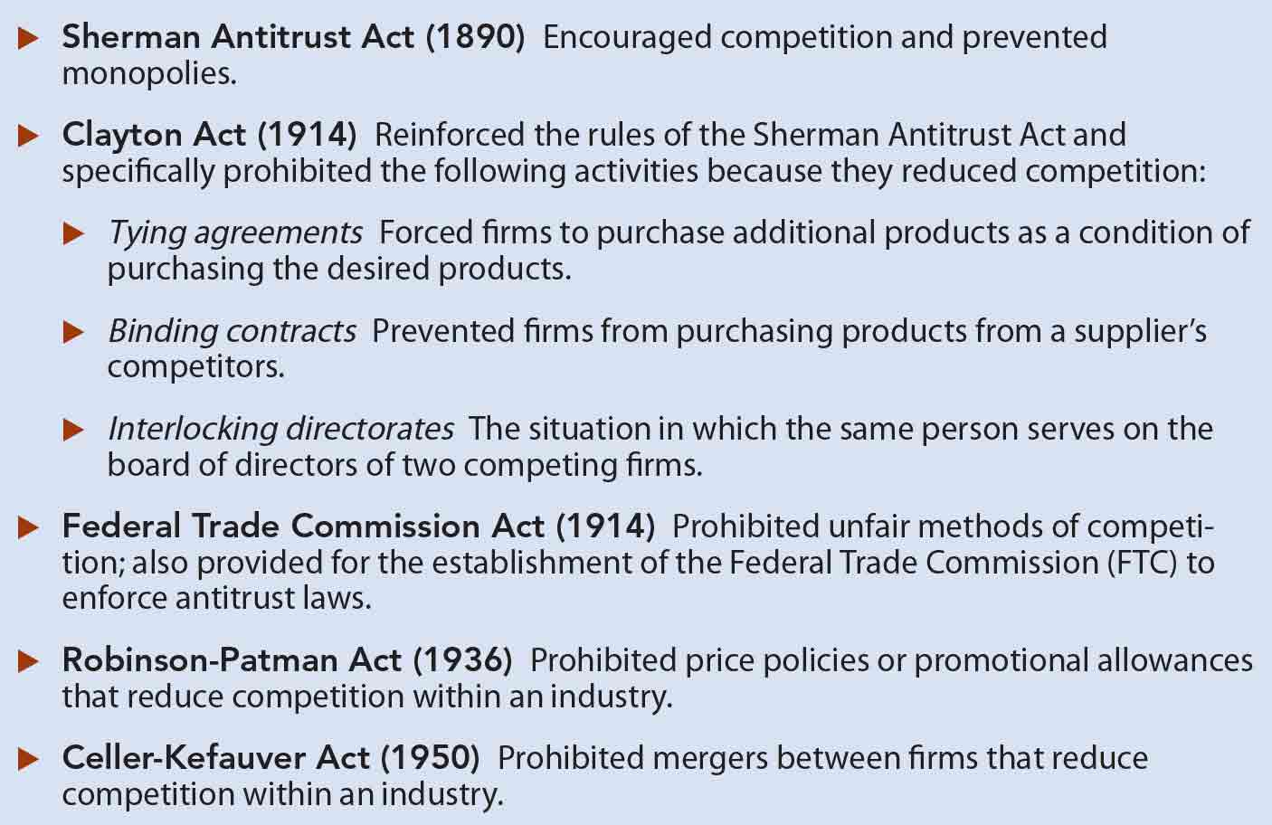
Figure 3 Key Antitrust Laws

Responsibility to Employees
- Employee safety: Ensured by closely monitoring the production process and establishing safety precautions. This prevents injuries and improves morale.
- Proper treatment by other employees
  - Diversity
  - Prevention of Sexual harassment: Unwelcome comments or actions of a sexual nature.

How firms ensure responsibility toward employees
- Code of responsibility: Responsibility towards employees should be disclosed here, however, this is just a guide.
- Grievance policy: To ensure proper treatment, this policy is established for employees who believe they are not being given equal opportunity.
- Job satisfaction initiatives: Job satisfaction reduce employee turnover.
- Equal employment opportunity: Employees should not be subjected to discrimination. Civil Right Act prohibits this, enforced by the Equal Employment Opportunity Commission (EEOC).
  - Affirmative action: A set of activities intended to increase opportunities for minorities and women.

Responsibility to Stockholders

How firms ensure responsibility
Managers of a firm monitor employee decisions to ensure that they are made in the best interest of the owners. Employee compensation may be directly tied to the firm’s performance in the form of stock.
- Conflicts in the efforts to ensure responsibility: CEO compensation has increased substantially over recent decades. Customers and stockholders argue that firms that do this are not meeting their social responsibilities.
- Temptations to distort performance: Managers who receive stock my report artificially high performance level in periods where they want to sell their stock holdings.

How the government ensures responsibility
Sarbanes-Oxley Act = Public Company Accounting Reform and Investor Protection Act: Encourages publicly traded firms to behave more responsibly toward their stockholders.
- Information provided must be clarified.
- Required to establish methods to ensure errors can be detected.
- Top executives and board members are held more accountable.

How stockholders ensure responsibility
Shareholder activism: Active efforts by stockholders to influence a firm’s management policies.
- Institutional investors: Financial institutions that purchase large amounts of stock. If they believe the firm is poorly managed they express dissatisfaction and may team up with other investors for more negotiating power. They do not attempt to dictate how the firm should be managed though, they only ensure decisions made are in the best interest of all stockholders.

Responsibility to Creditors
Firms are responsible for meeting their financial obligation to their creditors. If it’s unable to meet its obligations, it should inform its creditors.
Some firms violate their responsibility to creditors by providing misleading financial information that exaggerates their financial condition.

Responsibility to the Environment
- Air pollution: Some production processes cause air pollution, which is harmful to society.
  - How firms prevent air pollution:
    - Changing the production process to reduce pollution.
  - How the government prevents air pollution:
    - Enforces specific guidelines that call for firms to limit pollution.
- Land pollution: Land has been polluted by toxic waste resulting from some production processes.
  - How firms prevent land pollution:
    - Revised production and packaging processes to reduce amount of waste.
    - Store toxic waste and deliver it to specified toxic waste storage sites.
    - Recycle plastic and limit use of materials that would become solid waste.
    - Many have environmental programs designed to reduce damage to the environment.
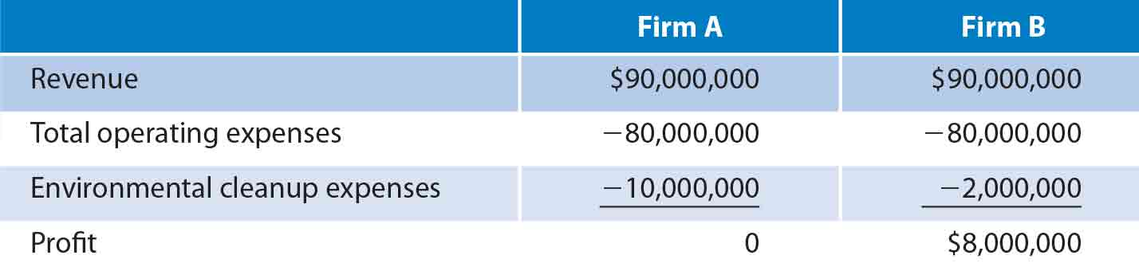
Figure 4 Effect of environmental expenses on business performance

Responsibility to the Community
When firms establish a base in a community, they become part of that community and rely on it for customers and employees.

Satisfying the community versus stockholders
The decisions of a firm’s managers that maximize social responsibility could conflict with maximizing firm value. The costs involved in achieving such a goal will have to be passed on to consumers. Attempts to maximize responsibility to the community may reduce the firm’s ability to provide products at a reasonable price.
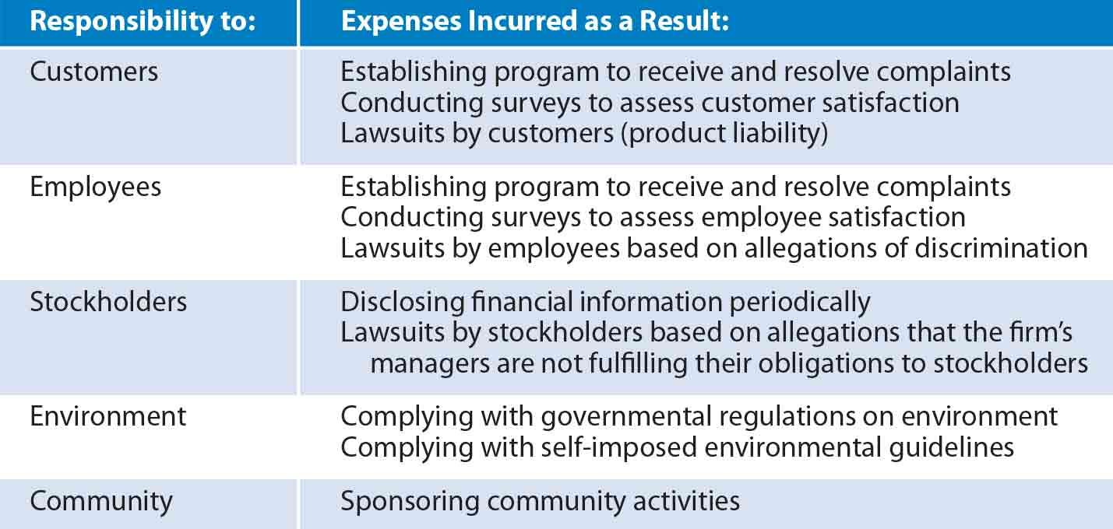
Figure 5 Possible expenses incurred as a result of social responsibilities

Chapter 3 – Managing Effectively

Levels of Management
- Top (high-level) management: Managers in positions such as president, chief executive officer, chief financial officer, and vice-president who make decisions regarding the firm’s long-run objectives.
- Middle management: Managers who are often responsible for the firm’s short-term decisions.
- Supervisory management: Managers who are usually highly involved with the employees who engage in the day-to-day production process.
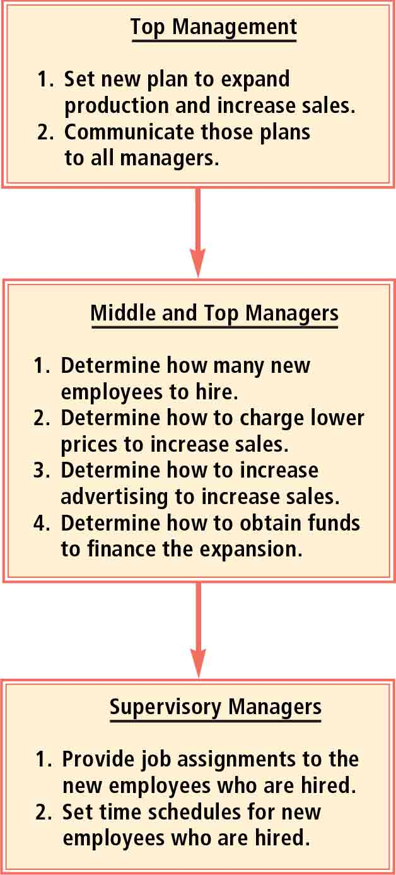
Figure 6 Comparison of responsibilities among managers

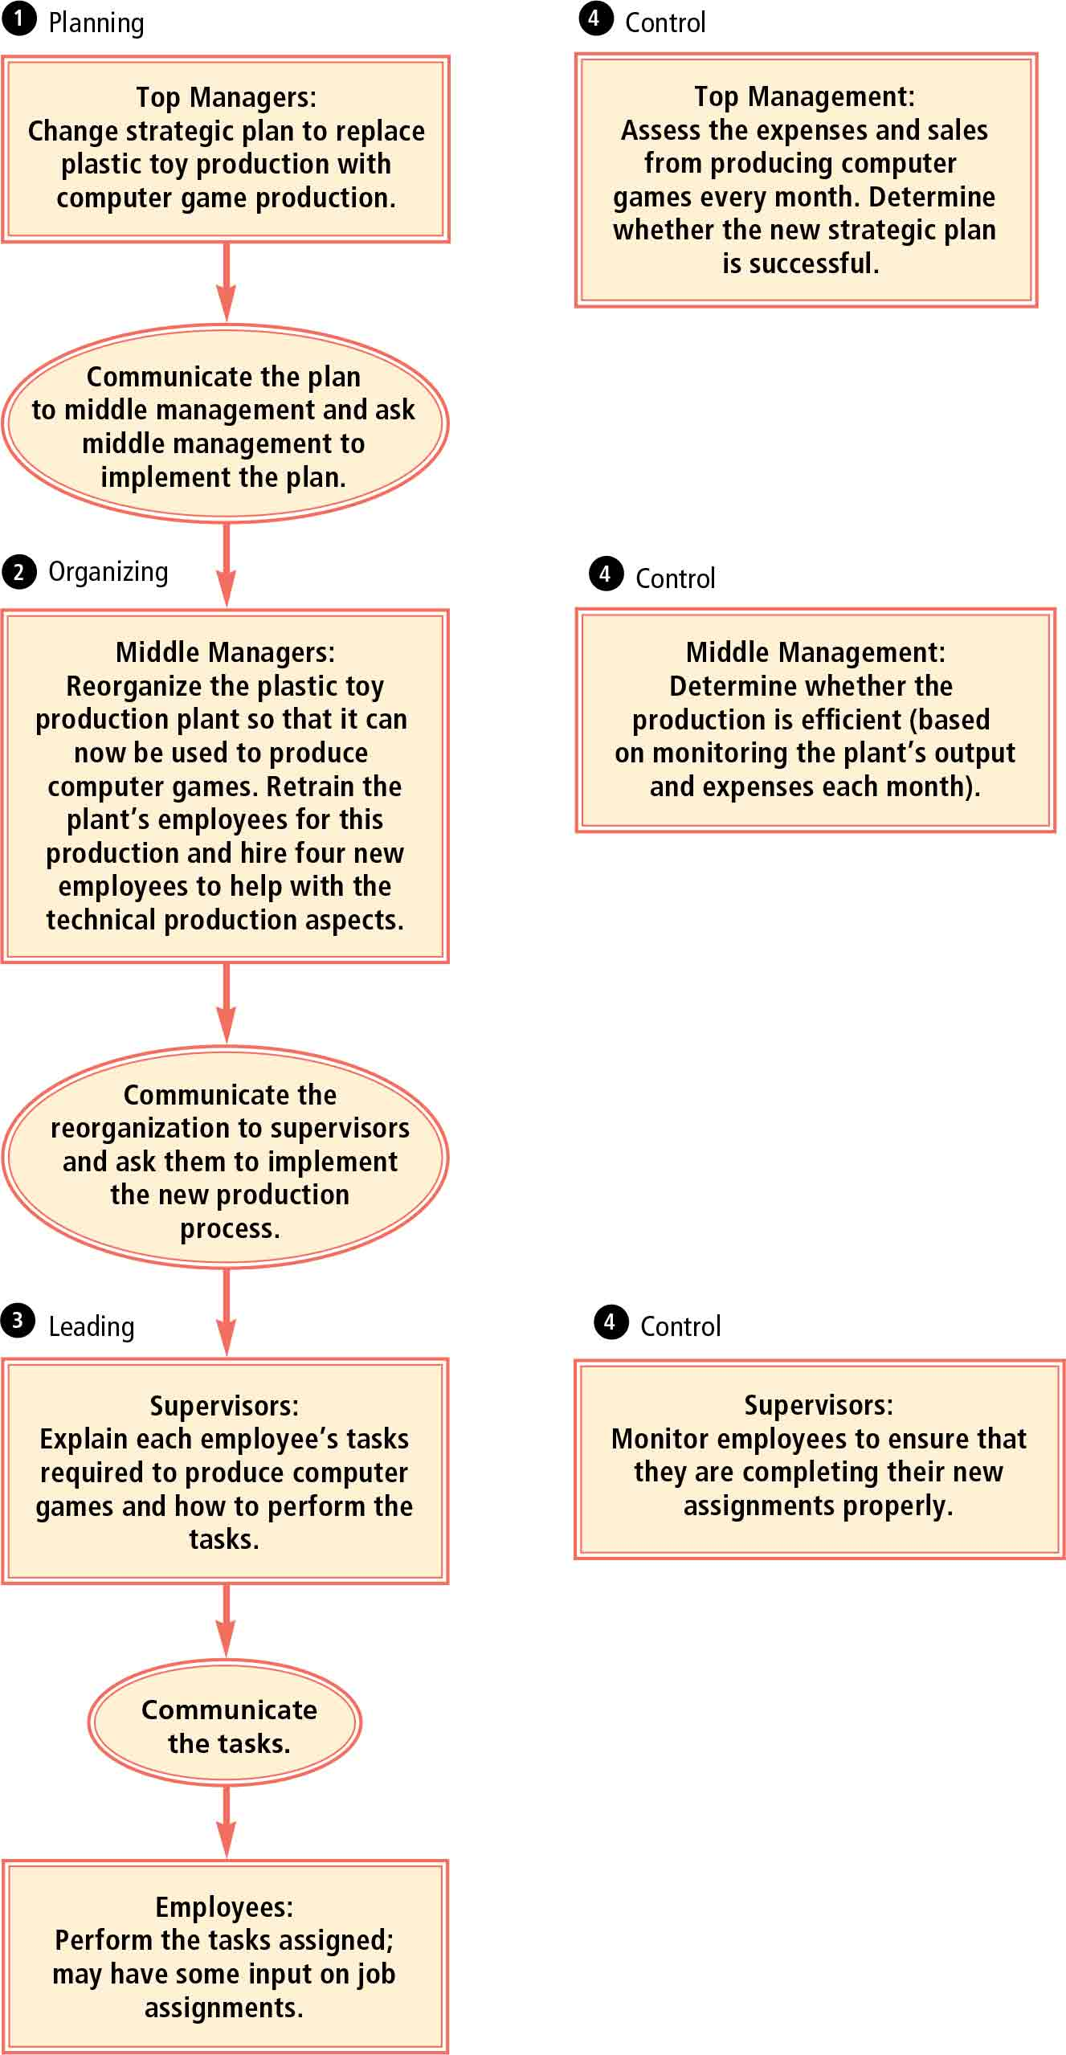
Functions of Managers
- Planning: The preparation of a firm for future business conditions.
  - Missing statement: A description of a firm’s primary goal.
  - Strategic plan: Identifies a firm’s main business focus over a long-term period, perhaps three to five years.
  - Tactical planning: Smaller-scale plans (over one or two years) that are consistent with the firm’s strategic (long-term) plan.
  - Operational planning: Establishes the methods to be used in the near future (such as the next year) to achieve the tactical plans.
    - Policies: Guidelines for how tasks should be completed.
    - Procedures: Steps necessary to implement a policy.
  - Contingency planning: Alternative plans developed for various possible business conditions.
- Organizing: The organization of employees and other resources in a manner that is consistent with the firm’s goals.
- Leading: The process of influencing the habits of others to achieve a common goal.
  - Autocratic: A leadership style in which the leader retains full authority for decision making.
  - Free-rein: A leadership style in which the leader delegates much authority to employees.
  - Participative: A leadership style in which the leaders accept some employee input but usually use their authority to make decisions.
- Controlling: The monitoring and evaluation of tasks.
  - Control used to correct deficiencies
  - Control used to correct standards
  - Control of management process
  - Control of reporting

Use of technology to improve management functions
Technology facilitates the integration of management functions.
- Planning: Input from various managers through an online network.
- Plans are immediately communicated to managers everywhere.
- Decide how to achieve the plans that have been established.
- Perform leading function by offering instructions to employees, some online some personally.
- Online network can be used to conduct the controlling function.

Software to improve management functions
- Personnel hiring: Software for screening job applicants, based upon psychological principles.
- Personnel evaluation: Software that helps construct and write reviews and record employee progress toward goals.
- General management: Software to assist managers in day-to-day management like scheduling and keeping track of information.
- Negotiating: Software that employ psychological models to help managers negotiate.
- Decision making: Software that help make rational decisions.
- Creativity: Software designed to stimulate managerial creativity.

Managerial Skills
- Conceptual (analytical) skills: The ability to understand the relationships among the various tasks of a firm.
  - Commonly used by top and middle management not directly involved in the production process. These skills are necessary to optimally utilize employees and resources in a manner that can achieve a firm’s goals.
- Interpersonal skills: The skills necessary to communicate with customers and employees.
  - Communication with customers: Listen to complaints, respond in an acceptable manner. Ability to ask good questions is key.
  - Communication with employees: Clearly communicate assignments and errors. Must also listen to complaints.
- Technical skills: Skills used to perform specific day-to-day tasks.
  - Managers close to the production process use these the most.
- Decision-making skills: Skills for using existing information to determine how the firm’s resources should be allocated.
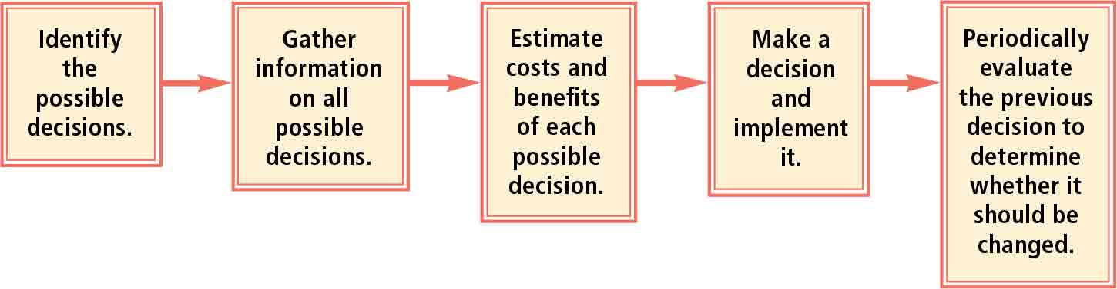
Figure 7 Steps involved in making decisions

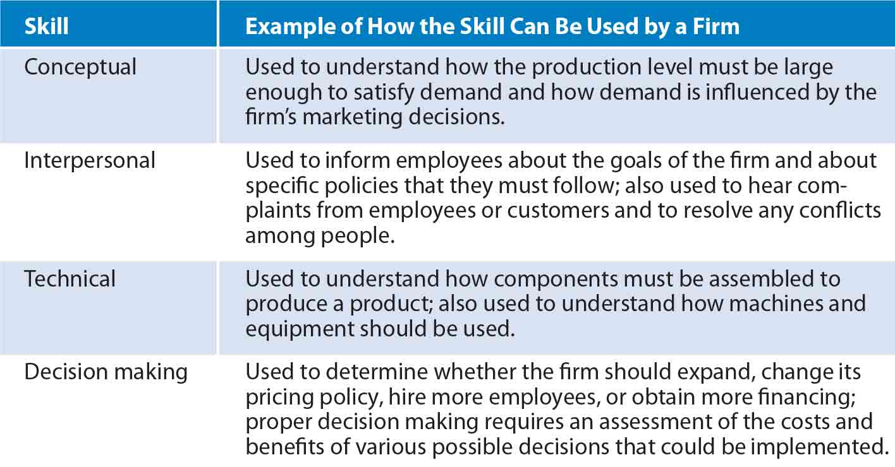

Managing Time

Time management: The way managers allocate their time when managing tasks.
- Set proper priorities
- Schedule long time intervals for large tasks
- Minimize interruptions
- Set short-term goals
- Delegate some tasks to employees

Chapter 4 – Organizational Structure

Organizational structure: Identifies responsibilities for each job position and the relationship among those positions.
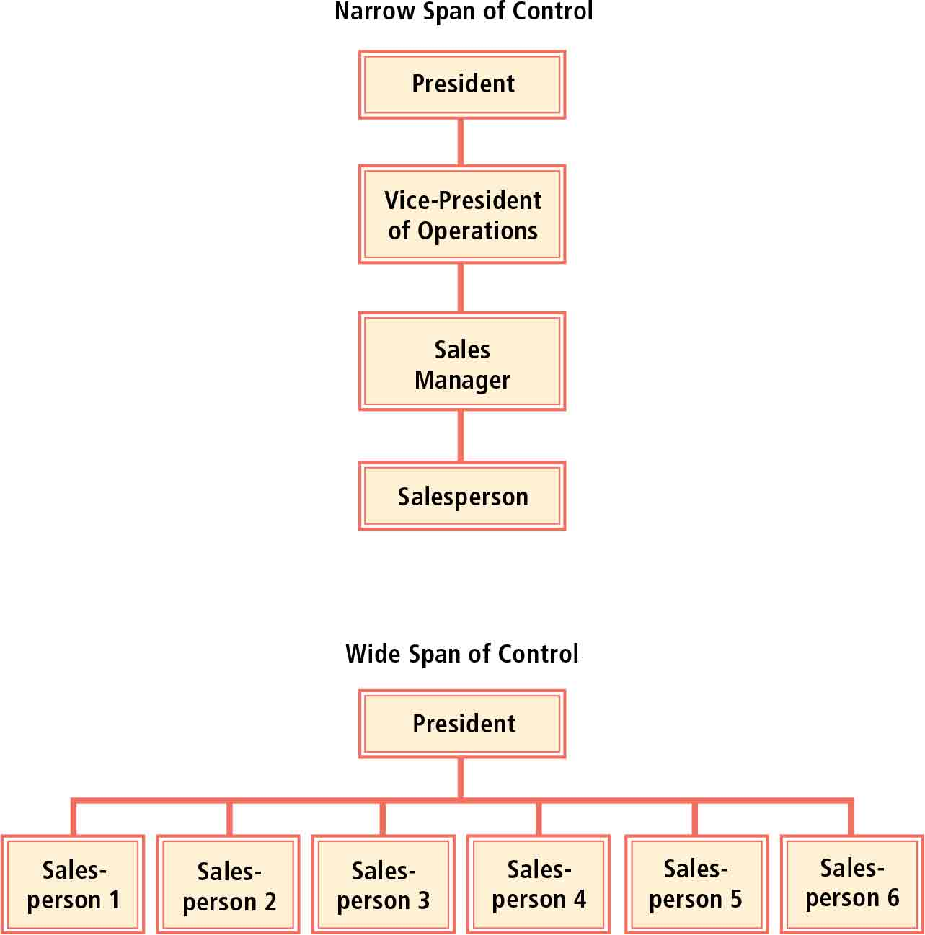
Chain of command: Identifies the job position to which each type of employee must report. Can be used to ensure that managers make decisions that maximize the firm’s value rather than serve their own interests.

How organizational structure varies among firms
- Span of control: The number of employees managed by each manager.
  - Narrow span of control: Each manager supervises just a few employees.
  - Wide span of control: Each manager supervises numerous employees.
- Organizational height:
  - Tall organizational structure: Many layers from the bottom to the top.
  - Short (flat) organizational structure: Not much distance between the bottom and the top.
- Line versus staff positions: How job positions are classified.
  - Line positions: Job positions established to make decisions that achieve specific business goals.
  - Staff positions: Job positions established to support the efforts of line positions.
  - Line organization: An organizational structure that contains only line positions and no staff positions. Appropriate for business that can’t afford to hire staff for support.
  - Line-and-staff organization: An organizational structure that includes both line and staff positions and assigns authority from higher-level management to employees.
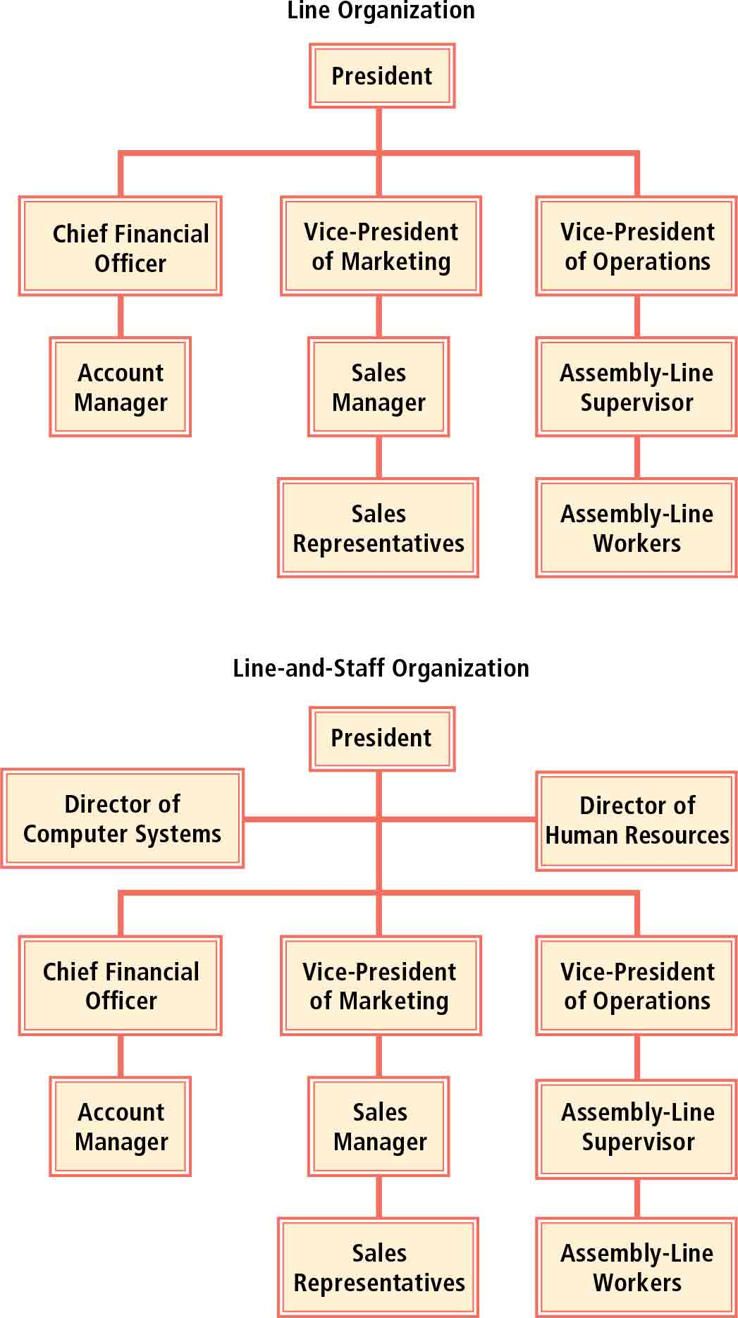

Accountability in an Organizational Structure
- Managers: Evaluate the employees and make them accountable for fulfilling their responsibilities.
- High-level managers: Accountable for general performance of the firm. Make key decisions regarding product line, production process, compensation system, marketing, and financing.
- Board of directors + auditors: Ensure that firms achieve accountability.
Board of directors: A set of executives who are responsible for monitoring the activities of the firm’s president and other high-level managers. Also responsible for supervising the business and affairs of the firm. Focuses on major issues and is not involved in day-to-day activities of the firm.
Inside board members: Board members who are also managers of the same firm.
Outside board members: Board members who are not managers of the firm.
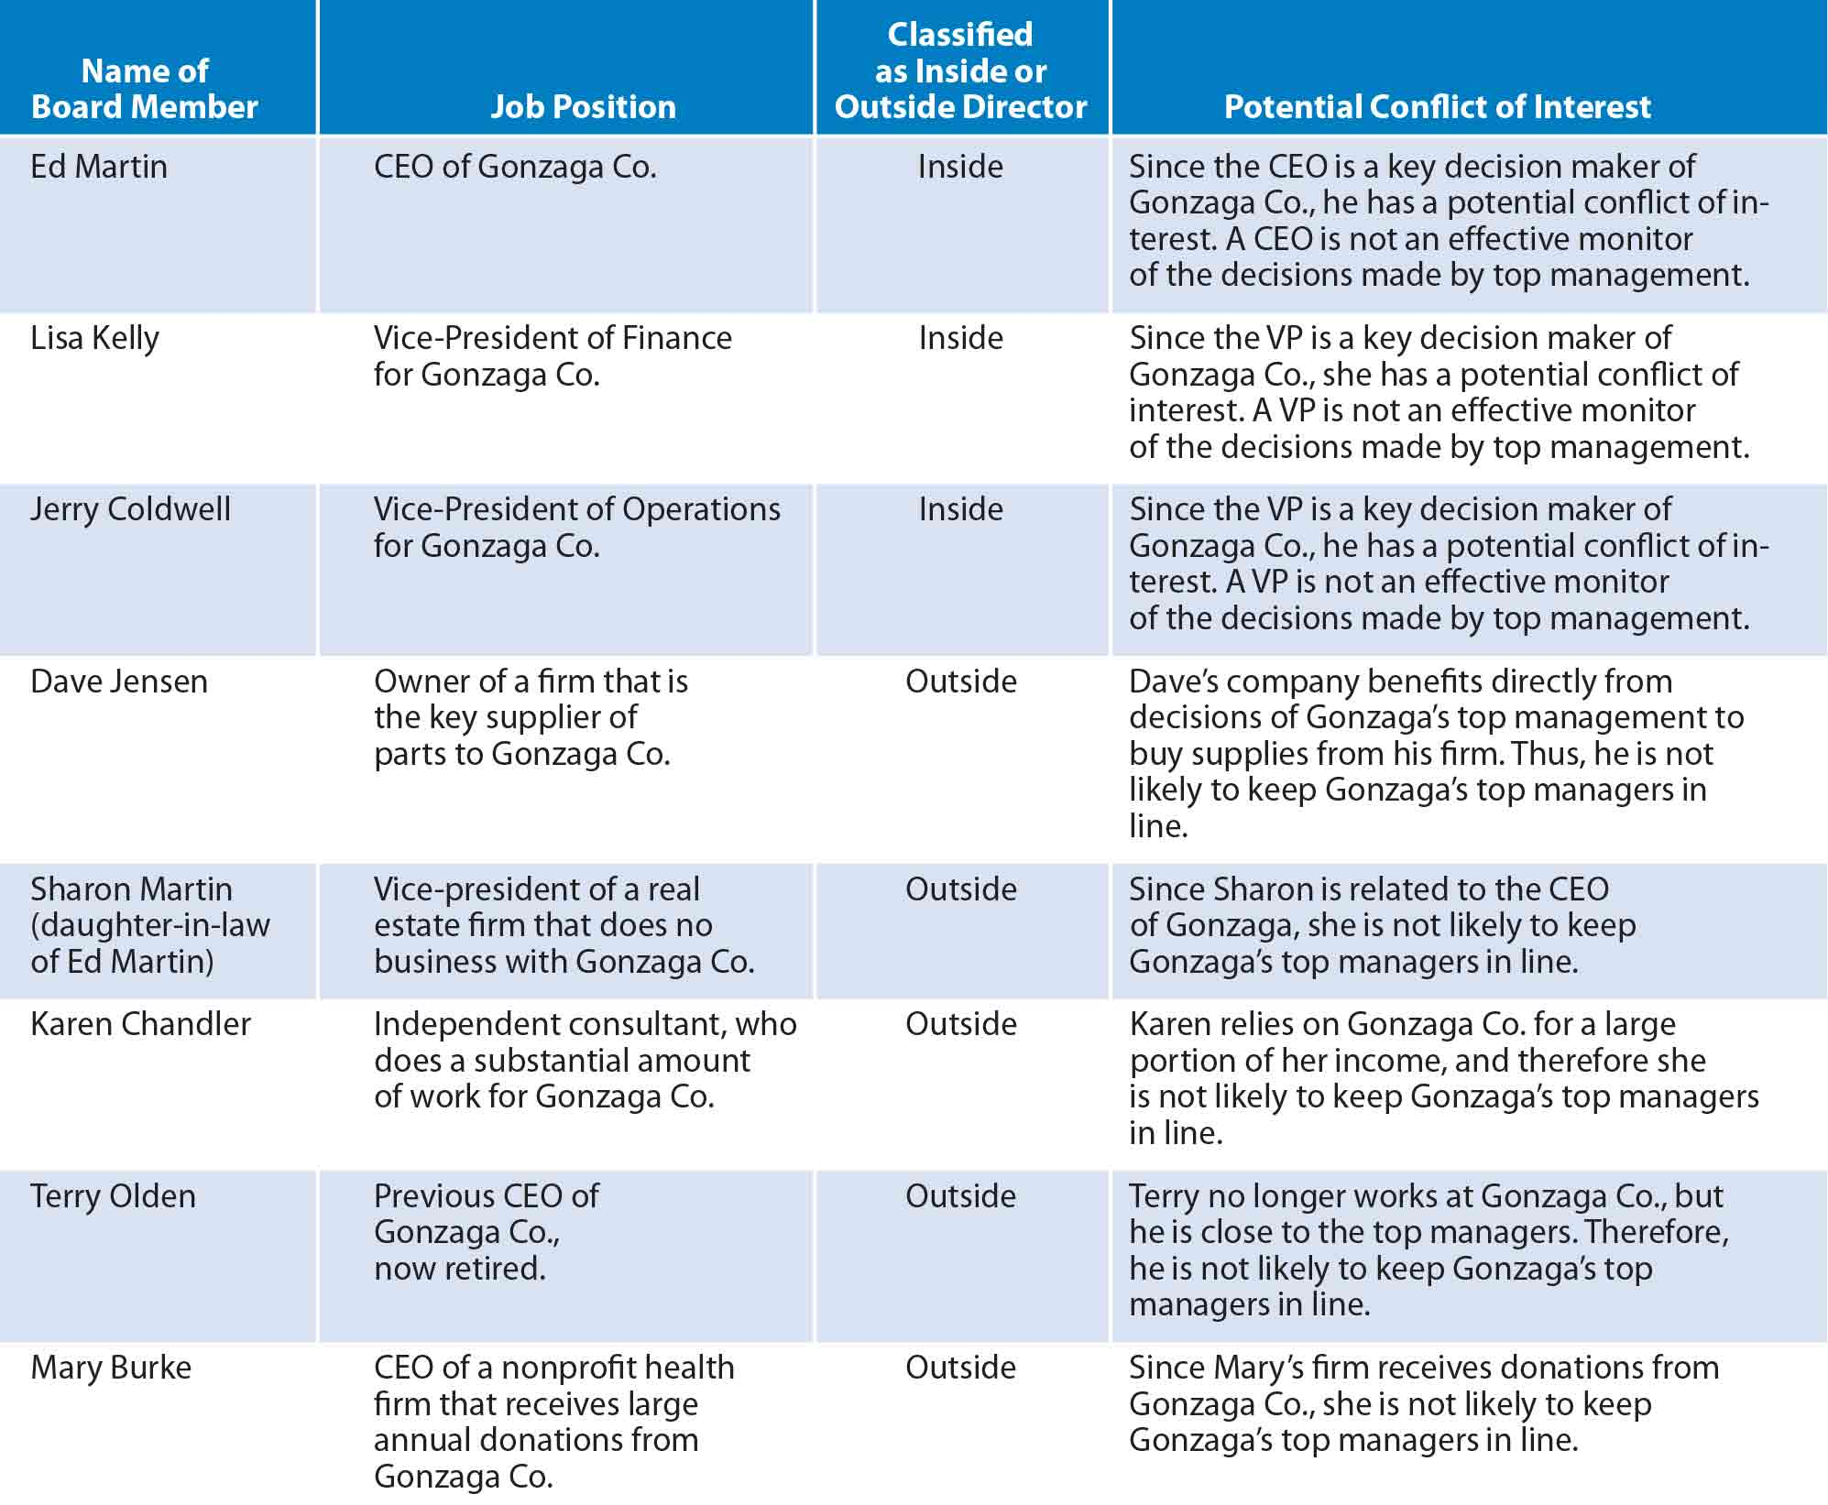
Figure 8 Examples of conflicts of interest within the board
Board committees: Committees made up of members of the board of directors given specific assignments to ensure proper oversight of the firm. Commonly consist of only independent board members to ensure no conflicts of interest.
- Compensation committee: Reviews existing salaries and compensation formulas for high-level managers.
- Nominating committee: Assesses whether the existing board members have the knowledge and skills necessary to be effective; make recommendations to the board of directors about the size and composition of the board.
- Audit committee: Oversees the hiring and work of an external auditor that audits the firm’s financial statements
Internal auditor: Responsible for ensuring that all departments follow the firm’s guidelines and procedures.
Internal control process:
- Establishing a centralized database of information.
- Ensuring that all data reported by each division are reviewed for accuracy.
- Implementing a system that detect possible errors in the data.
- Acknowledging the risk associated with specific business operations.
- Ensuring that all departments are using consistent data.
- Speeding the process by which data are transferred among departments.
- Having their executives sign off on specific financial statements to verify their accuracy.

Distributing Authority Among the Job Positions

- Centralized: Most authority is held by the high-level managers.
- Decentralized: Authority is spread among several divisions or managers.
  - Autonomy: Divisions can make their own decisions and act independently.
  - Decentralization reduces operating expenses because salaries of some employees no longer needed are eliminated.
  - Decentralization can shorten the decision-making process because lower level employees are assigned more power, thus don’t have to wait for approval from top management.
  - Delegation of authority can improve the morale of employees, who may be more enthusiastic about their work with more responsibilities.
  - Could force some managers to make major decisions even though they lack the experience.
  - Excessive responsibilities may lead to inability to complete all tasks.
Proper degree of decentralization is dependent on the skills of the managers who could be assigned more responsibilities. Beneficial only when managers are competent.
Downsizing: An attempt by a firm to cut expenses by eliminating job positions. Downsizing affects each manager’s span of control.
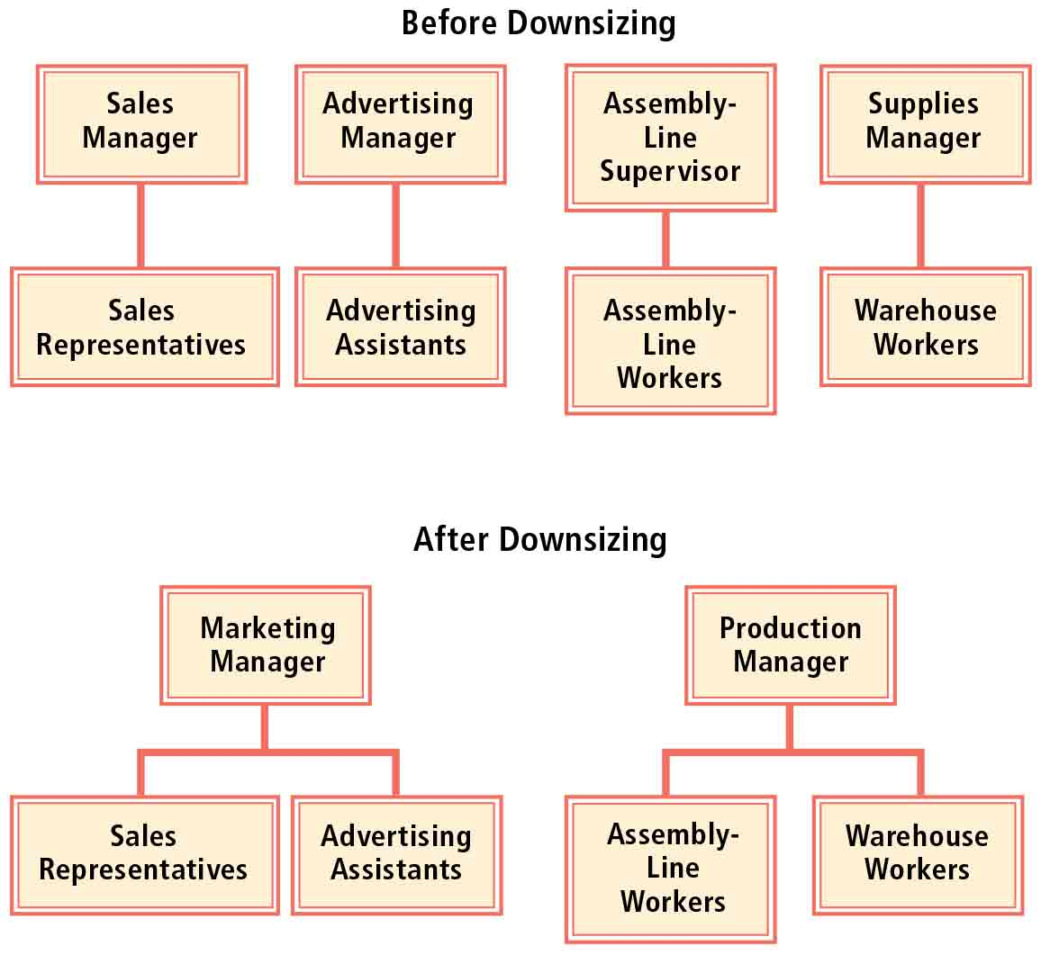
Figure 9 Effect of downsizing on span of control

Structures that Allow more Employee Input
- Matrix organization: An organizational structure that enables various parts of the firm to interact to focus on specific projects. Participants can continue to perform their normal tasks and are still accountable to the same boss for those tasks.
  - Brings together employees who can offer insight from different perspective.
  - No employee may feel responsible.
  - Any time used to participate in projects reduces time allocated for normal tasks.
  - Ultimate responsibility not clear.
- Intrapreneurship: The assignment of particular employees of a firm to generate ideas, as if they were entrepreneurs running their own firms.
  - Allows firms to be more innovative because employees are encouraged to search for new ideas.
  - Can pull employees away from day-to-day tasks.
- Informal organizational structure: An informal communications network among a firm’s employees.
  - Encourages communication in a less formal environment. Employees may be more willing to provide feedback in an informal environment because they realize manager is truly interested in their opinions.
  - Employees who need held in performing a task may benefit from others.
  - May encourage friendship among employees.
  - May obtain incorrect or unfavorable information about the firm.

Departmentalizing Tasks
- By function: Allocate their tasks and responsibilities according to employee functions.
- By product: Tasks and responsibilities are separated according to the type of product produced.
- By location: Establishing regional offices to cover specific geographic regions. It can more easily estimate the expenses incurred at each location.
- By customer: Establish divisions based on the type of customer.

Chapter 5 – Improving Productivity and Quality

Production process (conversion process): A series of tasks in which resources are used to produce a product or service.
Production management (operations management): The management of a process in which resources (such as employees and machinery) are used to produce products and services.
The main resources that firms use for the production process are:
- Human resources: Firms must identify the type of employees needed for production. Skilled vs unskilled.
- Materials: The materials used in the production process, normally transformed by the firm’s human resources into a final product.
- Other resources: Building, machinery, equipment, etc.
Managers attempt to utilize the resources in a manner that achieves production at a low cost.
- Work station: An area in which one or more employees are assigned a specific task.
- Assembly line: A sequence of work stations in which each work station is designed to cover specific phases of the production process.

Selecting a Site

Factors affecting the site decision
- Cost of workplace space
- Cost of labor
- Tax incentives
- Source of demand
- Access to transportation
- Supply of labor

Evaluating possible sites
- Choice of location
- Restrictive leases

Design and Layout

Design: The size and structure of a plant or office.
Layout: The arrangement of machinery and equipment within a factory or office.

Factors affecting design and layout
- Site characteristics
- Production process:
  - Product layout: A layout in which tasks are positioned in the sequence that they are assigned.
  - Fixed-position layout: A layout in which employees go to the position of the product, rather than waiting for the product to come to them.
  - Flexible manufacturing: A production process that can be easily adjusted to accommodate future revisions.
- Product line: As market preferences change, demand for products change. The layout must be revised to accompany these changes.
  - Narrow product line: Focus on production of one or a few products, allows specialization.
  - Broad product line: Offer a wide range of products.
- Desired production capacity
  - Hoteling (just-in-time office): Providing an office with a desk, a computer, and a telephone for any employee who normally works at home but needs to use work space at the firm.

Production Control
- Purchasing materials
  - Selecting a supplier: Consider price, speed, quality, servicing, and credit availability.
    - Approach: Obtain prices, receive sample and inspect quality, ask to provide further information on speed of delivery and service warranties, single out and evaluate reliability over time. Or use a few suppliers simultaneously. E-procurement may be an important factor too.
  - Obtaining volume discounts
  - Delegating production to suppliers:
    - Outsourcing: Purchasing parts from a supplier rather than producing the parts. Reduces firm’s expenses. However, places more responsibility on other manufacturing companies.
    - Deintegration: The strategy of delegating some production tasks to suppliers.
  - Electronic payments for supplies
- Inventory control: The process of managing inventory at a level that minimized costs.
  - Control of materials inventories: When firms carry excessive inventories of materials, they may need to borrow more funds to finance these inventories.
    - Carrying costs: Costs of maintaining (carrying) inventories.
    - Order costs: Costs involved in placing orders for materials.
    - Just-in-time (JIT): A system that attempts to reduce materials inventories to a bare minimum by frequently ordering small amounts of materials.
    - Materials requirements planning (MR): A process for ensuring that materials are available when needed.
  - Control of work-in-process inventories: Attempt to avoid shortages of all types of products.
    - Work-in-process inventories: Inventories of partially completed products.
  - Control of finished goods inventories: Monitor anticipated supply differential. Inventory decisions may adjust during the year due to seasonal demand. If an excess supply is anticipated, excessive inventories can be prevented by redirecting resources toward the production of other products.
- Routing: The sequence (or route) of tasks necessary to complete the production of a product. Periodically evaluated to determine whether it can be improved.
- Scheduling: The act of setting time periods for each task in the production process.
  - Production schedule: A plan for the timing and volume of production tasks.
  - ERP: Enterprise Resource Planning systems, connect to computer systems from different departments.
  - Gantt chart: A chart illustrating the expected timing for each task in the production process.
  - Program evaluation and review technique (PERT): A method of scheduling tasks to minimize delays in the production process. Steps:
    - The various tasks involved in the production process are identified.
    - The tasks are arranged in the order in which they must take place.
    - The time needed for each activity is estimated.
  - Critical path: The path that takes the longest time to complete.
- Quality control: A process of determining whether the quality of a product meets the desired quality level.
    - Quality: The degree to which a product or service satisfies a customer’s requirements or expectations.
    - Total quality management (TQM): The act of monitoring and improving the quality of products and services provided.
  - Control by technology: Use of technology to assess quality.
  - Control by employees: Use of employees to assess quality.
    - Quality control circle: A group of employees who assess the quality of a product and offer suggestions for improvement.
  - Control by sampling:
    - Sampling: Randomly selecting some of the products produced and testing them to determine whether they satisfy the quality standards.
  - Control by monitoring complaints
  - Correcting deficiencies: Correct quality deficiencies.

Improving Production Efficiency

- Production efficiency: The ability to produce products at a low cost.
    - Benchmarking: A method of evaluating performance by comparison to some specified (benchmark) level, typically a level achieved by another company.
    - Stretch targets: Production efficiency targets (or goals) that cannot be achieved under present conditions.
  - Technology
    - Automated: Tasks are completed by machines without the use of employees.
  - Economies of scale: As the quantity produces increases, the cost per unit decreases.
    - Fixed costs: Operating expenses that do not change in response to the number of products produced.
    - Variable costs: Operating expenses that very directly with the number of products produced.
    - Break-even point: The quantity of units sold at which total revenue equals total cost.
  - Restructuring: The revision of the production process in an attempt to improve efficiency.
    - Reengineering: The redesign of a firm’s organizational structure and operations.
    - Downsizing: An attempt by a firm to cut expenses by eliminating job positions.
    - Corporate anorexia: The problem that occurs when firms become so obsessed with eliminating their inefficient components that they downsize too much.
Supply chain: The process from the beginning of the production process until the product reaches the customer.

Chapter 6 – Motivating Employees

Theories on Motivation

Job satisfaction: The degree to which employees are satisfied with their jobs.

Maslow’s Hierarchy of Needs
Hierarchy of needs: Needs are ranked in five general categories. Once a given category of needs is achieved, people become motivated to reach the next category.
Psychological needs: The basic requirements for survival.
Safety needs: Job security and safe working conditions.
Social needs: The need to be part of a group.
Esteem needs: Respect, prestige, and recognition.
Self-actualization: The need to fully reach one’s potential.
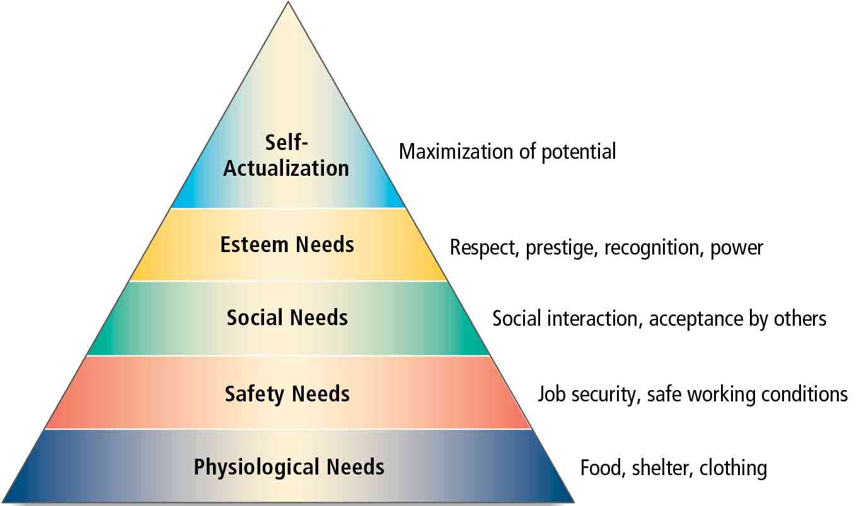
Figure 10 Maslow's Hierarchy of Needs

Herzberg’s Job Satisfaction Study
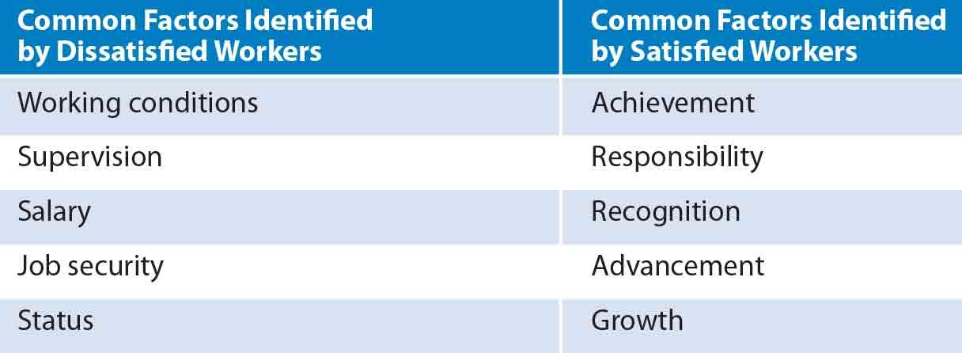
Figure 11 Hygiene factors (left) Motivational factors (right)
Hygiene factors: Work-related factor that can fulfill basic needs and prevent job dissatisfaction.
Motivational factors: Work-related factors that can lead to job satisfaction and motivate employees.

McGregor’s Theory X and Theory Y
Theory X | Theory Y
Employees dislike work and job responsibilities and will avoid work if possible | Employees are willing to work and prefer more responsibility
Supervisors cannot delegate responsibilities | Supervisors should delegate responsibilities, which will satisfy and motivate employees

Theory Z: Partially based on the Japanese style of allowing all employees to participate in decision making. Participation can increase job satisfaction because it gives employees responsibility.

Expectancy theory: Holds that an employee’s efforts are influenced by the expected outcome (reward) for those efforts.

Equity theory: Suggests that compensation should be equitable, or in proportion to each employee’s contribution.

Reinforcement theory: Suggests that reinforcement can influence behavior.
Positive reinforcement: Motivates employees by providing rewards for high performance.
Negative reinforcement: Motivates employees by encouraging them to behave in a manner that avoids unfavorable consequences.

Improving Employee Motivation

Job enrichment programs: Programs designed to increase the job satisfaction of employees.
- Adequate compensation program
  - Merit system: A compensation system that allocates raises according to performance (merit)
  - Across-the-board system: A compensation system that allocates similar raises to all employees.
  - Incentive plans: Provide employees with various forms of compensation if they meet specific performance goals.
  - Developing a proper compensation plan:
    - Align the compensation plan with business goals
    - Align compensation with specific employee goals
    - Establish achievable goals for employees
- Job security
- Flexible work schedule
  - Flextime programs: Programs that allow for a more flexible work schedule.
  - Compressed workweek: Compresses the workload into fewer days per week.
  - Job sharing: Two or more persons share a particular work schedule.
- Employee involvement programs
  - Job enlargement: A program to expand the jobs assigned to employees.
  - Job rotation: A program that allows a set of employees to periodically rotate their job assignments.
  - Empowerment: Allowing employees the power to make more decisions.
  - Participative management: Employees are allowed to participate in various decisions made by their supervisors or others.
  - Management by objectives (MBO): Allows employees to participate in setting their goals and determining the manner in which they complete their tasks.
  - Teamwork: A group of employees with varies job positions have the responsibility to achieve a specific goal.
  - Open-book management: A form of employee involvement that educates employees on their contribution to the firm and enables them to periodically assess their won performance levels.

Chapter 7 – Hiring, Training, and Evaluation Employees

- Human resource planning: Planning to satisfy a firm’s needs for employees.
  - Forecasting staffing needs
  - Job analysis: The analyses used to determine the tasks and the necessary credentials for a particular position.
    - Job specification: States the credentials necessary to qualify for a job position.
    - Job description: States the tasks and responsibilities of a job position.
  - Recruiting:
    - Human resource manager: Helps each specific department recruit candidates for its open positions.
    - Internal recruiting: An effort to fill open positions with persons already employed by the firm.
    - Promotion: The assignment of an employee to a higher-level job with more responsibility and compensation.
    - External recruiting: An effort to fill positions with applicants from outside the firm
    - Screening applicants:
      - Step 1: Assess each application to screen out unqualified applicants.
      - Step 2: Interview process.
      - Step 3: Contact the applicant’s references.
      - Step 4: Employment test: A test of a job candidate’s abilities.

Providing Equal Opportunity
Benefits of diversity:
- More innovative
- More likely to understand points of view and be capable of interacting with a diverse set of customers
- Larger proportion of eligible employees will be from minority groups in the future

Compensation Packages: The total momentary compensation and benefits offered to employees.
- Salary: The dollars paid for a job over a specific period.
- Stock options: A form of compensation that allows employees to purchase shares of their employer’s stock at a specific price.
- Commissions: Compensation for meeting specific sales objectives.
- Bonuses: An extra onetime payment at the end of a period in which performance was measured.
- Profit sharing: A portion of the firm’s profits is paid to employees.
- Employee benefits: Additional privileges beyond compensation payments, such as paid vacation time; health, life, or dental insurance; and pension programs.
- Perquisites: Additional privileges beyond compensation payments and employee benefits.

Developing skills of employees
- Technical skills: Employees must be trained to perform the various tasks they engage in daily.
- Decision-making skills: Providing employees with some guidelines to consider when making decisions and generating ideas.
- Customer service skills: Employees who frequently deal with customers need to have customer service skills.
- Safety skills: Educate employees about safety within the work environment.
- Human relations skills: Training seminars may be necessary for supervisors who lack skills in managing other employees.

Evaluation of Employee Performance
- Communication of responsibilities
- Communication of deficiencies
- Communication of evaluations
Upward appraisals: Used to measure the managerial abilities of supervisors.

