Organizational Behavior

Table of Contents
What is Organizational Behavior? 1
The Importance of Interpersonal Skills 1
What Managers Do 1
Management Functions 1
Management Roles 1
Management Skills 2
Effective versus Successful Managerial Activities 2
Enter Organizational Behavior 3
Complementing Intuition with Systematic Study 3
Disciplines That Contribute to the OB Field 4
Challenges and Opportunities for OB 5
Coming Attractions: Developing an OB Model 5
An Overview 5
Inputs 5
Processes 5
Outcomes 5
Diversity in Organization 7
Diversity 7
Levels of Diversity 7
Discrimination 7
Biographic Characteristics 7
Ability 7
Implementing Diversity Management Strategies 7
Effective Diversity Programs 8
Attitudes and Job Satisfaction 9
Attitudes 9
Main Components of Attitudes 9
Does Behavior Always Follow from Attitudes? 9
Major Job Attitudes 9
Job Satisfaction 9
Measuring Job Satisfaction 9
What Causes Job Satisfaction? 10
The Impact of Satisfied and Dissatisfied Employees on the Workplace 10
Personality and Values 11
Personality Frameworks 11
Myers-Briggs Type Indicator (MBTI) 11
Big Five Mode 11
Dark Triad 12
Other Personality Attributes Relevant to OB 12
Core self-evaluation (CSE) 12
Self-monitoring 12
Proactive personality 12
Personality and Situations 12
Situation Strength Theory 12
Values 12
Terminal versus Instrumental Values 13
Linking an Individual’s Personality and Values to the Workplace 13
Personality-job fit theory 13
Person-organization fit 13
Cultural Values 13
Hofstede’s Framework 13
Perception and Individual Decision Making 14
What is Perception? 14
Factors that influence Perception 14
Person Perception: Making Judgments About Others 14
Attribution Theory 14
Common Shortcuts in Judging Others 15
Specific Applications of Shortcuts in Organizations 15
The Link Between Perception and Individual Decision Making 15
Decision Making in Organizations 15
The Rational Model, Bounded Rationality, and Intuition 15
Common Biases and Errors in Decision Making 15
Influences on Decision Making 16
Individual Differences 16
Organizational Constraints 16
Ethics in Decision Making 16
Three Ethical Decision Criteria 16
Improving Creativity in Decision Making 17
Motivation: From Concepts to Applications 18
The Job Characteristics Model 18
The Job Characteristics Model 18
Job Redesign 18
Job Rotation 18
Relational Job Design 18
Alternative Work Arrangements 18
Job Sharing 19
Telecommuting 19
Employee Involvement and Participation 19
Examples of Employee Involvement Programs 19
Using Rewards to Motivate Employees 19
Rewarding Individual Employees through Variable-Pay Programs 20
Using Benefits to Motivate Employees 20
Using Intrinsic Rewards to Motivate Employees 20
Employee recognition program 20

What is Organizational Behavior?

The Importance of Interpersonal Skills

- Developing managers’ interpersonal skills also helps organizations attracts and keep high-performing employees.
- Having managers with good interpersonal skills is likely to make the workplace more pleasant, thus making it easier to hire and keep qualified people.
- Companies with reputations as good places to work have been found to generate superior financial performance.

What Managers Do

- Managers get things done through other people.
  - They make decisions
  - Allocate resources
  - Direct the activities of others to attain goals
  - They do their work in an organization, which is a consciously coordinated social unit, composed of two or more people, that functions on a relatively continuous basis to achieve a common goal or set of goals.
  - Sometimes called administrators, especially in not-for-profit organizations.

Management Functions
Managers perform four management functions:
- Planning: A process that includes defining goals, establishing strategy, and developing plans to coordinate activities.
- Organizing: Determining what tasks are to be done, who is to do them, how the tasks are to be grouped, who reports to whom, and where decisions are to be made.
- Leading: A function that includes motivating employees, directing others, selecting the most effective communication channels, and resolving conflicts.
- Controlling: Monitoring activities to ensure the are being accomplished as planned and correcting any significant deviations.

Management Roles
Managers perform ten different roles, which are primarily:
- Interpersonal Roles
  - Figurehead role
  - Leadership role
  - Liaison role
- Informational Roles
  - Monitor role
  - Disseminator role
  - Spokesperson
- Decisional Roles
  - Entrepreneur role
  - Disturbance handlers
  - Resource allocators
  - Negotiator
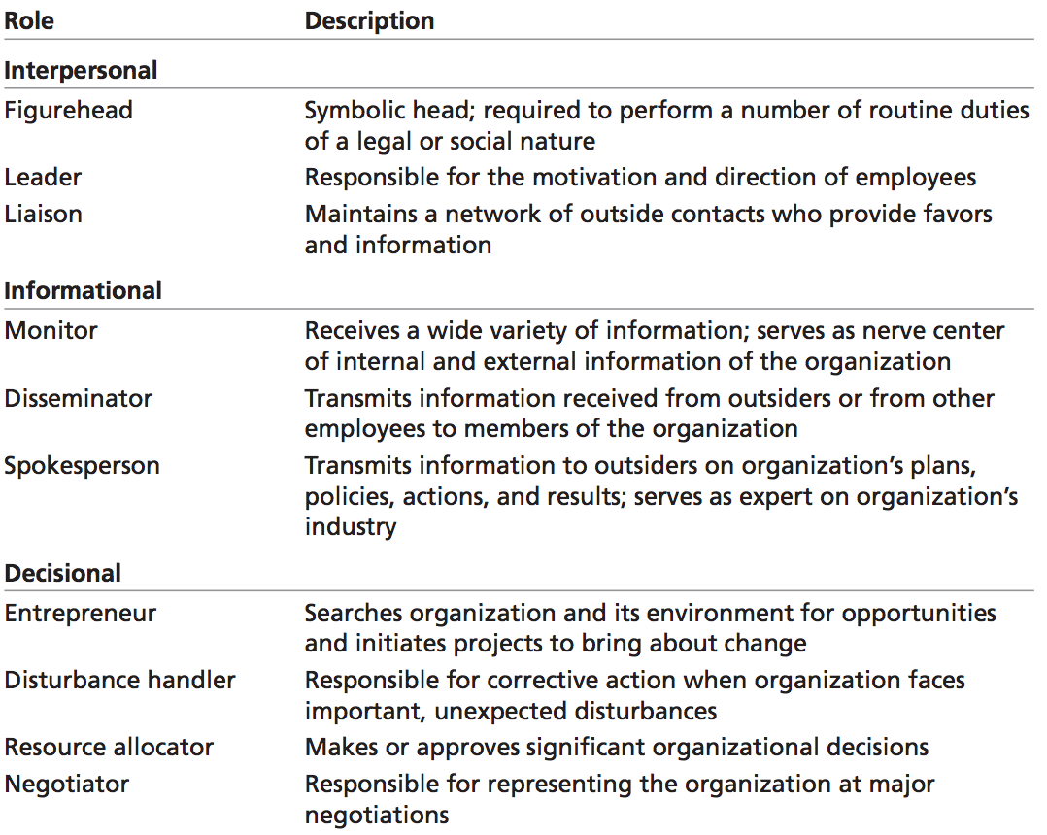

Management Skills
- Technical skills: The ability to apply specialized knowledge or expertise.
- Human skills: The ability to work with, understand, and motivate other people, both individually and in groups.
- Conceptual skills: The mental ability to analyze and diagnose complex situations.

Effective versus Successful Managerial Activities
Four managerial activities:
- Traditional management: Decision making, planning, and controlling.
- Communication: Exchanging routine information and processing paperwork.
- Human resource management: Motivating, disciplining, managing conflict, staffing, and training.
- Networking: Socializing, politicking, and interacting with outsiders.

Enter Organizational Behavior

Organization behavior (OB): A field of study that investigates the impact that individuals, groups, and structure have on behavior within organizations, for the purpose of applying such knowledge toward improving an organization’s effectiveness.

Complementing Intuition with Systematic Study

Systematic study: Looking at relationships, attempting to attribute causes and effects, and drawing conclusions based on scientific evidence.

Evidence-based management (EBM): The basing of managerial decisions on the best available scientific evidence.

Intuition: A gut feeling not necessarily supported by research.

Disciplines That Contribute to the OB Field
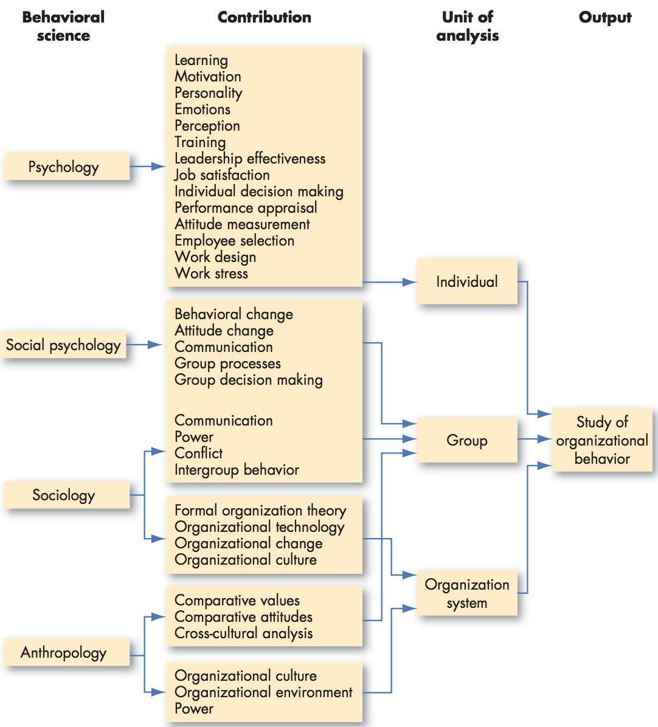

- Psychology: The science that seeks to measure, explain, and sometimes change the behavior of humans and other animals.
- Social psychology: An area of psychology that blends concepts from psychology and sociology and that focuses on the influence of the people on one another.
- Sociology: The study of people in relation to their social environment or culture.
- Anthropology: The study of societies to learn about human beings and their activities.

Contingency variables: Situational factors: variables that moderate the relationship between two or more variables.

Challenges and Opportunities for OB

- Responding to Economic Pressures.
  - During difficult economic times, effective management is often at a premium.
- Responding to Globalization
  - Increased foreign assignments
  - Working with people from different cultures
  - Overseeing movement of jobs to countries with low-cost labor
- Managing Workforce Diversity
  - Workforce diversity: The concept that organizations are becoming more heterogeneous in terms of gender, age, race, ethnicity, sexual orientation, and inclusion of other diverse groups.
- Improving Customer Service
- Improving People Skills
- Stimulating innovation and change
- Coping with temporariness
- Working in networked organizations
- Helping employees balance work-life conflicts
- Creating a positive work environment
  - Positive organizational scholarship: An area of OB research that concerns how organizations develop human strength, foster vitality and resilience, and unlock potential
- Improving ethical behavior
  - Ethical dilemmas and ethical choices: Situations in which individuals are required to define right and wrong conduct.

Coming Attractions: Developing an OB Model

An Overview
Model: An abstraction of reality. A simplified representation of some real-world phenomenon.

Inputs: Variables that lead to processes.

Processes: Actions that individuals, groups, and organizations engage in as a result of inputs and that lead to certain outcomes.

Outcomes: Key factors that are affected by some other variables.
- Attitudes and Stress
- Task performance: The combination of effectiveness and efficiency at doing your core job tasks.
- Citizenship behavior: Discretionary behavior that contributes to the psychological and social environment of the workplace.
- Withdrawal behavior: The set of actions employees take to separate themselves from the organization.
- Group cohesion: The extent to which members of a group support and validate on another while at work.
- Group functioning: The quantity and quality of a work group’s output.
- Productivity: The combination of the effectiveness and efficiency of an organization.
  - Effectiveness: The degree to which an organization meets the needs of its clientele or customers.
  - Efficiency: The degree to which an organization can achieve its ends at a low cost.
- Survival
  - Organizational survival: The degree to which an organization is able to exist and grow over the long term.

Diversity in Organization

Diversity

Levels of Diversity

Surface-level diversity: Differences in easily perceived characteristics, such as gender, race, ethnicity, age, or disability, that do not necessarily reflect the ways people think or feel but that may activate certain stereotypes.

Deep-level diversity: Differences in values, personality, and work preferences that become progressively more important for determining similarity as people get to know one another better.

Discrimination: Noting of a difference between things, often we refer to unfair discrimination, which means making judgments about individuals based on stereotypes regarding their demographic group.

Biographic Characteristics

Biographical characteristics: Personal characteristics, such as age, gender, race, and length of tenure, that are objective and easily obtained from personnel records. These characteristics are representative of surface-level diversity.
- Age
- Sex
- Race and Ethnicity
- Disability
- Others
  - Tenure
  - Religion
  - Sexual orientation and gender identity

Ability

- Intellectual abilities: The capacity to do mental activities, thinking, reasoning, and problem solving.
  - General mental ability (GMA): An overall factor of intelligence, as suggested by the positive correlations among specific intellectual ability dimensions.
- Physical abilities: The capacity to do tasks that demand stamina, dexterity, strength, and similar characteristics.

Implementing Diversity Management Strategies

Diversity management: The process and programs by which managers make everyone more aware of a sensitive to the needs and differences of others.

Effective Diversity Programs
- They teach managers about the legal framework for equal employment opportunity and encourage fair treatment.
- They teach managers how a diverse workforce will be better able to serve a diverse market of customers and clients.
- They foster personal development practices that bring out the skills and abilities of all workers.

Diversity experiences are more likely to lead to positive adaptation for all parties if:
- The diversity experience undermines stereotypical attitudes
- If the perceiver is motivated and able to consider a new perspective on others
- If the perceiver engages in stereotype suppression and generative thought in response to the diversity experience
- If the positive experience of stereotype undermining is repeated frequently

Attitudes and Job Satisfaction

Attitudes

Attitudes: Evaluative statements or judgments concerning objects, people, or events.

Main Components of Attitudes
- Cognitive component: The opinion or belief segment of an attitude.
- Effective component: The emotional or feeling segment of an attitude.
- Behavioral component: An intention to behave in a certain way toward someone or something.

Does Behavior Always Follow from Attitudes?
Cognitive dissonance: Any incompatibility between two or more attitudes or between behavior and attitudes.

Moderating variables: The most powerful moderators of the attitudes relationship are the importance of the attitude, its correspondence to behavior, its accessibility, the presence of social pressures, and whether a person has direct experience with the attitude.

Major Job Attitudes
- Job satisfaction: A positive feeling about one’s job resulting from an evaluation of its characteristics.
- Job involvement: The degree to which a person identifies with a job, actively participates in it, and considers performance important to self-worth.
  - Psychological empowerment: Employees’ belief in the degree to which they affect their work environment, their competence, the meaningfulness of their job, and their perceived autonomy in their work.
- Organizational commitment: The degree to which an employee identifies with a particular organization and its goals and wishes to maintain membership in the organization.
- Perceived organizational support (POS): The degree to which employees believe an organization values their contribution and cares about their well-being.
- Employee engagement: An individual’s involvement with, satisfaction with, and enthusiasm for the work they do.

Job Satisfaction

Measuring Job Satisfaction
Two approaches are popular:
- Single global rating
  - Respondents circle a number between 1 and 5 on a scale from highly satisfied to highly dissatisfied.
- Summation of job facets
  - Identifies key elements in a job such as the nature of the work, supervision, present pay, promotion opportunities, and relationship with co-workers.
  - Employees rate these on a standardized scale.

What Causes Job Satisfaction?
Jobs that provide training, variety, independence, and control satisfy most employees. Interdependence, feedback, social support, and interaction with co-workers outside the workplace are strongly related to job satisfaction. Handsomely compensated jobs have average satisfactions levels no higher than those that pay much less. Money motives people, but doesn’t necessarily make them happy.

Core self-evaluations: Bottom-line conclusions individuals have about their capabilities, competence, and worth as a person.

The Impact of Satisfied and Dissatisfied Employees on the Workplace
- Exit: Dissatisfaction expressed through behavior directed toward leaving the organization.
- Voice: Dissatisfaction expressed through active and constructive attempts to improve conditions.
- Loyalty: Dissatisfaction expressed by passively waiting for conditions to improve.
- Neglect: Dissatisfactions expressed through allowing conditions to worsen.

- Job satisfaction and job performance
  - Happy workers are more likely to be productive workers.
- Job satisfaction and OCB
  - Job satisfaction is moderately correlated with organization citizenship behavior.
- Job satisfaction and customer satisfaction
  - For front-line employees: satisfied employees increase customer satisfaction and loyalty
- Job satisfaction and absenteeism
  - Negative relationship between satisfaction and absenteeism, but it is moderate to weak.
- Job satisfaction and turnover
  - Stronger relationship between job satisfaction and turnover compared to absenteeism.
- Job satisfaction and workplace deviance
  - Job dissatisfaction and antagonistic relationships with co-workers predict a variety of behaviors organizations find undesirable.

Personality and Values

Personality: The sum total of ways in which an individual reacts to an interacts with others.

Heredity: Factors determined at conception; one’s biological, psychological, and inherent psychological makeup.

Personality traits: Enduring characteristics that describe an individual’s behavior.

Personality Frameworks

Myers-Briggs Type Indicator (MBTI): A personality test that taps four characteristics and classifies people into one of 16 personality types.
- Extraverted
- Sensing
- Thinking
- Judging

Big Five Model: A personality assessment model that taps five basic dimensions:
- Conscientiousness: A personality dimension that describes someone who is responsible, dependable, persistent, and organized.
  - Develop higher levels of job knowledge
  - Can prioritize work over family
  - May become too focused on their own work to help others
  - Don’t adapt well to changing contexts
  - May have trouble learning complex skills early in a training process because their focus is on performing well rather than on learning
  - Often less creative
- Emotional stability: A personality dimension that characterizes someone as calm, self-confident, and secure versus nervous, depressed, and insecure.
  - Strongly related to life satisfaction, job satisfaction, and low stress levels
  - Can adapt to unexpected or changing demands in the workplace
  - Tend to experience work-family conflict
- Extraversion: A personality dimension describing someone who is sociable, gregarious, and assertive.
  - Perform better in jobs with significant interpersonal interaction
  - Socially dominant
  - Strong predictor of leadership emergence in groups
  - More impulse than introverts
  - More likely to be absent from work
  - More likely to lie during job interviews
- Openness to experience: A personality dimension that characterizes someone in terms of imagination, sensitivity, and curiosity.
  - More likely to be effective leaders
  - More comfortable with ambiguity
  - Cope better with organizational change and are more adaptable
  - Less susceptible to a decline in performance over a longer time period
  - Experience less work-family conflict
- Agreeableness: A personality dimension that describes someone who is good natured, cooperative, and trusting.
  - Better liked than others
  - Tend to do better in interpersonally-oriented jobs
  - More compliant and rule abiding
  - Less likely to get into accidents
  - More satisfied in their jobs
  - Contribute or organizational performance by engaging in organization citizenship behavior (OCB)

Dark Triad: A constellation of negative personality traits consisting of Machiavellianism, narcissism, and psychopathy.
- Machiavellianism: The degree to which an individual is pragmatic, maintains emotional distance, and believes that ends can justify means.
- Narcissism: The tendency to be arrogant, have a grandiose sense of self-importance, require excessive admiration, and have a sense of entitlement.
- Psychopathy: The tendency for a lack of concern for others and a lack of guilt or remorse when actions cause harm.

Other Personality Attributes Relevant to OB

Core self-evaluation (CSE): Bottom-line conclusions individuals have about their capabilities, competence, and worth as a person.

Self-monitoring: A personality trait that measures an individual’s ability to adjust his or her behavior to external, situational factors.

Proactive personality: People who identify opportunities, show initiative, take action, and preserve until meaningful change occurs.

Personality and Situations

Situation Strength Theory: A theory indicating that the way personality translates into behavior depends on the strength of the situation.
- Clarity
- Consistency
- Constraints
- Consequences

Trait activation theory (TAT): A theory that predicts that some situations, events, or interventions activate a trait more than others.

Values

Values: Basic convictions that a specific mode of conduct or end-state of existence is personally or socially preferable to an opposite or converse mode of conduct or end-state of existence.

Value system: A hierarchy based on a ranking of an individual’s values in terms of the intensity.

Terminal versus Instrumental Values
Terminal values: Desirable end-state of existence, the goals a person would like to achieve during his or her lifetime.

Instrumental values: Preferable modes of behavior or means of achieving one’s terminal values.

Linking an Individual’s Personality and Values to the Workplace

Personality-job fit theory: A theory that identifies six personality types and proposes that the fit between personality type and occupational environment determines satisfaction and turnover.

Person-organization fit: A theory that people are attracted to and selected by organizations that match their values, and leave when there is not compatibility.

Cultural Values

Hofstede’s Framework
- Power distance: A national culture attribute that describes the extent to which a society accepts that power in institutions and organizations in distributed unequally.
- Individualism: A national culture attribute that describes the degree to which people prefer to act as an individual rather than as members of groups.
- Collectivism: A national culture attribute that describes a tight social framework in which people expect others in groups of which they are a part to look after them and protect them.
- Masculinity: A national culture attribute that describes the extent to which the culture favors traditional masculine work roles of achievement, power, and control. Societal values are characterized by assertiveness and materialism.
- Femininity: A national culture attribute that indicates little differentiation between male and female roles; a high rating indicates that women are treated as the equals of men in all aspects of the society.
- Uncertainty avoidance: A national culture attribute that describes the extent to which a society feels threatened by uncertain and ambiguous situations and tries to avoid them.
- Long-term orientation: A national culture attribute that emphasizes the future, thrift, and persistence.
- Short-term orientation: A national culture attribute that emphasizes the present and accepts change.

Perception and Individual Decision Making

What is Perception?

Perception: A process by which individuals organize and interpret their sensory impressions in order to give meaning to their environment.

The world as it is perceived is the world that is behaviorally important.

Factors that influence Perception
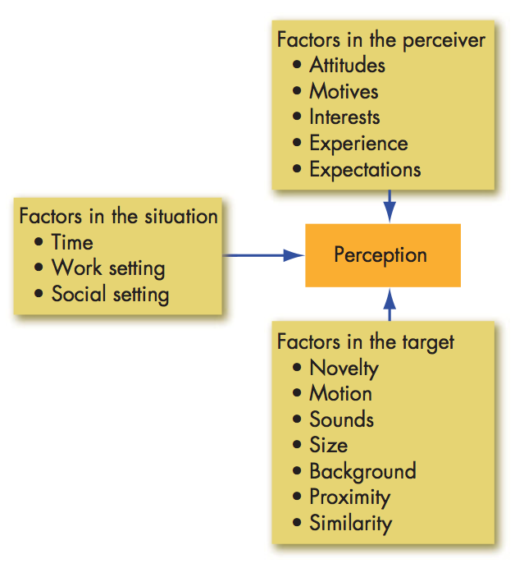

Person Perception: Making Judgments About Others

Attribution Theory: An attempt to determine whether an individual’s behavior Is internally or externally caused. Depends on 3 factors:
- Distinctiveness
- Consensus
- Consistency

Fundamental attribution error: The tendency to underestimate the influence of external factors and overestimate the influence of internal factors when making judgments about the behavior of others.

Self-serving bias: The tendency for individuals to attribute their own successes to internal factors and put the blame for failures on external factors.

Common Shortcuts in Judging Others
- Selective perception: The tendency to selectively interpret what one sees on the basis of one’s interests, background, experience, and attitudes.
- Halo effect: The tendency to draw a general impression about an individual on the basis of a single characteristic.
- Contrast effect: Evaluation of a person’s characteristics that is affected by comparisons with other people recently encountered who rank higher or lower on the same characteristics.
- Stereotyping: Judging someone on the basis of one’s perception of the group to which that person belongs.

Specific Applications of Shortcuts in Organizations
- Employment interview
- Performance expectations
  - Self-fulfilling prophecy: A situation in which a person inaccurately perceives a second person, and the resulting expectations cause the second person to behave in ways consistent with the original perception.
- Performance evaluation

The Link Between Perception and Individual Decision Making

Decisions: Choices made from among two or more alternatives.
Problem: A discrepancy between the current state of affairs and some desired state.

Decision Making in Organizations

The Rational Model, Bounded Rationality, and Intuition
Rational: Characterized by making consistent, value-maximizing choices within specified constraints.
Rational decision-making model: A decision-making model that describes how individuals should behave in order to maximize some outcome.
- Relies on a number of assumptions, including that the decision maker has complete information, is able to identify all the relevant options in an unbiased manner, and chooses the option with the highest utility.
Bounded rationality: A process of making decisions by constructing simplified models that extract the essential features from problems without capturing all their complexity.
Intuitive decision making: An unconscious process created out of distilled experience.

Common Biases and Errors in Decision Making
- Overconfidence bias
- Anchoring bias: A tendency to fixate on initial information, from which one then fails to adequately adjust for subsequent information.
- Confirmation bias: The tendency to seek out information that reaffirms past choices and to discount information that contradicts past judgments.
- Availability bias: The tendency for people to base their judgments on information that is readily available to them.
- Escalation of commitment: An increased commitment to a previous decision in spite of negative information.
- Randomness error: The tendency of individuals to believe that they can predict the outcome of random events.
- Risk aversion: The tendency to prefer a surge gain of a moderate amount over a riskier outcome, even if the riskier outcome might have a higher expected payoff.
- Hindsight bias: The tendency to believe falsely, after an outcome of an event is actually known, that one would have accurately predicted that outcome.

Influences on Decision Making

Individual Differences
- Personality
- Gender
- Mental ability
- Cultural differences

Organizational Constraints
- Performance evaluation
- Reward systems
- Formal regulations
- System-imposed time constraints
- Historical precedents

Ethics in Decision Making

Three Ethical Decision Criteria
- Utilitarianism: A system in which decisions are made to provide the greatest good for the greatest number.
  - Promotes efficiency and productivity.
  - Sidelines the rights of some individuals.
- Rights
  - Whistle-blowers: Individuals who report unethical practices by their employer to outsiders.
  - Protects individuals from injury and is consistent with freedom and privacy.
  - Can create a legalistic environment that hinders productivity and efficiency.
- Justice
  - Protects the interests of the underrepresented and less powerful.
  - Can encourage a sense of entitlement that reduces risk taking, innovation, and productivity.

Improving Creativity in Decision Making
Creativity: The ability to produce novel and useful ideas.

Three-Component Model of Creativity: The proposition that individual creativity requires expertise, creative thinking skills, and intrinsic task motivation.
- Expertise
- Creative-thinking skills
- Intrinsic task motivation: This is the desire to work on something because it’s interesting, involving, exciting, satisfying, or personally challenging. It’s what turns creativity potential into actual creative ideas.

Motivation: From Concepts to Applications

The Job Characteristics Model

Job design: The way the elements in a job are organized.

The Job Characteristics Model: A model that proposes that any job can be described in terms of five core job dimensions:
- Skill variety: The degree to which a job requires a variety or different activities.
- Task identity: The degree to which a job requires completion of a whole and identifiable piece of work.
- Task significance: The degree to which a job has a substantial impact on the lives or work of other people.
- Autonomy: The degree to which a job provides substantial freedom and discretion to the individual in scheduling the work and in determining the procedures to be used in carrying it out.
- Feedback: The degree to which carrying out the work activities required by a job results in the individual obtaining direct and clear information about the effectiveness of his or her performance.

Motivating potential score (MPS): A predictive index that suggests the motivating potential in a job.

MPS = (Skill variety + Task identity + Task significance / 3) x Autonomy x Feedback

Job Redesign

Job Rotation: The periodic shifting of an employee from one task to another.
- Shown to increate job satisfaction and organizational commitment.
- Reduces boredom, increases motivation, helps employees understand how their work contributes to the organization.
- Drawbacks include:
  - Work done repeatedly becomes habitual and routine, making decision making automatic and efficient, though less considered.
  - Training costs increase when each rotation necessitates a round of training.
  - Reduces overall productivity.
  - Creates disruptions when members of the work group have to adjust to new employees.

Relational Job Design: Constructing jobs so employees see the positive difference they can make in the lives of others directly through their work.

Alternative Work Arrangements

Flextime: Flexible work hours.
- Benefits include:
  - Reduced absenteeism
  - Increased productivity
  - Reduced overtime expenses
  - Reduced hostility toward management
  - Reduced traffic congestion
  - Elimination of tardiness
  - Increased autonomy and responsibility for employees
  - Increases profitability

Job Sharing: An arrangement that allows two or more individuals to split a traditional 40-hour-a-week job.
- Not widely adopted due to:
  - Difficulty of finding compatible partners
- Allows an organization to draw on the talents of more than one individual.
- Can increase motivation and satisfaction.
- Decision often based on economics and national policy.

Telecommuting: Working from home at least 2 days a week on a computer that is linked to the employer’s office.
- Benefits include:
  - Larger labor pool to select from
  - Higher productivity
  - Improved morale
  - Reduced office-space costs
- Disadvantages include:
  - Less direct supervision
  - More difficult to coordinate teamwork
  - Reduce knowledge transfer in organizations
  - Can increase feelings of isolation and reduce job satisfaction
  - Does not reduce work-family conflict

Employee Involvement and Participation

Employee involvement and participation (EIP): A participative process that uses the input of employees to increase employee commitment to organizational success.

Examples of Employee Involvement Programs
- Participative management: A process in which subordinates share a significant degree of decision-making power with their immediate superiors.
- Representative participation: A system in which workers participate in organizational decision making through a small group of representative employees.

Using Rewards to Motivate Employees

Rewarding Individual Employees through Variable-Pay Programs
- Variable-pay program: A pay plan that bases a portion of an employee’s pay on some individual and/or organization measure of performance.
- Piece-rate pay plan: A pay plan in which workers are paid a fixed sum for each unit of production completed.
- Merit-based pay plan: A pay plan based on performance appraisal ratings.
- Bonus: A pay plan that rewards employees for recent performance rather than historical performance.
- Profit-sharing plan: An organization-wide program that distributes compensation based on some established formula designed around a company’s profitability.
- Employee stock ownership plan (ESOP): A company-established benefits plan in which employees acquire stock, often at below-market prices, as part of their benefits.

Using Benefits to Motivate Employees

Flexible benefits: A benefits plan that allows each employee to put together a benefits package individually tailored to his or her own needs and situation.
- Can accommodate differences in employee needs based on age, marital status, partner’s benefit status, and number and age of dependents.
- Downsides include:
  - Costlier to administer
  - Identifying the motivational impact of different provisions is challenging.

Using Intrinsic Rewards to Motivate Employees

Employee recognition program: A plan to encourage specific employee behaviors by formally appreciating specific employee contributions.

