Research skills

Table of Contents
1. Introduction to research 3
What is research? 3
Business research 3
Definition of business research 3
Research and the manager 3
Types of business research 4
Managers and research 4
Internal consultants/researchers 4
External consultants/researchers 5
Ethics 5
2. Scientific investigation 6
Hallmarks of scientific research 6
Obstacles to conducting scientific research in the management area 7
Hypothetico-deductive method 7
Review of the hypothetico-deductive method 7
Case studies 8
Action research 8
3. The research process 9
Preliminary information gathering 9
Literature review 9
Conducting the literature review 10
Defining the problem statement 11
The research proposal 11
Managerial implications 12
Ethical issues in the preliminary stages of investigation 12
4. The research process: theoretical framework & hypothesis dev. 13
Variables 13
Theoretical framework 14
Components of the theoretical framework 14
Hypothesis development 15
5. The research process: elements of research design 17
Testing 17
Exploratory study 18
Descriptive study 18
Case study analysis 18
Casual versus correlational relationship 19
Extent of researcher interference with the study 19
Contrived and noncontrived study setting 19
Unit of analysis: individuals, dyads, groups, organizations, cultures 19
Cross-sectional studies 20
Longitudinal studies 20
Managerial implications 20
6. Measurement of variables: operational definition 21
How variables are measured 21
Operationalization of variables 21
Operationalization: dimensions and elements 22
Operationalizing the multidimensional concept of achievement motivation 22
Dimensions and elements of achievement motivation 22
7. Measurement: scaling, reliability, validity 24
Scales 24
Rating scales 25
International dimensions of scaling 27
Item analysis 27

1. Introduction to research

What is research?
Research is simply the process of finding solutions to a problem after a thorough study and analysis of the situational factors.

The difference between making good decisions and committing blunders lies in how managers go about the decision-making process.

Business research
Business research can be described as a systematic and organized effort to investigate a specific problem encountered in the work setting, which needs a solution.

The first step in research is to know where the problem areas exist in the organization, and to identify as clearly and specifically as possible the problems that need to be studied and resolved. Once a problem is clearly defined, steps can be taken to gather information, analyze the data, and determine the factors that are associated with the problem and then solve it with corrective measures.

The entire process by which we attempt to solve problems is called research. Research involves a series of well-thought-out and carefully executed activities that enable the manager to know how organizational problems can be solved, or minimized.

Research encompasses the process of inquiry, investigation, examination, and experimentation.

Definition of business research
Business research can be defined as an organized, systematic, data-based, critical, objective scientific inquiry or investigation into a specific problem, undertaken with the purpose of finding answers or solutions to it.

Research provides the necessary information that guides managers to make informed decisions to successfully deal with problems.

Data can be:
- Quantitative: Generally gathered through structured questions
- Qualitative: Generated from broad answers to specific questions, open-ended questions, observation, available information from other sources

Research and the manager
Not only are the issues within any subarea related to many factors within that particular system, but they must also be investigated in the context of the external environment facing the business.

Types of business research
Applied research: Research done with the intention of applying the results of the findings to solve specific problems currently being experienced in an organization.

Basic research: Research done chiefly to make a contribution to existing knowledge. Also called fundamental or pure research.

Both applied and basic business research are scientific in nature, the main difference being that the former is undertaken specifically to solve a current business problem whereas the latter is primarily resorted to because of the importance of the subject to the researcher.

Both basic and applied research have to be carried out in a scientific manner so that the findings or results generated by them can be relied upon to effectively solve the problem investigated.

Managers and research
Being knowledgeable about research and research methods helps professional managers:
- Identify and effectively solve minor problems in the work setting
- Know how to discriminate good from bad research
- Appreciate and be constantly aware of the multiple influences and effects or factors impinging on a situation
- Take calculated risks in decision making, knowing the probabilities associated with different outcomes
- Prevent possible vested interests from exercising their influence in a situation
- Relate to hired researchers and consultants more effectively
- Combine experience with scientific knowledge while making decisions

While hiring researchers or consultants the manager should make sure that:
- The roles and expectations of both parties are made explicit
- Relevant philosophies and value systems of the organization are clearly stated and constraints, if any, communicated
- A good rapport is established with the researchers, and between the researches and the employees in the organization, enable the full cooperation of the latter

Internal consultants/researchers
Advantages:
- Stand a better chance of being readily accepted by the employees where research needs to be done
- Less time required to understand the structure, philosophy, climate, functioning, and work systems of the organization
- Available to implement their recommendations after research findings have been implemented. Important because any bugs in the implementation of the recommendations may be removed with their help, and they are available to evaluate the effectiveness of the changes.
- Might cost considerably less than external team, due to needing less time to understand the system. Ideal for low complexity problems.

Disadvantages:
- Internal teams may fall into a stereotyped way of looking at the organization and its problems. This inhibits fresh ideas that might be needed to correct the problem.
- Coalitions in the organization could influence the internal team to conceal, distort, or misrepresent certain facts.
- Possibility that even the most highly qualified internal research teams are not perceived as experts by the staff and management, thus their recommendations may not get consideration or attention.
- Organizational biases of the internal research team might make the findings less objective and scientific.

External consultants/researchers
Advantages:
- Can draw on a wealth of experience from having worked with different organizations that might have had same or similar problems. This experience allows them to think divergently and convergently. Able to ponder over several alternative ways of looking at the problem.
- Might have more knowledge of current sophisticated problem-solving models. External research institutions ensure that their members are current on the latest innovations through periodic training programs.

Disadvantages:
- High cost
- Considerable time to understand the organization being research and usually not well received by employees.
- Additional fees charged for assistance in implementing and evaluating phases

Ethics
Ethics in business research refers to a code of conduct or expected societal norm of behavior while conducting research. Ethical conduct applies to the organization and the members that sponsor the research, the researchers who undertake the research, and the respondents who provide them with the necessary data.

The observance of ethics begins with the person instituting the research and should also be reflected in the behavior of the research who conduct the investigation, the participants, and the analysts. Ethical behavior pervades each step of the research process.

2. Scientific investigation

Managerial decisions based on the results of scientific research tend to be effective.
Scientific research focuses on solving problems and pursues a step-by-step logical, organized, and rigorous method to identify the problems, gather data, analyze them, and draw valid conclusions from them.

Scientific investigation tends to be more objective than subjective, and helps managers highlight the most critical factors at the workplace that need specific attention so as to avoid, minimize, or solve problems.

Scientific research applies to both basic and applied research.

Applied research has to be an organized and systematic process where problems are carefully identified, data scientifically gathered and analyzed, and conclusions drawn in an objective manner for effective problem solving.

Hallmarks of scientific research
- Purposiveness
  - Starting the research with a definite aim or purpose, thus purposive focus
- Rigor
  - A good theoretical base and a sound methodological design add rigor to a purposive study. Rigor connotes carefulness, scrupulousness, and the degree of exactitude in research investigations
  - Research lacks rigor:
    - Conclusions are incorrectly drawn because they are based on the responses of just a few employees
    - The manner of framing and addressing the questions could have introduced bias
    - There might be many other influenced on organizational commitment that the small sample of respondents did not communicate
- Testability
  - Scientific research lends itself to testing logically developed hypotheses to see whether or not the data support the educated conjectures or hypotheses that are developed after a careful study of the situation
- Replicability
  - Hypotheses have not been supported merely by chance, but are reflective of the true state of affairs in the population
- Precisions and confidence
  - Precision refers to the closeness of the findings to reality based on a sample, thus it reflects the degree of accuracy
  - Confidence refers to the probability that our estimates are correct
- Objectivity
  - The conclusions drawn through the interpretation of the results of data analysis should be objective; they should be based on the facts of the findings derived from actual data, and not on subjective values
- Generalizability
  - Refers to the scope of applicability of the research findings in one organizational setting to other settings. The wider the range, the more useful the research.
  - For wider generalizability, the research sampling design has to be logically developed and a number of other details in the data-collection methods need to be meticulously followed. This increases the cost of the research.
- Parsimony
  - Simplicity is always preferred to complex research frameworks that consider and unmanageable number of factors.
  - Parsimony can be introduced with a good understanding of the problem and the important factors that influence it.

Obstacles to conducting scientific research in the management area
Quantifying human behavior.

Hypothetico-deductive method
This method provides a useful, systematic approach to solving basic and managerial problems. It involves seven steps:
- Identify a broad problem area
- Define the problem statement
- Develop hypotheses
- Determine measures
- Data collection
- Data analysis
- Interpretation of data

Review of the hypothetico-deductive method
Deductive reason is a key element in the hypothetico-deductive method. In deductive reasoning, we start with a general theory and then apply this theory to a specific case.

Hypothesis testing is deductive in nature because we test if a general theory is capable of explaining a particular problem; service quality theory is used to make predictions about relationships between certain variables in our specific situation.

Inductive reasoning is a process where we observe specific phenomena and on this basis arrive at general conclusions.

The method of starting with a theoretical framework, formulating hypotheses, and logically deducing from the results of the study is know as the hypothetico-deductive method.

Case studies
Case studies involve in-depth, contextual analysis of similar situation in other organization, where the nature and definition of the problem happen to be the same as experienced in the current situation. Hypotheses can be developed in case studies.

Case study, as a problem-solving technique, is not often undertaken in organization because such studies dealing with problems similar to the one experienced by a particular organization of a particular size and in a particular type of setting are difficult to come by. Authentic case studies are difficult to find due to companies wanting to keep their findings private.

Case studies usually provide qualitative rather than quantitative data for analysis and interpretation.

Action research
Action research is sometimes undertaken by consultants who want to initiate change processes in organizations. Action research methodology is most appropriate while effecting planned changes.

The researcher begins with a problem that is already identified, and gathers relevant data to provide a tentative problem solution.

Action research is a constantly evolving project with interplay among problem, solution, effects, or consequences, and new solution. A sensible and realistic problem definition and creative ways of collecting data are critical to action research.

3. The research process

A problem could indicate an interest in an issue where finding the right answers might help to improve an existing situation. A problem is any situation where a gap exists between the actual and the desired ideal state.

Preliminary information gathering
Unstructured interviews, structured interviews, and a review through existing sources of information will help narrow the broad problem are and define a specific problem statement. A problem may be broadly classified under two headings:
- Contextual factors – background information on the organization
- Relevant findings from previous research – prevailing knowledge of the topic

Secondary data: data that already exist and do not have to be collected by the researcher.
Primary data: data gathered for research from the actual site of occurrence of events.

It is important for the researcher or the research team to be well acquainted with the background of the company or organization studied.
- The origin and history of the company
- Size in terms of employees, assets, or both
- Charter
- Location
- Resources
- Interdepend relationships with other institutions and the external environment
- Financial position during the previous 5 – 10 years and relevant financial data
- Information on structural factors
- Information on the management philosophy

A literature review should help the researcher to identify and highlight the important variables that are related to the problem. It ensures that the research is structured on work already done and that it build on the foundation of prevailing knowledge.

Literature review
A literature review is a step-by-step process that involves the identification of published and unpublished work from secondary data sources on the topic of interest, the evaluation of this work in relation to the problem, and the documentation of this work.
A good literature review ensures that:
- Important variables likely to influence the problem aren’t left out
- A clearer idea emerges as to what variables will be most important to consider, why they are considered important, and how they should be investigated
- The problem statement can be made with precision and clarity
- Testability and replicability of the findings of the current research are enhanced
- Not running the risk of reinventing the wheel
- The problem investigated is perceived by the scientific community as relevant and significant

Conducting the literature review
- Data sources
- Textbooks
- Journals
  - Review articles summarize previous research findings to inform the reader of the state of existing research
  - Research articles are reports of empirical research, describing one or a few related studies
- Theses
  - PhD theses often contain an exhaustive review of the literature in a specific area
- Conference proceedings
  - Very up to date
  - Quite valuable if working in a relatively new area or domain
- Unpublished manuscripts
  - Any information source that is not officially released by an individual, publishing house, or other company.
  - Very up to date
- Reports
- Newspapers
- The Internet

Computerized databases provide a number of advantages:
- Save time
- Comprehensive in their listing and review of references
- Gaining access to them is relatively inexpensive

Most libraries have the following electronic resources available:
- Electronic journals
- Full-text databases
- Bibliographic databases
- Abstract databases

The abstract of an article usually provides an overview of the study purpose, general research strategy, findings, and conclusions.
An article’s introduction provides an overview of the problem addressed and specific research objectives. It often ends with a summary of the research questions that guide the study.
The problem statement, research questions, and/or research objectives give you a feel for what the researcher is studying.
The table of contents and the first chapter help assess the relevance of the book.

A good literature review needs to include references to the key studies in the field.

The impact factor of a journal can be viewed as the average number of citations in a year given to those papers in the journal that were published during a given period.

A review of the literature identifies and highlights the important variables, and documents the significant findings from earlier research. Documenting the literature review is important to convince the reader that the researcher is knowledgeable about the problem area and that the theoretical framework will be structured on work already done.

A literature survey should bring together all relevant information in cogent and logical manner.

Defining the problem statement
It is critical that the problem be unambiguously identified and defined.

A problem statement is a clear, precise, and succinct statement of the specific issue that a research wishes to investigate.

3 key criteria to assess the quality of a problem statement:
- Relevant
- Feasible
- Interesting

From a managerial perspective, research is relevant if it relates to:
- A problem that currently exists in an organizational setting
- An area that a manager believes needs to be improved in the organization

From an academic perspective, research is relevant if:
- Nothing is known about a topic
- Much is known about the topic, but the knowledge is scattered and not integrated
- Much research on the topic is available, but the results are contradictory
- Established relationships do not hold in certain situations

A good problem statement is relevant but also feasible. A problem statement is feasible is you are able to answer the problem statement within the restrictions of the research project.

The research proposal
The research proposal drawn up by the investigator is the result of a planned, organized, and careful effort, and contains the following:
- The purpose of the study
- The specific problem to be investigated
- The scope of the study
- The relevance of the study
- The research design offering details on:
  - The sampling design
  - Data collection methods
  - Data analysis
- Time frame of the study
- The budget
- Selected bibliography

Managerial implications
A well-developed research proposal allows managers to judge the relevance of the proposed study.

Ethical issues in the preliminary stages of investigation
Preliminary information is gathered by the researcher to narrow the broad problem area and define a specific problem statement.
Once a problem is specific and a problem statement defined, the researcher needs to assess their capabilities; and decline the problem if incapable. If the project is carried out employees should be informed, assure them their responses will be kept confidential, and they shouldn’t be forced to participate. Attempts to obtain information through deceptive means should be avoided at all costs.

4. The research process: theoretical framework & hypothesis dev.

A theoretical framework is the foundations of hypothetico-deductive research as it is the basis of the hypotheses that will be developed. It represents your beliefs on how certain phenomena are related to each other and an explanation of why you believe that these variables are associated with each other.

The process of building a theoretical framework includes:
- Introducing definitions of the concepts or variables in your model
- Developing a conceptual model that provides a descriptive representation of your theory
- Coming up with a theory that provides an explanation for relationships between the variables in your model

Testable hypotheses can be developed to examine whether your theory is valid or not, and they can be tested through appropriate statistical analysis.

Variables
A variable is anything that can take on differing or varying values.

4 main types of variables:
- The dependent variable
  - The variable of primary interest to the researcher
  - The researcher’s goal is to understand and describe the dependent variable, or to explain its variability, or predict it
- The independent variable
  - One that influences the dependent variable in either a positive or negative way
  - The variance in the dependent variable is accounted for by the independent variable. To establish that a change in the independent variable causes a change in the dependent variable, all 4 of the following conditions must be met:
    - The independent and dependent variable should covary
    - The independent variable should precede the dependent variable
    - No other factor should be a possible cause of the change in the dependent variable
    - A logical explanation is needed about why the independent variable affects the dependent variable
- The moderating variable
  - One that has a strong contingent effect on the independent – dependent variable relationship
  - The presence of a third variable modifies the original relationship between the independent and the dependent variables
- The mediating variable
  - Or intervening variable, is one that surfaces between the time the independent variables start operating to influence the dependent variable and the time their impact is felt on it
  - There is a temporal quality or time dimension to the mediating variable

Variables can be discrete or continuous.

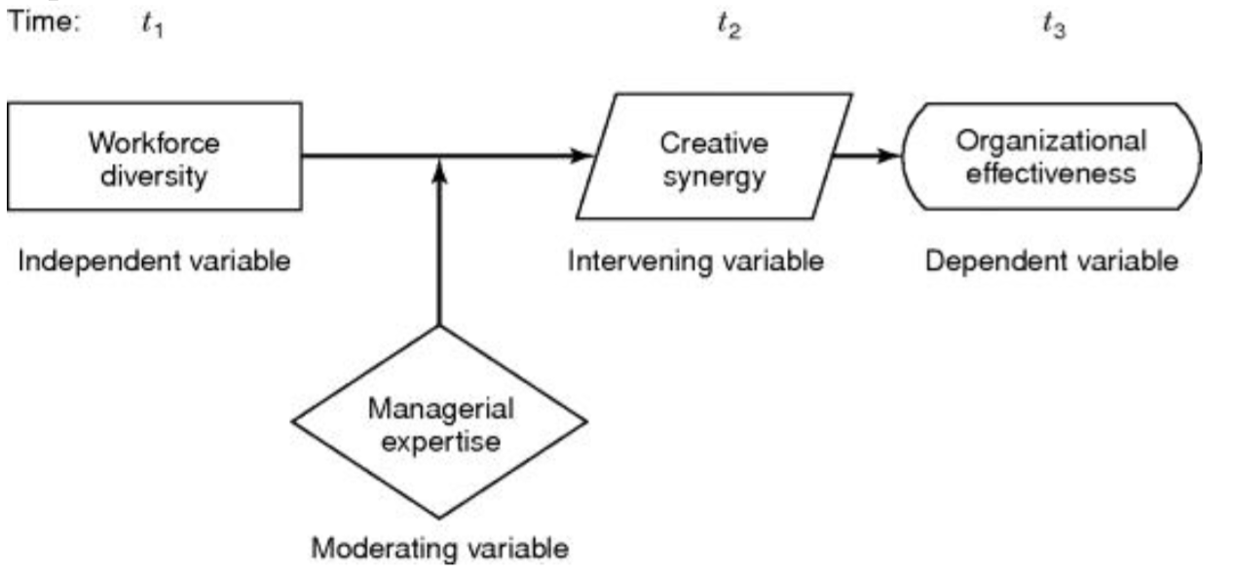

The independent variable helps to explain the variance in the dependent variable; the mediating variable surfaces at time t₂ as a function of the independent variable; the moderating variable has a contingent effect on the relationship between two variables.

Theoretical framework
The theoretical framework is the foundation on which the entire research project is based. It is a logically developed, described, and elaborated network of associations among the variables deemed relevant to the problem and identified through such processes as interviews, observations, and literature review.

Based on the results of hypothesis testing, the extent to which the problem can be solved becomes evident.

The relationship between the literature review and the theoretical framework is that the former provides a solid foundation for developing the latter. This forms the basis for the theoretical model.

Components of the theoretical framework
A good theoretical framework identifies and defines the important variables in the situation that are relevant to the problem and subsequently describes and explains the interconnections among these variables. The relationships between all variables are elaborated.

A good theoretical framework is not necessarily complex.

3 basic features that should be incorporated in any theoretical framework:
- The variables considered relevant to the study should be defined
- A conceptual model that described the relationships between the variables in the model should be given
- There should be a clear explanation of why we expect these relationships to exist

A conceptual model described how the concepts in your model are related to each other.
A schematic diagram of the conceptual model helps the reader to visualize the theorized relationship. Theoretical models are often expressed in this form.

Both a schematic diagram of the conceptual model and a description of the relationships between the variables in words should be given.

A good model is based on sound theory. A theory is the last component of the theoretical framework; it attempts to explain the relationships between the variables in a model.

Hypothesis development
A hypothesis can be defined as a tentative, yet testable, statement, which predicts what you expect to find in your empirical data. Hypotheses are derived from the theory on which your conceptual model is based and are often rational in nature, they can be defined as logically conjectured relationships between two or more variables expressed in the form of a testable statement.

To examine whether or not the conjectured relationships or differences exist, these hypotheses can be set either as propositions or in the form of if-then statement.

If terms such as positive, negative, more than, less than, etc. are used, then these are directional hypotheses because the direction of the relationship between the variables is indicated or the nature of the difference between two groups on a variable is postulated.

Nondirectional hypotheses are those that do postulate a relationship or difference, but offer no indication of the direction of these relationships or differences. These hypotheses are formulated either because the relationships have never been explored or because there have been conflicting findings in previous research studies.

The hypothetico-deductive method requires that hypotheses are falsifiable. A null hypothesis (H₀) is one set up to be rejected in order to support an alternate hypothesis (H_{A}). The null hypothesis is presumed true until statistical evidence indicates otherwise.

The alternate hypothesis, which is the opposite of the null, is a statement expressing a relationship between two variables or indicating differences between groups.

The null hypothesis is formulated so that it can be tested for possible rejection. If rejected, all other permissible alternate hypotheses could be supported.

The steps to be followed in hypothesis testing are:
- State the null and the alternate hypotheses
- Choose the appropriate statistical test
- Determine the level of significance desired
- See if the output results indicate that the significance level is met

Testing can be done both through:
- Deduction
  - The theoretical model is first developed
  - Testable hypotheses are formulated
  - Data collected
  - Hypotheses tested
- Induction
  - New hypotheses are formulated based on what is known from the data already collected
  - Tested

New hypotheses not originally though of might be developed after data are collection.

Hypotheses can also be tested with qualitative data.

5. The research process: elements of research design

Issues relating to decisions regarding the purpose of the study, it’s location, the type it should conform to, the extent to which it is manipulated and controlled by the researcher, its temporal aspects, and the level at which the data will be analyzed, are integral to research design.

Decisions have to be made as to the type of sample to be used, how the data will be collected, how variables will be measured, and how they will be analyzed to test the hypotheses.

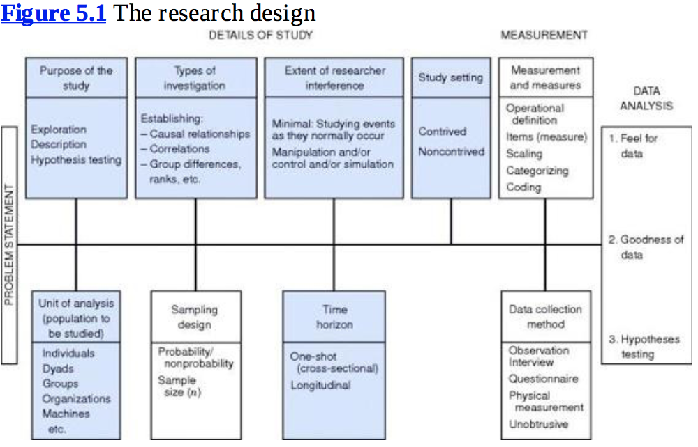

Each component of the research design offers several critical choice points.

The more sophisticated and rigorous the research design is, the greater the time, costs, and other resources expended on it will be.

Testing
Studies may be either exploratory in nature or descriptive, or may be conducted to test hypotheses.

Case study is an examination of studies done in other similar organizational situations. It is also a method of solving problems or understanding phenomena of interest. The nature of the study depends on the stage to which knowledge about the research topic has advanced.

Exploratory study
An exploratory study is undertaken when not much is known about the situation at hand, or no information is available on how similar problems or research issues have been solved in the past.
Extensive preliminary work needs to be done to gain familiarity with the phenomena before developing a model. Exploratory studies are undertaken to better comprehend the nature of the problem.

Doing a study for the first time in a particular organization does not make the research exploratory in nature; only when knowledge is scant and deeper understanding is sought does the study become exploratory.

Descriptive study
A descriptive study is undertaken in order to ascertain and be able to describe the characteristics of the variables of interest in a situation.
Descriptive studies are undertaken in organizations to learn about and describe the characteristics of a group of employees. They are also undertaken to understand the characteristics of organizations that follow certain common practices.

Descriptive studies that present data in a meaningful form help to:
- Understand the characteristics of a group in a given situation
- Think systemically about aspects in a given situation
- Offer ideas for further probe and research
- Help make certain simple decisions

Qualitative data obtained by interviewing individuals may help the understanding of phenomena at the exploratory stages of a study, quantitative data in terms of frequencies, or mean and standard deviations, become necessary for descriptive studies.

Case study analysis
Case studies involve in-depth, contextual analyses of matters relating to similar situations in other organizations.

In exploratory studies:
- Researcher explores situational factors to understand the characteristics of the phenomena
- Pilot studies on a small scale are not uncommon
Descriptive studies:
- Undertaken when the characteristics in a situation are known to exist
- Hypothesis testing offers an enhanced understanding of the relationship that exists among variables
  - May establish cause and effect relationships
  - Can be done with qualitative and quantitative data

Casual versus correlational relationship

Casual study: A study in which the researcher wants to delineate the cause of one or more problems
Correlational study: A study in which the researcher is interested in delineating the important variables associated with the problem

Extent of researcher interference with the study
The extent of interference by the researcher with the normal flow of work has a direct bearing on whether the study is casual or correlational.
A correlational study is conducted in the natural environment with minimal interference.
If trying to establish cause and effect relationships, the researcher tries to manipulate certain variables to study the effects on the dependent variable.

Contrived and noncontrived study setting

Noncontrived settings: Organizational research done in the natural environment where work proceeds normally
Contrived settings: Artificial settings

Correlational studies are invariably conducted in noncontrived settings
Most rigorous causal studies are done in contrived settings

Field studies: Correlational studies done in organizations
Field experiments: Studies conducted to establish cause-and-effect relationships using the same natural environment as default
Lab experiments: Experiments done to establish cause-and-effect relationship beyond the possibility of the least doubt which require the creation of an artificial, contrived environment in which all the extraneous factors are strictly controlled.

Unit of analysis: individuals, dyads, groups, organizations, cultures

Unit of analysis: The level of aggregation of the data collected during the subsequent data analysis stage

Dyads: Several two-person groups

If the problem statement is related to group effectiveness, then the unit of analysis will be at the group level.

Cross-sectional studies

Cross-sectional studies (one-shot): A study undertaken in which data are gathered just once in order to answer a research question.

Longitudinal studies

Longitudinal studies: Studies where data on the dependent variable are gathered at two or more points in time to answer the research question.
- Take more time and effort & cost more than cross-sectional studies
- Help to identify cause-and-effect relationships

Most field studies conducted are cross-sectional because of time, effort, and costs involved.

Managerial implications
Knowledge about research design issues helps the manager to understand what the research is attempting to do.
One of the important decisions a manger has to make before starting a study pertains to how rigorous the study ought to be.

6. Measurement of variables: operational definition

How variables are measured
Measurement is the assignment of numbers or other symbols to characteristics (attributes) of objects according to a pre-specified set of rules.

Objects include:
- Persons
- Business units
- Companies
- Countries
- Items
- Etc.

Examples of characteristics of objects:
- Arousal-seeking tendency
- Achievement motivation
- Organizational effectiveness
- Shopping enjoyment
- Length
- Weight
- Ethnic diversity
- Service quality
- Conditioning effects
- Taste
- Etc.

There are at least two types of variables: one lends itself to objective and precise measurement; the other is more nebulous and does not lend itself to accurate measurement because of its abstract and subjective nature.

Operationalization of variables
One technique to tap the previously mentioned variables is to reduce abstract notions or concepts to observable behavior and/or characteristics. Reduction of abstract concepts to render them measurable in a tangible way is called operationalizing the concepts.

Operationalizing is done by looking at the behavioral dimensions, facets, or properties denoted by the concept. These are then translated into observable and measurable elements to develop an index of measurement of the concept.
- Come up with a definition of the construct you want to measure
- Think about the content of the measure; an instrument that actually measures the concept that you want to measure has to be developed
- A response format is needed (e.g.7-point rating)
- The validity and reliability of the measurement has to be assessed

Operationalization: dimensions and elements
A valid measure of need for cognition contains 34 items even though need for cognition is a unidimensional construct.

Operationalizing the multidimensional concept of achievement motivation
After defining the construct, the next step in the process of measuring abstract constructs is to go through the literature to find out whether there are any existing measures of the concept.

Scientific journals and scale handbooks are important sources of existing measures.

Empirical articles published in academic journals provide a detailed description of how specific constructs were measured.

Dimensions and elements of achievement motivation
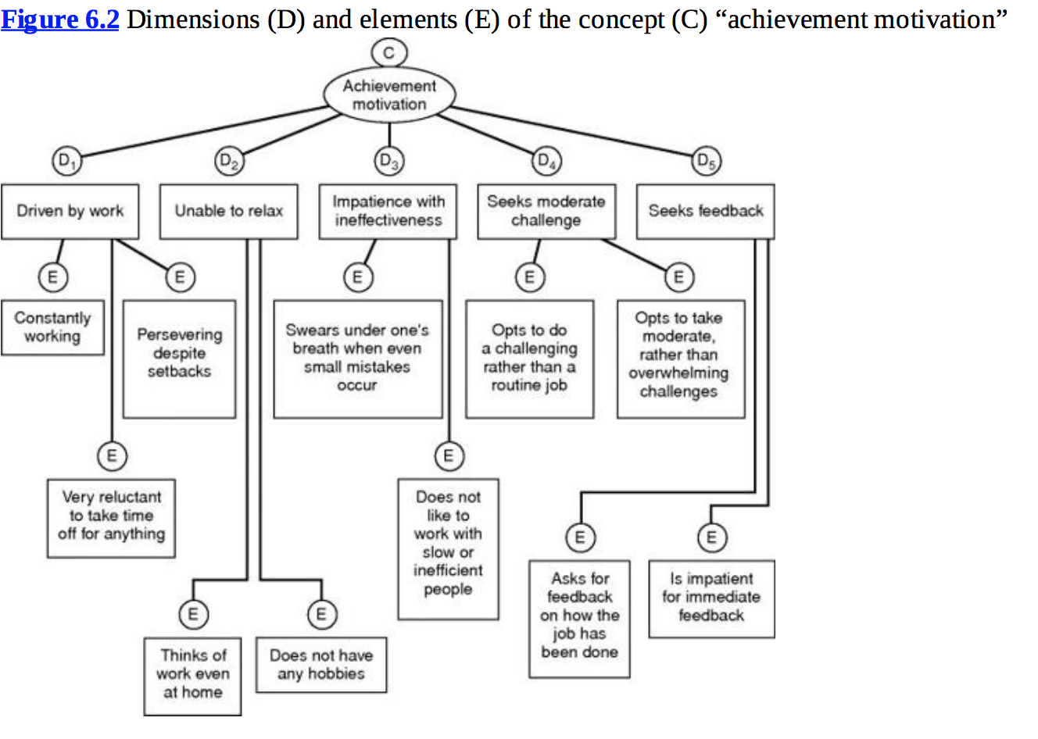

Operationalization is likely to:
- Exclude some of the important dimensions and elements arising from failure to recognize or conceptualize them
- Include certain irrelevant features, mistakenly thought to be relevant

Operationalization consists of the reduction of the concept from its level of abstraction, by breaking it into dimensions and elements.

An operationalization does not describe the correlated of the concept.

Operationalizing a concept does not consist of delineating the reasons, antecedents, consequences, or correlates of the concept. It describes its observable characteristics in order to be able to measure the concept.

Only a well-developed instrument, which has been operationalized with care, will be accepted and frequently used by other researchers.

In conducting transnational research, it is important to remember that certain variables have different meanings and connotations in different cultures.

7. Measurement: scaling, reliability, validity

There are two main categories of attitudinal scales, the rating scale and the ranking scale.
- Rating scales have several response categories and are used to elicit responses with regard to the object, even, or person studied.
- Ranking scales make comparisons between or among objects, events, or persons and elicit the preferred choices and ranking among them.

Scales

A scale is a tool or mechanism by which individuals are distinguished as to how they differ from one another on the variables of interest to the study.
- The scale or tool may be a gross one (it only broadly categorizes individuals on the variables with varying degrees of sophistication)
- 4 basic types of scales (with the degree of sophistication increasingly progressively from nominal to ratio):
  - Nominal scale: one that allows the researcher to assign subjects to certain categories or groups.
    - The information that can be generated from nominal scaling is the calculation of the % or frequency.
    - Gives basic, categorical, gross information.
  - Ordinal scale: not only categorizes the variables in such a way as to denote differences among the various categories, it also rank-orders the categories in some meaningful way.
    - With any variable for which the categories are the be ordered according to some preference, the ordinal scale would be used.
    - The preference would be ranked, numbered, etc.
    - Goes beyond differentiating the categories to providing information on how respondents distinguish them by rank-ordering them.
    - Does not give any indication of the magnitude of the differences among the ranks.
  - Interval scale: allows us to perform certain arithmetical operations on the data collected from the respondents.
    - Lets us measure the distance between any two points on the scale, which helps to compute the means and the standard deviations of the responses on the variables.
    - The interval scale not only groups individuals according to certain categories and taps the order of these groups, it also measures the magnitude of the differences in the preferences among the individuals.
    - Taps the differences, the order, and the equality of the magnitude of the differences in the variable.
    - It is a more powerful scale than the nominal and ordinal scale and has for its measure of central tendency the arithmetic mean.
    - Its measures of dispersion are the range, the standard deviation, and the variance.
  - Ratio scale: not only measures the magnitude of the differences between points on the scale, it also taps the proportions in the differences.
    - Overcomes the disadvantage of the arbitrary origin point of the interval scale, in that it has an absolute zero point.
    - The most powerful of the 4 scales because it has a unique zero origin and subsumes all the properties of the other three scales.
    - Some variables, such as gender, can be measured only on the nominal scale, while others, such as temperature, can be measured on various scales.
    - Whenever possible the more powerful scale should be used.

Rating scales

The following rating scales are often used in organizational research:
- Dichotomous scale
  - Used to elicit a yes or no answer
- Category scale
  - Uses multiple items to elicit a single response
- Semantic differential scale
  - Used to assess respondents’ attitudes toward a particular brand, advertisement, object, or individual.
  - Responses can be plotted to obtain a good idea of their perceptions
  - Treated as an interval scale
- Numerical scale
  - Similar to the semantic differential scale, with the difference that numbers on a 5 or 7-point scale are provided, with bipolar adjectives at both ends
  - An interval scale
- Itemized rating scale
  - A 5 or 7-point scale with anchors is provided for each item and the respondent states the appropriate number on the side of each item
  - Interval scale
  - Provides the flexibility to use as many points in the scale as considered necessary
  - Also possible to use different anchors
  - When a neutral point is provided, it is a balanced rating scale, and when it is not, it is an unbalanced rating scale.
  - Frequently used in business research, since it adapts itself to the number of points the researcher wishes to use.
- Likert scale
  - Designed to examine how strongly subjects agree or disagree with statements on a 5-point scale
  - The summated approach is widely used; thus the Likert scale is referred to as a summated scale
  - Treated as interval scales
- Fixed or constant sum rating scale
  - Respondents are asked to distribute a given number of points across various items.
  - Ordinal scale
- Staple scale
  - Simultaneously measures both the direction and intensity of the attitude toward the items under study.
  - The characteristic of interest to the study is placed at the center with a numerical scale ranging from +x to –x
  - Interval scale
- Graphic rating scale
  - Graphical representation helps the respondents to indicate on this scale their answers to a particular question by placing a mark at the appropriate point on the line
  - Ordinal scale
  - Easy to respond to
  - Brief descriptions on the scale points are meant to serve as a guide in locating the rating rather than representing discrete categories.
  - Faces scale is also a graphic rating scale
- Consensus scale
  - A panel of judges selects certain items, which in its view measure the relevant concept.
  - Items are chosen particularly based on their pertinence of relevance to the concept.
  - Thurstone Equal Appearing Interval Scale: a concept is measured by a complex process followed by a panel of judges
  - Rarely used for measuring organizational concepts because of the time necessary to develop it
- Other scales
  - Advanced scaling methods such as multidimensional scaling, where objects, people, or both, are visually scaled, and a conjoint analysis is performed.
    - Provides visual image of the relationships in space among the dimensions of a construct.
  - Likert or some form of numerical scale is the one most frequently used to measure attitudes and behaviors in organizational research.
- Ranking scales
  - Used to tap preferences between two or among more objects or items (ordinal in nature)
  - Such rankings may not give definitive clues to some of the answers sought
  - Alternative methods used are paired comparisons, forced choice, and the comparative scale
- Paired comparison
  - Used when respondents are asked to choose between 2 objects at a time
  - Helps to assess preferences
- Forced choice
  - Enables respondents to rank objects relative to one another, among the alternatives provided.
  - Easier for the respondents
- Comparative scale
  - Provides a benchmark or a point of reference to assess attitudes toward the current object, event, or situation under study.
  - Nominal data lend themselves to dichotomous or category scales
  - Ordinal data to any one of the ranking scales
  - Interval or interval-like data to the other rating scales
  - The semantic differential and the numerical scale are not interval scales
  - Rating scales are used to measure most behavioral concepts
  - Ranking scales are used to make comparisons or rank the variables that have been tapped on a nominal scale

International dimensions of scaling

Different cultures reach differently to issues of scaling.

The use of better instruments will ensure more accuracy in results, which in turn will enhance the scientific quality of the research.

Item analysis: carried out to see if the items in the instrument belong there or not.
- The means between the high-score group and the low-score group are tested to detect significant differences through the t-values.
- Reliability is a test of how consistently a measuring instrument measures whatever concept it is measuring.
  - Reliability measure indicates the extent to which it is without bias and hence ensures consistent measurement across time and across the various items in the instrument.
  - The ability of a measure to remain the same over time is indicative of its stability and low vulnerability to changes in the situation
  - Two tests of stability are:
    - Test-retest reliability: The reliability coefficient is obtained by repetition of the same measure on a second occasion.
    - Parallel-form reliability: When responses on 2 comparable sets of measures tapping the same construct are highly correlated
  - The internal consistency of measures is indicative of the homogeneity of the items in the measure that tap the construct.
  - The interitem consistency reliability is a test of the consistency of respondents’ answers to all the items in a measure
  - Splif-half reliability reflects the correlations between two halves of an instrument. The estimates will vary depending on how the items n the measure are split into two halves.
- Validity is a test of how well an instrument that is developed measures the particular concept it is intended to measure
  - Several types of validity tests are used
    - Content validity: ensures that the measure includes an adequate and representative set of items that tap the concept
    - the more the scale items represent the domain or universe of the concept being measured, the greater the content validity.
    - Face validity indicates that the items that are intended to measure a concept, do, on the face of it, look like they measure the concept.
      - Face validity is considered by some a basic and minimum index of content validity
    - Criterion-related validity is established when the measure differentiates individuals on a criterion it is expected to predict.
      - Can be done by establishing concurrent validity or predictive validity
      - Concurrent validity is established when the scale discriminates individuals who are known to be different
      - Predictive validity: indicated the ability of the measuring instrument to differentiate among individuals with reference to a future criterion
    - Construct validity testifies to how well the results obtained from the use of the measure fit the theories around which the test is designed.
    - Convergent validity is established when the scores obtained with 2 different instruments measuring the same concept are highly correlated.
    - Discriminant validity is established when, based on theory, 2 variables are predicted to be uncorrelated, and the scores obtained by measuring them are indeed empirically found to be so.
    - Some of the ways the above forms of validity can be established are through:
      - Correlational analysis
      - Factor analysis, a multivariate technique that confirms the dimensions of the concept that have been operationally defined
      - The multitrait, multimethod matrix of correlations derived from measuring concepts by different forms and different methods

It is not unusual for 3 or more equally good measures to be developed for the same concept. When more than one scale exists for any variable, it is preferable to use the measure that has better reliability and validity and is also more frequently used.

In a reflective scale, the items are expected to correlate. Each item in a reflective scale is assumed to share a common basis in the underlying construct of interests.

A formative scale is used when a construct is viewed as an explanatory combination of its indicators.

The job description index includes 5 dimensions and 72 items. These 72 items are not necessarily related to each other, because the 5 dimensions they represent do not necessarily hang together.
A scale that contains items that are not necessarily related is called a formative scale. Formative scales are used when a construct is viewed as an explanatory combination of its indicators.
The job description index is formative in nature.
A good (valid) formative scale is one that represents the entire domain of the construct.
While it makes sense to test the interitem consistency of reflective scales, it does not make sense to test the interitem consistency of formative scales.

